**Supplementary Information**

**Toxic emissions resulting from sucralose added to electronic cigarette liquids**

Rachel El-Hage, MS,†,§ Ahmad El-Hellani, Ph.D,†,§, Christina Haddad, MS,†,§ Rola Salman, BS,‡,§ Soha Talih, PhD,‡,§ Thomas Eissenberg, PhD,˧,§ Alan Shihadeh, ScD,‡,§ and Najat Aoun Saliba, Ph.D.†,§,*

† Chemistry Department, Faculty of Arts and Sciences, American University of Beirut, Beirut, Lebanon

‡ Mechanical Engineering Department, Maroun Semaan Faculty of Engineering and Architecture American University of Beirut, Beirut, Lebanon

˧ Department of Psychology, Institute for Drug and Alcohol Studies, Virginia Commonwealth University, Richmond, Virginia, USA

§ Center for the Study of Tobacco Products, Virginia Commonwealth University, Richmond, Virginia, USA

* Corresponding Author: Najat A. Saliba, Tel: +961 1 350000/3992. E-mail: ns30@aub.edu.lb.

**Thermo Gravimetric Analysis (TGA) of sucralose**

As reported in the literature, the thermo gravimetric analysis(TGA) experiment conformed the low stability of sucralose upon heating. The sucralose degradation reaction initiated at around 130⁰C and led to the formation of HCl and other decomposition products as shown by the Fourier Transform Infra Red (FTIR) spectra (Figure S1). Thermo-gravimetric analysis (TGA) was done on Netzsch TG 209 F1 Libra coupled to Bruker TGA-IR Tensor 27. Pure sucralose (10 mg) was added to an alumina crucible that was placed in the TGA machine. The temperature program was: 30°C/20.0(K/min)/800°C, and the effluent gas was monitored on FTIR.



**Figure S1.** The superimposition of FTIR spectra obtained from TGA analysis of sucralose. Spectra show emission of HCl (peak around 2900 cm-1) starting at 130 ⁰C.

**Formation of acid-catalyzed product in the gas phase**

Gaseous products of the propylene glycol (PG)-sucralose degradation reaction during aerosolization were monitored by FTIR and nuclear magnetic resonance (NMR) spectroscopy. The experimental design consisted of a PG liquid (blank solution) or a PG liquid containing sucralose (1 % by mass), a sub-ohm device with 10 wraps kanthal wire coil operated at 125 W, a filter intercepting the gas flow and a gas tube directed onto the FTIR gas cell or to an impinger to trap the gases in deuterated chloroform for NMR measurements (Figure S2).

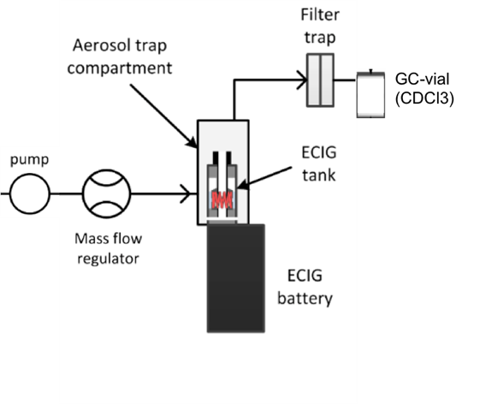

NMR

IR

**Figure S2.** The experimental setup used to analyze the gas phase produced from vaping sucralose in PG via FTIR and NMR.

Figure S3 shows that the aerosolization with sucralose does not show any chloropropanol in the gas phase and adds two new peaks to the already identified PG degradation products (El-Hellani et al. 2019). They are identified in the 1000-1200 and 2900-3100 cm-1 ranges as C-O-C and sp3 C-H bonds, respectively, and hint to HCl induced reactions. When HCl was scavenged by nicotine addition, these new products disappeared and confirmed the contribution of HCl to their formation as shown in Figure S4. The product attributed to the C-O-C bond was further identified by NMR. The NMR analysis of the gases produced from the four different solutions (1% nicotine in PG, 1% sucralose + 1% nicotine in PG, 1% sucralose in PG, and PG alone aerosolized at 125W) showed a unique peak for the 1% sucralose in PG solution between 3.3 and 5.3 ppm (Figure S5) identified as propylene acetal of acetaldehyde (IUPAC name: 2,4-dimethyl-1,3-dioxolane) (Scheme S1). The formation of acetals is known to be an acid transformation (Hunt 2019) catalyzed in this case by HCl produced from the sucralose degradation reaction.



**Scheme S1.** Reaction between acetaldehyde and propylene glycol to produce acetal in the presence of HCl



**Figure S3.** FTIR spectra of gases produced by aerosolization, using a sub-ohm device at 125 W, pure PG and sucralose in PG liquids.



**Figure S4.** FTIR spectra of gases produced by aerosolization, using a sub-ohm device at 125 W, sucralose in PG, pure PG and sucralose and nicotine in PG solutions. Nicotine is used as a scavenger for HCl in this case.



**3**

**3**

**2**

**2’**

**1**

**2**

**1**

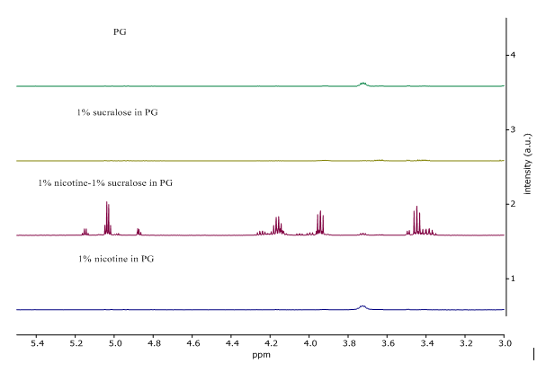

PG

1%Sucra-PG

1%Nic-PG

5.4

5.2

5.0

4.8

4.6

4.4

4.2

4.0

3.8

3.6

3.4

3.2

ppm

1%Sucra-1%Nic-PG

**Figure S5.** NMR spectra of gases produced by aerosolization, using a sub-ohm device at 125 W, pure PG, sucralose in PG, sucralose and nicotine in PG and nicotine in PG solutions

1. 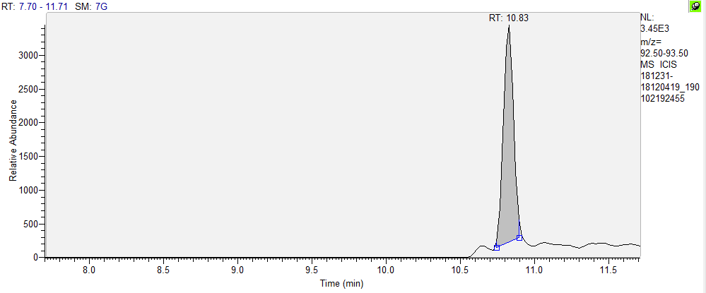

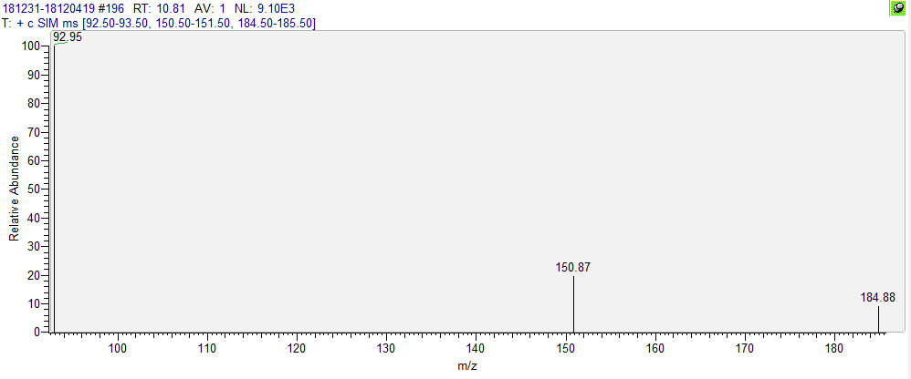B)

**Figure S6.** Example of the detection of 1,3-DCP in a sample on GC-MS using selected ion monitoring (SIM): A) GC chromatogram and B) MS spectrum.

A)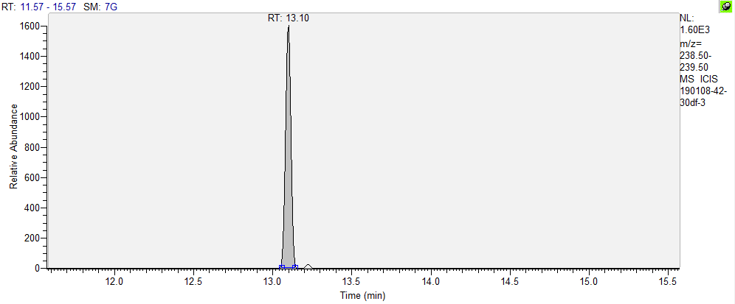

B) 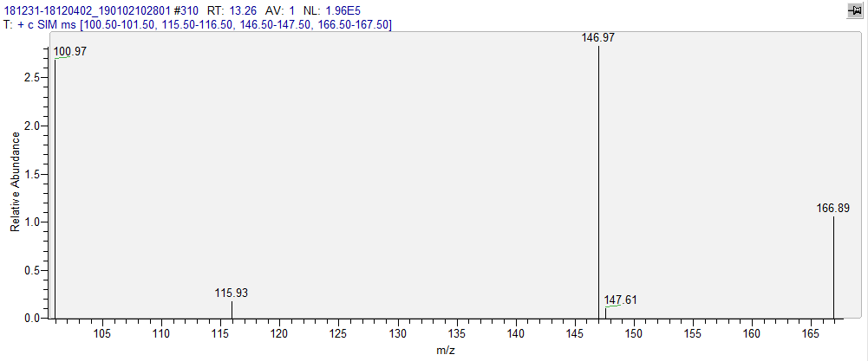

**Figure S7.** Example of the detection of 3-MCPD in a sample on GC-MS using selected ion monitoring (SIM): A) GC chromatogram and B) MS spectrum.

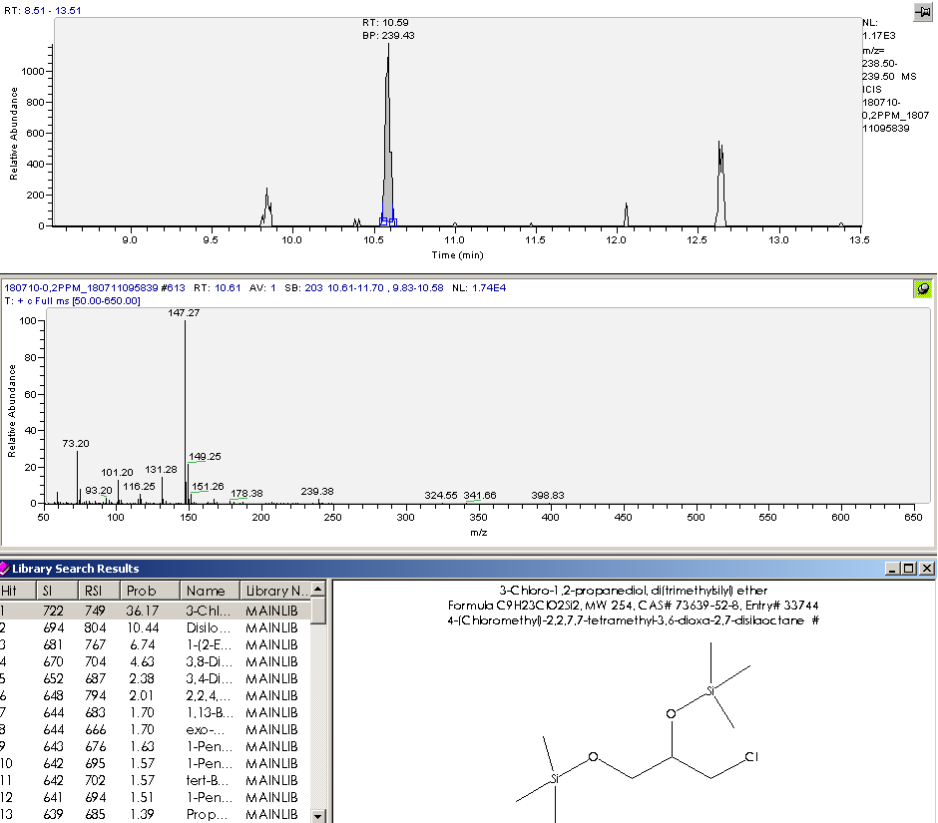

**Figure S8.** GC chromatogram with MS spectrum (full scan) of an extracted filter pad from our preliminary experiment in which the liquid contained sucralose and nicotine.

El-Hellani, A., S. Al-Moussawi, R. El-Hage, S. Talih, R. Salman, A. Shihadeh, and N. A. Saliba. 2019. Carbon Monoxide and Small Hydrocarbon Emissions from Sub-ohm Electronic Cigarettes. *Chemical Research in Toxicology*. 32 (2): 312-317. DOI: 10.1021/acs.chemrestox.8b00324.

Hunt, I. 2019. Reactions of Alcohols to give Acetals. Retrieved Feb 5, 2019, from <http://www.chem.ucalgary.ca/courses/351/Carey5th/Ch17/ch17-3-4-2.html>.