Supplemental Information
Morphological characterization and chemical composition of PM_{2.5} and PM₁₀ collected from four typical Chinese restaurants.
Yuanju Li, Aihua Wu, Yuandong Wu, Jie Xu, Ziwei Zhao, Mengxue Tong, Shengji Luan
Additional information as noted in text. Tables describing restaurant information and cooking fumes during sampling. Information regarding calibration of the DustTraks (Model 8530, TSI, USA).

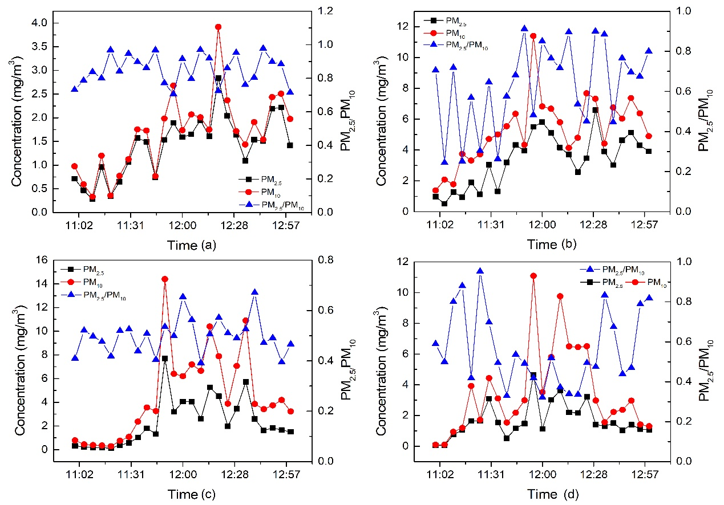
Figure S1. Concentrations of PM_{2.5} and PM₁₀ from the four restaurants from 11:00 am to 13:00 pm. The data was recorded every five minutes. Figure 1(a) was Cantonese style (GD), (b) Sichuan style (SC), (c) Xibei (XB) style and (d) Hunan (HN) style.
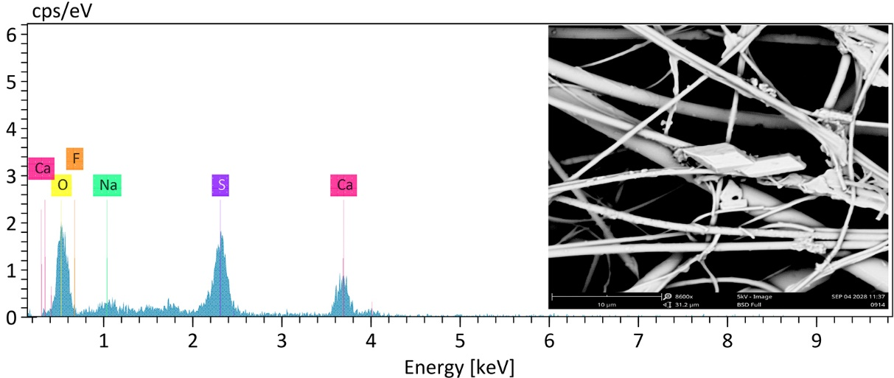
Figure S2. Micrographs and chemical analysis of rectangular particles using EDS.

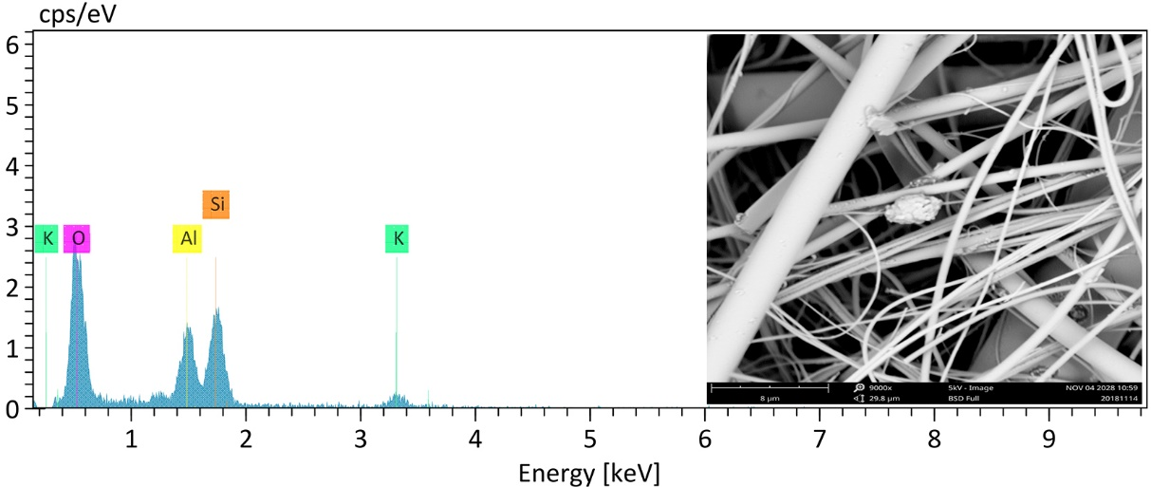
Figure S3 Micrographs and chemical analysis of irregular particles with EDS.

Table S1. The basic information of each restaurant
Restaurant | Method | Ingredients | Spices | Number of stoves | Attendance | Maximum Number of diners
Cantonese (GD) | Steam, boil and simmer. | Main: Meat type - seafood, goose, pigeon  Vegetable- cabbage, broccoli  Others: rice, milk, coconut | Salt, sugar | 4 | 90% | 66
Sichuan (SC) | Stir-frying, pan-frying and deep frying | Main: Meat type - pork, chicken, beef  Vegetable- lettuce, potato, ginger  Others: rice, animal innards | Sichuan Pepper, Chili pepper, shallots, garlic, ginger, salt | 4 | 95% | 60
Hunan (HN) | Quick-frying, boil and steam | Main: Meat type - fresh-water fish, pork, duck  Vegetable- carrots, cucumber  Others: rice, eggs | Chili pepper, salt, essence of chicken | 5 | 85% | 72
Xibei (XB) | Grill, roast and boil | Main: Meat type - Lamb, beef, chicken  Vegetable- carrots, cucumber  Others: flour, noodles, yoghurt | Black pepper, cumin, Chili pepper | 5 | 80% | 70

Table S2. The basic information of cooking fumes during sampling.
Restaurant | Temperature | Relative humidity | SO₂ (mg / m³)
Cantonese (GD) | 26.5℃ | 67% | 0.0113
Sichuan (SC) | 28℃ | 65% | 0.0124
Hunan (HN) | 27℃ | 69% | 0.0112
Xibei (XB) | 27.5℃ | 73% | 0.0116
Calibration of the DustTraks
Before sampling, the Dsttrak samplers were combined with a low-volume sampler (MiniVol TAS, Airmetrics) to determine the calibration factor for the PM emitted from these restaurants. The two instruments were started at the same time, and the sampling time was 30 minutes at a flow rate of 3L/min. Then, the mass concentration in mg/m³ was determined using the Dusttrak sampler and the MiniVol samples (quartz fiber filters, 47 mm diameter, Whatman) were weighed. Then, the new calibration constant, NewCal, was computed using the following formula:
$$NewCal=\left(\frac{MiniVol Concentration}{DustTrak Concentration}\right)×CurrentCal$$
Finally, select photometric and enter the NewCal.

