Identification and evaluation of novel drug combinations of Aurora kinase inhibitor CCT137690 for enhanced efficacy in oral cancer cells
Supplementary Results:

Size and Morphology of L-P-NCps

The size of NCps depends on their inherent capacity to accommodate drug. The ~500 nm L-P-NCps represent the most stable form of NCps; their stability decreases with the change in the concentration of drugs. We observed that CG-L-P-NCps were smaller than the E-P-NCps, which may be attributed to the sequestering of most of the drug molecules by the polymer due to the strong electrostatic interactions that make them smaller and more stable. Polydispersity Index, determined by Zetasizer Nano ZSP, for all formulations was found to be < 0.5 (Supplementary Figure S1). The UV-visible absorption spectrum of NCps formulation confirmed the encapsulation of CCT137690, pictilisib and gefitinib with λ-max at 320 nm, 240 nm and 278 nm (Supplementary Table 1 and Supplementary Figure S1). Surface morphology was observed to be fairly spherical and smooth in STEM images (Supplementary Figure S1).
Sample | Diameter (nm) ±SD | Zeta potential (mV) ± SD | Drug encapsulation efficiencyª EE % (mg/mL) ± SD
 |  |  | CCT137690 | Gefitinib/pictilisib
E-P-NCps | 458.5 ± 2.6 | −3.9 ± 0.02 | - | -
CGe-L-P-NCps | 615 ± 1.5 | −7.6 ± 0.05 | 5.9 ± 0.002 | 6.05 ± 0.001
CG-L-P-NCps | 400 ± 2 | −7.6 ± 0.05 | 7.68 ± 0.001 | 6.9 ± 0.004
Supplementary Table 1: Characterization of drugs loaded nanocapsules. CCT137690 with GDC0941 pictilisib in CG-L-P-NCps and CCT137690 with gefitinib in CGe-L-P-NCps. ª5 mg/ml of each drug was initially fed to the system during the synthesis of L-P-NCps and encapsulation efficiency was determined after separating the un-trapped drug.
E-P-NCps: Empty nano-capsules
CGe-L-P-NCps: Loaded nanocapsules with CCT137690 and gefitinib
CG-L-P-NCps: Loaded nanocapsules with CCT137690 and pictilisib

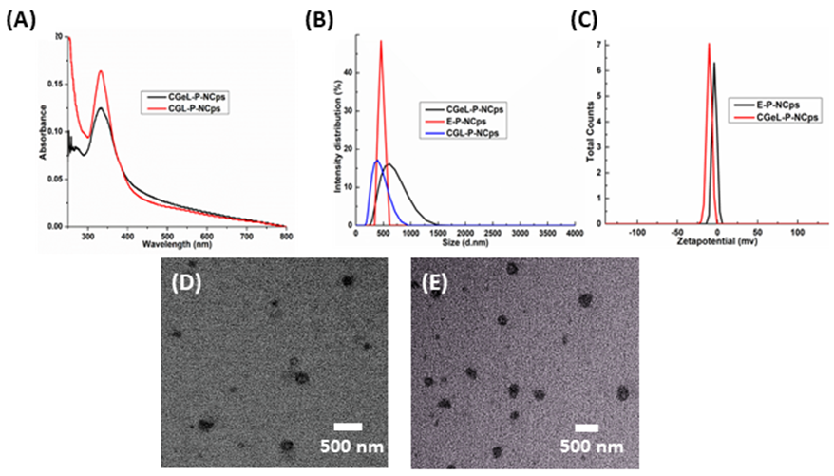

Supplementary Figure S1: Characterization of Nanocapsules (A) UV-Visible absorption spectrum of CG-L-P-NCps and CGe-L-P-NCps (B) DLS-analysis showing an average hydrodynamic size of E-P-NCps, CG-L-P-NCps and CGe-L-P-NCps to be 458.5, 400 and 615 nm (B) Zetapotential of E-P-NCps, CG-L-P-NCps and CGe-L-P-NCps (D & E) SEM Micrographs confirming size of CG-L-P-NCps and CGe-L-P-NCps

Drug Encapsulation Efficiency

The drug encapsulation efficiency of L-P-NCps depends on the amount of encapsulated drug and the drug adsorbed/entangled in the apparent pockets of PEG. Different concentrations of drugs were entrapped in L-P-NCps (0.2-0.3 mg/ml). Encapsulation efficiency was determined by removing the free/loosely bound drug from the L-P-NCps through centrifugation of the NCps suspension for 10 min at 8000 rpm at 4 °C. Water-insoluble, unentrapped drug settled down as a pellet and the L-P-NCps were diluted with chloroform:methanol (1:4) mixture and vigorously sonicated for 3 min to rupture the NCps and release all the drug in the solvent system. The concentrations of entrapped drugs released from L-P-NCps were quantified by measuring the absorbance of CCT137690, pictilisib and gefitinib at 320 nm, 240 nm and 278 nm, respectively (Supplementary Table 1). The encapsulation efficiency was calculated using the following mathematical expression:

Encapsulation efficiency (%) = [drug in supernatant after rupturing of L P NCps / [total drug added to mixture] × 100

Optimization of 3D spheroids of oral cancer cell lines:
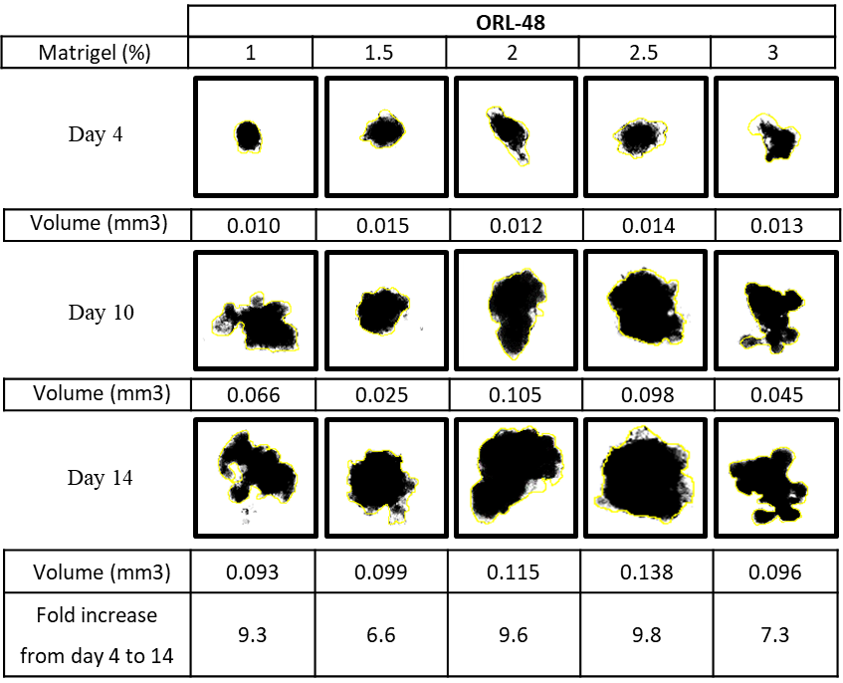
(A)
(B)
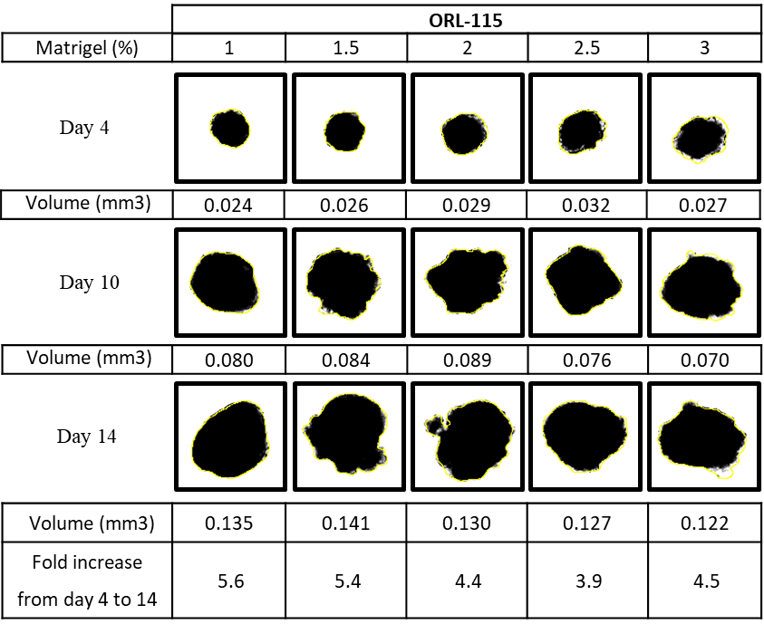

Supplementary Figure S2: Optimization of the growth of oral cancer cells in 3D spheroids. (A) ORL-48 and (B) ORL-115 cells were grown with different concentrations of Matrigel in agarose coated plates for 14 days. Images shown above were taken at day 14, and their volumes were calculated as described in methods section.

Evaluation of free drug combinations in 3D spheroids of oral cancer cell lines:
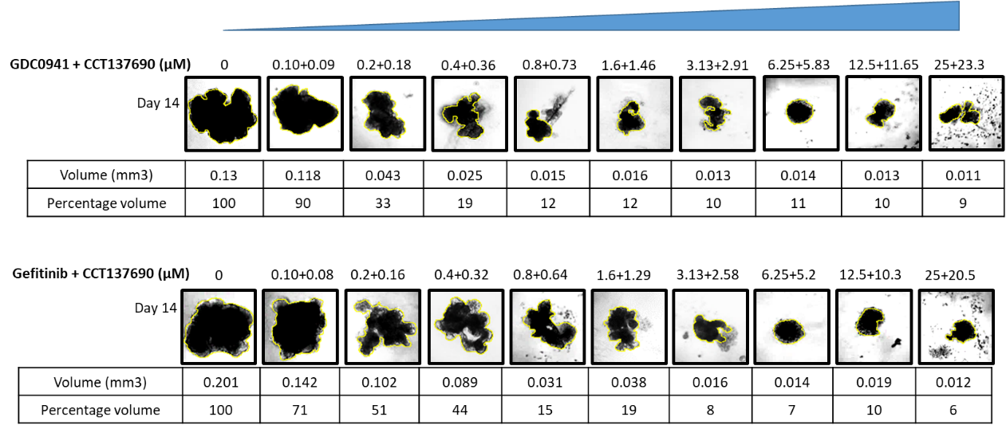
(A)
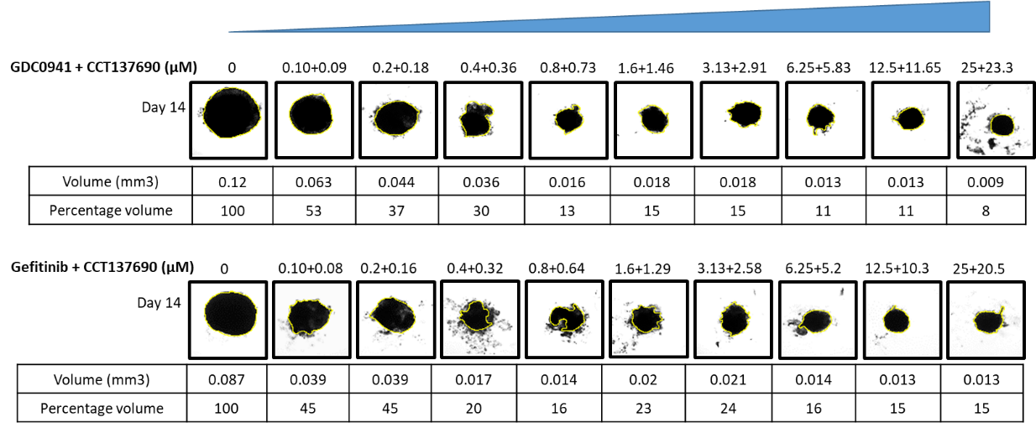
(B)
Supplementary Figure S3: Purified drug combinations inhibit growth of the oral cancer cells in 3D spheroid cultures. (A) ORL-48 and (B) ORL-115 spheroids treated with increasing concentrations of indicated drugs in combinations, pictilisib + CCT137690 (above) and gefitinib + CCT137690 (below). Represented images were taken at 14th day and their parameters were calculated by using open source tools like ReViSP, AnaSP and ImagJ as described in method section.

Supplementary Materials and Methods:

Drug combination analysis

Combinations of CCT137690 with Gefitinib or Pictilisib were evaluated for their enhanced antiproliferative activity in oral cancer cells by using cell viability assay, but with few additional steps. Briefly, ORL-48 and ORL-115 cells (3000, and 4000 cells respectively) were split in 100µl of media in 96 well plates on day one. Following 24-hours incubation, cells were treated with different concentrations of drug combinations i.e. (23.3 µM CCT137690 + 25 µM Pictilisib) and (20.5 µM CCT137690 + 25 µM Gefitinib), each combination was two folds serially diluted upto nine dilutions. After 72 hours of treatment, Sulphorhodamine B (SRB) assay was performed as described above and combination index (CI) values were calculated through Compusyn software. CI values less than 0.8 indicate synergism, while CI values greater than 1 indicate antagonism between two inhibitors.

Synthesis of Polyethylene glycol Nanocapsules (P-NCps)
Linoleic acid, Sodium dodecyl sulfate and Polyethylene glycol were acquired from Sigma-Aldrich. The solvents used in this study were all of the analytical grade. A modified emulsification-diffusion method was used to prepare P-NCps. Briefly, 50 µL of linoleic acid, 50 µL of PEG solution (100 mg/mL) in water and 50 µL of SDS (70 mg/mL) were added to 850 µL of Milli-Q water in 1.5 mL Eppendorf. This mixture was emulsified in an amalgamator for 100s at 5000 rpm to get template droplets. These template droplets were dispersed in 1 mL of Milli-Q water to form empty Nanocapsules (E-P-NCps). Drug-loaded Nanocapsules (L-P-NCps) were synthesized by using the same procedure, but with 5 mg/mL of each drug in linoleic acid. Centrifugation was performed for 5 min at 8000 rpm, in order to separate the un-entrapped drug. The whitish and less turbid suspension of the L-P-NCps was lyophilized for further characterization.

Characterization of Nanocapsules (NCps)
UV-visible spectrophotometer (Shimadzu; UV-1800) was used to record UV-visible absorption spectra and calculate the encapsulation efficiency of NCps in the electromagnetic radiations range of 200-800 nm. The size and morphology of nanocapsules were studied with a field emission scanning electron microscope (FEI; Nova Nano SEM-450) which was equipped with the STEM detector, operated at 10 kV. A dilute drop of aqueous dispersion of NCps was placed on the carbon-coated copper grids, which was followed by air drying, for the preparation of the SEM samples. The dynamic light scattering (DLS) measurements of NCps were performed using Zetasizer (Malvern, Nano ZSP).

