Supplemental materials for:
Testing the Effects of Certain versus Hypothetical Language in Health Risk Messages

Table S1

Bivariate Correlation Matrices (Adults and Youth)

ADULTS | Negative Affect | Risk Beliefs (Old) | Risk Beliefs (New) | Quit Intentions
Negative Affect | 1 | .08 | .18** | .22***
Risk Beliefs (Old) |  | 1 | .72*** | -.16**
Risk Beliefs (New) |  |  | 1 | -.07
Quit Intentions |  |  |  | 1

YOUTH | Negative Affect | Health Risk Beliefs | Susceptibility
Negative Affect | 1 | .20*** | -.13*
Health Risk Beliefs |  | 1 | -.22***
Susceptibility |  |  | 1

⁺p ≤ .10,*p ≤ .05, **p ≤ .01, ***p ≤ .001.

Table S2

Regression Models Illustrating the Interaction Between Hypothetical Language and Self-Reported Sex Category (Adults)

 | Negative  Affect |  |  | Old Health  Risk Beliefs |  |  | New Health  Risk Beliefs
Self-reported sex category  Female (versus male)  Condition (v. non-modal, definitive) | .31 (.22) |  |  | -.37 (.20)⁺ |  |  | -.30 (.26)
Will | -.04 (.20) |  |  | -.45 (.19)* | * | -.35 (.23)
May | -.17 (.21) |  |  | -.38 (.19)* | * | -.43 (.24) |  |  | ⁺
Can  Interactions (sex and condition) | .00 (.22) |  |  | -.19 (.20) |  | -.20 (.26)
Interaction (Will and Female) | .10 (.32) |  |  | .71 (.29)* | * | .69 (.37) |  |  | ⁺
Interaction (May and Female) | .32 (.32) |  |  | .49 (.29)⁺ | + | .72 (.37) |  |  | *
Interaction (Can and Female) | -.06 (.32) |  |  | .28 (.29) |  |  | .21 (.37)
Constant | 1.30 (.27) | *** | 3.85 (.20)*** |  |  |  |  | 3.36 (.19)***
Adjusted R² | .14 |  | .03 |  |  |  |  | .01
N | 298 |  | 308 |  |  |  |  | 309

Note. Cells present unstandardized regression coefficients and standard errors. All models are ordinary least squares (OLS) regressions. Covariates that were significant in the main effects model (Table 2) are included in the regressions; however, they are not displayed in the table above.

Note. The unstandardized regression coefficients and standard errors for these models without covariates are as follows: Negative affect [Female: .23 (.23); Will: -.11 (.21); May: -.17 (.22); Can: .04 (.23); Will and Female: .15 (.34); May and Female: .30 (.33); Can and Female: -.02 (.33)]. Old Health Risk Beliefs [Female: -.37 (.21)⁺; Will: -.45 (.19)*; May: -.40 (.19)*; Can: -.18 (.20);Will and Female: .69 (.30)*; May and Female: .54 (.29)⁺; Can and Female: .30 (.29)]. New health risk beliefs [Female: -.32 (.26); Will: -.36 (.23); May: -.46 (.24)⁺; Can: -.21 (.26); Will and Female: .72 (.37)*; May and Female: .76 (.37)*; Can and Female: .26 (.37)].

⁺p ≤ .10,*p ≤ .05, **p ≤ .01, ***p ≤ .001.

Table S3

Regression Models Illustrating the Interaction Between Hypothetical Language and Self-Reported Sex Category (Youth)

 |  | Negative  Affect |  |  |  | Health  Risk Beliefs
Self-reported sex category  Female (versus male)  Condition (v. non-modal, definitive) |  |  |  | .20 (.20) |  | -.89 (.59)
Will |  |  |  | -.20 (.23) |  | -1.25 (.64) | ⁺
May |  |  |  | -.15 (.19) |  | .26 (.54)
Can  Interactions (sex and condition) |  |  |  | .05 (.19) |  | -.25 (.55)
Interaction (Will and Female) |  |  |  | .11 (.30) |  | 2.48 (.86) | **
Interaction (May and Female) |  |  |  | .16 (.29) |  | 1.23 (.84)
Interaction (Can and Female) |  |  |  | -.12 (.29) |  | .68 (.83)
Constant |  |  |  | 2.47 (.14) | *** | 6.14 (.39) | ***
Adjusted R² |  |  |  | .01 |  | .02
N |  |  |  | 307 |  | 313

Note. Cells present unstandardized regression coefficients and standard errors. All models were ordinary least squares (OLS) regressions.

Note. The unstandardized regression coefficients and standard errors for these models without covariates are as follows: Negative affect [Female: .16 (.20); Will: -.24 (.23); May: -.16 (.19); Can: .04 (.19); Will and Female: .18 (.30); May and Female: .17 (.29); Can and Female: -.08 (.29)]. Health Risk Beliefs [Female: -.89 (.59); Will: -1.25 (.64)*; May: .26 (.54); Can: -.25 (.55);Will and Female: 2.48 (.86)**; May and Female: 1.23 (.84); Can and Female: .68 (.83)].

⁺p ≤ .10, *p ≤ .05, **p ≤ .01, ***p ≤ .001.

Figure S1

Old and New Health Risk Beliefs By Hypothetical Language Condition, Split By Self-Reported Sex Category (adults)

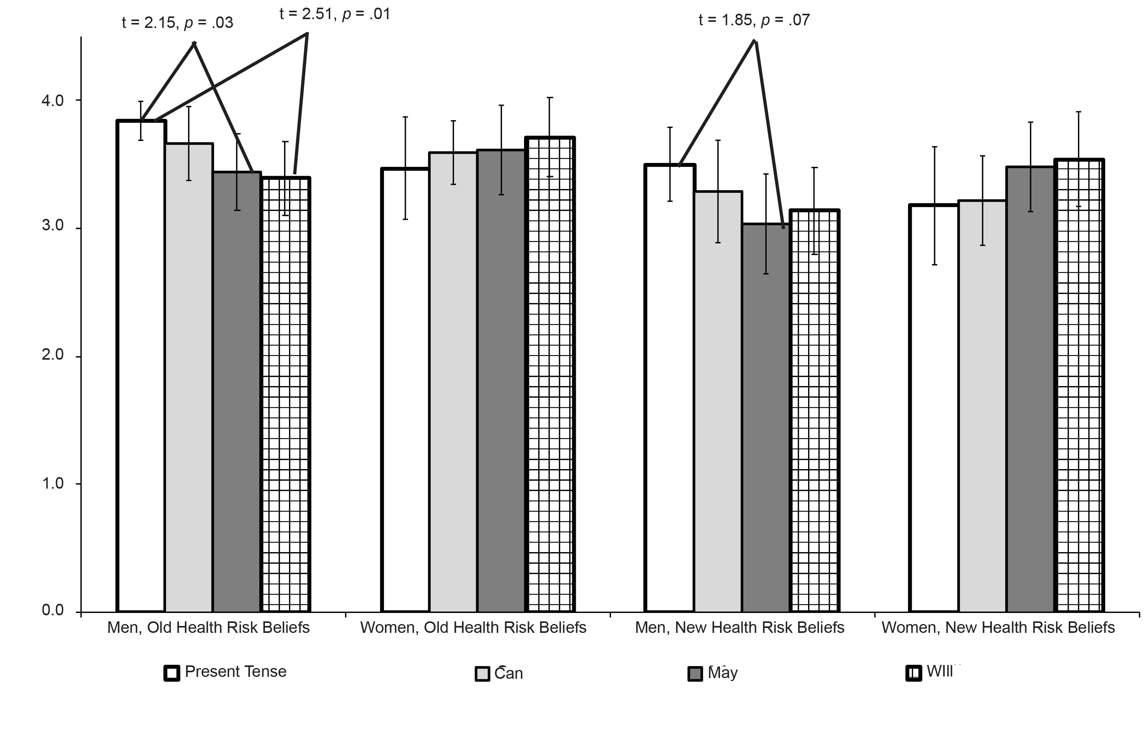

Note. As described above, additive index scales (Range: 0-4) were used to calculate old and new health risk beliefs for adults.

Figure S2

Health Risk Beliefs By Hypothetical Language Condition, Split By Self-Reported Sex Category (youth)

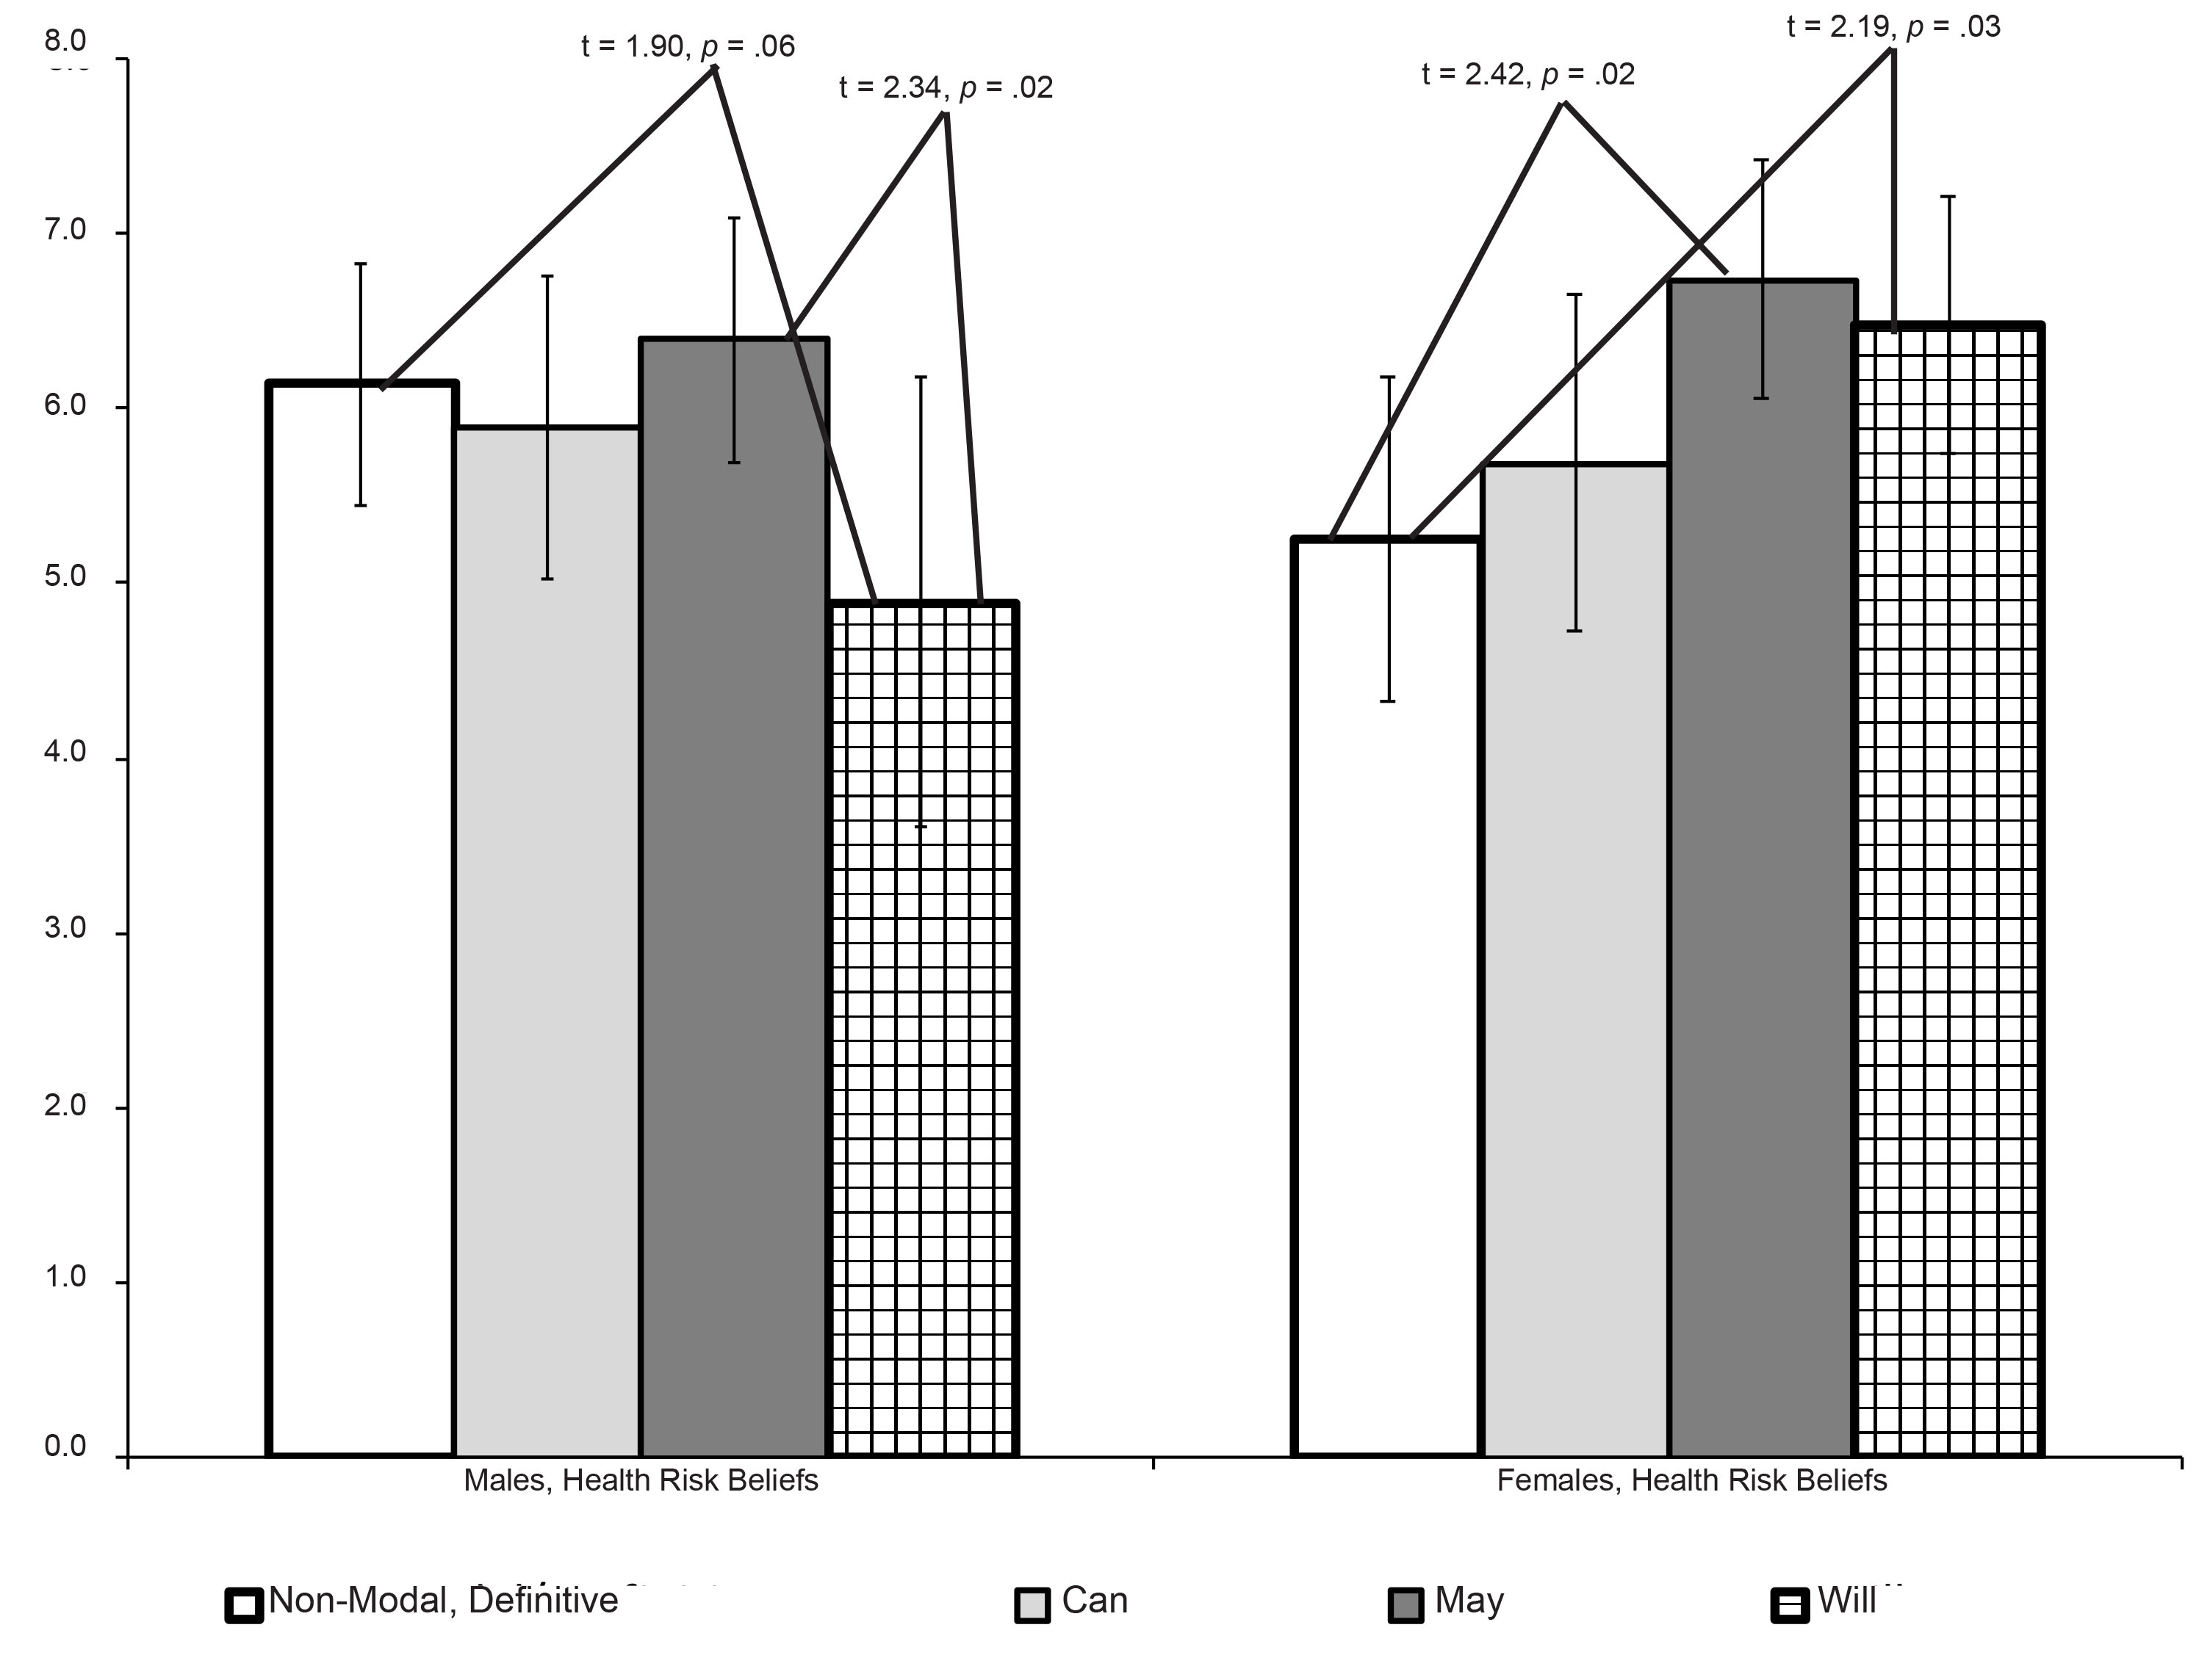

Note. As described above, an additive index scale (Range: 0-8) was used to calculate health risk beliefs for youth.

