Pseudomonas putida strain B2017 produced as technical grade active ingredient controls fungal and bacterial crop diseases.

Clara Oliver, Iker Hernández, Marta Caminal, José M. Lara and Carolina Fernàndez*.

Futureco Bioscience S.A., Avinguda del Cadí 23, 08799 Olèrdola (Barcelona), Spain.

*Corresponding author: carolina@futurecobioscience.com; tel. +34 938182891

Supplemental Table 1. List of strains (all are type strains) used in the multi-locus sequence analysis, and the GenBank accession numbers of the genes used for the analysis.
Species | Strain | DSMZ ID | 16S | rpoD | gyrB
P. agarici | 71A | 11810 | Z76652 | AB039563.1 | AB039457
P. baetica | a390 | 26532 | NR_116899.1 | FN678357 | FM201278
P. benzenivorans | 1477 | 8628T | NR_116904 | HE800490 | HE800472
P. borbori | R-20821 | 17834 | NR_042450 | FN554456 | FN554175
P. chloritidismutans | AW-1 | 13592 | NR_115115 | AJ880091 | AJ880092
P. cremoricolorata | N/S | 17059T | AB060137 | FN554462 | FN554181
P. entomophila | L48 | 28517 | AY907566 | AY907568 | AY907567
P. fulva | N/S | 17717 | D84015 | AB039586 | AB039395
P. gessardii |  | 17152 | AF074384 | JN589936 | FN554186
P. guariconensis | PCAVU11 | 28410 | NR_135703 | LN851842 | LN851841
P. helmanticensis | OHA11 | 28442 | HG940537 | HG940517 | HG940516
P. hunanensis | LV | N/A | JX545210 | KP151501 | KP151497
P. mendocina | CH50 | 50017 | AF094734 | AJ633567 | AJ633103
P. meridiana | CMS 38 | N/A | AJ537602 | FN554485 | FN554203
P. monteilii | strain 1 | 14164 | AF064458 | FN554488 | FN554205
P. mosselii | CFML 90-83 | 17497 | AF072688 | FN554491 | FN554207
P. parafulva | CB-1 | 17004 | AB060132 | FN554500 | FN554216
P. plecoglossicida | FPC951 | 15088 | AB009457 | FN554503 | FN554218
P. pseudoalcaligenes | Stainer 63 | 50188 | AB021379 | AB039552 | AB039481
P. putida | 90 | 291 | D84020 | AB039581 | AB039451
P. resinovorans | N/S | 21078 | Z76668.1 | FN554509 | FN554223
P. soli | F-279,208 | 28043 | HF930598 | HF930597 | HF930595
P. taiwanensis | CMS | 21245 | EU103629.2 | HE577796 | HE800487
P. vancouverensis | DhA-51 | 17555 | NR_041953.1 | FN554517 | FN554232
P. yamanorum | 8H1 | 26522 | LT629793 | LT629793 | LT629793
P. aeruginosa | N/S | 50071 | CP012001 | AB39607 | AB39386
N/S, not specified; DSMZ ID, strain identifier in the German Collection of Microorganisms and Cell Cultures.

Supplemental Table 2. Sequence fragments used in the multi-locus sequence analysis based on the gene coordinates in P. aeruginosa.
Gene | GenBank accession | Start | End | Total (nt)
16S | X06684 | 52 | 1081 | 1029
gyrB | AB39386 | 43 | 843 | 800
rpoD | AB39607 | 42 | 759 | 717
 |  |  |  | 2536

Supplemental Table 3. Average nucleotide identity (ANI) among selected Pseudomonas putida strains, and B2017.
ANI | NBRC 14164^{T} | KT2440 | W619 | GB-1 | S16 | HB3267 | BIRD-1 | B6-2 | ND6 | F1 | LS46 | CSV86 | B2017
NBRC 14164^{T} | * | 89.09 | 84.50 | 90.02 | 88.78 | 88.84 | 88.96 | 89.00 | 88.90 | 88.97 | 89.09 | 79.53 | 89.11
KT2440 | 89.32 | * | 84.41 | 89.92 | 88.47 | 88.87 | 96.84 | 96.49 | 96.12 | 96.28 | 96.28 | 79.42 | 96.38
W619 | 84.75 | 84.33 | * | 84.72 | 84.93 | 85.16 | 84.05 | 84.08 | 84.17 | 84.35 | 84.18 | 79.20 | 84.42
GB-1 | 90.04 | 89.75 | 84.43 | * | 88.79 | 89.13 | 89.77 | 89.79 | 89.75 | 89.93 | 89.76 | 79.39 | 89.89
S16 | 89.06 | 88.51 | 84.92 | 89.15 | * | 96.54 | 88.62 | 88.43 | 88.47 | 88.49 | 88.60 | 80.14 | 88.52
HB3267 | 89.24 | 88.89 | 85.27 | 89.43 | 96.63 | * | 88.72 | 88.50 | 88.63 | 88.74 | 88.64 | 80.23 | 88.83
BIRD-1 | 89.32 | 97.04 | 84.21 | 90.12 | 88.63 | 88.78 | * | 96.31 | 96.43 | 96.42 | 96.20 | 79.48 | 96.43
B6-2 | 89.12 | 96.24 | 84.01 | 89.78 | 88.25 | 88.32 | 96.00 | * | 97.68 | 97.48 | 97.90 | 79.64 | 97.46
ND6 | 89.13 | 96.11 | 84.09 | 89.92 | 88.40 | 88.51 | 96.25 | 97.80 | * | 98.80 | 97.70 | 79.35 | 97.66
F1 | 89.17 | 96.33 | 84.35 | 90.15 | 88.43 | 88.72 | 96.23 | 97.70 | 98.86 | * | 97.64 | 79.43 | 97.73
LS46 | 89.26 | 96.33 | 84.17 | 90.01 | 88.56 | 88.60 | 96.13 | 98.12 | 97.83 | 97.65 | * | 79.62 | 98.04
CSV86 | 79.36 | 79.12 | 78.88 | 79.13 | 79.64 | 79.74 | 79.02 | 79.30 | 79.02 | 78.98 | 79.27 | * | 79.27
B2017 | 89.18 | 96.05 | 84.11 | 90.00 | 88.20 | 88.60 | 95.85 | 97.33 | 97.36 | 97.36 | 97.68 | 79.37 | *
ANI values higher than 95 % are highlighted in bold.

Supplemental Table 4. Average nucleotide identity (ANI) among selected Pseudomonas monteilii strains, and B2017.
ANI | DSM 14164^{T} | B5 | IOFA19 | QM | NBRC 103158 | GTC 10899 | GTC 10897 | CY06 | CD10 2 | BCN3 | MO2 | UBA3487 | SB3078 | SB3101 | B2017
DSM 14164^{T} | * | 98.55 | 88.39 | 98.88 | 99.99 | 83.14 | 83.06 | 88.28 | 98.57 | 95.49 | 88.98 | 78.66 | 88.88 | 88.88 | 88.93
B5 | 98.78 | * | 88.35 | 99.53 | 98.82 | 83.20 | 83.05 | 88.37 | 99.40 | 95.83 | 89.13 | 78.51 | 89.11 | 89.12 | 88.92
IOFA19 | 88.62 | 88.53 | * | 88.55 | 88.63 | 83.06 | 83.06 | 99.28 | 88.62 | 88.75 | 88.58 | 78.40 | 88.56 | 88.59 | 94.80
QM | 98.92 | 99.63 | 88.44 | * | 98.94 | 83.27 | 83.13 | 88.46 | 99.36 | 95.83 | 89.09 | 78.67 | 89.25 | 89.27 | 88.97
NBRC 103158 | 99.95 | 98.51 | 88.27 | 98.75 | * | 83.00 | 83.04 | 88.26 | 98.45 | 95.45 | 88.83 | 78.50 | 88.76 | 88.75 | 88.95
GTC 10899 | 83.24 | 83.10 | 82.88 | 83.22 | 83.26 | * | 83.02 | 82.73 | 83.24 | 83.15 | 84.06 | 78.74 | 83.77 | 83.78 | 83.03
GTC 10897 | 83.66 | 83.31 | 83.11 | 83.47 | 83.68 | 83.33 | * | 83.14 | 83.50 | 83.56 | 84.08 | 78.07 | 83.94 | 83.96 | 83.20
CY06 | 88.53 | 88.61 | 99.24 | 88.60 | 88.52 | 82.90 | 83.08 | * | 88.52 | 88.71 | 88.41 | 78.44 | 88.61 | 88.61 | 94.85
CD10 2 | 98.32 | 98.88 | 88.21 | 99.08 | 98.35 | 83.07 | 82.88 | 88.15 | * | 95.60 | 89.06 | 78.53 | 88.91 | 88.92 | 88.95
BCN3 | 95.34 | 95.52 | 88.45 | 95.54 | 95.38 | 83.06 | 83.07 | 88.46 | 95.55 | * | 88.95 | 78.56 | 89.02 | 89.02 | 88.80
MO2 | 88.83 | 88.94 | 88.17 | 88.86 | 88.84 | 83.60 | 83.50 | 88.10 | 88.89 | 88.92 | * | 78.93 | 96.61 | 96.61 | 88.40
UBA3487 | 79.46 | 79.52 | 79.06 | 79.49 | 79.47 | 79.76 | 78.65 | 79.18 | 79.54 | 79.77 | 80.04 | * | 79.96 | 79.97 | 79.21
SB3078 | 89.15 | 89.16 | 88.39 | 89.20 | 89.20 | 83.75 | 83.68 | 88.37 | 89.28 | 89.28 | 96.84 | 79.05 | * | 99.96 | 88.75
SB3101 | 89.18 | 89.19 | 88.48 | 89.24 | 89.24 | 83.72 | 83.70 | 88.44 | 89.30 | 89.22 | 96.89 | 78.95 | 100.00 | * | 88.85
B2017 | 88.86 | 88.57 | 94.21 | 88.60 | 88.92 | 82.85 | 82.79 | 94.37 | 88.99 | 88.62 | 88.37 | 78.02 | 88.44 | 88.46 | *
ANI values higher than 95 % are highlighted in bold.

Supplemental Figures
Supplemental Figure 1. Molecular phylogenetic analysis of concatenated 16S, gyrB and rpoD sequences from selected Pseudomonas spp. type strains (P. aeruginosa was included as outgroup) and B2017, performed by the Maximum Likelihood method. The evolutionary history was inferred by using the Maximum Likelihood method based on the Jukes-Cantor model. The tree with the highest log likelihood (-18841.12) is shown. The percentage of trees in which the associated taxa clustered together is shown next to the branches. Initial tree(s) for the heuristic search were obtained automatically by applying Neighbor-Join and BioNJ algorithms to a matrix of pairwise distances estimated using the Maximum Composite Likelihood (MCL) approach, and then selecting the topology with superior log likelihood value. The tree is drawn to scale, with branch lengths measured in the number of substitutions per site. Evolutionary analyses were conducted in MEGA7.

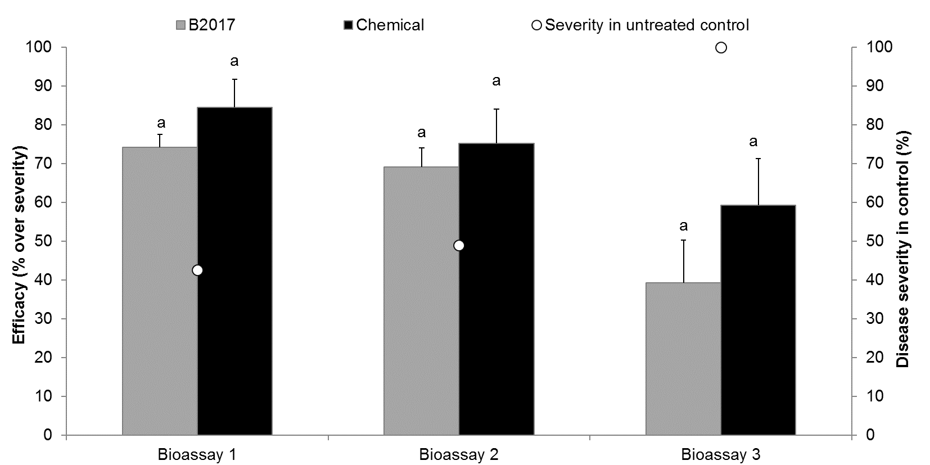
Supplemental Figure 2. Efficacy of B2017 TGAI over the disease severity caused by Fusarium oxysporum f. sp. radicis-licopersici (FORL) on tomato plants in three independent bioassays (bars), and the disease severity in untreated control plants (dots). Chemical, plants inoculated with with FORL and treated with a reference chemical (propamocarb and fosetil); B2017, plants inoculated with with FORL and treated with Pseudomonas putida B2017 technical grade active ingredient. Letters indicate statistically significant differences among treatments within each bioassay (p<0.05; ANOVA).

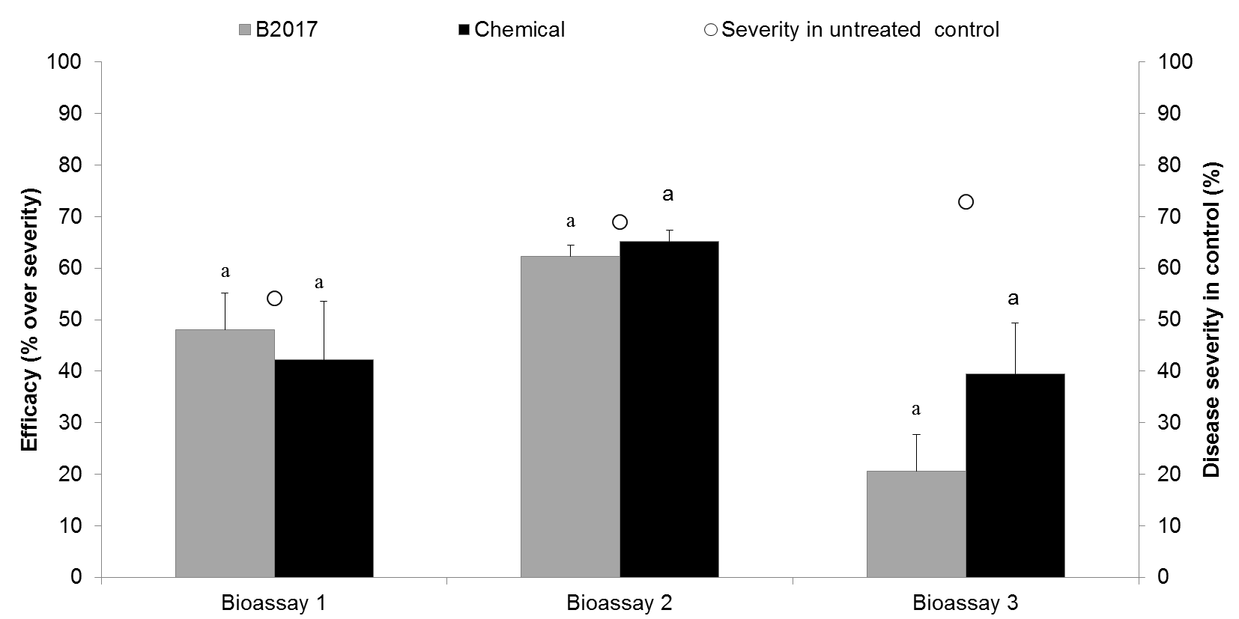
Supplemental Figure 3. Efficacy of B2017 TGAI over the disease severity caused by Rhizoctonia solani on potato plants in three independent bioassays (bars), and the disease severity in untreated control plants (dots). Chemical, plants inoculated with with R. solani and treated with a reference chemical (penicuron); B2017, plants inoculated with with R. solani and treated with Pseudomonas putida B2017 technical grade active ingredient. Letters indicate statistically significant differences among treatments within each bioassay (p<0.05; ANOVA).
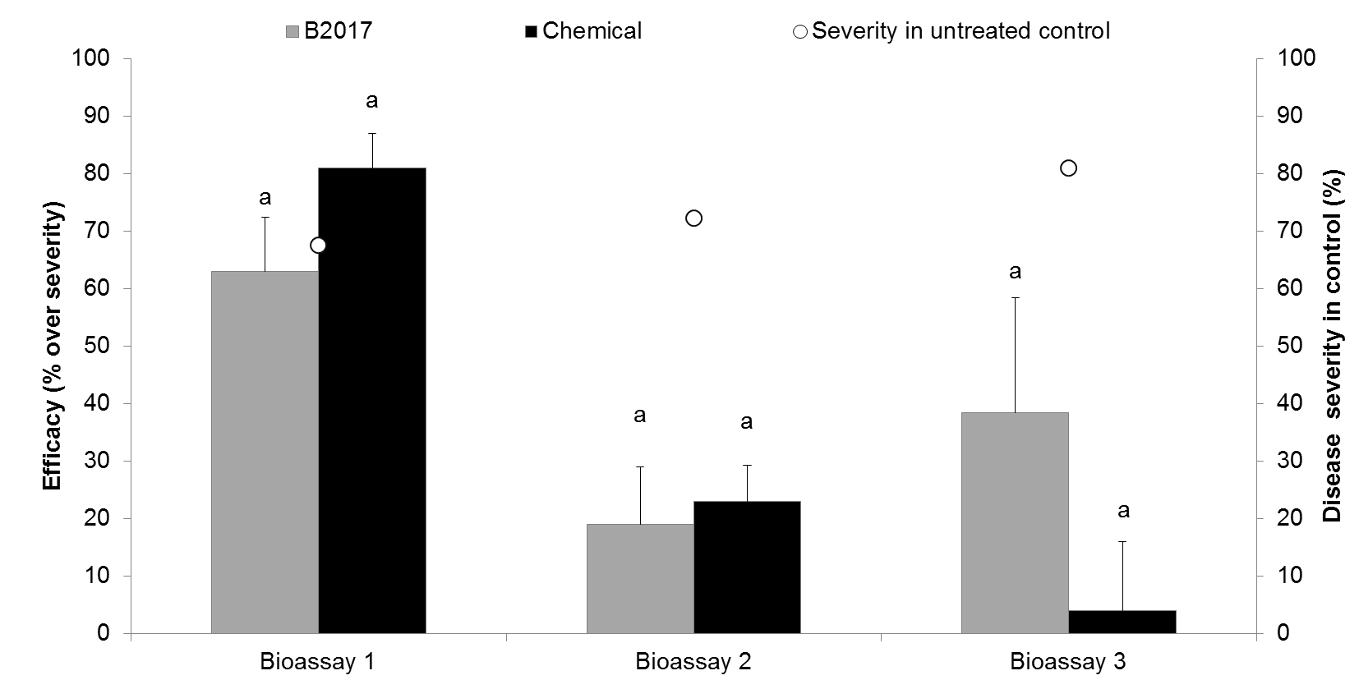
Supplemental Figure 4. Efficacy of B2017 TGAI over the disease severity caused by Sclerotinia sclerotiurum on lettuce plants in three independent bioassays (bars), and the disease severity in untreated control plants (dots). Chemical, plants inoculated with with S. sclerotiurum and treated with a reference chemical (fenhexamide and tebuconazol); B2017, plants inoculated with with S. sclerotiurum and treated with Pseudomonas putida B2017 technical grade active ingredient. Letters indicate statistically significant differences among treatments within each bioassay (p<0.05; ANOVA).
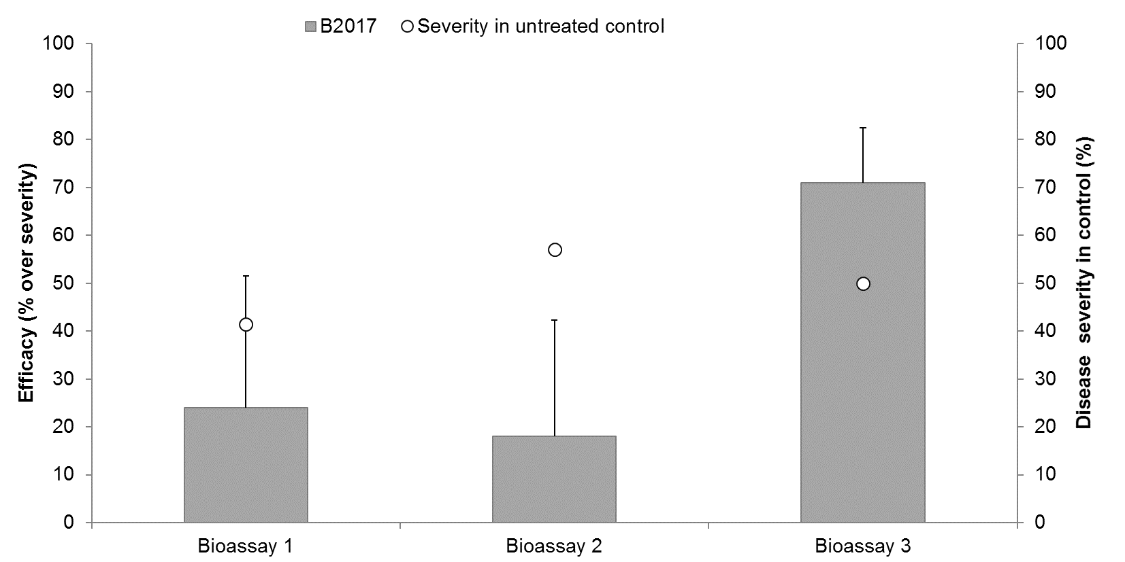
Supplemental Figure 5. Efficacy of B2017 TGAI over the disease severity caused by Pectobacterium atrosepticum on lettuce plants in three independent bioassays (bars), and the disease severity in untreated control plants (dots). B2017, plants inoculated with with E. carotovora and treated with Pseudomonas putida B2017 technical grade active ingredient. Letters indicate statistically significant differences among treatments within each bioassay (p<0.05; ANOVA).

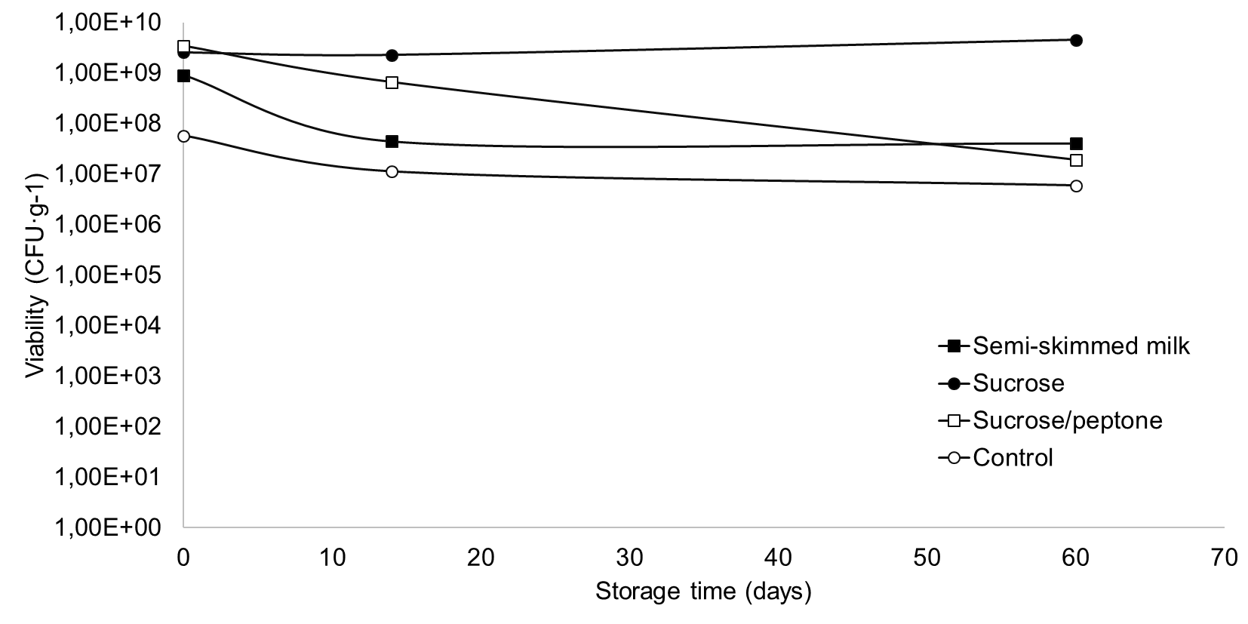
Supplemental Figure 6. Effect of the cryo-protectant solution on the stability of B2017 technical grade active ingredient. Semi-skimmed milk and sucrose were usad at 10 % (v:v and w:v, respectively), and sucrose/peptone was used at 70 % (w:v) each.

