Appendix 1 – AT User Interview Guide

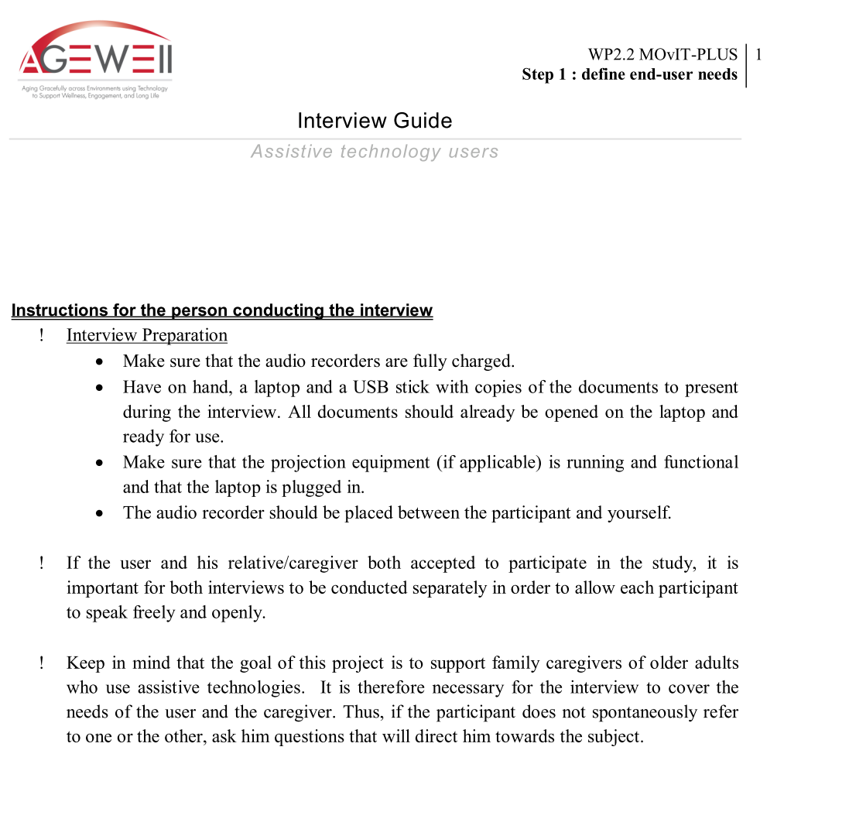
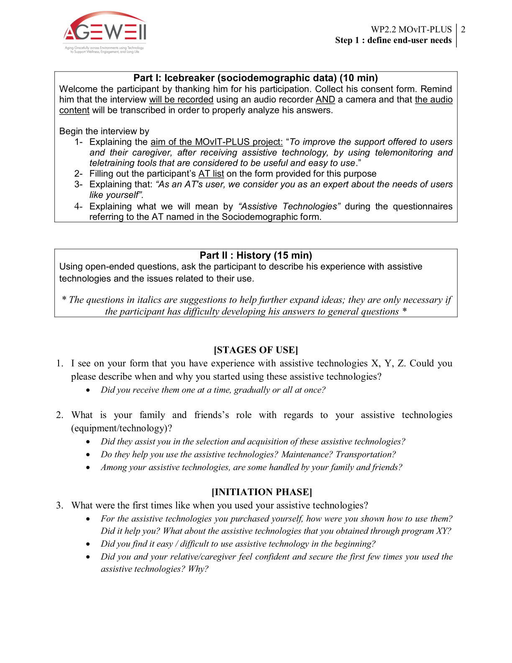
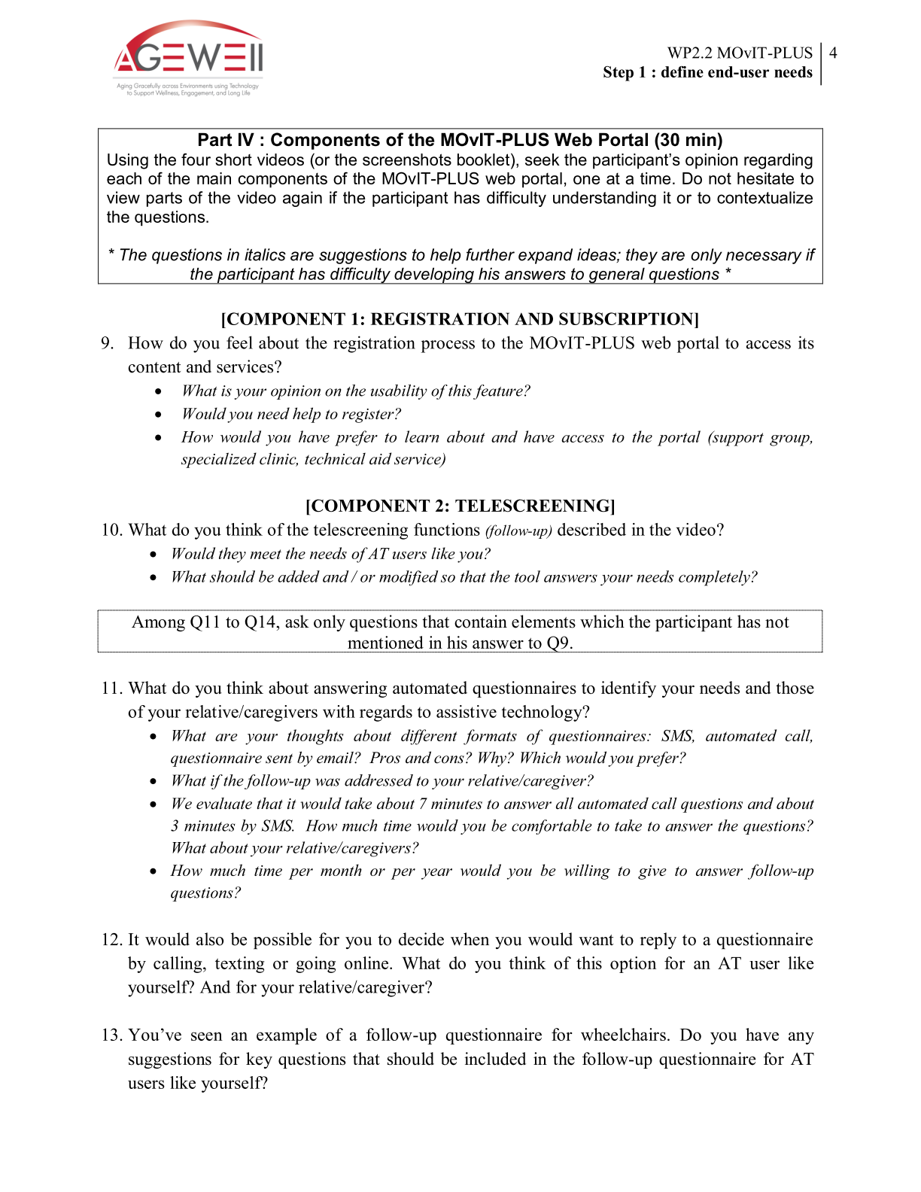
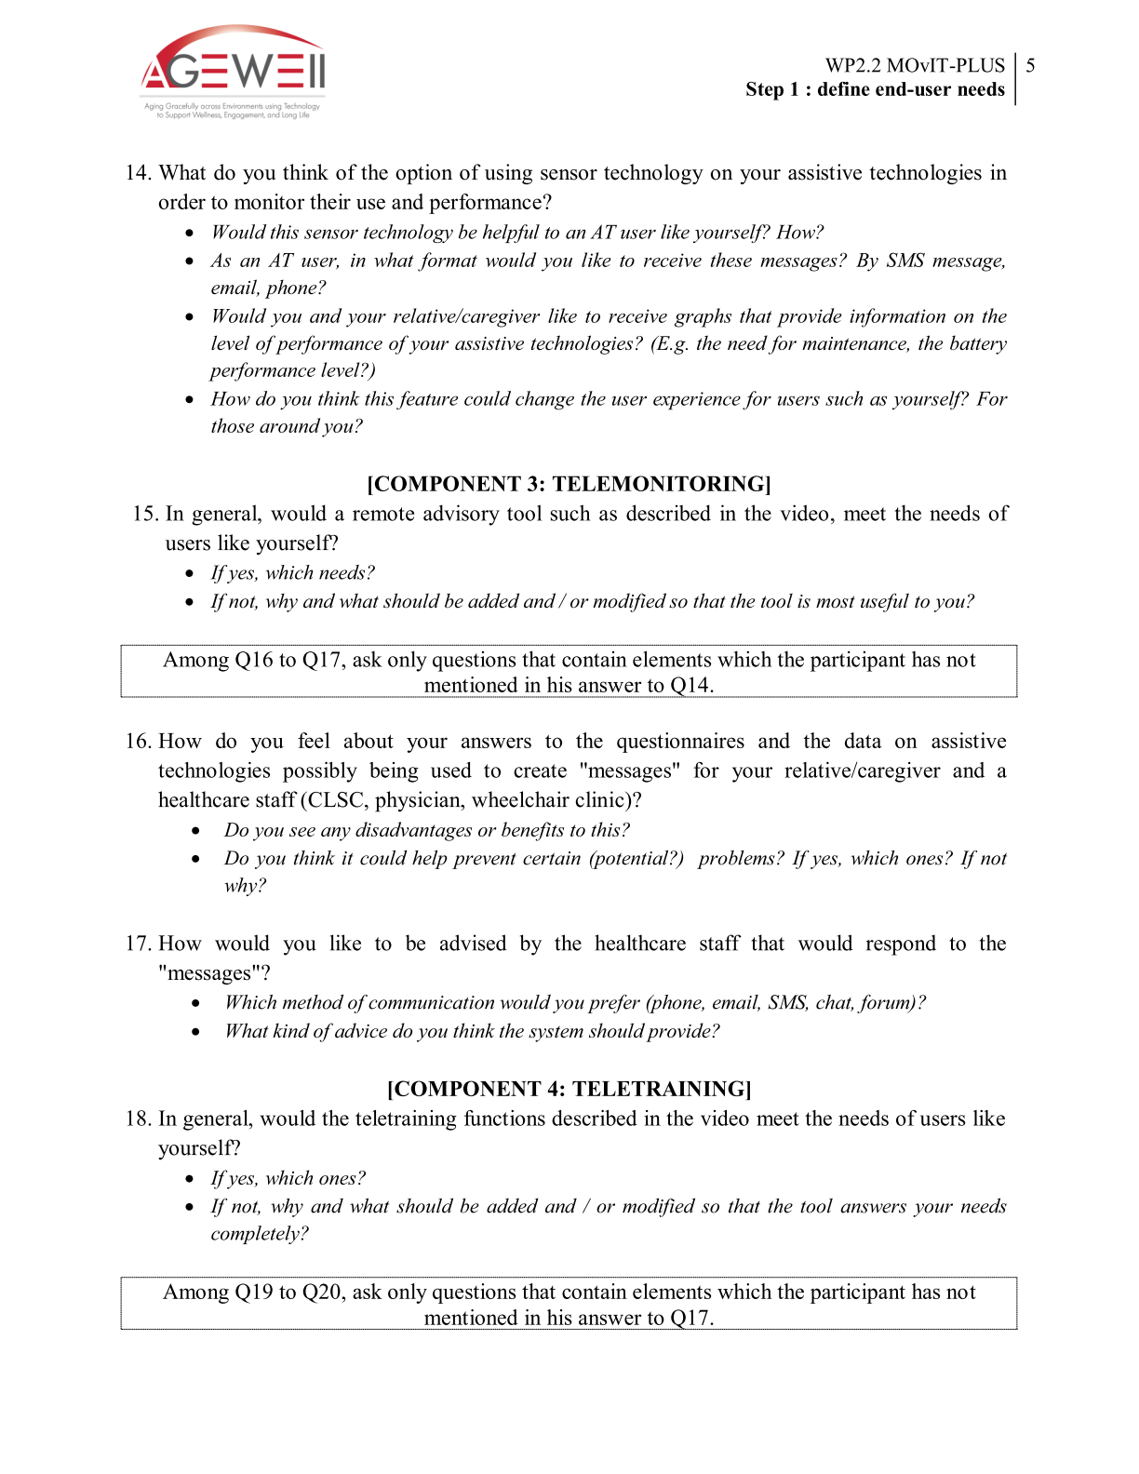
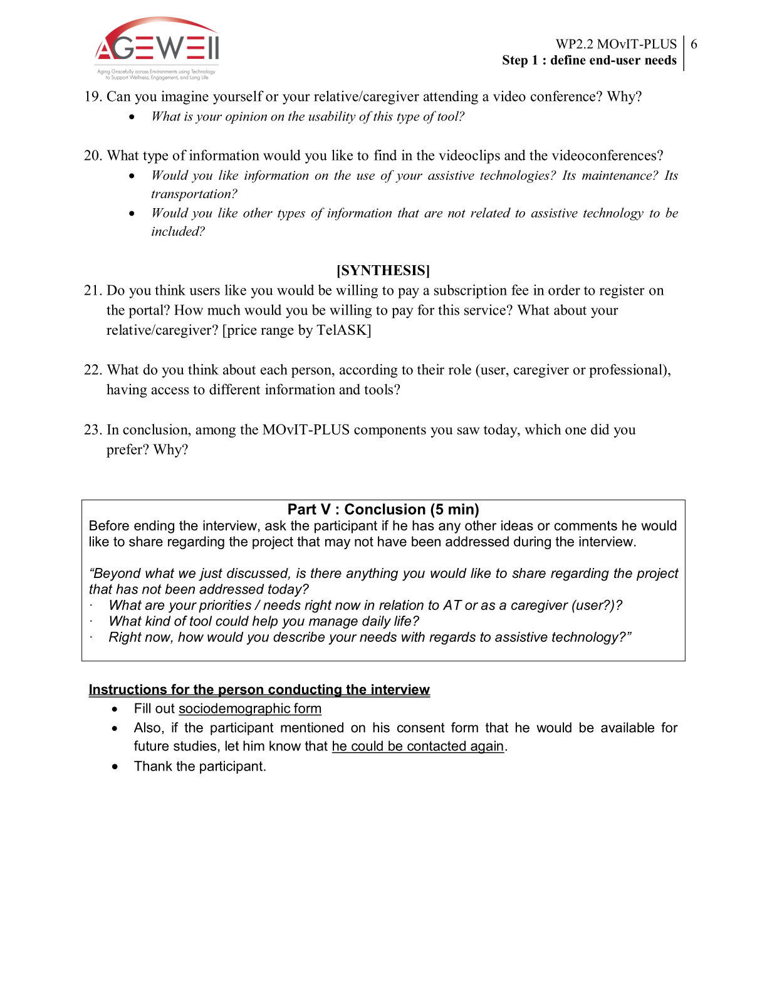

Appendix 2 – Caregiver Interview Guide

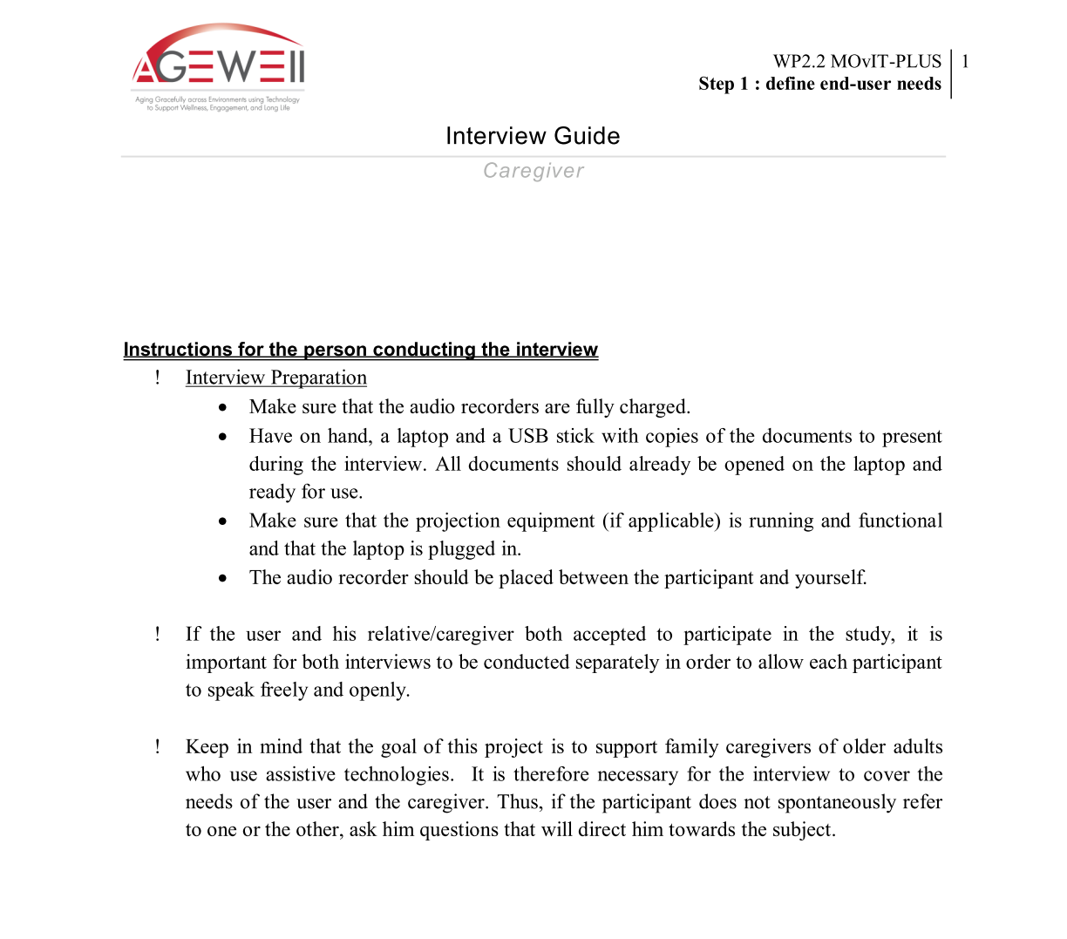

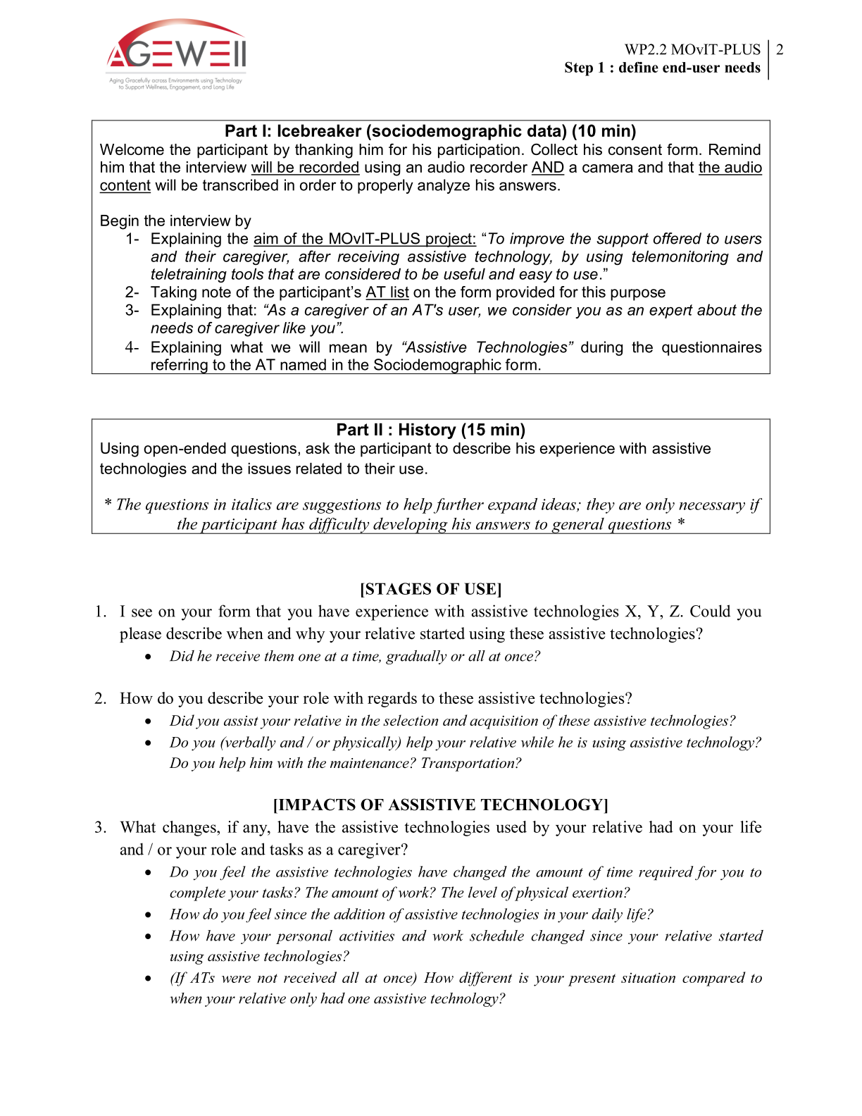
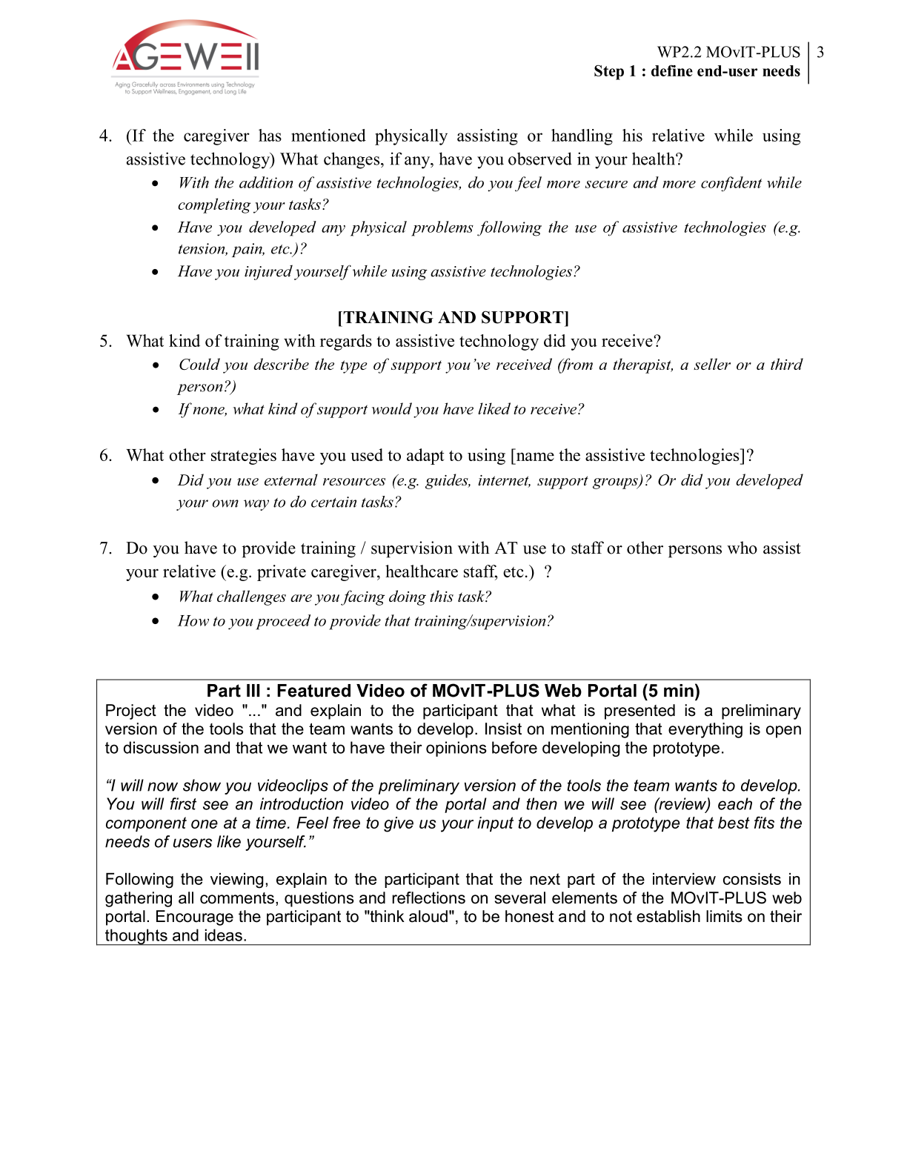
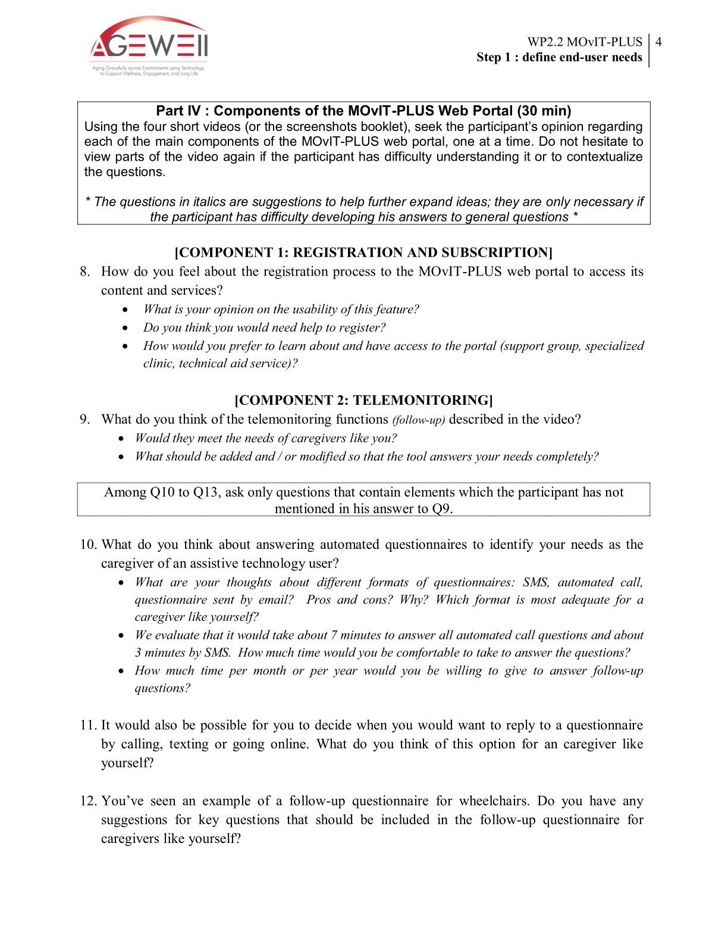
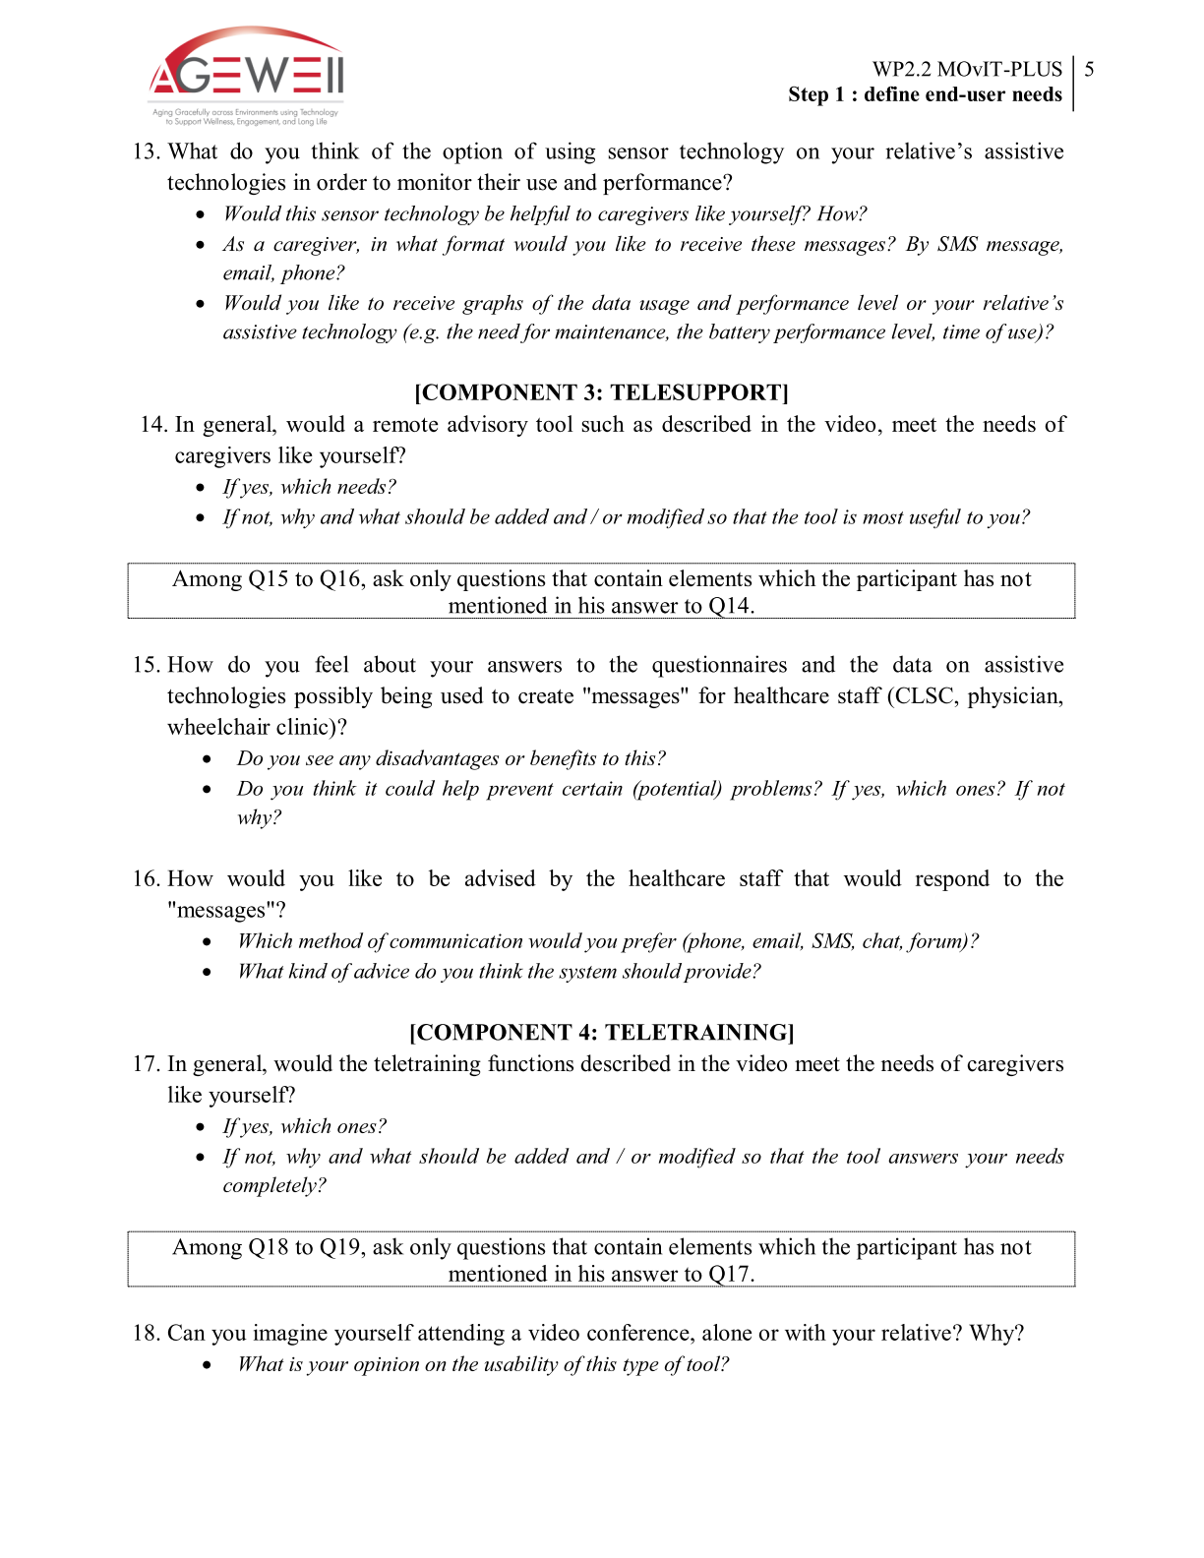
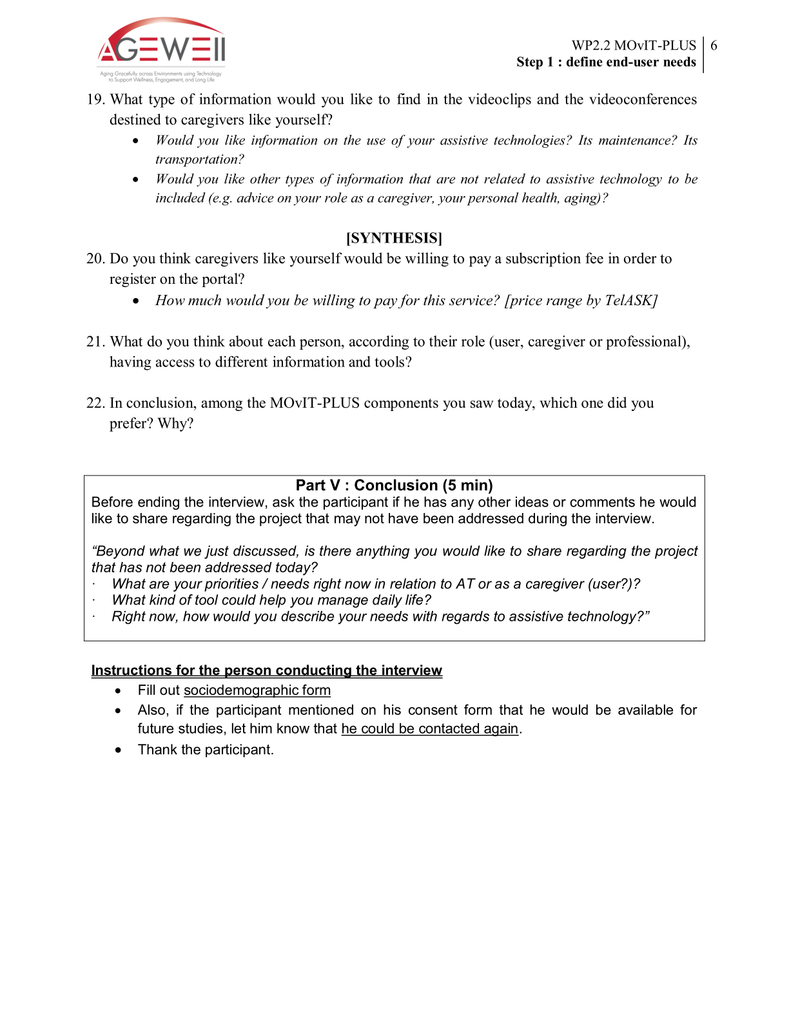

Appendix 3 – Key Informant Interview Guide

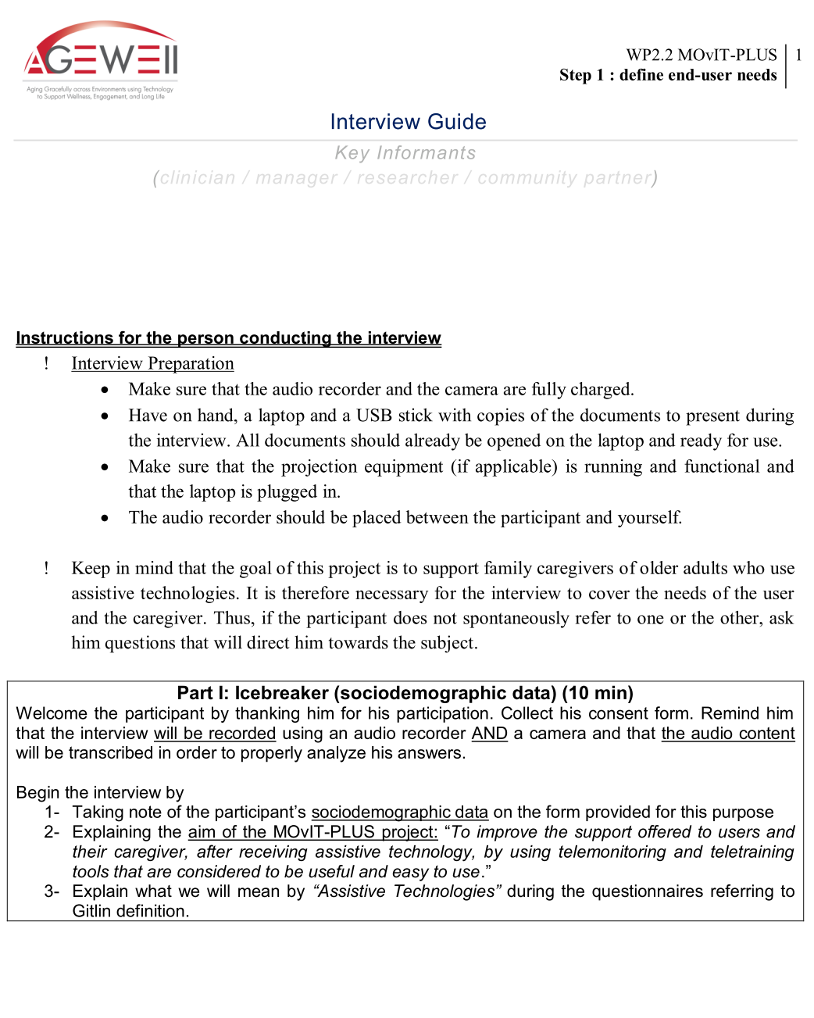

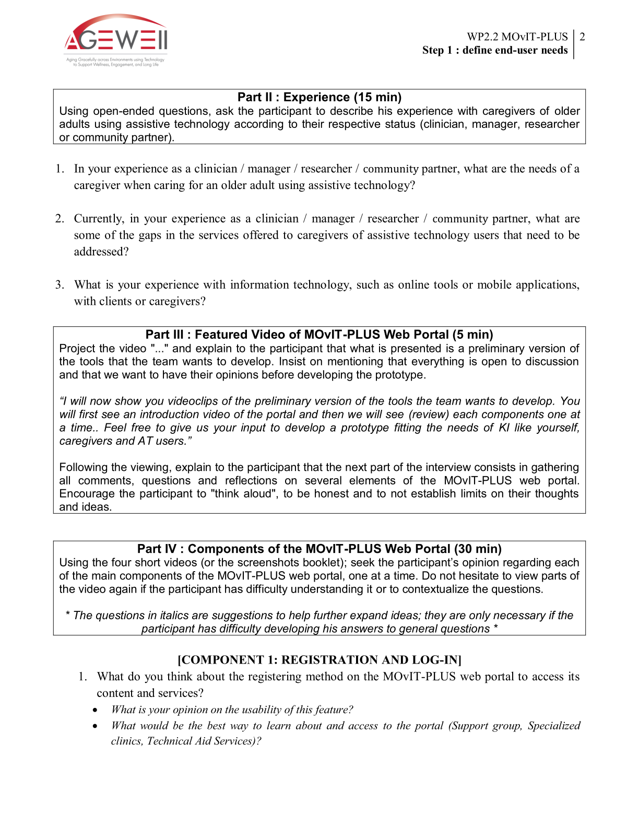
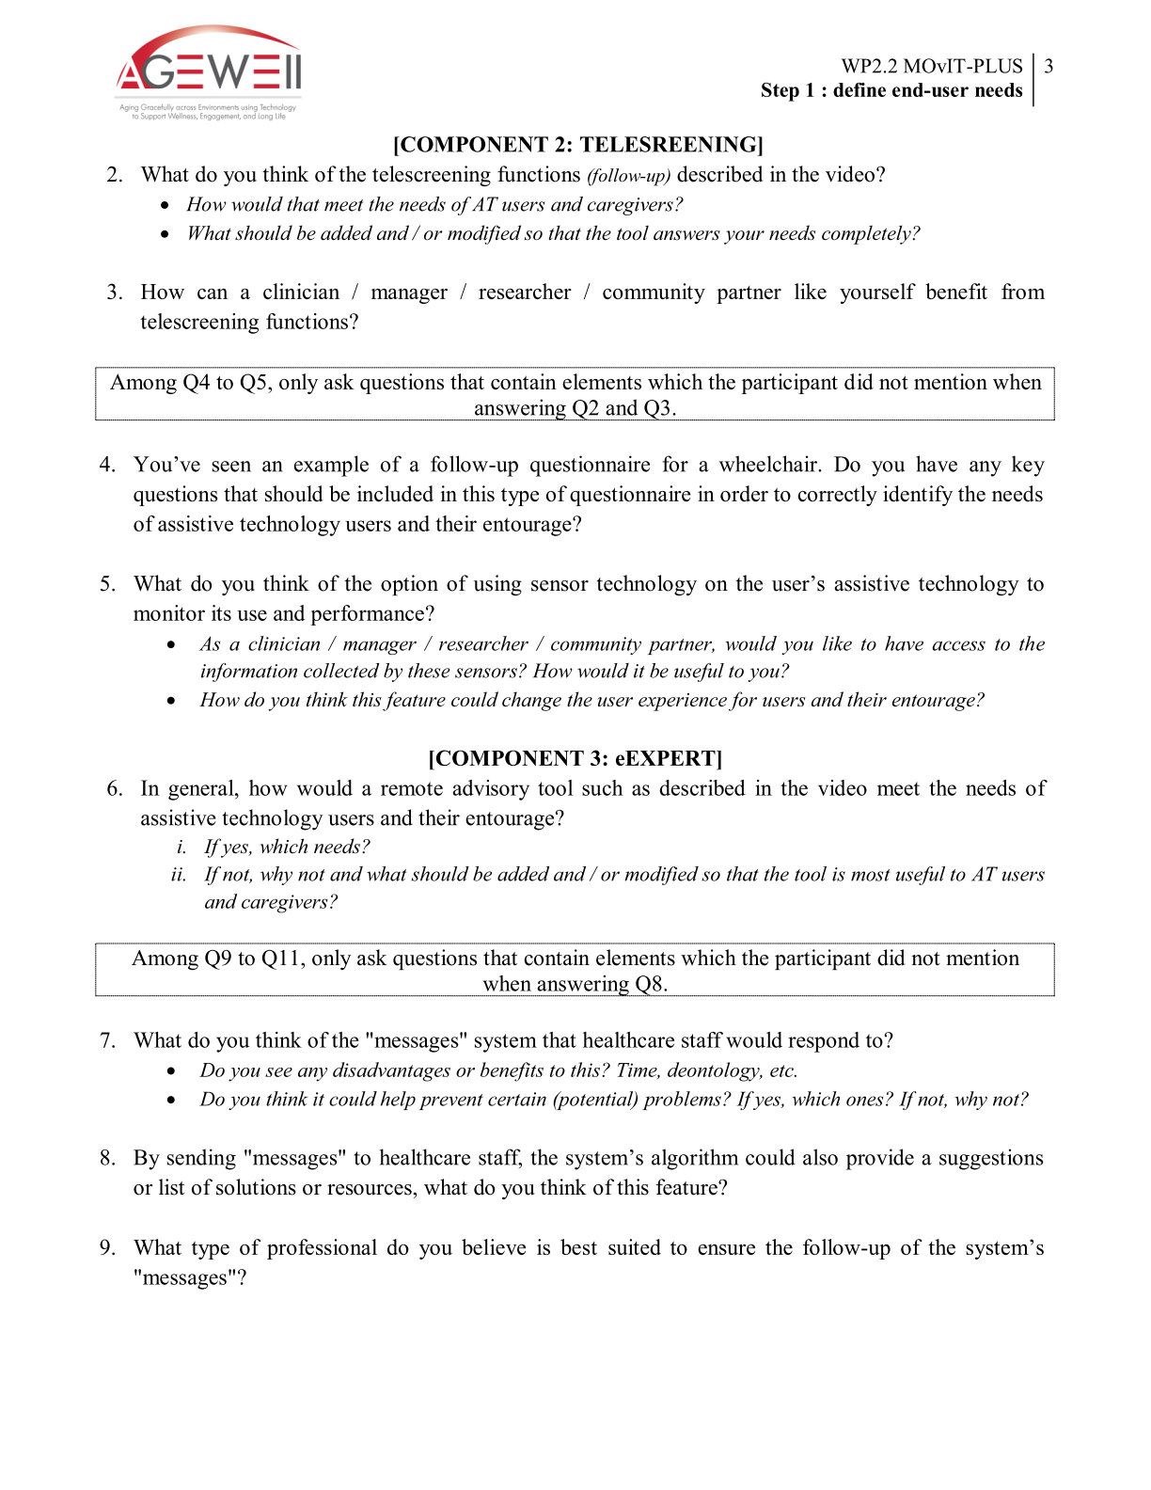
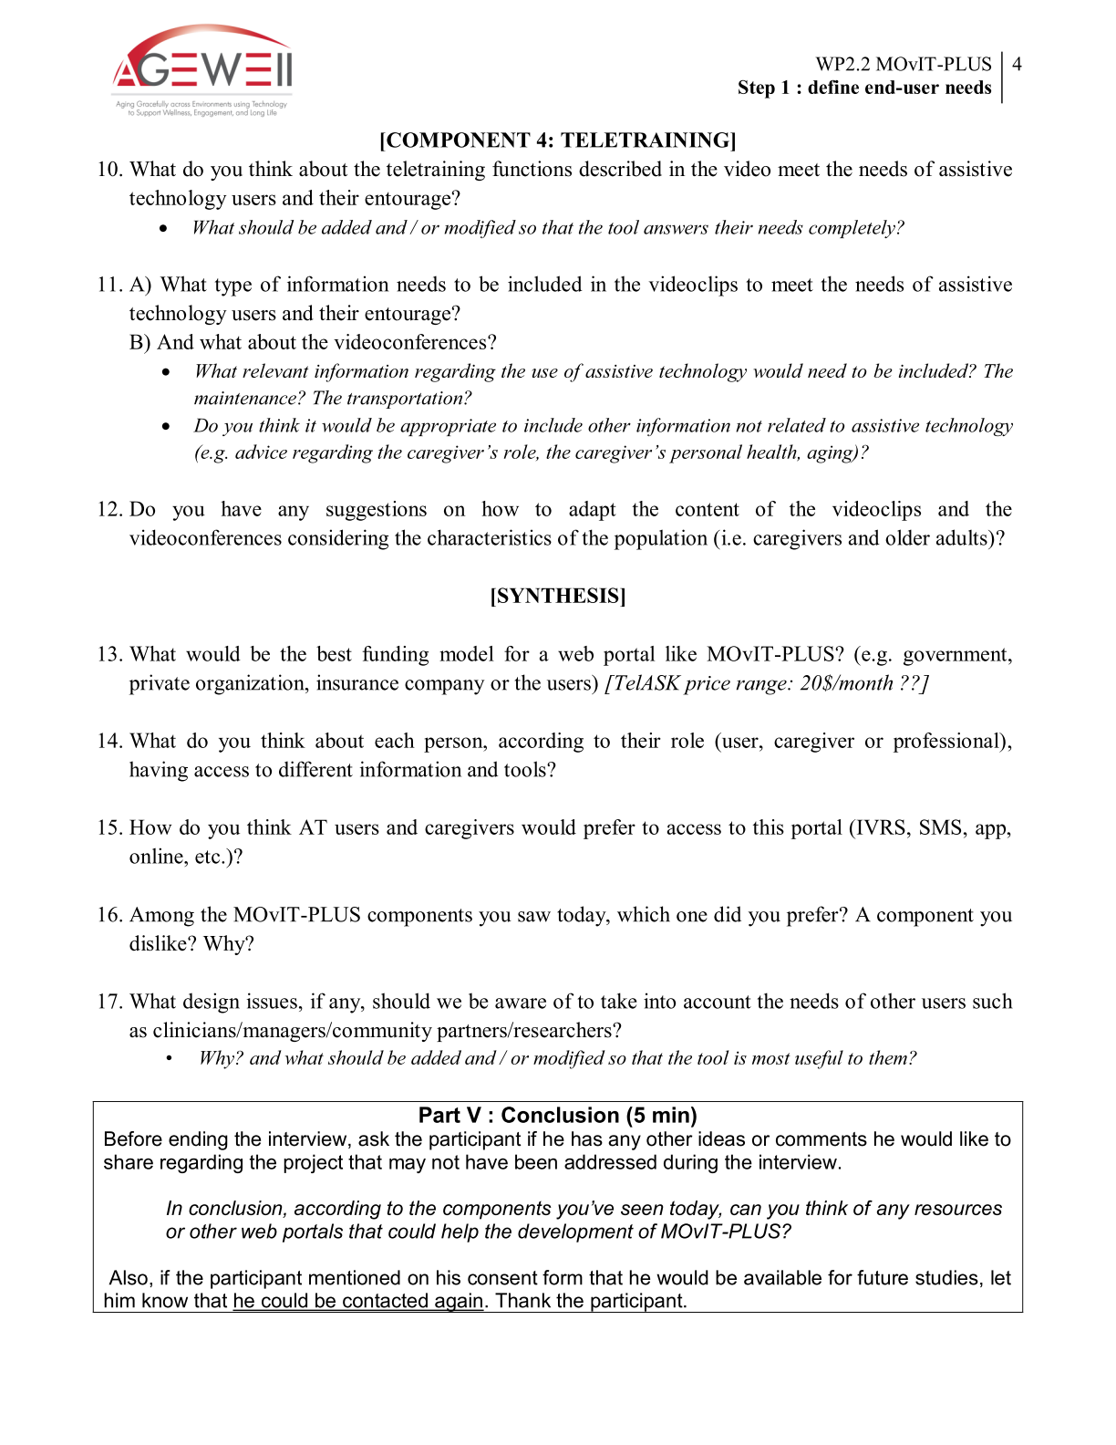

Appendix 4 – Features and tools illustrated in the mock-up narrated slideshow
 |  |  |  | MOvIT-PLUS™ functionalities
 | Features |  | Target behavior | Registration |  |  | Monitoring |  | eExpert |  | Support and training
Content and multimedia | Written caregiver tips |  | Read advices and tips, from healthcare professionals or other caregivers, about the caregiving role and related topics. |  |  |  |  |  |  |  | X
 | Written healthy living tips |  | Read information about maintaining a healthy lifestyle. |  |  |  |  |  |  |  | X
 | Educational videos |  | Watch educational content about the diagnosis of the care recipient, caregiving, AT use and other related topics. |  |  |  |  |  |  |  | X
 | Skill-based videos |  | Watch a professional, another caregiver or an instructor performing a specific caregiving or AT oriented task. |  |  |  |  |  |  |  | X
 | Interactive and thematic classes |  | Attend a live or videotaped class by watching interactive content about a selected topic and by participating in discussion following the presentation (if applicable). |  |  |  |  |  |  |  | X
Peer support | Peer-led videoconference sessions  (synchronous) |  | Share and discuss experiences, feelings, events, problems and solutions with peers. |  |  |  |  |  |  |  | X
Professional and peer support | Professional-led videoconference  (synchronous) |  | Share and discuss experiences, feelings, events, problems and solutions with peers in a structured manner led by professional. |  |  |  |  |  |  |  | X
Professional support |  | Clinician support by email  (asynchronous) | Request a contact with a professional by email for help or information regarding the health condition of the care recipient, caregiving and/or AT use. |  |  |  |  | X
 |  | Clinician support by phone  (synchronous) | Request a contact with a professional by phone for help or information regarding the health condition of the care recipient, caregiving and/or AT use. |  |  |  |  | X
 |  | Clinician support by videoconference  (synchronous) | Visually demonstrate the issue or the problematic situation to the professional via videoconference. |  |  |  |  | X
 |  | Call center  (asynchronous or synchronous) | Request contact with a professional during specified hours for help of or information regarding the health condition of the care recipient, caregiving and/or AT use. |  |  |  |  | X
 |  | Reference system online | Request an appointment or a reference to be made with the appropriate professional. |  |  |  |  | X
Interactive online activities |  | Online questionnaires | Report health status and other characteristics of their situation (e.g. what is their relationship with the care recipient) |  |  | X
Automated component |  | Clinician report | No target behavior for the caregiver, this feature is designed for the healthcare professional. |  |  |  |  | X
 |  | Clinical / emergency alerts | No target behavior for the caregiver, this feature is designed for the healthcare professional. |  |  |  |  | X
 |  | Decision aids | Caregiver or Clinician make the best decision possible regarding health status, caregiving problems and/or AT use following the suggestions and advices from the system. |  |  |  |  | X |  | X
 |  | Automated calls | Report health status, caregiving situation and/or AT use. Take appropriate actions, depending on what is requested by the automated call. |  |  | X
 |  | Short Messaging Service (SMS) | Report health status, caregiving situation and/or AT use. Take appropriate actions, depending on what is requested by the SMS. |  |  | X |  |  |  | X
Monitoring technologies | Bluetooth technology |  | No target behavior for the caregiver. This feature exchanges information between a device installed on the AT or the person and the MOvIT-PLUS™ system. |  |  |  | X
 | Global Positioning System (GPS) |  | Monitor the location and movements of the care recipient and take appropriate actions, in case of "abnormal" location or movements. |  |  |  | X
 | Home video monitoring |  | Record problematic behavior, for interactions with the care recipient or AT use issue. |  |  |  | X
 | Sensors recording AT use |  | Monitor the use of AT and to reinforce proper usage or take appropriate actions if not performed as prescribed by the health care professional. |  |  |  | X
Technical support | Technical support by phone |  | Ask a question, related to technical aspects of the program (e.g. Internet problem, difficulties accessing a feature or registering) to a qualified technician. | X |  |  | X |  | X |  | X
Resources | Resource directory |  | Read and use information about local and national resources/services. |  |  |  |  |  | X |  | X
 | Data base of accessible public places |  | Consult and choose, from a list, a place that can be visited regardless of the limitations of the care recipient. |  |  |  |  |  |  |  | X
Personal Space | Tool to develop customised training material |  | Share tailored AT use instructions with paid caregivers |  |  |  |  |  |  |  | X

Table 1. Sociodemographic characteristics - AT users and family caregivers
 | AT users  (n = 5) | Family caregivers  (n = 5)
Age (years) mean ± SD
 | 75 ± 8 | 63 ± 8
Gender (n)
Female | 2 | 5
Male | 3 | 0
Living with caregiver/care recipient (n)
yes | 3 | 4
no | 2 | 1
Level of care (hours per week)
 | 10 ± 6 | 23 ± 17
Type of ATs use (n)
mobility | 5 | 5
communication | 2 | 1
vehicule adaptation | 2 | 1
oxygen therapy | 1 | 1
ADL-IADL* | 5 | 5
home adaptation | 3 | 4
Highest level of education (n)
Less than high school | 0 | 1
High school | 0 | 2
College | 1 | 0
University | 4 | 2
Perceived ICT literacy (n)
limited | 3 | 3
experienced | 2 | 2
* Activity of daily living- Instrumental activity of daily living

Table 2. Sociodemographic characteristics - Clinicians, decision makers, community partners and researchers
 | Clinicians  (n = 5) | Decision  makers  (n = 5) | Community partners  (n = 5) | Researchers  (n = 5)
Age (years) mean ± SD
 | 40 ± 10 | 47 ± 9 | 51 ± 11 | 45 ± 9
Gender (n)
Female | 5 | 3 | 4 | 4
Male | 0 | 2 | 1 | 1
Perceived ICT literacy (n)
limited | 1 | 0 | 1 | 0
experienced | 4 | 5 | 4 | 5
Experience with (n)
Assistive technology | 5 | 5 | 2 | 4
Caregivers | 5 | 4 | 5 | 5
Intervention via ICT | 3 | 5 | 4 | 4
Aging | 5 | 4 | 5 | 5
*Information and communication technologies

Table 3. Perceptions of the proposed Internet-based intervention
 | Benefits of the proposed intervention | Barriers to implementation
Technological  hardware and software  complexity | - Offers support through usual and standard ICT  - Is available on multiple ICT devices | - Challenges for data security and confidentiality  - Lack of proper and sufficient IT equipment in healthcare institutions
Human  user acceptance | - Prevents feeling of abandonment by healthcare system  - Provides reassurance  - Humanises remote communication | - Preference for direct contact with clinician (over phone, home visit or clinic appointment)  - Limited IT literacy
Usability  system’s usefulness from the users' point of view | - Eases access to early support and training  - Improves quality, frequency and easiness of AT follow-up  - Facilitates clinicians’ tasks | - Potential inefficiency or problem with the intervention technology decreasing ease of use
Managerial  leadership and organisational resources | - Mitigates transport barriers  - Helps to prioritise interventions | - Uncertainty about who is the right respondent  - Stress on clinical resources (time and access)
Strategic & political  Strategic planning and policies | - Answers clinicians’ ethical requirements for follow-up  - Improves access to services in remote areas | - Lack of political interest/value for follow-up  - Liability risk in case of misinformation  - Social justice risk if user-pay principle

