Appendix S1
A geolocator-tagged fledgling provides first evidence on juvenile movements of Cory’s Shearwater

Raül Ramos*, Virginia Morera-Pujol, Marta Cruz-Flores, Sofía López-Souto, Michael Brothers, Jacob González-Solís

Studied species: The Cory’s Shearwater is a medium-sized Procellariiform species that breeds colonially in remote islets and islands, mainly, in the Atlantic archipelagos of Azores, Salvages and Canaries (Gómez-Díaz et al. 2009). They are long-lived marine top predators with a life span over 30 years and with a high reproductive investment (Ramos et al. 2012). Breeding females lay a single egg per season, and both parents share similar incubation and chick rearing duties throughout the breeding (Thibault et al. 1997; Granadeiro et al. 2006). The species is classified as Least concern species by the Red List criteria of the International Union for the Conservation of Nature (BirdLife International 2014).

The Cory’s Shearwater undertakes long and rapid transoceanic migrations from their Macaronesian breeding grounds to its wintering areas in the North, Central and South Atlantic (González-Solís et al. 2007; Dias et al. 2011). These migrations are characterized by the large number of wintering areas described along the Atlantic, and the individual plasticity displayed while choosing among such areas (Dias et al. 2011). The general phenology of the species is as follows: birds return to the colony in late February/March, the laying period begins in the second half of May and chicks start hatching in mid-July. Fledglings usually leave the colony from the middle to end of October (Thibault et al. 1997; Granadeiro et al. 1999) and do not return to the natal colony for breeding until they reach about nine years old (Mougin et al. 2000). It is long assumed from other seabirds (e.g., Akesson & Weimerskirch 2005) that the first years following fledging, Cory’s Shearwaters spend most of their time at sea, learning about the oceanic environment and the foraging opportunities spread along the Atlantic Ocean. All these characteristics (i.e., non-endangered, long-lived, relatively well-studied, long-distance migratory species, and with multiple and remote wintering areas) make the Cory’s Shearwater the ideal model species to investigate spatial ecology of juvenile individuals.
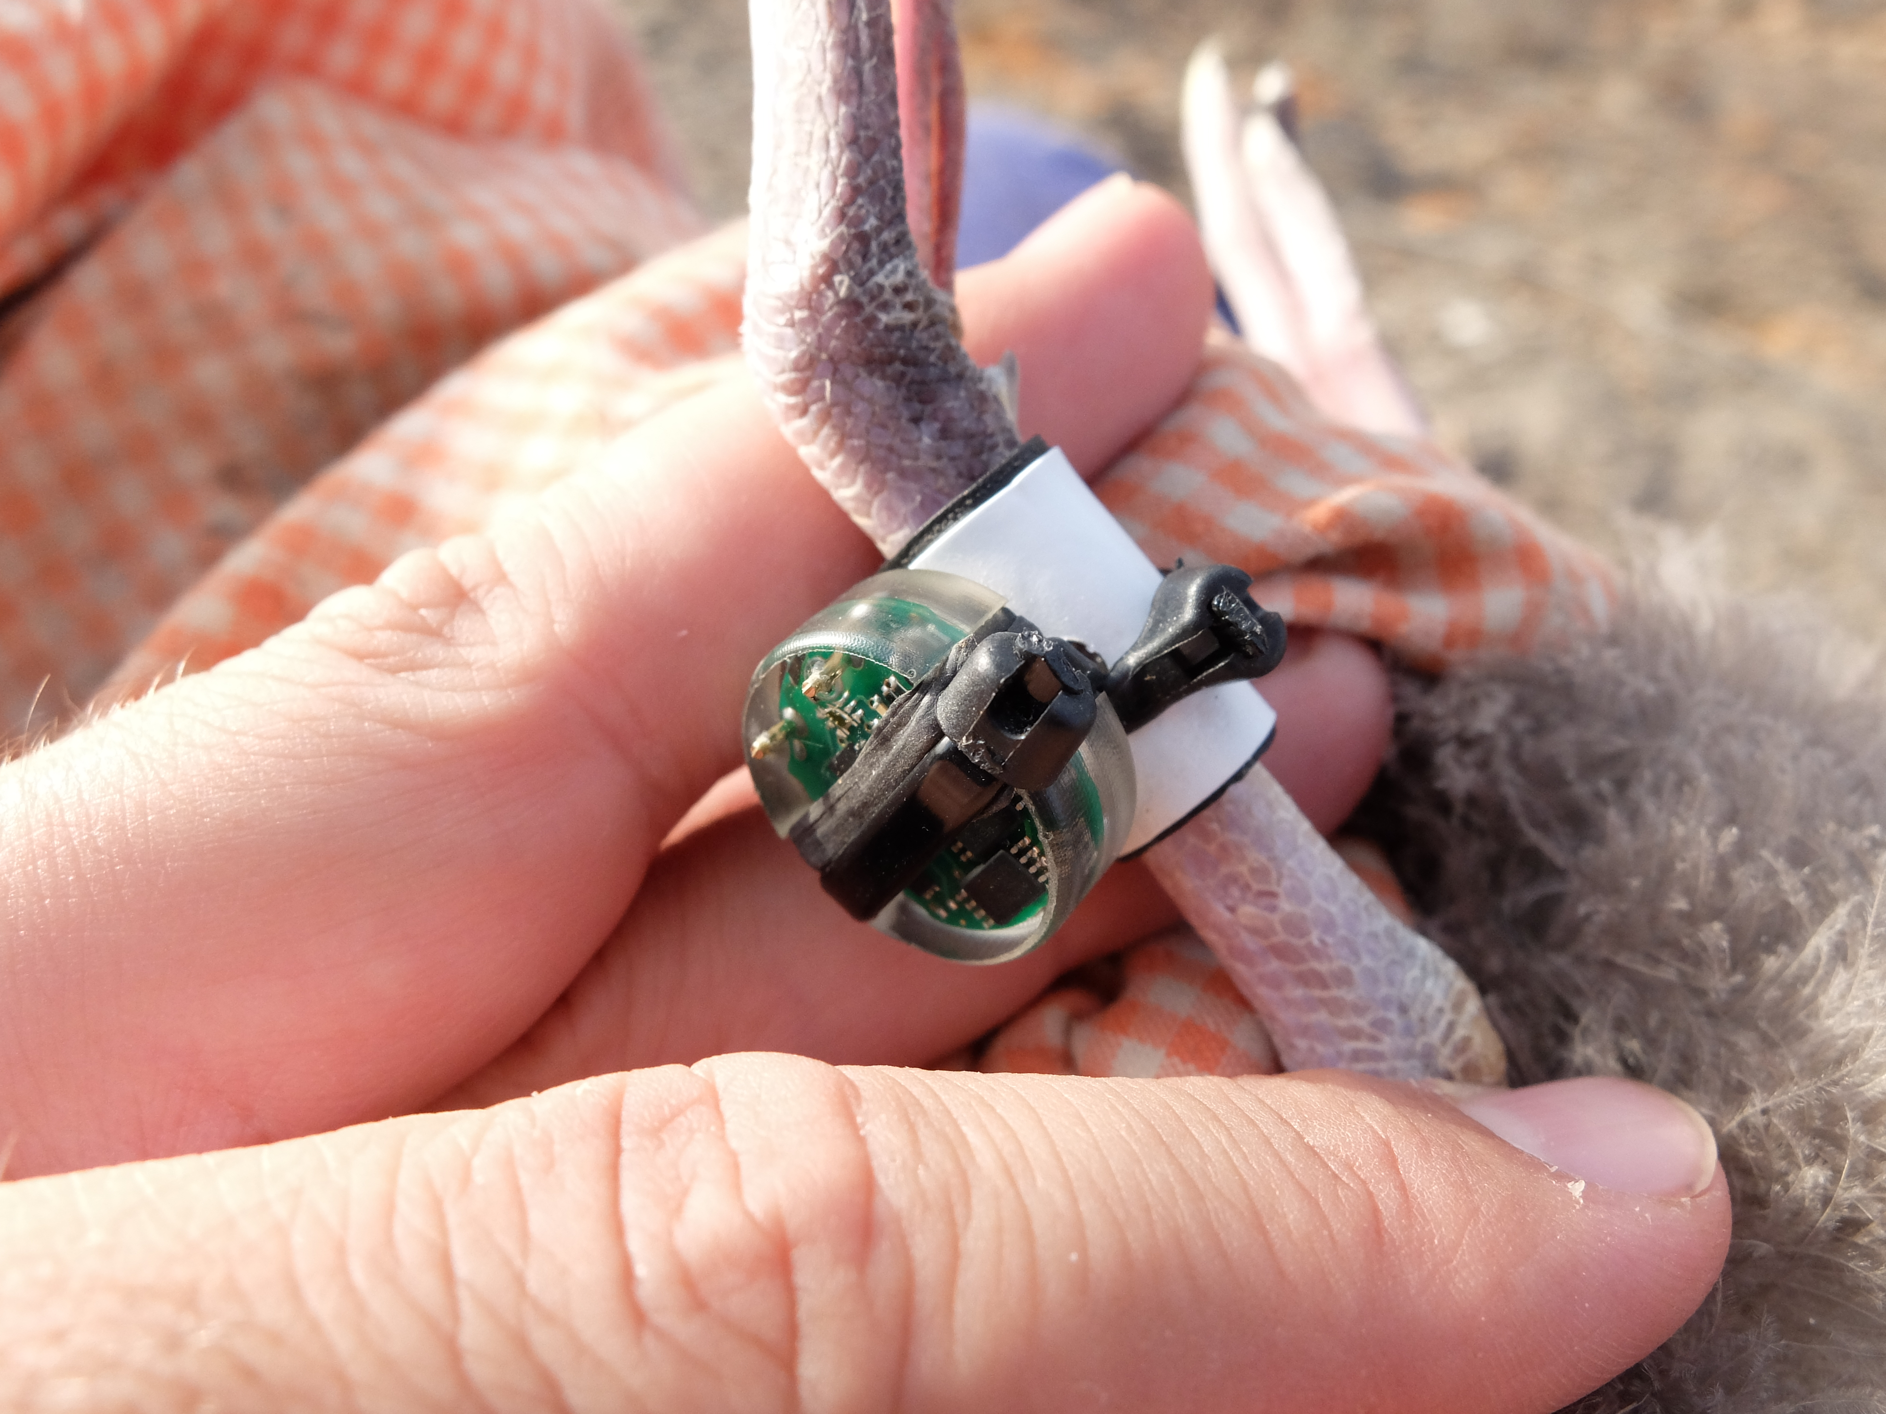
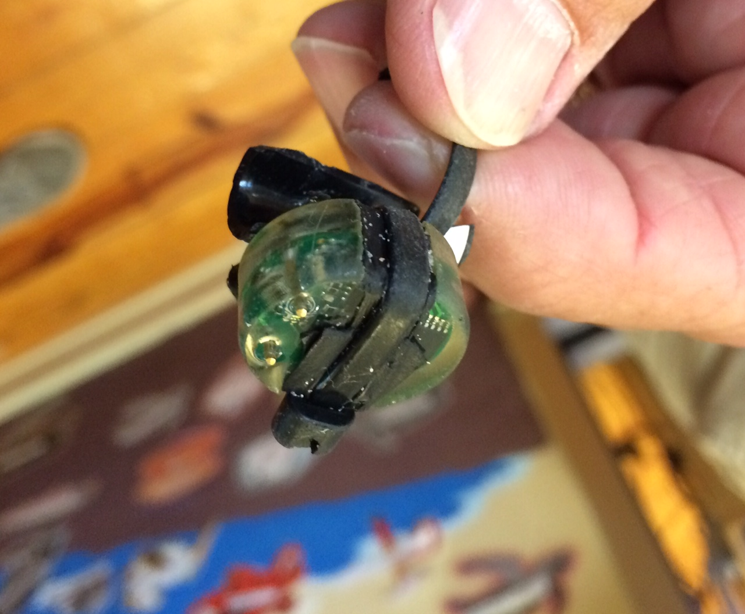

Figure S1. Every shearwater chick included in the study was fitted with a small, leg-mounted, combined geolocator-immersion logger that allowed us to study the migratory behaviour of every bird (including migratory schedule, wintering destination, and at-sea activity during the non-breeding period). Upper picture shows in detail the retrieved logger. Photo credit: Raül Ramos & Michael Brothers.
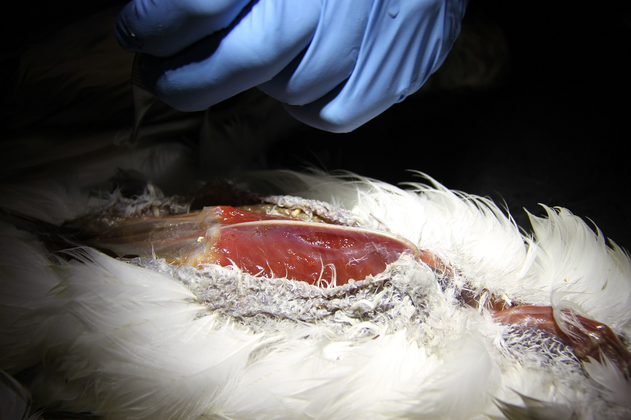

Figure S2. The juvenile shearwater found on a beach in Florida, USA (29°12'10.55" N; 80°59'41.85"), on 05 July 2018, suffered from a strong emaciation condition of pectoral muscles. Formal necropsy was performed on 16 July 2018 by the veterinarian Dr Craig Pelton, at the Marine Science Center in Ponce Inlet (Florida, USA). Photo credit: Craig Pelton.

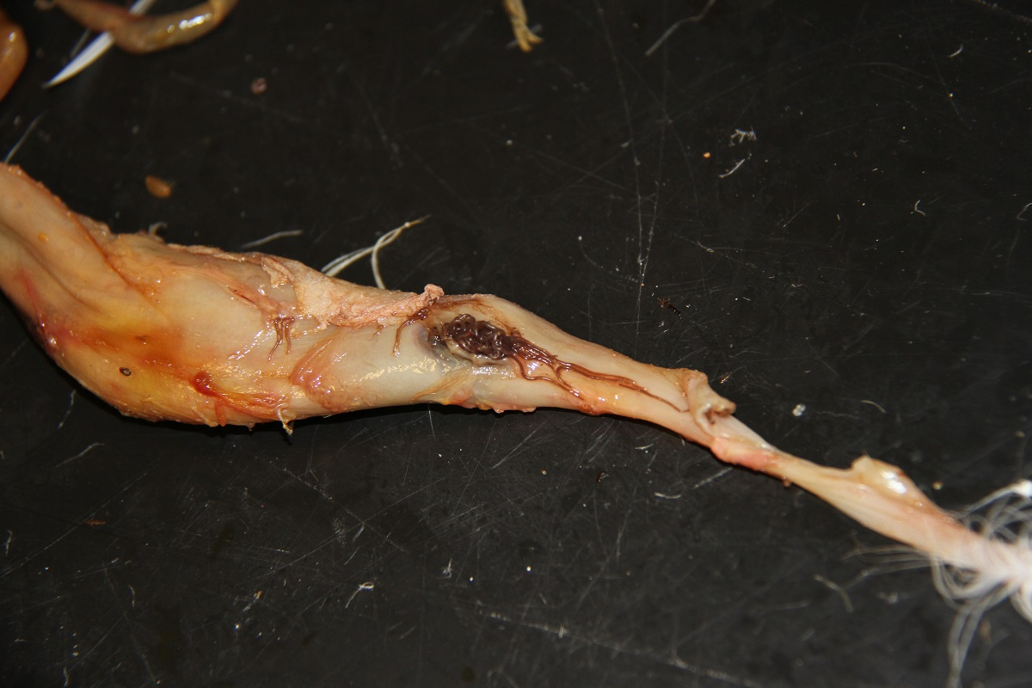
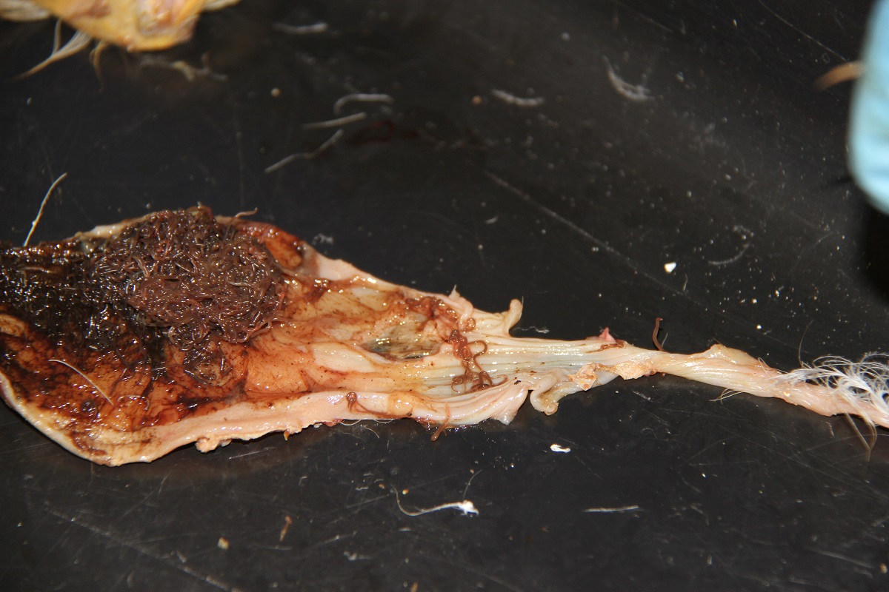

Figure S3. The juvenile shearwater suffered from a gut worm infestation that already perforated all gastrointestinal layers of the gut. Upper picture shows in detail the worm infestation inside the intestine. Photo credit: Craig Pelton.

Results on the spatio-temporal distribution: The tagged juvenile Cory’s Shearwater left its natal colony on 30 October 2017 and moved southward spending a few days in the Canary Current and another few days in Cape Verdean waters (Fig. 1a). From there, the bird moved, on 24 November, towards a first staging area in the middle of the Atlantic Ocean, where it stayed until 23 January. It then kept moving southward towards the Southern Hemisphere, following the coast of Brazil, and reached the Brazil Current, where it remained for almost four months, from 04 February to 26 May (Fig. 1a). In May, the bird moved back to the Northern Hemisphere following again the coast of Brazil, and spent the entire month of June moving westward towards the Lesser and Greater Antilles. At this point, the bird was apparently approaching Florida Peninsula (Fig. 1a). However, this final trajectory should be regarded with caution because the bird was found beached, internally emaciated, with two major issues: a serious lung infection, and also major infestation of worms in the gut, which had eaten through the stomach lining (see Photos 2 & 3 of the formal necropsy performed on 16 July 2018 by the veterinarian Dr Craig Pelton, Marine Science Center, Ponce Inlet, Florida 32127).

Regarding adult birds from the same colony and year, and as previously described for the species (González-Solís et al. 2007, Dias et al. 2011), most adults (79%) undertook a long-distance, trans-equatorial migration from their breeding grounds in the Canary Current to their main wintering grounds in the South Atlantic Ocean (Fig. 1b). On average, migratory adults left the breeding area on 14 November 2017 (± 11.3 days), starting the outward migration, using similar trajectories, and moving south-westward through the Southern Hemisphere (Table 1 & Fig. 1b). Most birds wintered around South Africa (n=23), in waters of the Benguela Current and its confluence with the Agulhas Current; only three adults used the Brazil Current for wintering. Migratory adults crossed the Equator on 20 November 2017 (± 12.0 days) and 22 February 2018 (± 19.1 days), on their outward and return migrations, respectively (Table 1). However, a relevant proportion of birds (21%) stayed around the Canary Current for wintering (Fig. 1b). Interestingly, although essentially resident, most of these birds undertook a long-distance short trip (of less than 15 days) at the end of the non-breeding period, two of them visiting the Brazil Current.

Results on the at-sea activity patterns: At-sea activity pattern of the juvenile shearwater revealed remarkable heterogeneity throughout its first year of life (left-hand panel in Fig. 2). It rested most of the day on the water during the first days post-fledgling, in mid-January when it stayed in the middle of the Atlantic Ocean, as well as during last days prior to its death. Regarding adults, resident and migratory birds displayed different activity patterns throughout the annual cycle: while resident birds tended to rest equally throughout the non-breeding period, migratory birds displayed a sinusoidal shape in their activity profile, clearly reflecting the post-nuptial migration they undertook in mid-late November (left-hand panel in Fig. 2).

During its first days out of the natal burrow and in waters of the Canary Current, the juvenile spent a higher proportion of time flying during daylight time than adults but the proportion of time resting at night on the water was similar to adults (right-hand panels in Fig. 2). In the Brazil Current the juvenile spent a higher proportion of time flying than adult in both periods, during daylight and also during darkness.

REFERENCES
Akesson S, Weimerskirch H (2005) Albatross Long-Distance Navigation : Comparing Adults And Juveniles. J Navig 58:365–373. doi: 10.1017/S0373463305003401
BirdLife International (2014) IUCN Red List for birds.
Dias MP, Granadeiro JP, Catry P (2012) Working the day or the night shift? Foraging schedules of Cory’s Shearwaters vary according to marine habitat. Mar Ecol Prog Ser 467:245–252.
Dias MP, Granadeiro JP, Phillips RA, et al (2011) Breaking the routine: individual Cory’s Shearwaters shift winter destinations between hemispheres and across ocean basins. Proc R Soc B Biol Sci 278:1786–1793. doi: 10.1098/rspb.2010.2114
Fox J (2015) Intiproc geolocation processing software. User reference manual Intiproc v1.03. Migrate Technology Ltd, Cambridge, UK,
Gómez-Díaz E, González-Solís J, Peinado MA (2009) Population structure in a highly pelagic seabird, the Cory’s Shearwater Calonectris diomedea: an examination of genetics, morphology and ecology. Mar Ecol Prog Ser 382:197–209. doi: 10.3354/meps07974
González-Solís J, Croxall JP, Oro D, Ruiz X (2007) Trans-equatorial migration and mixing in the wintering areas of a pelagic seabird. Front Ecol Environ 5:297–301.
Granadeiro JP, Burns MD, Furness RW (1999) Food provisioning to nestling shearwaters: why parental behaviour should be monitored? Anim Behav 57:663–671. doi: 10.1006/anbe.1998.0992
Granadeiro JP, Dias MP, Rebelo R, et al (2006) Numbers and population trends of Cory’s Shearwater Calonectris diomedea at Selvagem Grande, Northeast Atlantic. Waterbirds 29:56–60. doi: 10.1675/1524-4695(2006)29[56:NAPTOC]2.0.CO;2
Merkel B, Phillips RA, Descamps S, et al (2016) A probabilistic algorithm to process geolocation data. Mov Ecol 4:26. doi: 10.1186/s40462-016-0091-8
Mougin J-L, Jouanin C, Roux F (2000) Démographie du puffin cendré Calonectris diomedea de Selvagem Grande (30° 09’ N, 15° 52’ W). Rev d’Ecologie (La Terre la Vie) 55:275–290.
Phillips RA, Silk JRD, Croxall JP, et al (2004) Accuracy of geolocation estimates for flying seabirds. Mar Ecol Prog Ser 266:265–272. doi: 10.3354/meps266265
Phillips RA, Xavier JC, Croxall JP (2003) Effects of satellite transmitters on albatrosses and petrels. Auk 120:1082–1090.
Ramos R, Granadeiro JP, Nevoux M, et al (2012) Combined spatio-temporal impacts of climate and longline fisheries on the survival of a trans-equatorial marine migrant. PLoS One 7:e40822.
Ramos R, Ramírez I, Paiva VH, et al (2016) Global spatial ecology of three closely-related gadfly petrels. Sci Rep 6:6:23447.
Thibault J-C, Bretagnolle V, Rabouam C (1997) Cory’s Shearwater. Update. Birds of the Western Palearctic. Oxford University Press, Oxford, UK, pp 75–98
Wood S (2017) mgcv: Mixed GAM Computation Vehicle with Automatic Smoothness Estimation.
Wood SN, Augustin NH (2002) GAMs with integrated model selection using penalized regression splines and applications to environmental modelling. Ecol Modell 157:157–177. doi: 10.1016/S0304-3800(02)00193-X

