**Supplemental Information**

Materials and Methods

*Materials*

The following chemicals were used: dextran from *Leuconostoc mesenteroides* (9,000-11,000 MW), pyridinium p-toluenesulfonate (PPTS, ≥ 99.9%), 2-methoxypropene (2-MOP, ≥ 97%), triethylamine (TEA, ≥ 99%), anhydrous dimethyl sulfoxide (DMSO, ≥ 99.9%), deuterium chloride (DCl, 35 wt% in D2O, ≥ 99% atom D), sodium acetate (≥ 99%), acetic acid (1.0 N), chloroform (≥ 99%), anhydrous methanol (≥ 99.9%), and isopropanol (≥ 99%), sulforhodamine B sodium salt (SRB), Hydranal® KF reagent, and deuterium oxide (D2O, 99.8% atom D). All cell culture materials were purchased from American Type Culture Collection (ATCC, Manassas, VA, USA), Caisson Labs (Smithfield, UT, USA), or Fisher Scientific.

*Kinetics and Release Models*

The zero-order model describes the constant, controlled release of drug from a drug formulation, disregarding changes in equilibrium and erosion of the formulation [1]. Ideal delivery of drugs would follow zero-order kinetics to keep blood levels constant. The zero-order model is described by:

** (1)

where Mt is the mass of drug released at time t, M0 is the initial mass of drug released at t = 0, and K0 is the zero-order release rate constant.

The first-order model describes drug release profiles as proportional to the amount of unreleased drug remaining at time, t, thereby indicating sustained release of the drug [1], as described by:

 (2)

where Ct is the concentration of drug at time t, C0 is the initial drug concentration at t = 0, and K1 is the first-order release rate constant.

The Higuchi model describes drug release profiles based on square root time dependence [1] as seen in:

 (3)

where Mt/M∞ is fraction of drug released at time t and KH is the Higuchi dissolution constant.

The Korsmeyer-Peppas (K-P) model (a.k.a. Ritger-Peppas model) is a semi-empirical model that exponentially relates the amount of drug released with time [1] as seen in:

 (4)

where Mt/M∞ is fraction of drug released at time t, KKP is the Korsmeyer-Peppas release rate constant that characterizes the structural and geometric properties of the particles, and n is the drug release exponent indicating the drug release mechanism. The K-P model allows for the understanding of the type of dissolution mechanism occurring during degradation, where an n value of 0.43 indicates Fickian diffusion, n of 0.85 indicates case II transport (erosion), and 0.43 < n < 0.85 indicates anomalous drug transport.

The Corrigan model is used to model burst release kinetics by combining contributions from first-order kinetics and polymer degradation, where release of drug molecules close to the surface of the system and polymer degradation are both contributions to release [2,3].

 (5)

where Q is the fraction of drug released at time t, FB,in is the fraction of drug released during burst, and KC is the first-order Corrigan rate constant associated with the kinetics of the burst release [4].

The Peppas-Sahlin model [5,6] accounts for both Fickian diffusion (first term in equation) and case II relaxation (second term in equation) release contributions:

 (6)

where Mt/M∞ is fraction of drug released at time t, k1 and k2 are the kinetic constants, and m is the diffusional exponent. The ratio of relaxation versus Fickian contributions can be calculated from:

 (7)

where R/F = 1 indicates a release mechanism contains both erosion and diffusion equally, R/F > 1 indicates that relaxation (erosion) dominates, and R/F < 1 indicates that diffusion dominates.

Abbreviations

2-MOP = 2-methoxypropene; acetalated dextran = Ac-dex; CAC = cyclic-to-acyclic; D2O = deuterium oxide; DCl = deuterium chloride; DL = drug loading; DMSO = dimethyl sulfoxide; TEA = triethylamine; DSC = differential scanning calorimetry; EE = encapsulation efficiency; ED = emitted dose; FPD = fine particle dose; FPF = fine particle fraction; HPMC = hydroxypropyl methylcellulose; KFT = Karl Fischer titration; MMAD = mass median aerodynamic diameter; MP = microparticle; NGI = Next Generation Impactor; PLGA= poly(lactic-co-glycolic acid); PPTS = p-toluenesulfonate; RF = respirable fraction; SRB = sulforhodamine B; W/O = water/organic; XRD = x-ray diffraction.

Tables and Figures

**Table S1**. Zeta potential of microparticles systems (mean ± standard deviation, n = 3).

|  |  |
| --- | --- |
| **System** | **Zeta Potential**  **(mV)** |
| Fast-100°C-MedP | -16.1 ± 2.3 |
| Fast-150°C-MedP | -15.9 ± 1.8 |
| Fast-100°C-HighP | -13.5 ± 3.3 |
| Slow-100°C-MedP | -15.0 ± 1.5 |
| Slow-150°C-MedP | -15.9 ± 3.3 |
| Slow-100°C-HighP | -17.6 ± 1.8 |
| Man-100°C-LowP | --- |

**Table S2**. Values for ratio of relaxation versus Fickian contribution (R/F) of Peppas-Sahlin drug release kinetics model for microparticle drug release at pH 5. F100M = Fast-100°C-MedP, F150M = Fast-150°C-MedP, F100H = Fast-100°C-HighP, S100M = Slow-100°C-MedP, S150M = Slow-150°C-MedP, S100H = Slow-100°C-HighP.

|  |  |  |  |  |  |  |
| --- | --- | --- | --- | --- | --- | --- |
| **Time (hour)** | **F100M** | **F150M** | **F100H** | **S100M** | **S150M** | **S100H** |
| 0 | 0 | 0 | 0 | 0 | 0 | 0 |
| 1 | 0.2418 | 0.1931 | 0.1874 | 0.3134 | 0.6070 | 0.2364 |
| 2 | 0.2575 | 0.1719 | 0.1967 | 0.3277 | 0.6370 | 0.2461 |
| 4 | 0.2743 | 0.1813 | 0.2064 | 0.3426 | 0.6684 | 0.2562 |
| 6 | 0.2847 | 0.1970 | 0.2123 | 0.3517 | 0.6874 | 0.2624 |
| 8 | 0.2922 | 0.1911 | 0.2167 | 0.3582 | 0.7013 | 0.2667 |
| 24 | 0.3230 | 0.2078 | 0.2340 | 0.3844 | 0.7569 | 0.2843 |

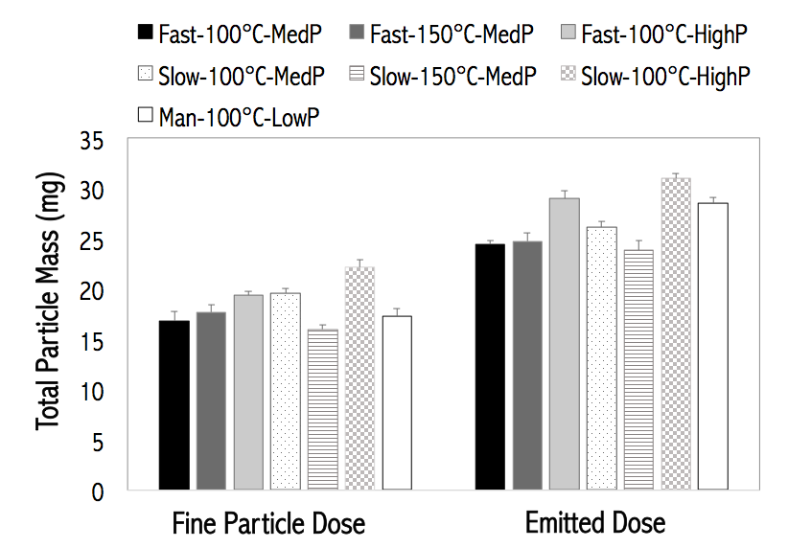

**Figure S1.** Total particle mass (mg) of aerosolization performance properties of particles, including fine particle fraction (FPF), respirable fraction (RF), and emitted dose (ED) (mean ± standard deviation, n = 3).

References

[1] Costa, P., & Lobo JMS. Modelling and Comparison of Dissolution Profiles. Eur. J. Pharm. Sci. 2001;13:123–133.

[2] Corrigan OI, Li X. Quantifying drug release from PLGA nanoparticulates. Eur. J. Pharm. Sci. 2009;37:477–485.

[3] Gallagher KM, Corrigan OI. Mechanistic aspects of the release of levamisole hydrochloride from biodegradable polymers. J. Control. Release. 2000;69:261–272.

[4] Rodrigues de Azevedo C, von Stosch M, Costa MS, et al. Modeling of the burst release from PLGA micro- and nanoparticles as function of physicochemical parameters and formulation characteristics. Int. J. Pharm. [Internet]. 2017;532:229–240. Available from: http://dx.doi.org/10.1016/j.ijpharm.2017.08.118.

[5] Unagolla JM, Jayasuriya AC. Drug transport mechanisms and in vitro release kinetics of vancomycin encapsulated chitosan-alginate polyelectrolyte microparticles as a controlled drug delivery system. Eur. J. Pharm. Sci. [Internet]. 2018;114:199–209. Available from: https://doi.org/10.1016/j.ejps.2017.12.012.

[6] Peppas NA, Sahlin JJ. A simple equation for the description of solute release. III. Coupling of diffusion and relaxation. International Journal of Pharmaceutics, 1989. 57(2): p. 169-172. Int. J. Pharm. 1989;57:169–172.