SUPPLEMENTARY INFORMATION

Revision of the subfamily Pitarinae Stewart, 1930 (Eucallista Dall, 1902; Austrocallista Erdmann & Morra, 1985; Proteopitar nov. gen.) from Cenozoic southern South America: Systematic and Phylogenetic Analyses

Maximiliano Jorge Alvarez ª, Claudia Julia del Río ª & Sergio Martínez ^{b}

ª Museo Argentino de Ciencias Naturales Bernardino Rivadavia, Angel Gallardo 470, 1405, Buenos Aires, Argentina; ^{b} Facultad de Ciencias, Universidad de la República, Iguá 4225, 11400 Montevideo, Uruguay
Appendix S1. List of studied material.
E=Eucallista; Austro=Austrocallista; P=Proteopitar
GSJ=San Julián Gulf; P. Log.=Punta Logaritmo; Pto. Pirámides=Puerto Pirámides; Valdés P.= Valdés Peninsula; SAE=San Antonio Este
NS=Number of specimens
Collection number | NS | Taxon | Locality | Province/Region | Country | Formation | Age
MGGC 606 | 1 | Austro. australis | Estancia Quién Sabe | Santa Cruz | Argentina | Ea 25 de Mayo | early Miocene
MGGC 607 | 1 | Austro. australis | Estancia Quién Sabe | Santa Cruz | Argentina | Ea 25 de Mayo | early Miocene
MGGC 608 | 1 | Austro. australis | Estancia Quién Sabe | Santa Cruz | Argentina | Ea 25 de Mayo | early Miocene
MGGC 609 | 1 | Austro. australis | Estancia Quién Sabe | Santa Cruz | Argentina | Ea 25 de Mayo | early Miocene
MGGC 610 | 1 | Austro. australis | Estancia Quién Sabe | Santa Cruz | Argentina | Ea 25 de Mayo | early Miocene
MGGC 611 | 1 | Austro. australis | Estancia Quién Sabe | Santa Cruz | Argentina | Ea 25 de Mayo | early Miocene
MGGC 635 | 1 | Austro. australis | Estancia Quién Sabe | Santa Cruz | Argentina | Ea 25 de Mayo | early Miocene
MGGC 636 | 1 | Austro. australis | Estancia Quién Sabe | Santa Cruz | Argentina | Ea 25 de Mayo | early Miocene
MGGC 641 | 1 | Austro. australis | Estancia Quién Sabe | Santa Cruz | Argentina | Ea 25 de Mayo | early Miocene
MGGC 642 | 1 | Austro. australis | Estancia Quién Sabe | Santa Cruz | Argentina | Ea 25 de Mayo | early Miocene
MGGC 643 | 1 | Austro. australis | Estancia Quién Sabe | Santa Cruz | Argentina | Ea 25 de Mayo | early Miocene
MGGC 644 | 1 | Austro. australis | Estancia Quién Sabe | Santa Cruz | Argentina | Ea 25 de Mayo | early Miocene
MGGC 645 | 1 | Austro. australis | Estancia Quién Sabe | Santa Cruz | Argentina | Ea 25 de Mayo | early Miocene
MGGC 646 | 1 | Austro. australis | Estancia Quién Sabe | Santa Cruz | Argentina | Ea 25 de Mayo | early Miocene
MGGC 647 | 1 | Austro. australis | Estancia Quién Sabe | Santa Cruz | Argentina | Ea 25 de Mayo | early Miocene
MGGC 648 | 1 | Austro. australis | Estancia Quién Sabe | Santa Cruz | Argentina | Ea 25 de Mayo | early Miocene
MGGC 649 | 1 | Austro. australis | Estancia Quién Sabe | Santa Cruz | Argentina | Ea 25 de Mayo | early Miocene
MGGC 650 | 1 | Austro. australis | Estancia Quién Sabe | Santa Cruz | Argentina | Ea 25 de Mayo | early Miocene
MGGC 651 | 1 | Austro. australis | Estancia Quién Sabe | Santa Cruz | Argentina | Ea 25 de Mayo | early Miocene
MGGC 652 | 1 | Austro. australis | Estancia Quién Sabe | Santa Cruz | Argentina | Ea 25 de Mayo | early Miocene
MGGC 653 | 1 | Austro. australis | Estancia Quién Sabe | Santa Cruz | Argentina | Ea 25 de Mayo | early Miocene
MGGC 654 | 1 | Austro. australis | Estancia Quién Sabe | Santa Cruz | Argentina | Ea 25 de Mayo | early Miocene
MGGC 655 | 1 | Austro. australis | Estancia Quién Sabe | Santa Cruz | Argentina | Ea 25 de Mayo | early Miocene
MGGC 656 | 1 | Austro. australis | Estancia Quién Sabe | Santa Cruz | Argentina | Ea 25 de Mayo | early Miocene
MGGC 657 | 1 | Austro. australis | Estancia Quién Sabe | Santa Cruz | Argentina | Ea 25 de Mayo | early Miocene
MGGC 658 | 1 | Austro. australis | Estancia Quién Sabe | Santa Cruz | Argentina | Ea 25 de Mayo | early Miocene
MGGC 659 | 1 | Austro. australis | Estancia Quién Sabe | Santa Cruz | Argentina | Ea 25 de Mayo | early Miocene
MGGC 660 | 1 | Austro. australis | Estancia Quién Sabe | Santa Cruz | Argentina | Ea 25 de Mayo | early Miocene
MGGC 661 | 1 | Austro. australis | Estancia Quién Sabe | Santa Cruz | Argentina | Ea 25 de Mayo | early Miocene
MGGC 662 | 1 | Austro. australis | Estancia Quién Sabe | Santa Cruz | Argentina | Ea 25 de Mayo | early Miocene
MGGC 663 | 1 | Austro. australis | Estancia Quién Sabe | Santa Cruz | Argentina | Ea 25 de Mayo | early Miocene
SGO.PI 96 | 1 | Austro. boliviana | Navidad | Cardenal Caro | Chile | Navidad | early Miocene
SGO.PI 1169 | 3 | Austro. boliviana | Caldera | Caldera | Chile | Bahia Inglesa | late Mio-late Plio
SGO.PI 2033 | 12 | Austro. boliviana | Licancheu | Cardenal Caro | Chile | Licancheu | Pliocene
SGO.PI 2042 | 1 | Austro. boliviana | Licancheu | Cardenal Caro | Chile | Licancheu | Pliocene
SGO.PI 2065 | 7 | Austro. boliviana | Licancheu | Cardenal Caro | Chile | Licancheu | Pliocene
SGO.PI 2068 | 1 | Austro. boliviana | Licancheu | Cardenal Caro | Chile | Licancheu | Pliocene
SGO.PI 5519 | 1 | Austro. boliviana | Maitenlahue | Cardenal Caro | Chile | Navidad | early Miocene
SGO.PI 5525 | 1 | Austro. boliviana | Rapel Norte | Cardenal Caro | Chile | Navidad | early Miocene
SGO.PI 5553 | 1 | Austro. boliviana | Rapel Norte | Cardenal Caro | Chile | Navidad | early Miocene
SGO.PI 5554 | 1 | Austro. boliviana | Rapel Norte | Cardenal Caro | Chile | Navidad | early Miocene
SGO.PI 5576 | 1 | Austro. boliviana | Rapel Norte | Cardenal Caro | Chile | Navidad | early Miocene
SGO.PI 5582 | 1 | Austro. boliviana | Rapel Norte | Cardenal Caro | Chile | Navidad | early Miocene
MACN-Pi 6360 | 1 | Austro. boliviana | Navidad | Cardenal Caro | Chile | Navidad | early Miocene
MACN-Pi 424 | 2 | Austro. iheringi | Bajo de San Julián | Santa Cruz | Argentina | San Julián | late Oligocene
MACN-Pi 423 | 3 | Austro. iheringi | Yegua Quemada | Santa Cruz | Argentina | Monte León | early Miocene
MACN-Pi 5397 | 1 | Austro. iheringi | Yegua Quemada | Santa Cruz | Argentina | Monte León | early Miocene
MACN-Pi 6359 | 1 | Austro. iheringi | - | Tierra del Fuego | Argentina | Carmen Silva | middle Miocene
MACN-Pi 6391 | 4 | Austro. iheringi | Lago Cardiel | Santa Cruz | Argentina | El Chacay | early Miocene
MACN-Pi 6396 | 2 | Austro. iheringi | La Mina beach | Santa Cruz | Argentina | San Julián | late Oligocene
MACN-Pi 6672 | 1 | Austro. iheringi | Las Cuevas | Santa Cruz | Argentina | Monte León | early Miocene
CPBA 9398 | 45 | Austro. iheringi | Las Cuevas | Santa Cruz | Argentina | Monte León | early Miocene
CPBA 9391 | 1 | Austro. iheringi | Las Cuevas | Santa Cruz | Argentina | Monte León | early Miocene
CPBA 13010 | 1 | Austro. iheringi | La Mina beach | Santa Cruz | Argentina | San Julián | late Oligocene
MACN-Pi 6451 | 2 | Austrocallista sp. | Yacimiento Río Turbio | Santa Cruz | Argentina | Río Turbio | Eocene
SGO.PI 77 | 1 | E. domeykoana | San Vicente de Pucalan | Litueche | Chile | La Cueva? | early Pliocene
SGO.PI 87 | 2 | E. domeykoana | La Cueva | La Estrella | Chile | La Cueva | early Pliocene
SGO.PI 138 | 1 | E. domeykoana | La Cueva | La Estrella | Chile | La Cueva | early Pliocene
SGO.PI 1296 | 9 | E. domeykoana | La Cueva | La Estrella | Chile | La Cueva | early Pliocene
SGO.PI 1298 | 6 | E. domeykoana | La Cueva | La Estrella | Chile | La Cueva | early Pliocene
SGO.PI 4910 | 1 | E. domeykoana | Lo Abarca | Valparaíso | Chile | Navidad | early Miocene
SGO.PI 5276p | 1 | E. domeykoana | Mocha island | Arauco | Chile | Unspecified | Miocene-Pliocene
SGO.PI 5595 | 1 | E. domeykoana | Estero del Ganso | Litueche | Chile | La Cueva | early Pliocene
SGO.PI 3766 | 1 | E. laziarina | Lebu | Arauco | Chile | Navidad | early Miocene
SGO.PI 3767 | 1 | E. laziarina | Matanzas | Cardenal Caro | Chile | Navidad | early Miocene
SGO.PI 3768 | 1 | E. laziarina | Matanzas | Cardenal Caro | Chile | Navidad | early Miocene
SGO.PI 5276p | 2 | E. laziarina | Mocha island | Arauco | Chile | Unspecified | Miocene-Pliocene
MACN-PI 5399 | 1 | E. laziarina | Bajo Madryn | Chubut | Argentina | Pto. Madryn | late Miocene
MACN-PI 431 | 8 | E. laziarina | Near cerro Laziar | Santa Cruz | Argentina | Araucanense | Pliocene
CIRGEO-PI 1259 | 1 | E. laziarina | GSJ e/P. Log y Tehuelche | Chubut | Argentina | Pto. Madryn | late Miocene
CIRGEO-PI 1262 | 1 | E. laziarina | GSJ e/P. Log y Tehuelche | Chubut | Argentina | Pto. Madryn | late Miocene
CPBA 13666 | 1 | E. laziarina | Fondeadero Ninfas | Chubut | Argentina | Pto. Madryn | late Miocene
CPBA 13668 | 1 | E. laziarina | Fondeadero Ninfas | Chubut | Argentina | Pto. Madryn | late Miocene
CPBA 13669 | 1 | E. laziarina | Fondeadero Ninfas | Chubut | Argentina | Pto. Madryn | late Miocene
CPBA 14490 | 1 | E. laziarina | Pto. Pirámides/Valdés P. | Chubut | Argentina | Pto. Madryn | late Miocene
CPBA 14491 | 1 | E. laziarina | Pto. Pirámides/Valdés P. | Chubut | Argentina | Pto. Madryn | late Miocene
CPBA 14493 | 1 | E. laziarina | Pto. Pirámides/Valdés P. | Chubut | Argentina | Pto. Madryn | late Miocene
CPBA 14494 | 1 | E. laziarina | Pto. Pirámides/Valdés P. | Chubut | Argentina | Pto. Madryn | late Miocene
CPBA 14495 | 1 | E. laziarina | Pto. Pirámides/Valdés P. | Chubut | Argentina | Pto. Madryn | late Miocene
CPBA 14496 | 1 | E. laziarina | Pto. Pirámides/Valdés P. | Chubut | Argentina | Pto. Madryn | late Miocene
CPBA 14497 | 1 | E. laziarina | Pto. Pirámides/Valdés P. | Chubut | Argentina | Pto. Madryn | late Miocene
CPBA 14498 | 1 | E. laziarina | Pto. Pirámides/Valdés P. | Chubut | Argentina | Pto. Madryn | late Miocene
CPBA 12471 | 1 | E. laziarina | Fondeadero Ninfas | Chubut | Argentina | Pto. Madryn | late Miocene
CPBA 12472 | 1 | E. laziarina | Fondeadero Ninfas | Chubut | Argentina | Pto. Madryn | late Miocene
CPBA 12477 | 1 | E. laziarina | Fondeadero Ninfas | Chubut | Argentina | Pto. Madryn | late Miocene
CPBA 12478 | 1 | E. laziarina | Fondeadero Ninfas | Chubut | Argentina | Pto. Madryn | late Miocene
CPBA 12479 | 1 | E. laziarina | Fondeadero Ninfas | Chubut | Argentina | Pto. Madryn | late Miocene
CPBA 12481 | 1 | E. laziarina | Fondeadero Ninfas | Chubut | Argentina | Pto. Madryn | late Miocene
CPBA 12482 | 1 | E. laziarina | Fondeadero Ninfas | Chubut | Argentina | Pto. Madryn | late Miocene
CPBA 12483 | 1 | E. laziarina | Fondeadero Ninfas | Chubut | Argentina | Pto. Madryn | late Miocene
CPBA 14178 | 1 | E. laziarina | Pto. Pirámides/Valdés P. | Chubut | Argentina | Pto. Madryn | late Miocene
CPBA 14179 | 1 | E. laziarina | Pto. Pirámides/Valdés P. | Chubut | Argentina | Pto. Madryn | late Miocene
CPBA 14181 | 1 | E. laziarina | Pto. Pirámides/Valdés P. | Chubut | Argentina | Pto. Madryn | late Miocene
CPBA 6717 | 1 | E. laziarina | Near cerro Laziar | Santa Cruz | Argentina | Araucanense | Pliocene
MNHN-IM-2000-31768 | 2 | E. purpurata | southern Brazil | - | Brazil | - | Recent
MACN-In 269 | 5 | E. purpurata | Bahía Blanca | Buenos Aires | Argentina | - | Recent
MACN-In 268 | 8 | E. purpurata | Bahía Blanca | Buenos Aires | Argentina | - | Recent
MACN-In 2469 | 26 | E. purpurata | San Antonio Oeste | Río Negro | Argentina | - | Recent
MACN-In 13342 | 26 | E. purpurata | San Antonio Oeste | Río Negro | Argentina | - | Recent
MACN-Pi 6299 | 1 | E. purpurata | Puerto Lobos | Chubut | Argentina | - | Holocene
MACN-Pi 6443 | 4 | E. purpurata | 25 Km east of SAE | Río Negro | Argentina | B. San Matías | Pleistocene
MLP 5409 | 2 | E. purpurata | Río Chico | Buenos Aires | Argentina | - | Holocene
MLP 2475 | 2 | E. purpurata | San Antonio Oeste | Río Negro | Argentina | - | Recent
MLP 33992 | 1 | E. purpurata | Bahía San Blas (Jabalí Is.) | Buenos Aires | Argentina | - | Recent
MLP 34022 | 1 | E. purpurata | Cantera Atlántida | Buenos Aires | Argentina | - | Holocene
MLP 34397 | 1 | E. purpurata | Río Colorado delta | Buenos Aires | Argentina | - | Recent
MLP 33801 | 1 | E. purpurata | Canal Villalonga | Buenos Aires | Argentina | - | Pleistocene
ANSP 30889 | 1 | E. purpurata | Argentinean Cont. Shelf | Chubut | Argentina | - | Pleistocene
ANSP 30890 | 1 | E. purpurata | Argentinean Cont. Shelf | Buenos Aires | Argentina | - | Pleistocene
CIRGEO-PI 2805p | 2 | P. mutabilis | Cantera a 7km Ea S. Julio | Tierra del Fuego | Argentina | Carmen Silva | middle Miocene
CIRGEO-PI 2867p | 2 | P. mutabilis | Puesto 26 | Tierra del Fuego | Argentina | Carmen Silva | middle Miocene
CPBA 15092 | 17 | P. mutabilis | Puesto Fracaso | Chubut | Argentina | Pto. Madryn | late Miocene
CPBA 12510 | 1 | P. mutabilis | Puesto San José | Chubut | Argentina | Pto. Madryn | late Miocene
CPBA 12512 | 1 | P. mutabilis | Puesto San José | Chubut | Argentina | Pto. Madryn | late Miocene
CPBA 12513 | 1 | P. mutabilis | Puesto San José | Chubut | Argentina | Pto. Madryn | late Miocene
CPBA 15514 | 1 | P. mutabilis | Puesto San José | Chubut | Argentina | Pto. Madryn | late Miocene
CPBA 12515 | 1 | P. mutabilis | Puesto San José | Chubut | Argentina | Pto. Madryn | late Miocene
CPBA 12516 | 1 | P. mutabilis | Puesto San José | Chubut | Argentina | Pto. Madryn | late Miocene
CPBA 12518 | 1 | P. mutabilis | Puesto San José | Chubut | Argentina | Pto. Madryn | late Miocene
CPBA 12519 | 1 | P. mutabilis | Puesto San José | Chubut | Argentina | Pto. Madryn | late Miocene
CPBA 12520 | 1 | P. mutabilis | Puesto San José | Chubut | Argentina | Pto. Madryn | late Miocene
CPBA 12522 | 1 | P. mutabilis | Puesto San José | Chubut | Argentina | Pto. Madryn | late Miocene
CPBA 17392 | 2 | P. mutabilis | Pto. Pirámides/Valdés P. | Chubut | Argentina | Pto. Madryn | late Miocene
CPBA 14469 | 1 | P. mutabilis | Pto. Pirámides/Valdés P. | Chubut | Argentina | Pto. Madryn | late Miocene
CPBA 14470 | 1 | P. mutabilis | Pto. Pirámides/Valdés P. | Chubut | Argentina | Pto. Madryn | late Miocene
CPBA 14471 | 1 | P. mutabilis | Pto. Pirámides/Valdés P. | Chubut | Argentina | Pto. Madryn | late Miocene
CPBA 14472 | 1 | P. mutabilis | Pto. Pirámides/Valdés P. | Chubut | Argentina | Pto. Madryn | late Miocene
CPBA 14473 | 1 | P. mutabilis | Pto. Pirámides/Valdés P. | Chubut | Argentina | Pto. Madryn | late Miocene
CPBA 14474 | 1 | P. mutabilis | Pto. Pirámides/Valdés P. | Chubut | Argentina | Pto. Madryn | late Miocene
CPBA 14475 | 1 | P. mutabilis | Pto. Pirámides/Valdés P. | Chubut | Argentina | Pto. Madryn | late Miocene
CPBA 14476 | 1 | P. mutabilis | Pto. Pirámides/Valdés P. | Chubut | Argentina | Pto. Madryn | late Miocene
CPBA 14477 | 1 | P. mutabilis | Pto. Pirámides/Valdés P. | Chubut | Argentina | Pto. Madryn | late Miocene
CPBA 14478 | 1 | P. mutabilis | Pto. Pirámides/Valdés P. | Chubut | Argentina | Pto. Madryn | late Miocene
CPBA 14479 | 1 | P. mutabilis | Pto. Pirámides/Valdés P. | Chubut | Argentina | Pto. Madryn | late Miocene
CPBA 14480 | 1 | P. mutabilis | Pto. Pirámides/Valdés P. | Chubut | Argentina | Pto. Madryn | late Miocene
CPBA 14481 | 1 | P. mutabilis | Pto. Pirámides/Valdés P. | Chubut | Argentina | Pto. Madryn | late Miocene
CPBA 14482 | 1 | P. mutabilis | Pto. Pirámides/Valdés P. | Chubut | Argentina | Pto. Madryn | late Miocene
CPBA 14483 | 1 | P. mutabilis | Pto. Pirámides/Valdés P. | Chubut | Argentina | Pto. Madryn | late Miocene
CPBA 14485 | 1 | P. mutabilis | Pto. Pirámides/Valdés P. | Chubut | Argentina | Pto. Madryn | late Miocene
CPBA 14486 | 1 | P. mutabilis | Pto. Pirámides/Valdés P. | Chubut | Argentina | Pto. Madryn | late Miocene
CPBA 14487 | 1 | P. mutabilis | Pto. Pirámides/Valdés P. | Chubut | Argentina | Pto. Madryn | late Miocene
CPBA 14488 | 1 | P. mutabilis | Pto. Pirámides/Valdés P. | Chubut | Argentina | Pto. Madryn | late Miocene
CPBA 14489 | 1 | P. mutabilis | Pto. Pirámides/Valdés P. | Chubut | Argentina | Pto. Madryn | late Miocene
CPBA 13284 | 1 | P. mutabilis | Punta Norte | Chubut | Argentina | Pto. Madryn | late Miocene
CPBA 14462 | 1 | P. mutabilis | Pto. Pirámides/Valdés P. | Chubut | Argentina | Pto. Madryn | late Miocene
CPBA 14463 | 1 | P. mutabilis | Pto. Pirámides/Valdés P. | Chubut | Argentina | Pto. Madryn | late Miocene
CPBA 14465 | 1 | P. mutabilis | Pto. Pirámides/Valdés P. | Chubut | Argentina | Pto. Madryn | late Miocene
CPBA 14466 | 1 | P. mutabilis | Pto. Pirámides/Valdés P. | Chubut | Argentina | Pto. Madryn | late Miocene
CPBA 14467 | 1 | P. mutabilis | Pto. Pirámides/Valdés P. | Chubut | Argentina | Pto. Madryn | late Miocene
CPBA 14468 | 1 | P. mutabilis | Pto. Pirámides/Valdés P. | Chubut | Argentina | Pto. Madryn | late Miocene
CPBA 12507 | 1 | P. mutabilis | Puesto San José | Chubut | Argentina | Pto. Madryn | late Miocene
CPBA 12508 | 1 | P. mutabilis | Puesto San José | Chubut | Argentina | Pto. Madryn | late Miocene
CPBA 12509 | 1 | P. mutabilis | Puesto San José | Chubut | Argentina | Pto. Madryn | late Miocene
CPBA 12511 | 1 | P. mutabilis | Puesto San José | Chubut | Argentina | Pto. Madryn | late Miocene
CPBA 12517 | 1 | P. mutabilis | Puesto San José | Chubut | Argentina | Pto. Madryn | late Miocene
CPBA 12487 | 1 | P. mutabilis | Puesto San José | Chubut | Argentina | Pto. Madryn | late Miocene
CPBA 12488 | 1 | P. mutabilis | Puesto San José | Chubut | Argentina | Pto. Madryn | late Miocene
CPBA 14460 | 1 | P. mutabilis | Puesto San José | Chubut | Argentina | Pto. Madryn | late Miocene
CPBA 14461 | 1 | P. mutabilis | Puesto San José | Chubut | Argentina | Pto. Madryn | late Miocene
CPBA 15491 | 1 | P. mutabilis | Puesto San José | Chubut | Argentina | Pto. Madryn | late Miocene
CPBA 15492 | 1 | P. mutabilis | Puesto San José | Chubut | Argentina | Pto. Madryn | late Miocene
CPBA 15493 | 1 | P. mutabilis | Puesto San José | Chubut | Argentina | Pto. Madryn | late Miocene
CPBA 15494 | 1 | P. mutabilis | Puesto San José | Chubut | Argentina | Pto. Madryn | late Miocene
CPBA 15495 | 1 | P. mutabilis | Puesto San José | Chubut | Argentina | Pto. Madryn | late Miocene
MAS-Pi 1005 | 1 | P. mutabilis | Estancia La Juanita | Entre Ríos | Argentina | Paraná | late Miocene
MACN-Pi 6395 | 6 | P. mutabilis | Puesto San José | Chubut | Argentina | Pto. Madryn | late Miocene
NHMUK 1854.12.4.712 | 2 | P. patagonicus | Bahía San Blas | Buenos Aires | Argentina | - | Recent
ANSP 31131 | 1 | P. patagonicus | Argentinean Cont. Shelf | - | Argentina | - | Pleistocene
MLP 2482 | 13 | P. patagonicus | Arroyo Las Brusquitas | Buenos Aires | Argentina | - | Holocene
MLP 26232 | 1 | P. patagonicus | Cerro de la Gloria | Buenos Aires | Argentina | - | Holocene
MLP 26253 | 1 | P. patagonicus | Mar Chiquita | Buenos Aires | Argentina | - | Holocene
MLP 26297 | 1 | P. patagonicus | Ea. Rincón de López | Buenos Aires | Argentina | - | Holocene
MLP 34020 | 1 | P. patagonicus | Cantera Atlántida | Buenos Aires | Argentina | - | Holocene
MLP 25946 | 1 | P. patagonicus | Ea. Rincón de López | Buenos Aires | Argentina | - | Holocene
MLP 2469 | 21 | P. patagonicus | Cno. La Magdalena a PI | Buenos Aires | Argentina | - | Holocene
MLP 33414 | 1 | P. patagonicus | Bahía San Blas | Buenos Aires | Argentina | - | Recent
MLP 26255 | 1 | P. patagonicus | Mar Chiquita | Buenos Aires | Argentina | - | Holocene
MLP 26252 | 1 | P. patagonicus | Mar Chiquita | Buenos Aires | Argentina | - | Holocene
MLP 26233 | 1 | P. patagonicus | Mar Chiquita | Buenos Aires | Argentina | - | Holocene
MLP 26234 | 1 | P. patagonicus | Mar Chiquita | Buenos Aires | Argentina | - | Holocene
MLP 26225 | 1 | P. patagonicus | Mar Chiquita | Buenos Aires | Argentina | - | Holocene
MLP 26254 | 1 | P. patagonicus | Mar Chiquita | Buenos Aires | Argentina | - | Holocene
MLP 2478 | 1 | P. patagonicus | Rawson | Chubut | Argentina | - | Recent
MLP 26251 | 1 | P. patagonicus | Mar Chiquita | Buenos Aires | Argentina | - | Holocene
MLP 2479 | 4 | P. patagonicus | Arroyo Las Brusquitas | Buenos Aires | Argentina | - | Holocene
MLP 2476 | 16 | P. patagonicus | Bahía Sanguinetti | Santa Cruz | Argentina | - | Holocene
MLP 2480 | 27 | P. patagonicus | Bahía Sanguinetti | Santa Cruz | Argentina | - | Holocene
MLP 34421 | 1 | P. patagonicus | Balneario La Chiquita | Buenos Aires | Argentina | - | Recent
MLP 33805 | 1 | P. patagonicus | Los Pocitos | Buenos Aires | Argentina | - | Holocene
MLP 1829p | 1 | P. patagonicus | San Antonio Oeste | Río Negro | Argentina | - | Holocene
MACN-Pi 426 | 1 | P. patagonicus | Puerto San Julián | Santa Cruz | Argentina | - | Pleistocene
MACN-Pi 425 | 2 | P. patagonicus | San Jorge Gulf | Santa Cruz | Argentina | - | Pleistocene
MACN-Pi 6301 | 1 | P. patagonicus | Puerto Madryn | Chubut | Argentina | - | Holocene
MACN-Pi 6397 | 5 | P. patagonicus | Ezeiza | Buenos Aires | Argentina | - | Pleistocene
MACN-Pi 6444 | 1 | P. patagonicus | 25 Km east of SAE | Río Negro | Argentina | B. San Matías | Pleistocene
MACN-In 35353 | 28 | P. patagonicus | La Paloma | Rocha | Uruguay | - | Recent
MACN-In 1814 | 6 | P. patagonicus | Ubatuba | São Paulo | Brazil | - | Recent
MACN-In 14151 | 8 | P. patagonicus | Mar del Plata | Buenos Aires | Argentina | - | Recent
MACN-In 11191 | 16 | P. patagonicus | Puerto Militar | Buenos Aires | Argentina | - | Recent
MACN-In 21268 | 16 | P. patagonicus | San Matías Gulf | Río Negro/Chubut | Argentina | - | Recent
MACN-In 18306 | 172 | P. patagonicus | Puerto Quequén | Buenos Aires | Argentina | - | Recent
MACN-In 16577 | 38 | P. patagonicus | Mar del Plata | Buenos Aires | Argentina | - | Recent
MACN-In 16145 | 6 | P. patagonicus | Bahía Brigman | Buenos Aires | Argentina | - | Recent
MACN-In 12021 | 18 | P. patagonicus | Necochea | Buenos Aires | Argentina | - | Recent
MACN-In 11581 | 14 | P. patagonicus | Mar del Plata | Buenos Aires | Argentina | - | Recent
MACN-In 13041 | 6 | P. patagonicus | Quequén | Buenos Aires | Argentina | - | Recent
CPBA 6930 | 1 | P. patagonicus | Arroyo Las Brusquitas | Buenos Aires | Argentina | - | Holocene
Total | 791

Appendix S2. List of taxa used for comparison and phylogeny.
Collection number | Taxon | Type of material
MACN-In 24352 | Amiantis callosa | 5 r, 5 l
UCMP 32571 | Amiantis callosa | 1 r
UCMP 11311 | Amiantis communis | 1 articulated
UCMP 12066 | Amiantis communis | 1 articulated
UCMP 12067 | Amiantis communis | 1 l
UCMP 32533 | Amiantis communis | 1 articulated
UCMP 11508 | Amiantis dalli | 1 l
UCMP 11509 | Amiantis dalli | 1 r
UCMP 11510 | Amiantis dalli | 1 r
UCMP 32401 | Amiantis diabloensis | 1 inner mold
USNM.Mo 646588 | Amiantis mathewsonii | 1 articulated
USNM.Mo 646589 | Amiantis mathewsonii | 1 l
USNM.Mo 646590 | Amiantis mathewsonii | 1 r
USNM.Mo 646591 | Amiantis mathewsonii | 1 r
ANSP-IP 4532 | Amiantis mathewsonii | 1 articulated
ANSP-IP 20131 | Amiantis mathewsonii | 11 articulated
UCMP 32532 | Amiantis mathewsonii | 1 r
USNM.Mo 851372 | ‘Amiantis’ umbonella | 1 l
NMWZ 1993.061.01214 | ‘Amiantis’ umbonella | 1 r, 1 l
NMWZ 1993.061.01218 | ‘Amiantis’ umbonella | 1 r, 1 l
NMWZ 1995.008.00221 | ‘Amiantis’ umbonella | 1 r, 1 l
MACN-In 1793 | Callista chione | 1 r, 1 l
MACN-In 28254 | Callista chione | 1 r, 1 l
NMR 53574 | Callista erycina | 1 r, 1 l
MACN-In 6945 | Callista maculata | 4 r, 4 l
NMR 18280 | Callista multistriata | 1 r, 1 l
MACN-In 844 | Costacallista grata | 1 r, 1 l
MACN-In 26089 | Dosinia concentrica | 5 r, 5 l
MACN-In s/n | Hysteroconcha dione | 1 r, 1 l
MACN-In 1964 | Hysteroconcha lupanaria | 1 r, 1 l
MACN-In 40940 | Hysteroconcha multispinosa | 2 r, 2 l
MACN-In 40941 | Lamelliconcha alternata | 1 r, 1 l
MACN-In 1815 | Lamelliconcha circinatus | 4 r, 6 l
MACN-In 9435-1 | Lamelliconcha concinna | 1 r, 1 l
MACN-In 6901 | Macrocallista nimbosa | 1 r, 1 l
MACN-In 28253 | Megapitaria aurantiaca | 1 r, 1 l
MACN-In 6016 | Megapitaria squalida | 3 r, 3 l
MACN-In 31253 | Notocallista kingii | 1 r, 1 l
NMR 17183 | Notopaphia elegans | 1 r, 1 l
MACN-In 3141 | Pitar albidus | 10 r, 10 l
MACN-In 5010 | Pitar fulminatus | 2 r, 2 l
MACN-In 40492 | Pitar tumens | 1 r, 1 l
FMNH 296352 | Pitar tumens | 2 r, 2 l
PRI 1878 | Pitar quimbrizensis | 1 r
MACN-In 2377 | Saxidomus gigantea | 4 r, 4 l
MACN-In 24313 | Saxidomus nuttalli | 3 r, 3 l

Appendix S3. Systematic Analysis of the genus Amiantis Carpenter, 1864.

Our systematic revision of the genus Eucallista Dall, 1902 has involved extensive revision of fossil and Recent species previously assigned to Amiantis throughout the world. The following is a review of the generic assignment of most of these taxa. Most of the species mentioned in the knowledge literature appear in lists and appendices, and therefore could not be checked.
Sacco (1900, 20–25) described four European taxa, assigning them to the genus Amiantis: Cytherea incrassata Sowerby, 1817 (Sacco 1900, 21, pl. IV, figs 31–35), Venus brocchi Deshayes, 1835 (Sacco 1900, 23, pl. V, figs 6–9), Cyprina islandicoides Lamarck, 1818 (Sacco 1900, 21, pl. V, figs 1–5), and Cyprina gigas Lamarck, 1818 (Sacco 1900, 24, pl. VI, figs 1–6).
Cytherea incrassata and Venus brocchi should be included in the genus Pelecyora Dall, 1902 because of their subcircular outline, straight anterior margin, hinge plate with a small AII tooth, short 4b, short nymph sculptured by fine dorsal lirae and wide lunule limited by a deep groove.
Cyprina gigas (late Pliocene; Lazio, Italy) also assigned by Bonadonna (1968) to the genus Amiantis s.s. and Cyprina islandicoides (Miocene; France), really belong to the genus Cyprina because they have a subtriangular outline, with very curved and inflated umbones, a hinge plate with small AII, short 4b, short and dorsally sculptured nymph and short pallial sinus.
Jukes-Browne (1913) mentioned Cytherea undata Basterot, 1825 (90, pl. 6. fig. 4) (Oligocene; Hungary) for the Miocene of Aquitaine, including it in Amiantis, but the nymphs are short and smooth, and the cardinal teeth and pallial sinus are closely similar to those of Pitar Römer, 1857.
Abrard & de La Rüe (1947) cited the presence of Meretrix (Amiantis) philippinarum (Hanley, 1844) and M. (Amiantis) sinuatocostata Abrard, 1947 in the late Miocene of the Hebrides islands (Scotland). The first one is an extant species from the Red and Arabian seas widely accepted as part of the genus Lioconcha (Huber 2010). Meretrix (A.) sinuatocostata is not an Amiantis because it has a straight hinge plate margin, short and thick teeth, short and smooth nymphs, and more curved and inflated umbones than those of the species of Amiantis.
Crame (1984) mentioned Amiantis lilacina (Lamarck, 1818) and A. erycina (Linnaeus, 1758) from the Pliocene of Pakistan. Both species were rendered as synonymous by Huber (2010). Amiantis erycina is the type species of Costacallista, a genus clearly different from Amiantis for having smooth nymphs, truncated pallial sinus and valves sculptured by low and wide ribs.
During the last three decades, numerous mentions of the presence of Amiantis [A. grata (Deshayes, 1853), A. hagenowi Dunker, 1849 and A. philippinarum (Hanley, 1844) from the late Pleistocene–Recent of the Arabian Sea have been made [Tantanasiriwong (1979), Morris & Purchon (1981), Dance (1995), Carpenter et al. (1997), Potts (2001), Lézine et al. (2002), Giraud et al. (2005), Al-Khayat & Al-Mohannadi (2006), Al-Maslamani et al. (2007)] but, according to Huber (2010), these taxa belong to other genera (e.g. Costacallista grata, Callista hagenowi, Lioconcha philippinarum), assignment we consider to be valid.
Cytherea umbonella Lamarck, 1818 is an extant species distributed from Kenya to Pakistan (Huber 2010), it was included by Lamy (1930) in the genus Amiantis and recently reassigned to Notocallista by Huber (2010). However, it has sculptured nymphs and is therefore not a Notocallista. This sculpture consists of fine vertical lirae placed in the inner margin of the right nymph and the groove that separate left nymph from 4b tooth. This is reminiscent of the nymphs of the genus Meretrix and not Amiantis.
Gladenkov & Sinelnikova (1990, 64, pl. 4, figs 2–4, 6, 7) described Amiantis penjicus (Miocene; Kamchatka, Russia), but this taxon has smooth nymphs and cardinal and lateral teeth closely similar to those of Callista and not those of Amiantis.
In South America, in addition to species from Argentina, Brazil and Chile discussed in detail in this paper, there are two other taxa that have been assigned to the genus Amiantis. The first one is Amiantis incrassata, a taxon that was discussed earlier in this text. It was mentioned by Spieker (1922) for the Zorritos Formation (Miocene, Peru). The other is Amiantis (Venidia) sp. (NMBG 17616) from the Eocene of Venezuela. The last one is based on a poorly preserved and fragmented valve very similar to Venidia steinekei Clark, 1946 (69, pl. 9, figs 3, 4, 8 and pl. 10, fig. 1; Eocene, Colombia), a species distinguished by its thick shells, with cardinal teeth and sculptured nymphs, similar to the genus Mercenaria Schumacher, 1817. However, it also has an anterior lateral tooth circular in section, which would separate it from this last genus and also from Amiantis.
According to our revision, the stratigraphic and geographic distribution of Amiantis s.s. must be restricted to the west coast of North America, where it has been present since the Oligocene to the Recent occurring as fossils in the Temblor, Santa Margarita and Etchegonian formations (Oligocene–late Miocene; California). It is represented by A. mathewsonii (Gabb, 1869, pl. 5, fig. 39), A. diabloensis (Anderson, 1905, pl. XVII, figs 83–85), A. communis (Nomland, 1917, pl. 14, fig. 2a–d), A. dalli (Clark, 1915, pl. 11, figs, 2a-2b) and by its type species A. callosa (Conrad, 1837) (MACN-In 24352; which ranges from late Miocene–Recent, Eastern Pacific Ocean from Santa Barbara, California to Magdalena Bay, Baja California; Fig. 2A–D, 2J).

Appendix S4. Character list.

Continuous characters

1 Shell length/height ratio.
2 Umbo position (Length measured from the umbo to the posterior margin over total length of the valve ratio).
3 Lunule length/valve height ratio.
4 Distance between the pallial line and the edge of the valve/valve height ratio.
5 Nymph length/valve length ratio.
6 Pallial sinus width/valve height ratio.
7 Tooth 4b length/tooth 2b length ratio.
8 How much of the hinge plate is occupied by the tooth 3a (length of 3a/height of the hinge plate in the place of the tooth 3a).
9 Tooth 3b length/ tooth 1 length ratio.
10 Tooth1 width/ tooth 3b width.
11 Inclination of the dorsal line of the pallial sinus measured with respect to the antero-posterior valve axis.
12 Inclination of 3a tooth with respect to the antero-posterior valve axis.
13 Inclination of 1 tooth with respect to the antero-posterior valve axis.
14 Inclination of 3b tooth with respect to the antero-posterior valve axis.
15 Dorsal margin slope measured as a tangent that connect the umbo with the angle between the dorsal and posterior margin.
16 Height of the lateral margin of the nymph/nymph length.
17 Adult size of the valves (average of the length of the antero-posterior axis)

Discrete characters
We illustrated some characters in order to make them easier to understand by the readers.

18 Valve thickness: Similar to the thickness of Dosinia concentrica (0), thicker than D. concentrica (1) Less thick than D. concentrica.
19 Adult shape: Subcircular (0), Subtriangular (1), Elliptic (2), Suboval (3), Subquadrate.

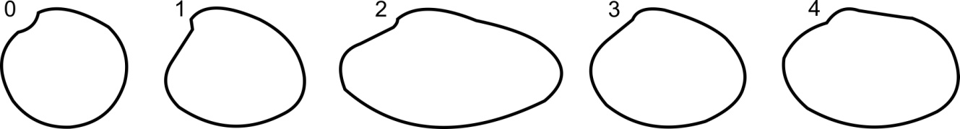

20 Anterior margin shape: Rounded (0), Angular (1).
21 Dorsal margin length: Short (0), Long (1).

22 Posterior margin height: Very high (0), Moderately high (1), Low (2).

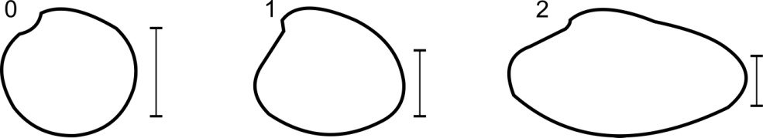

23 Posterior margin slope: Inclined backward (0), Vertical (1), Inclined forward (2).
24 Notch between the posterior and ventral margin: Absent (0), Present (1).
25 Ventral projection of the ventral margin: Absent (0), Present (1).
26 Type of commarginal sculpture: Narrow ribs (0), Wide ribs (1), Low lamellae (2), High lamellae (3), Notorious growth lines (4), Very weak growth lines (5).
27 Height of commarginal sculpture: Homogeneous (0), Higher anterior and posterior (1), Higher only anterior (2), Higher only posterior (3).
28 Bifid comarginal ribs: Anterior and posterior (0), Only anterior (1), Only posterior (2), Absent (3).
29 Interspace width between commarginal sculpture: Narrower than the width of the commarginal sculpture (0), Same width as the comarginal sculpture (1), Wider than commarginal sculpture (2).
30 Thin radial grooves: Absent (0), Present over all the valve surface (1), Present only in the postero-dorsal zone (2), Present only in the anterior zone (3), Present in both anterior and posterior zones, but absent centrally (4).
31 Posterior spines: Absent (0), Present (1).
32 Dorsal carina: Absent (0), Present (1).
33 Crenulated ventral margin: Absent (0), Present (1).
34 Umbo recurved: Absent (0), Present (1).
35 Outline of the umbones in an external view: Pointed (0), Slightly rounded (1).
36 Escutcheon: Not developed (0), Wide (1), Slightly narrow (2), Very narrow (3).

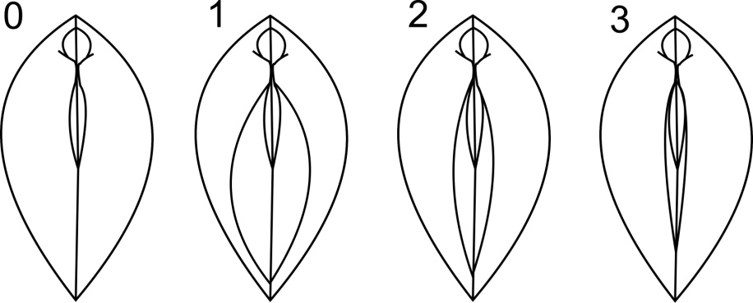

37 Delimitation of the escutcheon: Absent (0), Very marked (1), Smooth (2).

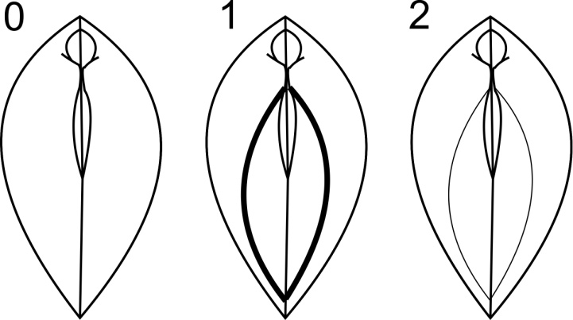
38 Escutcheon cleft: Absent (0), Present (1), Protruding (2).

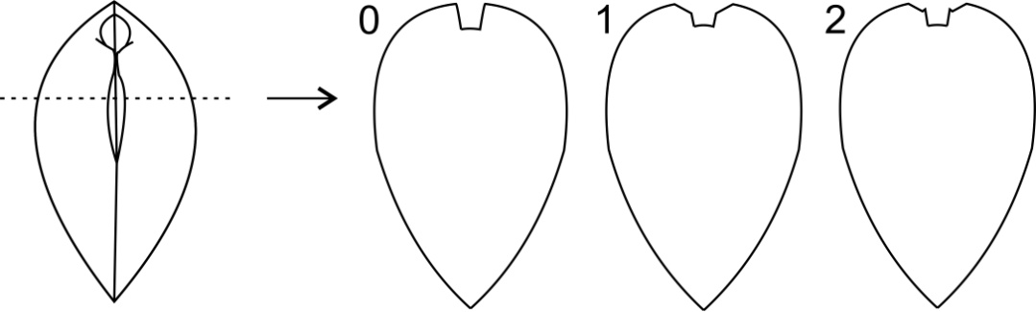

39 Length of the escutcheon: Absent (0), Extending past the adductor muscle scar (AMS) (1), Extending halfway along posterior side of the AMS (2), Extending to the dorsal side of the AMS (3).

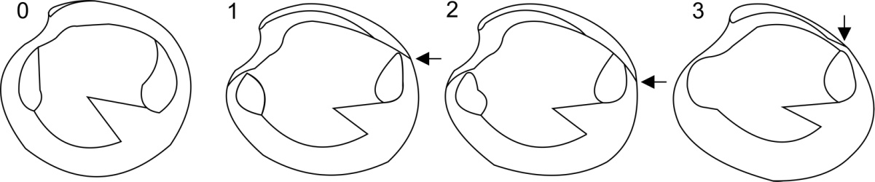

40 Depth of the lunule: Very deep (0), Moderately deep (1).

41 Demarcation of the lunule: Not demarcated (0), Delimited by a line (1), Delimited by a shallow groove (2), Delimited by a deep groove (3).

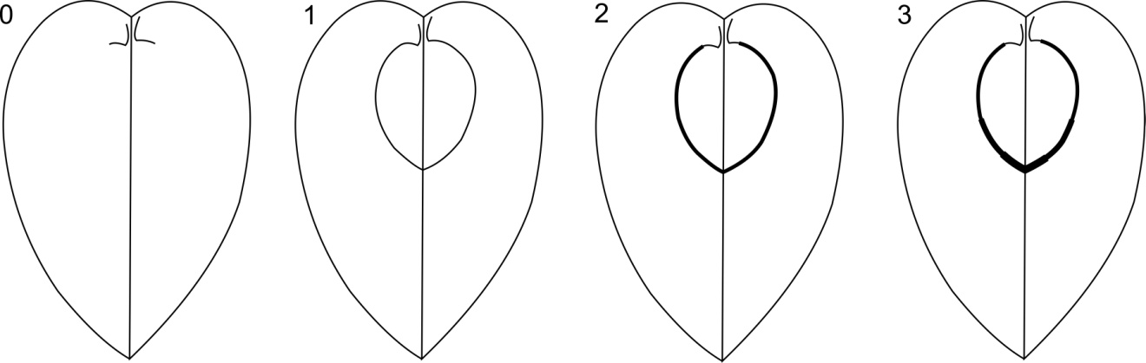

42 Lunule shape: Heart-shaped (0), Sub-rounded (1), Lanceolate (2), Sub-oval (3).

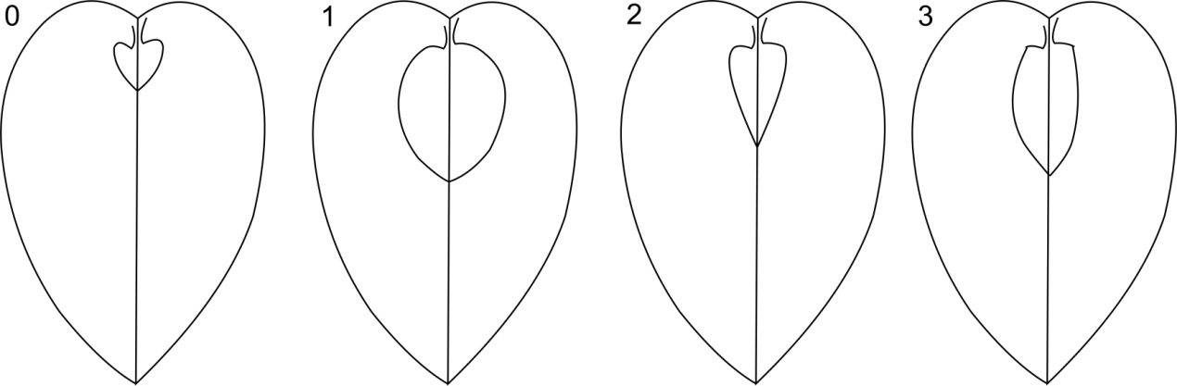

43 Lunule concavity: Convex (0), Strongly concave (1), Flat (2), Slightly concave (3).

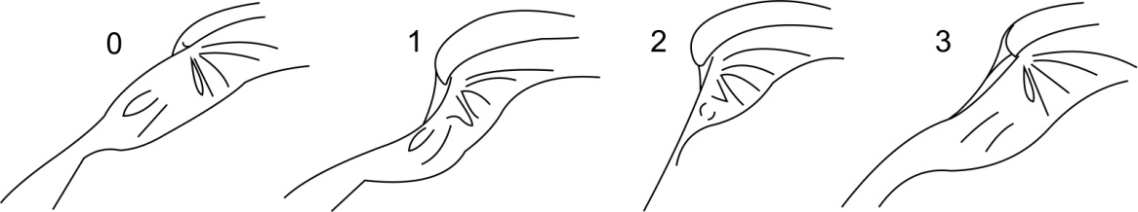

44 Depth of the pallial sinus: Long, reaching the posterior cardinal tooth (0), Long, but not reaching the posterior cardinal tooth (1), Short (2).

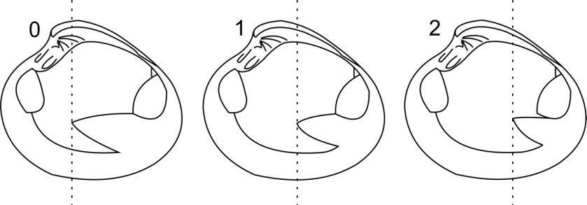

45 Dorsal line of the pallial sinus: Straight (0), Slightly convex (1), Very convex (2).

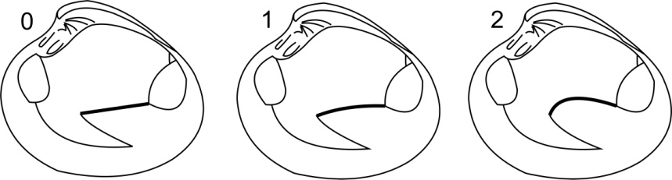

46 Ventral line of the pallial sinus: Straight (0), Slightly concave (1), Very concave (2).

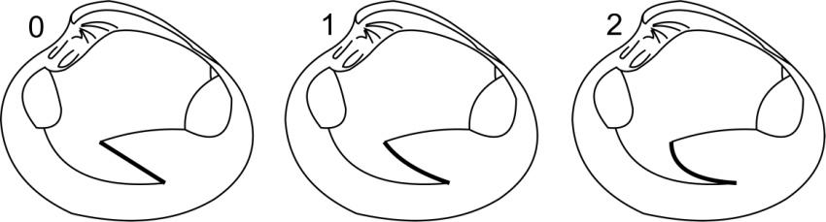

47 Pallial sinus apex: Rounded (0), Sharp (1), Truncated (2).

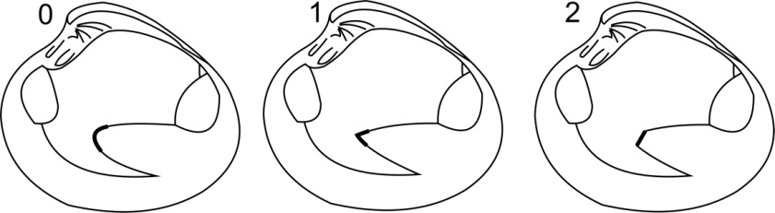

48 Anterior muscle retractor scar: Shallow (0), Deep (1).

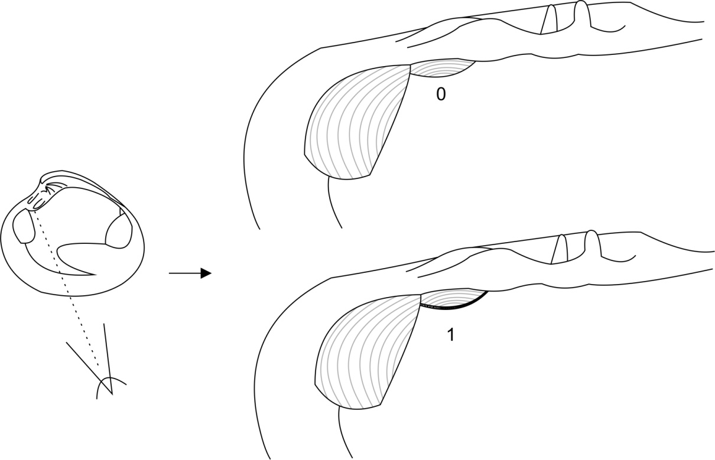

49 Anterior pedal retractor muscle scar and anterior adductor muscle scar: United (0), Separated (1).
50 Scars of the pedal lifts muscles: Shallow (non visible) (0), Deep (1).
51 Sculpture of the inner lateral margin of the nymph: Smooth (0), fine vertical ribs with straight margins (1), Thick vertical ribs with sinuous margins (2).
52 Location of the sculpture of the nymph: Absent (0), Extended over the entire inner lateral margin (1), Only present over the posterior cardinal teeth (2).
53 Height of the hinge plate: High (0), Low (1).

54 Shape of the hinge plate margin: Slightly curved (0), Very curved (1), Straight (2).

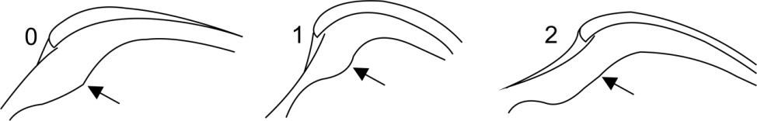

55 Thickness of the hinge plate: Thin (0), Posteriorly thicker (1), Anteriorly thicker (2).

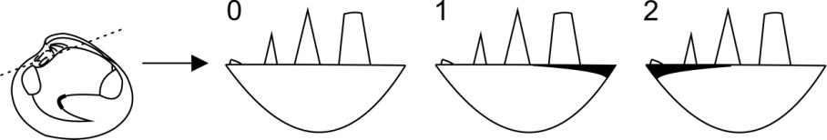

56 Type of anterior lateral tooth (sensu Kappner & Bieler, 2006): Type 1 (0), Type 2 (1).
57 Hinge plate excavated: No (0), Yes (1).
58 Shape of the AII tooth in perpendicular view: Pustular (0), Lamellar (1), Conical (2).
59 AII projected towards the umbo: No (0), Yes (1).
60 Distance between the most extreme apex of AII and 2a teeth: Close (0), Moderately distant (1), Very distant (2).

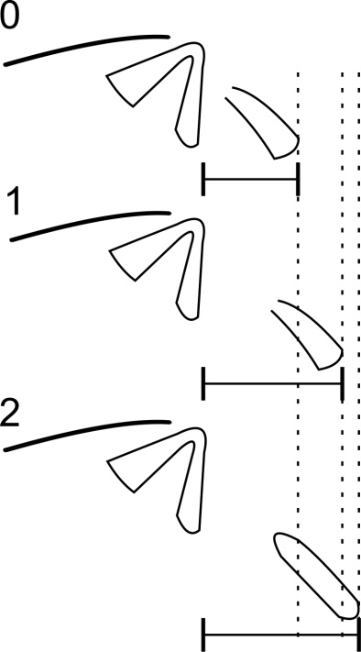

61 AII thickness: Thin (0), Thick (1).

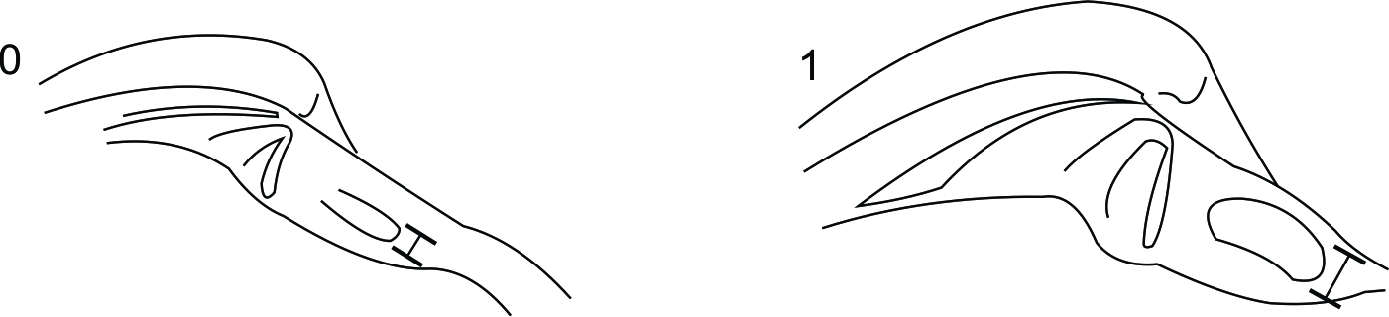

62 Shape of the AII in lateral view: Triangular (0), Sub-rounded (1), Sub-quadrate (2).

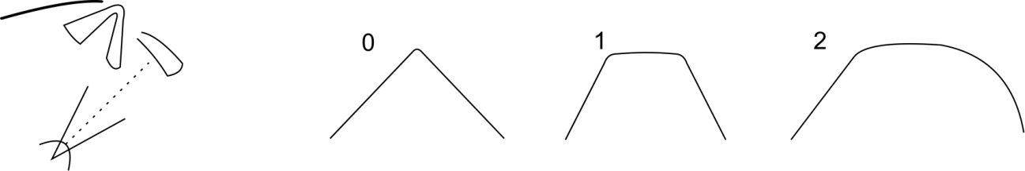

63 Union in a ‘V’-shape form of the 2a and 2b teeth: Present (0), Absent (1).
64 Height of the 2a and 2b teeth: 2a taller than 2b (0), 2a lower than 2b (1).
65 Separation between 4b tooth and the nymph: Present (0), Absent (1), Joined only towards the umbo (2).
66 Tooth 2a grooves: Absent (0), Present (1).
67 Sculpture of the nymph present in the 4b tooth: Absent (0), Present (1).
68 Size of the right anterior lateral teeth: AI bigger than AIII (0), AIII bigger than AI (1), Similar size (2).
69 Shape of the right anterior lateral teeth: Pustular, barely visible (0), Strong (1), Small but visible (2), AI strong and AIII small (3), Lamellar (4).
70 Groove between the anterior lateral pit and the space between 3a and 1 teeth: Absent (0), Shallow (1), Deep (2).

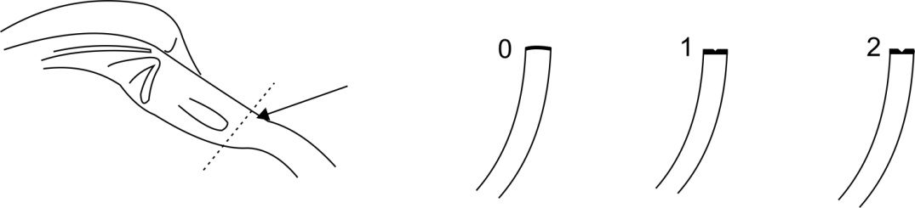

71 Height of the 3a tooth: Lower than the other teeth (0), Similar height to other teeth (1), Higher than other teeth (2).
72 3b morphology: Bifid (0), Grooved (1), Smooth (2).

Appendix S5. Data matrix.

Continuous characters

Dosinia concentrica
0.972085138 0.869019769 0.232893477 0.232407143 0.750755162 0.31533297 0.248 0.667603076 0.355318232 0.999300089 169.000 255.000 285.000 328.500 166 0.914559411 73
Notocallista kingii
0.889986941 0.853264134 0.556737013 0.358369359 0.367542708 0.340878627 0.273 0.827288482 0.325389342 1.157607853 182.000 283.000 290.000 349.000 163 1.057991947 53.45
Callista chione
0.886547333 0.840324127 0.518149559 0.257125623 0.462745869 0.434525702 0.280 0.882447644 0.415347498 1.15729198 180.000 288.000 308.000 360.000 169 0.850454578 82.03
Callista maculata
0.902647449 0.859088904 0.422442033 0.327859942 0.468944214 0.35092996 0.440 0.881127926 0.341643011 1.269064598 171.000 287.200 305.000 362.200 171.2 0.862197353 53.63
Costacallista grata
0.863725038 0.863725038 0.460040057 0.394335884 0.479909672 0.378112472 0.342 0.789146635 0.294190571 1.146128036 200.000 303.000 317.000 363.000 167 1.044940379 88.05
Macrocallista nimbosa
0.729667881 0.850902977 0.555189448 0.22780026 0.413655879 0.405452816 0.459 0.926213786 0.333222307 1.303035978 190.250 289.000 307.000 359.000 170.8333333 0.601295886 91.03
Amiantis callosa
0.891056029 0.82036175 0.346136363 0.214157985 0.486145053 0.432633336 0.531 0.810120456 0.549207684 0.951151432 187.750 283.000 297.500 349.500 163.5 0.786502028 60.08
Amiantis mathewsonii
0.983204301 0.776976586 ? ? ? ? 0.483 0.765001305 0.305674901 0.484299839 ? 278.000 296.000 345.000 152 0.897371842 57.94
Eucallista purpurata
0.953860556 0.84779145 0.36981378 0.213955485 0.565310601 0.470144486 0.328 0.790637933 0.169332222 1.134730453 197.333 291.833 310.333 354.333 161.5 0.981306104 59.77
Eucallista laziarina
0.935515197 0.855986378 0.327515601 0.254282204 0.530097691 0.441941006 0.330 ? 0.275135356 1.1952915 190.000 293.500 304.750 348.750 162.1666667 0.984972988 43.87
Eucallista domeykoana
0.949478085 0.841568464 0.36392835 ? 0.520409837 ? 0.287 ? 0.287241711 ? 187.000 289.000 306.500 339.500 165.3333333 0.899883606 55.41
Megapitaria squalida
0.890680729 0.891073934 0.51813231 0.354970935 0.515164609 0.488509844 0.469 0.672991162 0.468720713 1.230448921 185.000 296.000 314.000 359.000 163 0.818513709 100.5
Megapitaria aurantiaca
0.916494193 0.865663489 0.572418587 0.412813477 0.498289472 0.60238181 0.364 0.820555099 0.386201605 0.869666232 189.000 280.000 300.000 340.000 164 0.949833391 104.86
Austrocallista iheringi
0.916237014 0.8351869 0.499097869 0.231063515 0.547743028 0.42182583 0.577 0.807719304 0.495275878 1.03688093 188.000 288.000 308.750 361.500 164.5 0.854366598 67.48
Austrocallista boliviana
0.837493596 0.837493596 0.605111528 0.373804086 0.614386705 0.386563937 0.474 0.806998807 0.533641696 0.929750575 187.000 283.000 303.500 353.500 163.5 0.917971526 75.21
Hysteroconcha multispinosa
0.907959022 0.868315216 0.300678698 0.25598197 0.509938334 0.445856762 0.404 0.895760302 0.494893126 1.228009058 195.000 301.333 314.333 365.000 161.5 0.792294807 40
Hysteroconcha lupanaria
0.886056648 0.860279428 0.192935816 0.153427274 0.475040118 0.443991836 0.331 0.886643136 0.4732436 1.289448123 189.000 293.000 306.000 366.000 159 0.78828457 58.18
Hysteroconcha dione
0.891888336 0.870750613 0.127766352 0.211408476 0.510644289 0.390658254 0.389 0.851346989 0.447158031 1.176091259 203.000 300.000 314.000 365.000 161 0.732828272 55.45
Saxidomus gigantea
0.893835264 0.849560009 0.417535565 0.377418342 0.682981899 0.432599311 0.187 0.90982337 0.352182518 0.653212514 188.000 270.333 298.333 335.000 165.3333333 0.879293433 109.5
Saxidomus nuttalli
0.834468294 0.834039361 0.336813235 0.336813235 0.614900059 0.477264138 0.277 0.925366382 0.32330639 0.628932138 190.500 269.333 304.000 332.333 167.3333333 0.98030387 115.08
Pitar tumens
0.93492831 0.86651607 0.529886355 0.351413962 0.529560179 0.359248156 0.410 0.86450591 0.396860834 1.00481585 190.750 284.750 305.333 348.500 165.5 0.98987287 45.16
Pitar fulminatus
0.912149719 0.818351295 0.660741848 0.22383399 0.437508055 0.31601542 0.482 0.850841202 0.508802991 1.147418659 194.000 285.250 300.000 354.250 161 0.807221282 36.62
Pitar albidus
0.91548087 0.826302931 0.644765481 0.120968593 0.438030662 0.45796974 0.387 0.845000274 0.458386687 0.82756488 177.857 276.333 298.889 341.111 160.8333333 0.787141111 31.41
Proteopitar mutabilis
0.945937018 0.900694317 0.62890808 0.199769918 0.55543446 0.366393811 0.448 0.825511023 0.337949042 0.829491842 174.200 294.000 316.400 352.800 164 0.993773529 38.06
Proteopitar patagonicus
0.943502888 0.874276315 0.65003655 0.181597464 0.57115226 0.361205506 0.372 0.814337178 0.408506832 0.865905052 178.200 293.800 309.200 351.400 166.1666667 0.911137067 53.73
Lamelliconcha circinata
0.930477544 0.880232781 0.282775361 0.254185496 0.500600492 0.378261914 0.409 0.836576389 0.293068239 1.134625136 183.000 282.200 298.200 349.000 159.5 0.806764708 32.79
Lamelliconcha concinna
0.930798498 0.84764303 0.347645857 0.330822765 0.551487556 0.419334416 0.351 0.820703601 0.466655821 1.159700843 189.500 292.000 312.333 351.000 161.3333333 0.8906488 38.9
Lamelliconcha alternata
0.942649538 0.86170673 0.365619829 0.012929884 0.551328456 0.059555096 0.366 0.738 0.401400541 1.301029996 188.000 285.000 306.000 351.000 160 0.89034334 44.02
Austrocallista australis
0.913741887 0.834762731 0.522412519 0.214268856 0.667431049 0.373415225 0.487242246 ? 0.40241367 ? 189.000 116.64 129.4 177.42 163.2666667 0.896705886 40.56

Discrete characters

Dosinia concentrica 0000000000000000000000010000000000000000000000000002000
Notocallista kingii
0300120040302000011200112220021100010010110100-100001-1
Callista chione
0300120040301000010000122020120100010010111000000001111
Callista maculata
0300120040302010011200122000221100010010110100-00000111
Costacallista grata 1301120010102000012202112021121100001210110100000003101
Macrocallista nimbosa 2201220040301000011113112021200000012010100000000000121
Amiantis callosa
0300100010010010012121122300101001100110100000110101201
Amiantis mathewsoni
0301010010-1001001----12-0-------1100-101001-0-10-0-2-0
Eucallista purpurata 1101100012101010011221012301101102102210111110000000100
Eucallista laziarina 0300100010200010012221012301101102102210111110000000100
Eucallista domeykoana 1101110112100010011221012301101102102210111110000000100
Megapitaria squalida 1300120050300000010000112020220100002210110100000000100
Megapitaria aurantiaca 1300120050300000010000112020221100000210110100100000100
Austrocallista iheringi
01011200103000101132110120111110122022101021100101001-0
Austrocallista boliviana
1101120010-0001011--1-1120111110-2202-10102110-101001-0
Hysteroconcha multispinosa 2301210032020110111121110100111000010010110000010001211
Hysteroconcha lupanaria 2301210032020110111121110100111000010010110000010001211
Hysteroconcha dione 2301210032020110111121110100111000010010110000010001211
Saxidomus gigantea 1401010023300000013111112200111110010111110101000024000
Saxidomus nuttalli 0400020033220000013111112200111010010111110101000024010
Pitar tumens
0300110040300000002222112210011010010210100000120003201
Pitar fulminatus
2300110000300000102222112010010000010210100000000003211
Pitar albidus
2301110040300000102222112210010000010010100000100003210
Proteopitar mutabilis
1111121040300000102211111210111000011210200100001003100
Proteopitar patagonicus 1111121040300000102211113210111000010210200100001003110
Lamelliconcha circinata 0101220020320000102222113210110000010010110000000003101
Lamelliconcha concinna 0101221020020010102221113200110000010210100020000003101
Lamelliconcha alternata 0101110020320000102222113200110000010210110020000003101
Austrocallista australis
11011200123000101132231120000111-22022101021-0-1010-1--

Appendix S6. Topologies obtained with different k values.

k=2 (same topology with k values ranging from 2 to 4)
BS values
JK

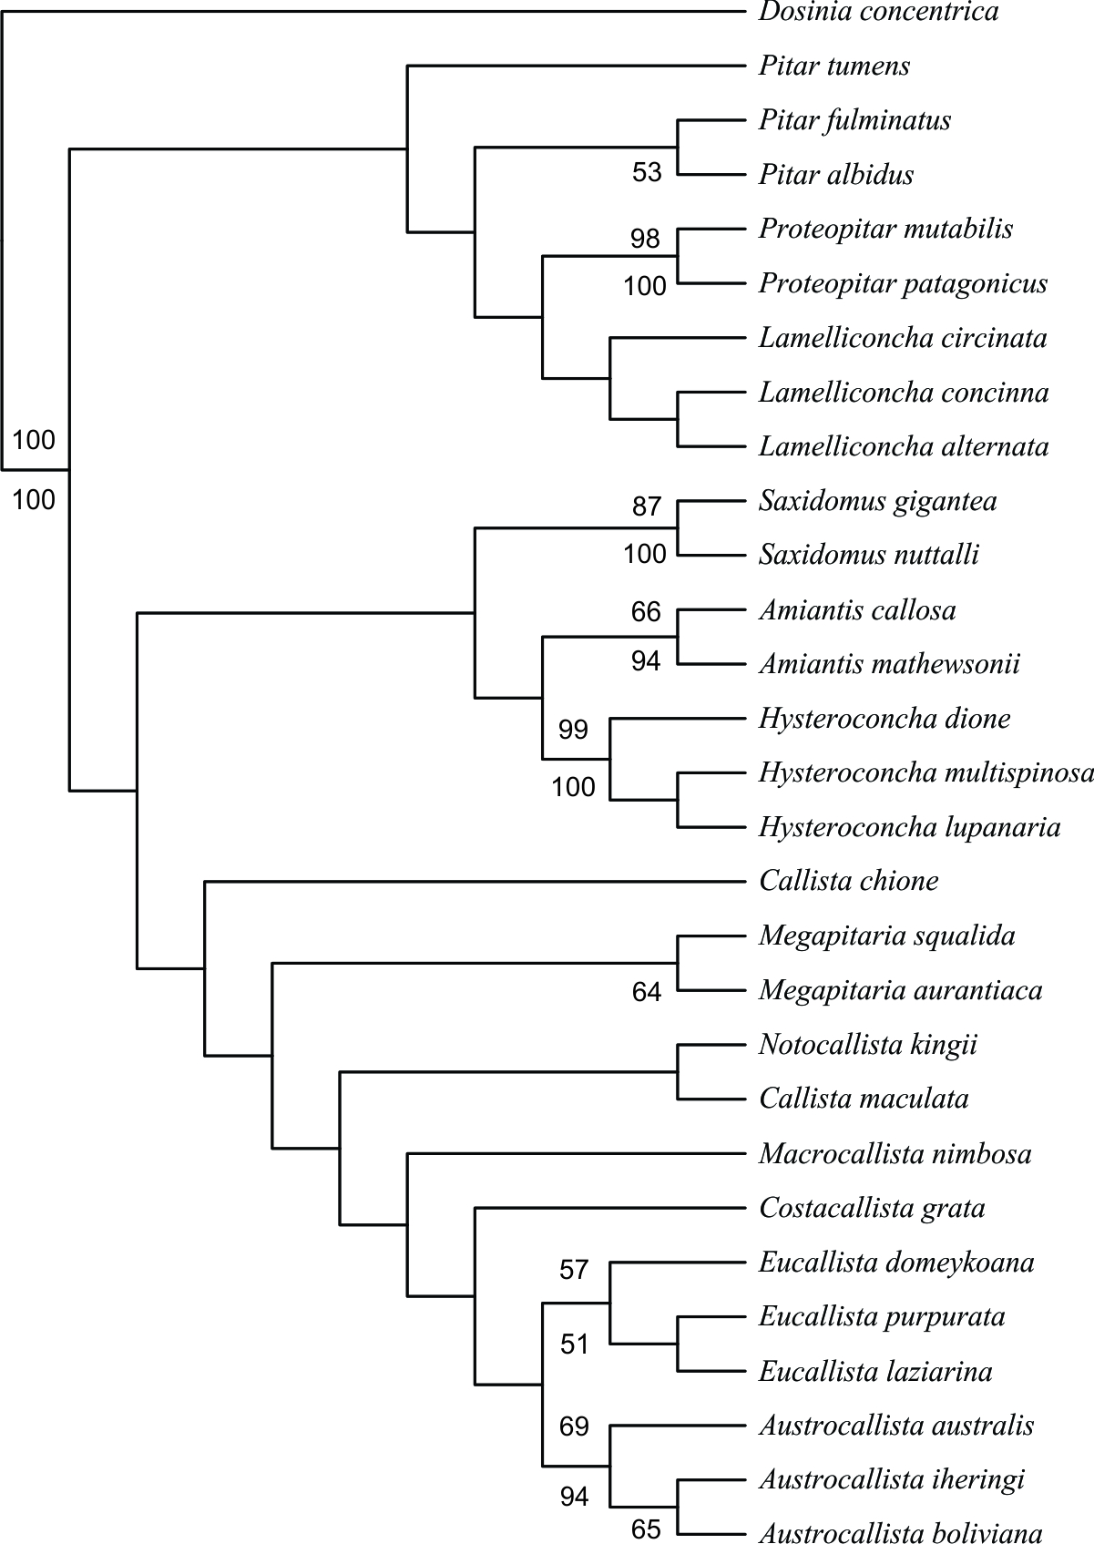

k=5 (5–6)
BS values
JK

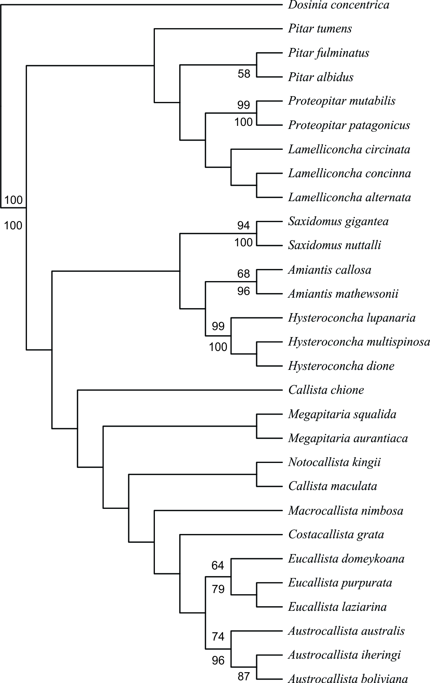

k=7 (7, 8)
BS values
JK

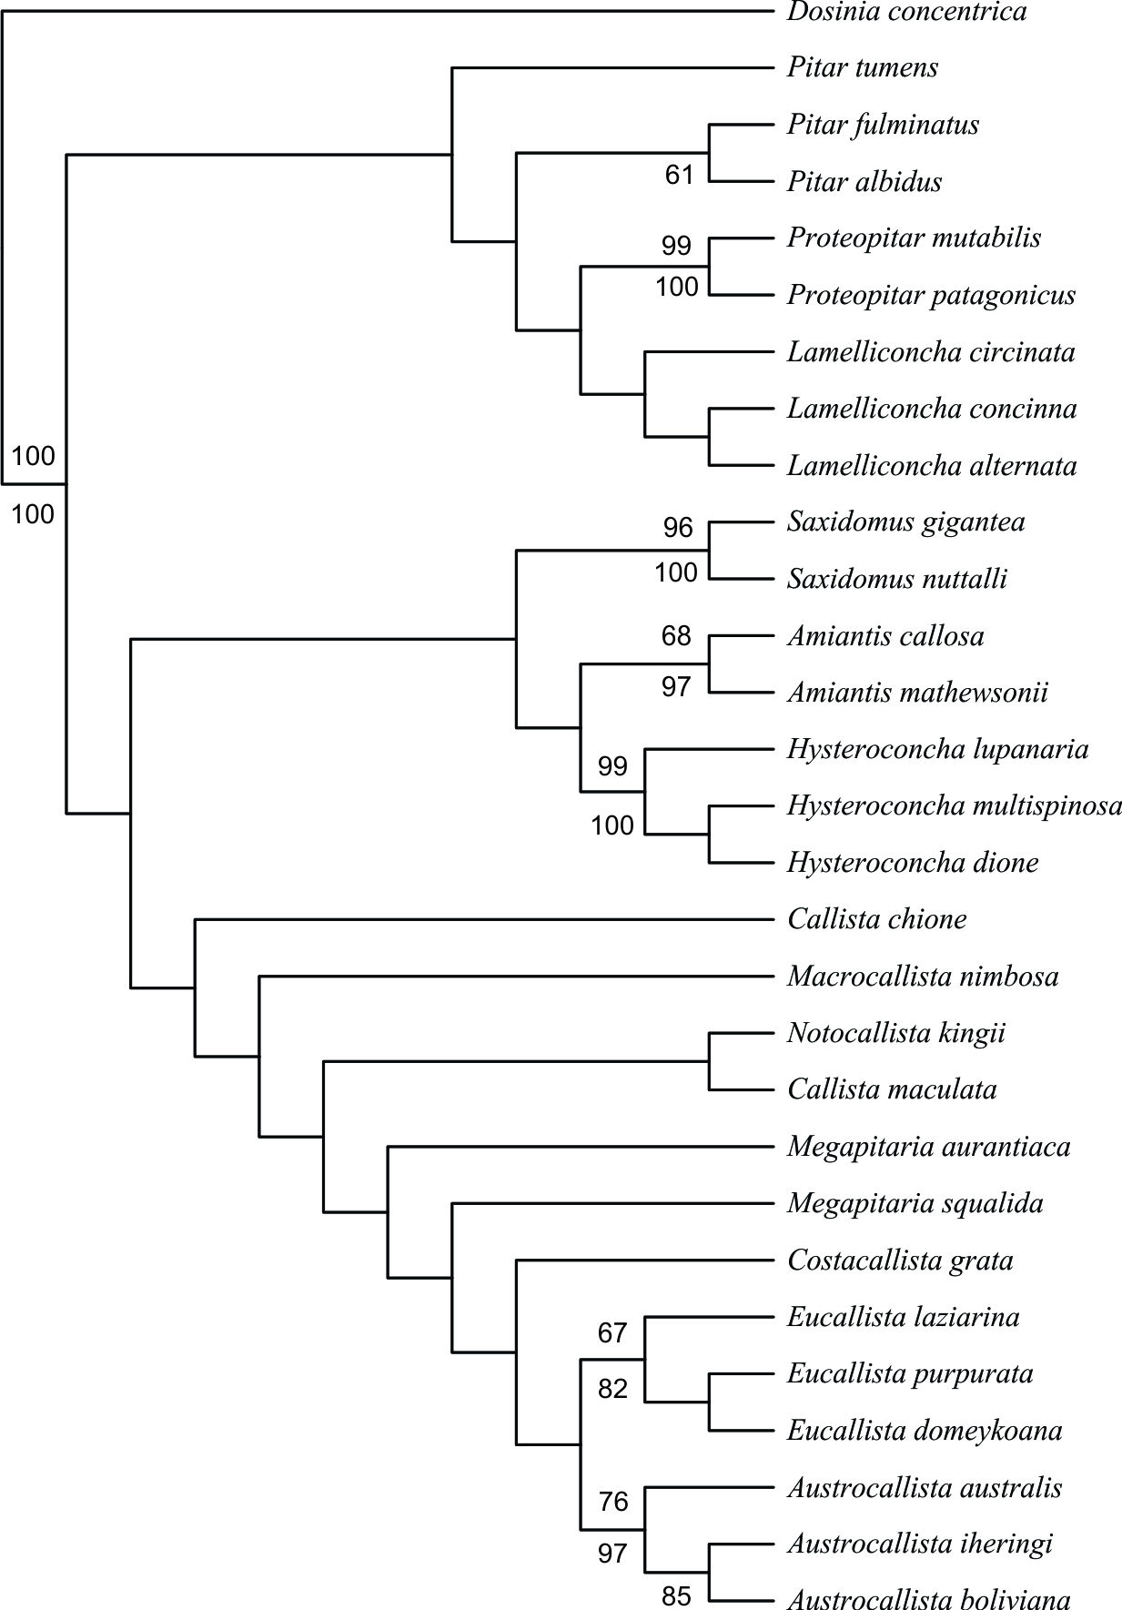

k=9 (9–21)
BS values
JK

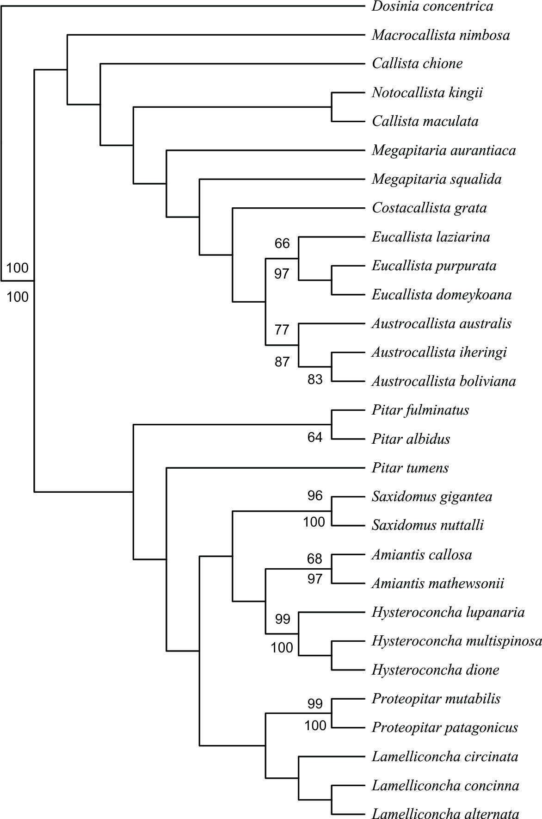

k=22 (22–33)
BS values
JK

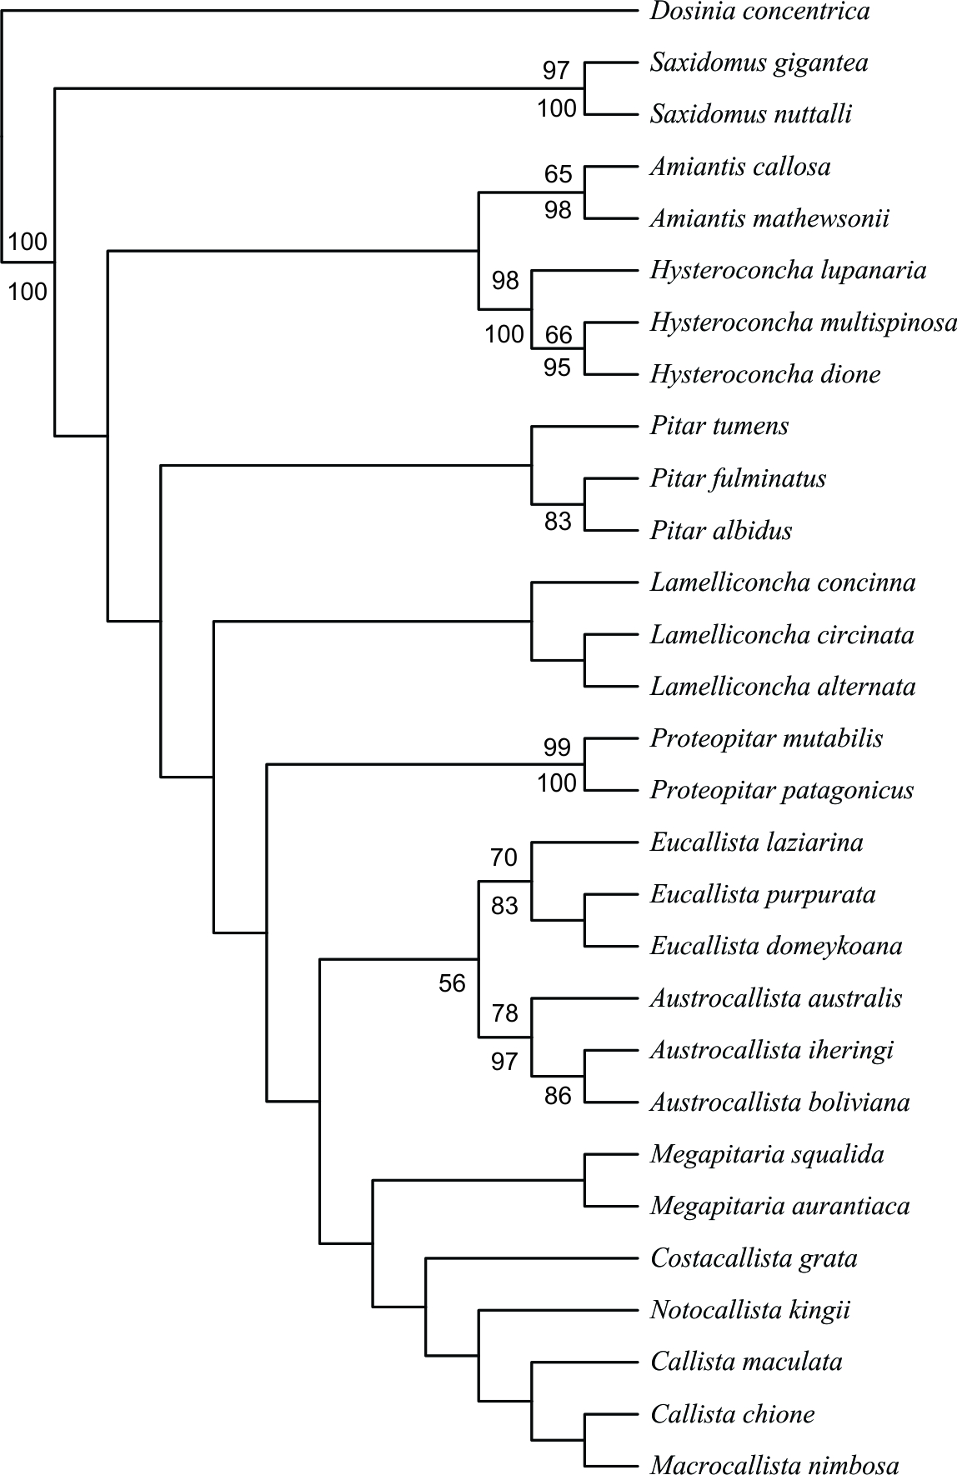

k=52 (52–100)
BS values
JK

