Intercalation and exfoliation syntheses of high specific surface area graphene and FeC₂O₄/graphene composite for anode material of lithium ion battery
Da Zhangª, Keyu Zhangª, Yaochun Yaoª, Feng Liang^{a,b ⃰}, Tao Qu^{a,b}, Wenhui Maª, Bing Yangª, Yongnian Daiª, Yong Lei^{c}.
ªFaculty of Metallurgical and Energy Engineering, Kunming University of Science and Technology, Kunming 650093, China
^{b}State Key Laboratory of Complex Nonferrous Metal Resources Clean Utilization, Kunming University of Science and Technology, Kunming 650093, China
^{c}Institute of Physics & IMN Macro Nanos (ZIK), Ilmenau University of Technology, Unterpörlitzer Strasse 38, Ilmenau 98693, Germany
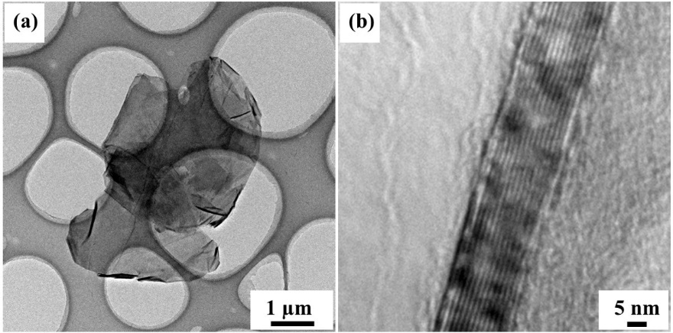
Fig. S1 (a) TEM, and (b) HRTEM of few-layers graphene obtained under the RCTK of 2:1 and water bath temperature of 15 ºC.
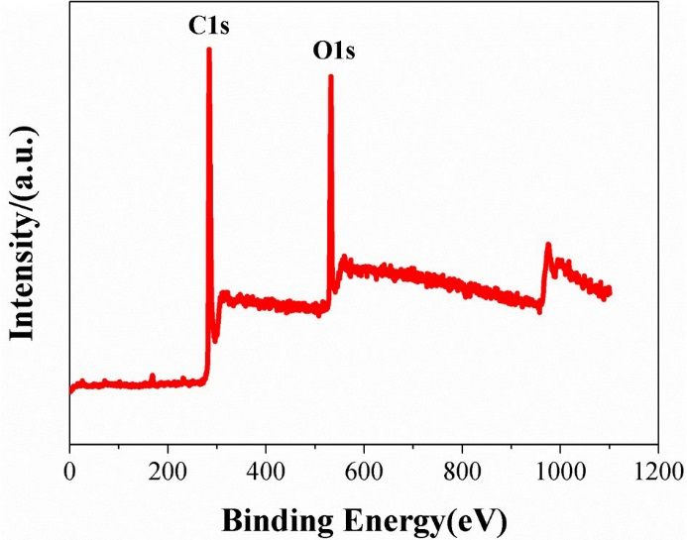
Fig. S2 XPS of graphite expansion composite obtained under the RCTK of 1:1with water bath temperature of 15 ºC.

