SUPPLEMENTAL MATERIALS

Supplemental Materials 1. Conceptual model instructions and scoring rubric.
DIAGRAM INSTRUCTIONS

Purpose
These diagrams are a reflection of what you know about how components are related within a biological system. These diagrams can be useful for you and the instructor to identify what you know and what may need additional study. There can be multiple possible and correct diagrams.
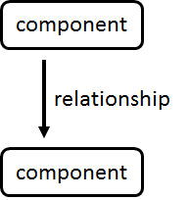
How to create a diagram
These diagrams will have components connected by labeled arrows.

Your diagram needs to follow these rules (see examples below):
- Connect individual components that are related to other components with an arrow.
- Label every arrow with a word or phrase that describes the direct relationship between each two components.
- Include arrow heads to give direction to the description.
- Each 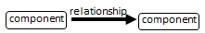should make sense alone and not depend on outside parts to make sense.

Example diagram on surfing

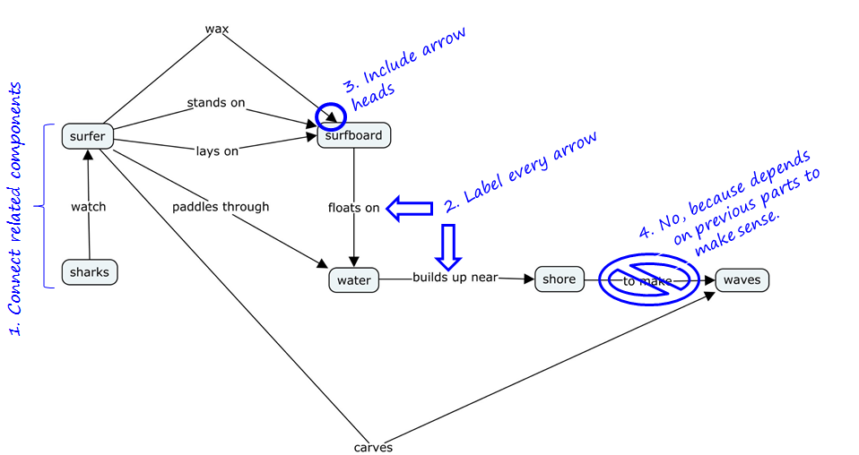

Recitation #6:
Gene Regulation Diagram

Activity
- Build a diagram to show how the components interact to affect transcription
- Use the component bank listed below to construct a diagram
- Use as many components as you can to show how transcription is regulated
- All provided components are relevant to gene regulation
- You may add your own components that are not already in the bank
- Connect two components that directly interact with an arrow AND label the arrow with a description of the relationship between each two components.
- No textbooks, no internet, no neighbors, no lab packets.
- When finished with the diagram, hand it into the TA

Component Bank
Use as many as you can and add your own components where you see appropriate
- Activator
- Co-activator
- Co-repressor
- DNA
- Inducer
- Operator
- Promoter
- Repressor
- RNA polymerase

Correctness Rubric
From Structure
To Structure
Relationship

Proposition:

- Structures are categorized into general structures and structures specific to the lac and trp operon systems.
- All relationships were generated by students.
- Relationships were categorized by coders using their expert knowledge, textbooks, and received feedback from a researcher external to the group that is familiar student thinking about the regulation of gene expression.
- Only propositions that included relationships in categories 2 (Plausible but lacking technical clarity) or 3 (Scientifically accurate) are presented here.
- Empty cells indicate that no student described a relationship that fit that category.
- Individual relationships are separated with commas.

COMPONENTS |  | RELATIONSHIPS
From component | To component | 1. Inaccurate | 2. Plausible but lacking technical clarity | 3. Scientifically accurate
General Structures
Activator | Co-activator | and, can make a, activates, assists, is, made up of | activates with, works with, are aided by, helped by, use, pairs with | regulated by, activated by, binds
Activator | DNA |  |  | binds
Activator | Operator | needs, starts, begins, comes before, part of, co-activator, uses | turns on, activates, found on | attaches, binds
Activator | Operon |  |  | turns on, activates, binds
Activator | Promoter | needs, starts, begins, initiates, comes before, part of, co-activator | activates, regulates, located on, found on | attaches, binds, turns on
Activator | RNA polymerase | produce, ex, begin synthesis of, starts, induces, binds to | activates, allows to bind, controls | recruits
Co-activator | Activator | is another form, part of, requires, similar to, starts | helps, assists, works with, aids, cooperates with, goes with | activates, binds to, joins with, attaches to
Co-activator | mRNA |  | begin transcription of
Co-activator | operator | leading to, bind to | activates, turns on,
Co-activator | operon |  | turns on
Co-activator | promoter | leading to, bind to | activates
Co-activator | RNA polymerase | begins synthesis of, binds, induces | helps activate
Co-repressor | Operator | are types of, binds, activate | turns off, stops
Co-repressor | Operon | binds to, example, helps with transcription | turns off
Co-repressor | Repressor | is another form, part of, requires, produces, needed for, inactivates, type, similar to, starts | helps, assists, works with, aids, cooperates with, goes with, pairs with | activates, binds to, joins with, attaches to
Co-repressor | RNA polymerase | example, stops synthesis of, helps translation of, | helps inhibit
DNA | Activator | has, contains, needs, requires, regulates, replication is started by an, signals | uses, transcription happens by | binds, produces
DNA | gene |  |  | is made of, contains
DNA | mRNA | translates | transcription, transcribes for | transcribes to
DNA | Operator | makes, uses, expressed by, expresses, becomes, codes for, goes after promoter, made up of, stretch of DNA, binds with, bound to, starts with, needs, synthesized by, exposes, located at the | composed of, has subsections | contains, part of, has
DNA | Operon | uses, segment of, collection of | has, included in
DNA | Promoter | makes, uses, expressed by, expresses, becomes, codes for, goes after promoter, made up of, stretch of DNA, binds with, bound to, starts with, needs, synthesized by, exposes, located at the | composed of, has subsections | contains, part of, has
DNA | Repressor | has, contains, encompasses, is, turns off, | is influenced by | produces
DNA | RNA polymerase | replicated by, broken down by, type of, copied by, converted to, by, consists of, translates to, involved for, initiates, activate, is made from, initiator, initiation, makes up, replicating by, and | transcribed, forms, uses, transcribed by, copied by, provides, info for | binds, is read by, is transcribed by, produces, split by
Gene | Activator | either, can be | activated by
Gene | DNA |  |  | consist of, make up
Gene | mRNA |  |  | transcribed into
Gene | Operator | are expressed as | begins with, starts with
Gene | Operon |  | are expressed through
Gene | Promoter |  | begins with, starts with
Gene | Repressor | can be | stopped by
Gene | RNA polymerase |  |  | transcribed by
Inducer | DNA | goes into the, starts | activates, turns on,
Inducer | Operator | binds, fuels, starts, kick starts, triggers, leads to | turns on, influences
Inducer | Operon | turns on, influence, for transcription in the | turns on
Inducer | Promoter | binds, fuels, starts, part of, leads to | turns on
Inducer | Repressor | turned off by, reuses, are controlled by, opposite of, starts |  | binds, inactivates, deactivates, inhibits, turns off, stops,
mRNA | DNA | copies |  | is made from
Operator | Activator | turns on/off, activates, can be a, contains |  | controlled by, activated by
Operator | DNA | binds to, attaches to, begins, transcribes, make | located on, influence the, turns on/off, on, is in, goes with | contains, part of, segment of, composed of
Operator | Operon | made of, consists of, active | located on, turns on/off | made up of, part of, is in the
Operator | Promoter | contains, needs, uses, triggers, opens, is a, inclusive, expresses genes using | located by the, makes up, made of, comes after, turn on, works with, run by | part of, segment of, is in
Operator | Repressor | turns on/off, follows after, have a, consists of, build up | on, uses, contains | controlled by, inhibited by, binds, attaches
Operator | RNA polymerase | produces proteins from, made up of, produces, starts, performs, is an | starting point for, binds to, uses, turns on, aids, signals, connects | allows or stops
Operon | DNA | works to transcribe, attached to, connected to, switch segment of | located on, is within the | consists of, is made of, include, segment of
Operon | Gene | activator, is based on | express | consist of, contain
Operon | mRNA | broken down, develops | transcribed, transcribes, makes
Operon | Operator | part of, is a |  | contains, includes, has an, comprised of, consists of
Operon | Promoter | part of, parts, all within, initiates | composed, uses | contains, includes, has an, comprised of, consists of
Operon | Repressor | influences | consists of, contains | turned off by
Operon | RNA polymerase | helps produce, part of | uses
Promoter | Activator | is an, contain, consists, activate, kick starts, promotes, induces, signals | activate transcription, contain sites for | binds, attaches, turned on by
Promoter | Co-repressor | contains, starts, unblocked by the | binds, connect
Promoter | DNA | binds to, attaches to, connected to, begins, transcribes, make, creates, starts, | located on, found on, influence the, turns on/off, on, is in, goes with | contains, part of, segment of, composes of, is
Promoter | Operator | binds, attaches, starts, stops, activates, are types of, runs | next to, work together, part of, precedes | contains, made up of,
Promoter | Operon | induces, promotes protein production | located on | part of, determines the on/off state of the
Promoter | Repressor | activates, and, using |  | bind, blocked by, turned off by
Promoter | RNA polymerase | made of, allows, utilize, starts, activate, are in, promotes, | contains, recruits | binds
Repressor | Co-repressor | and, can make a, activates, assists, is, made up of | activates with, works with, are aided by, helped by, use, needs, has a, pairs with | regulated by, binds with, turned on by
Repressor | DNA | inhibits, stops, contain, turns off |  | stop transcription of
Repressor | Inducer | inhibits, inactivates, turn off, block, consists of, signals |  | is inactivated by, binds to
Repressor | Operator | are types of, activates, consists of, acts as, induces | stops, deactivates, turns off, shuts off/down, inhibits, represses, uses | binds to, connects, found on, attaches,
Repressor | Operon |  | influence, counter acts | turns off, inhibits, stops, shuts off, represses
Repressor | Promoter | are types of, activates, consists of, acts as, induces | stops, deactivates, turns off, inhibits, represses, uses, shuts off/down | binds to, connects, found on, attaches,
Repressor | RNA polymerase | results in, makes, transcription, restarts, stops synthesis of | stops, inhibits, turns off | blocks
Repressor | Transcription |  |  | stops
RNA polymerase | Activator | makes up, uses, contains, accelerated by | requires, aided by, activated by
RNA polymerase | Co-repressor | contains | is stopped by
RNA polymerase | DNA | breaks down, transforms into, translates, creates, produces, results in, synthesizes, makes, facilitates, found in | copies, activates, performs with, comes from | binds, attaches, combines, transcribes, splits, unzips, reads
RNA polymerase | Gene | codes |  | transcribes
RNA polymerase | mRNA | made of |  | aids in synthesis of, creates, synthesizes
RNA polymerase | Operator | binds, attaches to, behind, type of, is an, part of, contains, makes, activates, turns on, requires | works with, runs along, goes along
RNA polymerase | Operon |  | starts | attaches, binds, joins, transcribes
RNA polymerase | Promoter | part of, creates, contains, begins the, activates | begins at, uses | binds, attaches, starts at, requires
RNA polymerase | Repressor | type of, contains, starts with, slowed down by | inactivated by, stopped by | blocked
System-specific structures
Allolactose | (lac) repressor | activates, induces | negative | binds, turns off, inhibits, represses, inactivates, deactivates, releases
Allolactose | Inducer |  |  | is an
cAMP | CAP | makes, represses, produces, turns into | positive, co-activates | activates, binds to, induces
cAMP | Co-activator |  |  | which is a, example of
cAMP | Glucose |  | inhibited by | produced when no
cAMP | Lactose |  | promotes
CAP | Activator | binds to |  | which is an, example of, also called,
CAP | cAMP | promotes |  | activated by
CAP | (lac) operon | activated by | positive | activates, turns on, binds to, induces
CAP | Operator | turns off | activates | binds to
CAP | Promoter |  | activates | binds to
CAP | RNA polymerase | binds to | assists
CAP | Transcription |  | activates
Glucose | Allolactose |  | inhibits
Glucose | cAMP | forms, converted to, binds to, activates, induces | represses, negatively regulates, inhibits, signals low levels | lack of makes
Glucose | (lac) operon |  |  | inhibits
Lactose | Allolactose | triggered by excess, inhibits | positive,  activates, makes, converts, creates, induces | makes, promotes presence of,  converts to, forms, turns into, becomes
Enzymes | Lactose |  |  | breakdown
lac operon | Activator | classified as, has an | requires an | activated by
lac operon | CAP | involves, uses | activator | activated by
lac operon | DNA | codes for |  | composed of
lac operon | Enzymes |  | produces,  leads to, creates | codes for
lac operon | mRNA | transcribes, binds, positive, uses,  activates | goes to, creates
lac operon | Repressor | always repressing |  | inhibited by,  controlled by, inactivated by
lac operon | Promoter | controls |  | includes
lac operon | Lactose | monitors levels of, integrates between | needs | codes for enzymes to break down

Supplemental Materials 2. Local Environment Post-Conceptual Model Comparison.

Summary of significant differences in the local environment (presence, average number of relationships, and average correctness) of each structure in students’ post conceptual models between treatments, build (B) and investigate (I). Structures shown in bold were provided in the instructions on both the pre and post conceptual model assessments.

Structure | Treatment | Presence | Relationships | Correctness
Activator | B | 80.0% | 2.06 | 1.94
 | I | 82.4% | 2.12 | 1.85
Allolactose | B | 25.2% | 2.07 | 2.08
 | I | 19.8% | 1.91 | 2.29
cAMP | B | 31.3% | 1.97 | 2.11
 | I | 21.2% | 1.85 | 2.10
CAP | B | 33.9% | 1.95 | 2.20
 | I | 21.6% | 2.1 | 1.95
Coactivator | B | 55.7% | 1.31 | 2.09
 | I | 55.0% | 1.26 | 1.98
Corepressor | B | 54.8% | 1.3 | 2.06
 | I | 57.7% | 1.25 | 1.93
DNA | B | 78.3% | 1.91 | 2.11
 | I | 79.7% | 1.77 | 2.05
Gene | B | 6.1% | 2.57 | 1.82
 | I | 8.1% | 2.56 | 2.06
Glucose | B | 19.1% | 1.45 | 2.31
 | I | 18.9% | 1.40 | 1.68
Inducer | B | 55.7% | 1.55 | 1.70
 | I | 55.9% | 1.47 | 1.70
Lac Operon | B | 22.6% | 3.00 | 2.00
 | I | 19.4% | 2.98 | 2.05
Lactose | B | 26.1% | 1.57 | 1.60
 | I | 23.0% | 1.45 | 1.96
mRNA | B | 17.4% | 1.90 | 1.70*
 | I | 7.7% | 1.94 | 1.97*
Operator | B | 69.6% | 2.33 | 1.89
 | I | 74.8% | 2.40 | 1.87
Operon | B | 19.1% | 3.50 | 2.08
 | I | 25.7% | 2.91 | 2.13
Promoter | B | 57.4% | 1.89 | 2.02
 | I | 66.7% | 2.05 | 1.90
Repressor | B | 74.8% | 2.15 | 2.05
 | I | 78.8% | 2.23 | 2.05
RNA polymerase | B | 81.7% | 2.04 | 2.05
 | I | 87.8% | 1.87 | 1.87
+ p < 0.1; * p < 0.05; ** p < 0.001

