Supplementary material

Table S1. ICD codes used to classify ILDs in the analysis of claims data.
ILD type | Classification based on ILD code alone | Classification based on systemic condition code  and ILD code
 | ILD ICD-9 or ICD-10 code | Systemic condition ICD-9 or ICD-10 code | ILD ICD-9 or ICD-10 code
SSc-ILD | 517.2: Lung involvement in systemic sclerosis  M34.81: Systemic sclerosis with lung involvement | 710.1: Systemic sclerosis  M34.0: Progressive systemic sclerosis  M34.1: CR(E)ST syndrome  M34.9: Systemic sclerosis, unspecified  M34.89: Other systemic sclerosis | Any ILD code (see table below)
RA-ILD | 714.81: Rheumatoid lung  M05.10: Rheumatoid lung disease with rheumatoid arthritis of unspecified site | 714.0: Rheumatoid arthritis  714.1: Felty's syndrome  714.2: Other rheumatoid arthritis with visceral or systemic involvement  714.4: Chronic postrheumatic arthropathy  714.89: Other specified inflammatory polyarthropathies  714.9: Unspecified inflammatory polyarthropathies  M06.9: Rheumatoid arthritis, unspecified  M05.00: Felty's syndrome, unspecified site  M05.30: Rheumatoid heart disease with rheumatoid arthritis of unspecified site  M05.60: Rheumatoid arthritis of unspecified site with involvement of other organs and systems  M12.00: Chronic postrheumatic arthropathy [Jaccoud], unspecified site  M06.4: Inflammatory polyarthropathy  M06.09: Rheumatoid arthritis without rheumatoid factor, multiple sites  M05.79: Rheumatoid arthritis with rheumatoid factor of multiple sites without organ or systems involvement  M05.89: Other rheumatoid arthritis with rheumatoid factor of multiple sites  M06.89: Other specified rheumatoid arthritis, multiple sites  M06.00: Rheumatoid arthritis without rheumatoid factor, unspecified site  M05.40: Rheumatoid myopathy with rheumatoid arthritis of unspecified site  M05.70: Rheumatoid arthritis with rheumatoid factor of unspecified site without organ or systems involvement  M05.741: Rheumatoid arthritis with rheumatoid factor of right hand without organ or systems involvement  M06.041: Rheumatoid arthritis without rheumatoid factor, right hand  M05.742: Rheumatoid arthritis with rheumatoid factor of left hand without organ or systems involvement  M06.80: Other specified rheumatoid arthritis, unspecified site  M05.69: Rheumatoid arthritis of multiple sites with involvement of other organs and systems  M06.042: Rheumatoid arthritis without rheumatoid factor, left hand | Any ILD code (see table below)
Sjogren's syndrome ILD* | n/a | 710.2: Sicca Syndrome  M35.00: Sicca syndrome, unspecified  M35.01: Sicca syndrome with keratoconjunctivitis  M35.09: Sicca syndrome with other organ involvement | Any ILD code (see table below)
SLE-ILD* | n/a | 710.0: Systemic lupus erythematosus  M32.10: Systemic lupus erythematosus, organ or system involvement unspecified  M32.19: Other organ or system involvement in systemic lupus erythematosus | Any ILD code (see table below)
PM/DM-ILD* | n/a | 710.3: Dermatomyositis  710.4: Polymyositis  M33.90: Dermatopolymyositis, unspecified, organ involvement unspecified  M33.20: Polymyositis, organ involvement unspecified  M33.22: Polymyositis with myopathy | Any ILD code (see table below)
MCTD-ILD* | n/a | 710.8: Other specified diffuse diseases of connective tissue  M35.5: Multifocal fibrosclerosis  M35.1: Other overlap syndromes | Any ILD code (see table below)
Non-specified CTD-ILD* | n/a | 710.9: Unspecified connective tissue disease  M35.9: Systemic involvement of connective tissue, unspecified | Any ILD code (see table below)
HP | 495.0: Farmer's lung  495.1: Bagassosis  495.2: Bird-fanciers' lung  495.3: Suberosis  495.4: Malt workers' lung  495.5: Mushroom workers' lung  495.6: Maple bark-strippers' lung  495.7: Ventilation pneumonitis  495.8: Other specified allergic alveolitis and pneumonitis  495.9: Unspecified allergic alveolitis and pneumonitis  J67.0: Farmer's lung  J67.1: Bagassosis  J67.2: Bird-fanciers' lung  J67.3: Suberosis  J67.4: Malt workers' lung  J67.5: Mushroom workers' lung  J67.6: Maple bark-strippers' lung  J67.7: Air conditioner and humidifier lung  J67.8: Hypersensitivity pneumonitis due to other organic dusts  J67.9: Hypersensitivity pneumonitis due to unspecified organic dust | n/a | n/a
Sarcoidosis ILD | D86.0: Sarcoidosis of the lung  D86.2: Sarcoidosis of the lung with sarcoidosis of the lymph nodes | 135: Sarcoidosis  D86.9: Sarcoidosis, unspecified  D86.89: Sarcoidosis of other sites  D86.3: Sarcoidosis of skin  D86.1: Sarcoidosis of lymph nodes | 515: Postinflammatory pulmonary fibrosis  517.8: Lung involvement in other diseases classified elsewhere  J84.10: Pulmonary fibrosis, unspecified  J84.89: Other specified interstitial pulmonary diseases  J84.17: Other interstitial pulmonary diseases with fibrosis in diseases classified elsewhere  J99: Respiratory disorders in diseases classified elsewhere
iNSIP | 516.32: Idiopathic NSIP  J84.113: Idiopathic non-specific interstitial pneumonitis | n/a | n/a
Other specified non-IPF ILDs | 516.30: Idiopathic interstitial pneumonia, not otherwise specified  516.33: Acute interstitial pneumonitis  516.34: Respiratory bronchiolitis interstitial lung disease  516.35: Idiopathic lymphoid interstitial pneumonia  516.36: Cryptogenic organizing pneumonia  516.37: Desquamative interstitial pneumonia  516.4: Lymphangioleiomyomatosis  516.5: Adult pulmonary Langerhans cell histiocytosis  J84.111: Idiopathic interstitial pneumonia, not otherwise specified  J84.114: Acute interstitial pneumonitis  J84.115: Respiratory bronchiolitis interstitial lung disease  J84.2: Lymphoid interstitial pneumonia  J84.116: Cryptogenic organizing pneumonia  J84.117: Desquamative interstitial pneumonia  J84.81: Lymphangioleiomyomatosis  J84.82: Adult pulmonary Langerhans cell histiocytosis  500: Coal workers' pneumoconiosis  501: Asbestosis  502: Pneumoconiosis due to other silica or silicates  503: Pneumoconiosis due to other inorganic dust  504: Pneumonopathy due to inhalation of other dust  505: Pneumoconiosis, unspecified  506.0: Bronchitis and pneumonitis due to fumes and vapors  506.3: Other acute and subacute respiratory conditions due to fumes and vapors  506.4: Chronic respiratory conditions due to fumes and vapors  508.0: Acute pulmonary manifestations due to radiation  508.1: Chronic and other pulmonary manifestations due to radiation  508.8: Respiratory conditions due to other specified external agents  508.9: Respiratory conditions due to unspecified external agent  J60: Coalworker pneumoconiosis  J61: Pneumoconiosis due to asbestos and other mineral fibres  J62.8: Pneumoconiosis due to other dust containing silica  J63.0: Aluminosis (of lung)  J63.1: Bauxite fibrosis (of lung)  J63.2: Berylliosis  J63.3: Graphite fibrosis (of lung)  J63.4: Siderosis  J63.5: Stannosis  J63.6: Pneumoconiosis due to other specified inorganic dusts  J66.0: Byssinosis  J66.1: Flax-dresser disease  J66.2: Cannabinosis  J64: Unspecified pneumoconiosis  J68.0: Bronchitis and pneumonitis due to chemicals, gases, fumes and vapours  J68.3: Other acute and subacute respiratory conditions due to chemicals, gases, fumes and vapours  J68.4: Chronic respiratory conditions due to chemicals, gases, fumes and vapours  J70.0: Acute pulmonary manifestations due to radiation  J70.1: Chronic and other pulmonary manifestations due to radiation  J70.8: Respiratory conditions due to other specified external agents  J70.9: Respiratory conditions due to unspecified external agent  J92.0: Pleural plaque with presence of asbestos  J62.0: Pneumoconiosis due to talc dust  J65: Pneumoconiosis associated with tuberculosis | n/a | n/a
Non-specified ILDs | 517.8: Lung involvement in other diseases classified elsewhere  515: Postinflammatory pulmonary fibrosis  516.8: Other specified alveolar and parietoalveolar pneumonopathies  516.9: Unspecified alveolar and parietoalveolar pneumonopathy  J99: Respiratory disorders in diseases classified elsewhere  J84.10: Pulmonary fibrosis, unspecified  J84.89: Other specified interstitial pulmonary diseases  J84.17: Other interstitial pulmonary diseases with fibrosis in diseases classified elsewhere  J84.09: Other alveolar and parieto-alveolar conditions  J84.9: Interstitial pulmonary disease, unspecified | n/a | n/a
Patients were classified based on the ILD code only if the code specified the ILD subtype. If patients had one of the ILD codes and a systemic condition code, they were classified as having ILD associated with that systemic condition. If a patient had claims with ILD or systemic codes that would meet the criteria for multiple subtypes, the patient was categorized based on the hierarchy in the subtype classification table under the ILD subtype highest on the list.
*Sjogren's syndrome ILD, SLE-ILD, PM/DM-ILD, MCTD-ILD, and non-specified CTD-ILDs were grouped as ‘other CTD-ILDs’ in the results.
CR(E)ST syndrome: combination of calcinosis, Raynaud phenomenon, esophageal dysfunction, sclerodactyly, telangiectasia.
DM, dermatomyositis; MCTD, mixed connective tissue disease; PM, polymyositis; SLE, systemic lupus erythematous.
Table S2. ICD-9 and ICD-10 ILD codes.
ICD-9 codes |  | ICD-10 codes
500: Coal Workers' Pneumoconiosis | 495.7: Ventilation pneumonitis | J60: Coal Workers' Pneumoconiosis | J70.9: Respiratory conditions due to unspecified external agent | J84.9: Interstitial pulmonary disease, unspecified | M05.142: RLD with RA in left hand
501: Asbestosis | 495.8: Other specified allergic alveolitis and pneumonitis | J61: Pneumoconiosis due to asbestos and other mineral fibers | J67.0: Farmer's lung | J84.114: Acute interstitial pneumonitis | M05.149: RLD with RA in unspecified hand
502: Pneumoconiosis due to silica | 495.9: Unspecified allergic alveolitis and pneumonitis | J62.8: Pneumoconiosis due to other dust containing silica | J67.1: Bagassosis | J84.115: Respiratory bronchiolitis interstitial lung disease | M05.151: RLD with RA in right hip
503: Pneumoconiosis due to other inorganic dust | 714.81: Rheumatoid Lung | J63.0: Aluminosis (of lung) | J67.2: Bird-fanciers' lung | J84.2: Lymphoid interstitial pneumonia | M05.152: RLD RA in left hip
504: Pneumoconiosis due to the inhalation of other dust | 517.2: Lung involvement in systemic sclerosis | J63.1: Bauxite fibrosis (of lung) | J67.3: Suberosis | J84.116: Cryptogenic organizing pneumonia | M05.159: RLD with RA in unspecified hip
505: Pneumoconiosis, unspecified | 517.8: Lung involvement in other diseases classified elsewhere | J63.2: Berylliosis | J67.4: Malt workers' lung | J84.117: Desquamative interstitial pneumonia | M05.161: RLD with RA in right knee
506.0: Bronchitis and pneumonitis due to fumes and vapors | 515: Postinflammatory pulmonary fibrosis | J63.3: Graphite fibrosis (of lung) | J67.5: Mushroom workers' lung | J84.81: Lymphangioleiomyomatosis | M05.162: RLD with RA in left knee
506.3: Other acute and subacute respiratory conditions due to fumes and vapors | 516.30: Idiopathic interstitial pneumonia, NOS | J63.4: Siderosis | J67.6: Maple bark-strippers' lung | J84.82: Adult pulmonary Langerhans cell histiocytosis | M05.169: RLD with RA in unspecified knee
506.4: Chronic respiratory conditions due to fumes and vapors | 516.31: Idiopathic pulmonary fibrosis | J63.5: Stannosis | J67.7: Air conditioner and humidifier lung | J92.0: Pleural plaque with asbestosis | M05.171: RLD with RA in right ankle and foot
508.0: Acute pulmonary manifestations due to radiation | 516.32: Idiopathic NSIP | J63.6: Pneumoconiosis due to other specified inorganic dusts | J67.8: Hypersensitivity pneumonitis due to other organic dusts | J62.0: Pneumoconiosis due to other talc dust | M05.172: RLD with RA in left ankle and foot
508.1: Chronic and other pulmonary manifestations due to radiation | 516.8: Other specified alveolar and parietoalveolar pneumonopathies | J66.0: Byssinosis | J67.9: Hypersensitivity pneumonitis due to unspecified organic dust | J65: Pneumoconiosis associated with tuberculosis | M05.179: RLD with RA in unspecified ankle and foot
508.8: Respiratory conditions due to other specified external agents | 516.9: Unspecified alveolar and parietoalveolar pneumonopathy | J66.1: Flax-dressers' disease | M05.10: RLD with RA of unspecified site | M05.111: RLD with RA in right shoulder | M05.19: RLD with RA of multiple sights
508.9: Respiratory conditions due to unspecified external agents | 516.33: Acute interstitial pneumonitis | J66.2: Cannabinosis | M34.81: Systemic sclerosis with lung involvement | M05.112: RLD with RA in left shoulder | M32.13: Lung involvement in systemic lupus erythematosus
495.0: Farmer's lung | 516.34: Respiratory bronchiolitis interstitial lung disease | J66.8: Airway disease due to other specific organic dusts | J99: Respiratory disorders in diseases classified elsewhere | M05.119: RLD with RA in unspecified shoulder | M35.02: Sicca syndrome with lung involvement
495.1: Bagassosis | 516.35: Idiopathic lymphoid interstitial pneumonia | J64: Unspecified pneumoconiosis | J84.10: Pulmonary fibrosis, unspecified | M05.121: RLD with RA in right elbow | M33.01: Juvenile dermatopolymyositis with respiratory involvement
495.2: Bird-fanciers' lung | 516.36: Cryptogenic organizing pneumonia | J68.0: Bronchitis and pneumonitis due to chemicals, gases, fumes and vapors | J84.89: Other specified interstitial pulmonary diseases | M05.122: RLD with RA in left elbow | M33.11: Other dermatopolymositis, with respiratory involvement
495.3: Suberosis | 516.37: Desquamative interstitial pneumonia | J68.3: Other acute and subacute respiratory conditions due to chemicals, gases, fumes and vapors | J84.17: Other interstitial pulmonary diseases with fibrosis in diseases classified elsewhere | M05.129: RLD with RA in unspecified elbow | M33.21: Polymyositis, with respiratory involvement
495.4: Malt workers' lung | 516.4: Lymphangioleiomyomatosis | J68.4: Chronic respiratory conditions due to chemicals, gases, fumes and vapors | J84.111: Idiopathic interstitial pneumonia, not otherwise specified | M05.131: RLD with RA in right wrist | M33.91: Dermatomyositis, unspecified, with respiratory involvement
495.5: Mushroom workers' lung | 516.5: Adult pulmonary Langerhans cell histiocytosis | J70.0: Acute pulmonary manifestations due to radiation | J84.112: Idiopathic pulmonary fibrosis | M05.132: RLD with RA in left wrist | D86.0: Sarcoidosis of the lung
495.6: Maple bark-strippers' lung |  | J70.1: Chronic and other pulmonary manifestations due to radiation | J84.113: Idiopathic non-specific interstitial pneumonitis | M05.139: RLD with RA in unspecified wrist | D86.2: Sarcoidosis of the lung with sarcoidosis of the lymph nodes
 |  | J70.8: Respiratory conditions due to other specified external agents | J84.09: Other alveolar and parieto-alveolar conditions | M05.141: RLD with RA in right hand
RLD, rheumatoid lung disease.
Figure S1. Specialty that filed first ILD insurance claim. Data based on US insurance claims from 36,579 patients who had ILD (defined as ≥2 claims with an ILD diagnosis and ≥1 visit to a pulmonologist between 2014 and 2016), whose first ILD claim was made in 2015 or 2016 and who had a claim for any indication ≤180 days prior to the first ILD claim.
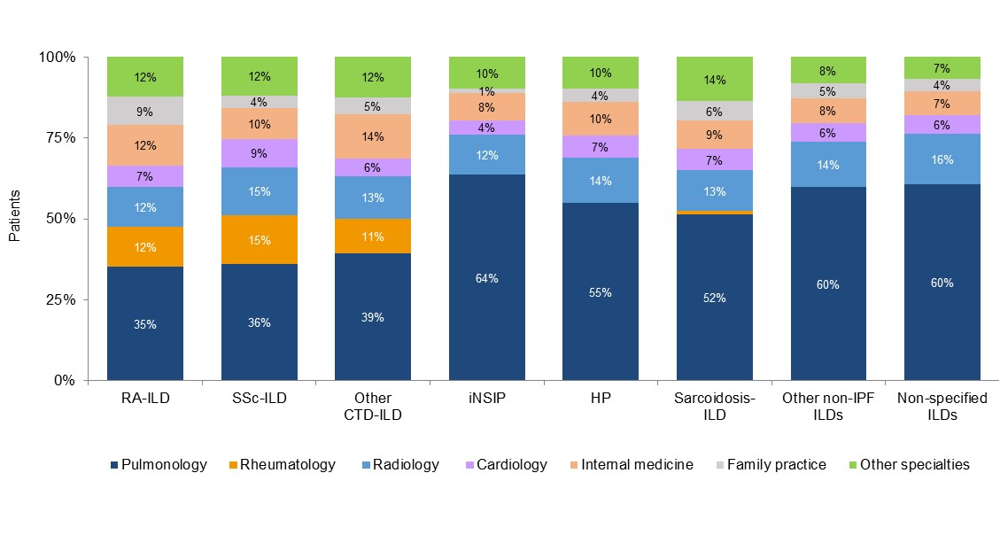

Figure S2. Frequency of follow-up visits and HRCT scans in patients with ILDs. Data from online survey of physicians (pulmonologists, n=243; rheumatologists, n=203; internists, n=40). Survey questions: In patients with ILD where you manage / help manage the ILD, on average how frequently do you have follow-up visits with the patient? In patients with ILD where you manage / help manage the ILD, on average how frequently do you check the status of the patients’ ILD with HRCT?
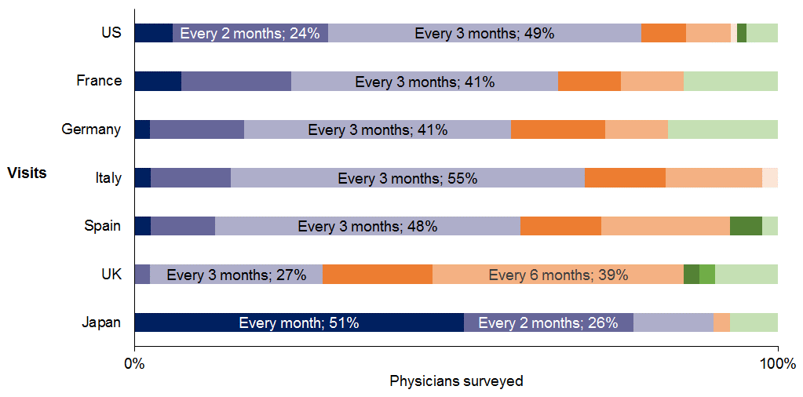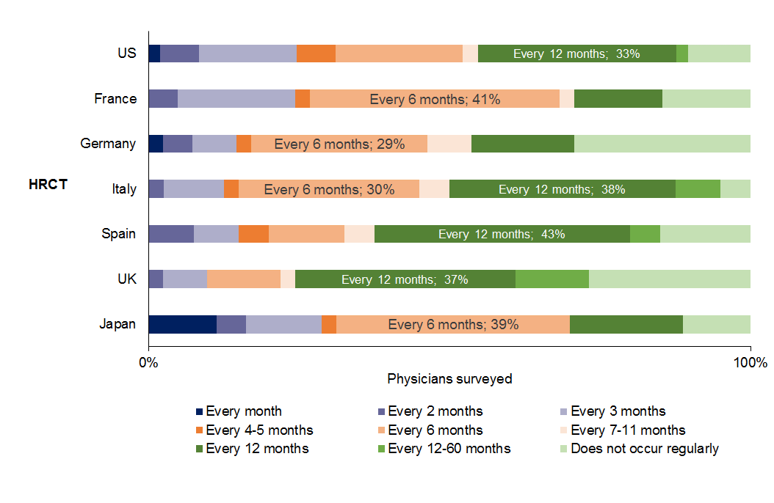

Figure S3. Number of visits to a pulmonologist or rheumatologist for ILD in 2014. Data based on US insurance claims from 30,090 patients who had ILD (defined as ≥2 claims with an ILD diagnosis and ≥1 visit to a pulmonologist between 2014 and 2016) and had ≥1 ILD claim in each of 2014, 2015 and 2016, and had ≥1 visit to a pulmonologist or rheumatologist, respectively, between 2014 and 2016.
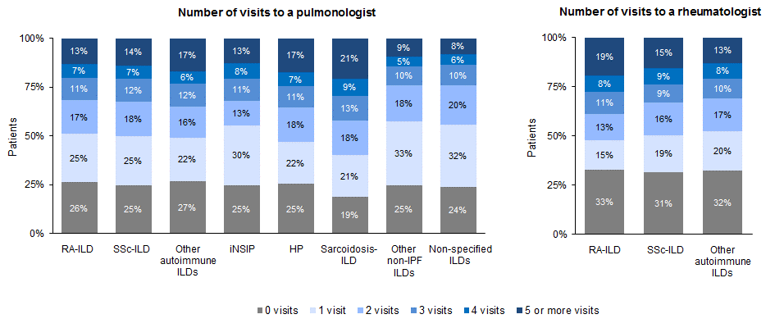

Figure S4. Specialties that led treatment decisions for patients with progressive fibrosing ILDs. Data from online survey of physicians (pulmonologists, n=243; rheumatologists, n=203; internists, n=40). Survey question: In your estimation, for patients with a non-IPF ILD that has fibrosis and is progressing, in what percentage of patients do the following specialties lead the decision-making on how to treat (i.e. drug treatment) the ILD? Examples of autoimmune ILDs provided to physicians participating in the survey were RA-ILD, SSc-ILD, and other CTD-ILDs. Examples of non-IPF non-autoimmune ILDs provided were iNSIP, HP, and sarcoidosis-ILD. Rheumatologists were only asked this question in relation to autoimmune ILDs.

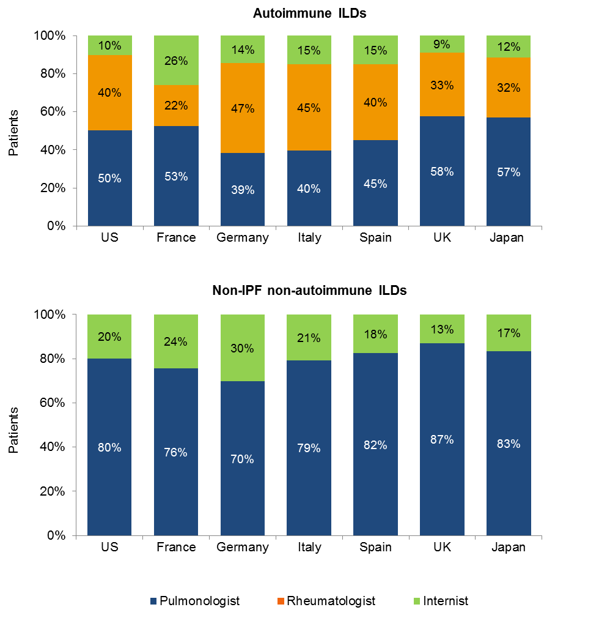

Figure S5. Action taken by pulmonologists managing a patient with a non-IPF progressive fibrosing ILD. Data from online survey of 243 pulmonologists. Survey question: What do you typically do if you determine that a patient you are managing has a non-IPF non-autoimmune / autoimmune ILD that has fibrosis and is progressing? Examples of autoimmune ILDs provided were RA-ILD, SSc-ILD, and other CTD-ILDs. Examples of non-IPF non-autoimmune ILDs provided were iNSIP, HP, and sarcoidosis-ILD.
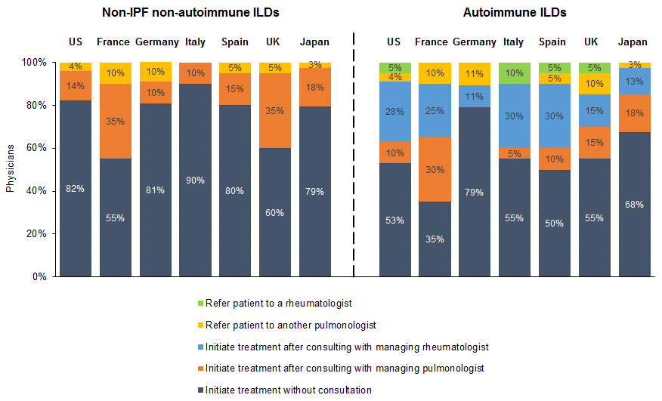
Figure S6. Action taken by rheumatologists managing a patient with a non-IPF progressive fibrosing ILD. Data from online survey of 203 rheumatologists. Survey question: What do you typically do if you determine that a patient you are managing has an autoimmune ILD that has fibrosis and is progressing? Examples of autoimmune ILDs provided were RA-ILD, SSc-ILD, and other CTD-ILDs.
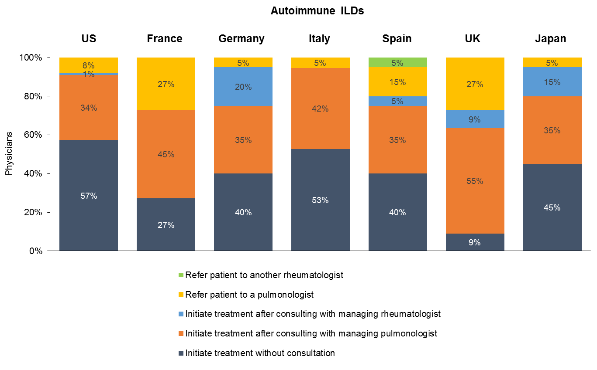
Figure S7. Agents used as first-, second- and third-line treatments for fibrotic autoimmune ILDs by region. Data from online survey of physicians. Survey question: For the following types of ILDs where patients also have lung fibrosis, please indicate your preferred first, second, and third line treatments for the respective ILD.

Physicians in the US:
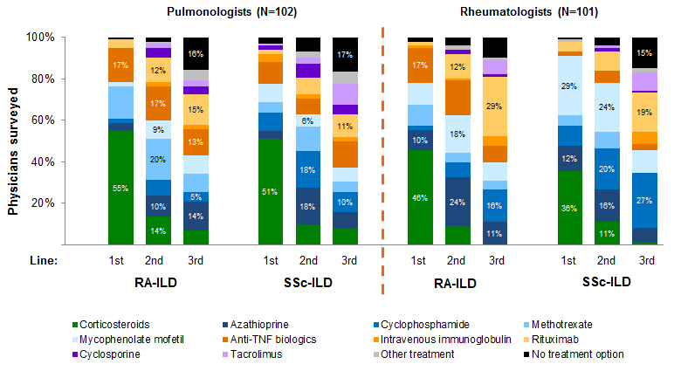
Physicians in Europe (France, Germany, Italy, Spain, UK):
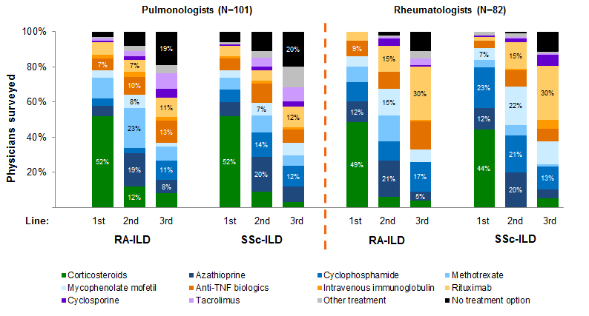
Physicians in Japan:
