Attachment I: The g(r) curves of rapidly cooling metal Zr at 300K and 1900K. The experimental data are taken from literature [1].The simulated results agree well with the experimental values.

Attachment II: The potential energy per atom in the system vs. temperature T during the rapid solidification of liquid metal Zr. The glass transition temperature is estimated to be 741K.

Attachment III: The fraction of typical clusters in the systems at different time steps (a) t=0 ps and (b) t=2000 ps during relaxation at various temperatures.

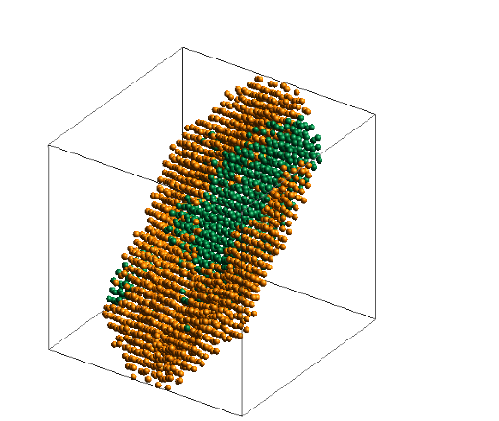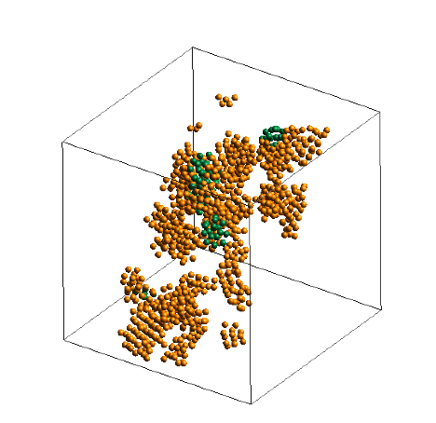
t=21 ps t=65 ps t=638 ps

Attachment IV: Cross sections of the MRO structures during the crystallization of undercooled liquid metal Zr at 1000 K. Orange and green spheres correspond to BCC and HCP atoms, respectively.

Attachment V: (a) The potential energy per atom in the system during isothermal relaxation of supercooled liquid Zr at various temperatures;(b)-(d)Time dependence of the fraction of BCC and HCP clusters in the system during crystallization.

Reference
[1] http://res.tagen.tohoku.ac.jp/~waseda/scm/LIQ/gr/Zr_1900_gr.txt

