Supplementary Material to the article:

The Death Spiral of Coal in the U.S.
Will new U.S. Energy Policy Turn the Tide?

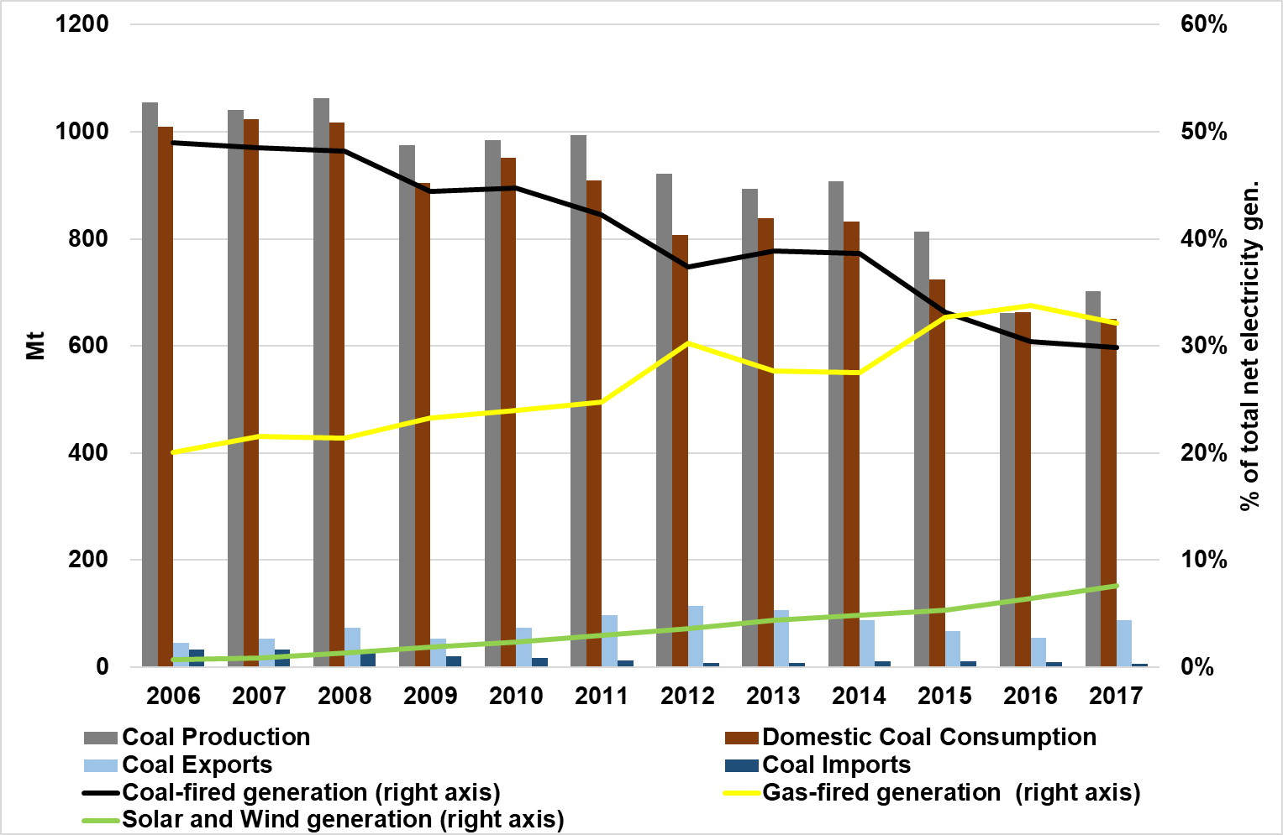
Figure S1: U.S. coal production, consumption, exports and imports, as well as share of coal, gas, and wind and solar in total U.S. net electricity generation
Source: U.S. Department of Energy Information Administration (EIA) data on coal: https://www.eia.gov/coal/data/browser/; and EIA total energy data: https://www.eia.gov/totalenergy/, last accessed: July 3, 2018.
Note: Domestic consumption and exports do not necessarily add up to the sum of coal production. Coal imports (~ 7 – 33 Mtpa) and stock changes (~ -40 – 39 Mtpa) explain minor deviations.

Box S1: CCTS equipped coal-fired capacities in the 450ppm scenario and calculation of their coal demand
We derive the amount of CCTS-equipped coal-fired power generation capacities from IEA/OECD’s (2016) 450ppm scenario. By the year 2040, it assumes around 258 GW coal-fired power generation equipped with CCTS globally (total power generation capacities with CCTS: 430 GW; 60 % of them coal-fired) (IEA/OECD 2016, 208). First significant amounts of annual power generation capacity additions equipped with CCTS (not limited to coal) occur around the year 2025 (ca. 5 GW), increasing with annual additions of ca. 30 GW by 2030, then staying at this level throughout 2040 (IEA/OECD 2016, 253). We therefore assume the following global CCTS equipped coal-fired power generation capacities: year 2025 – 5 GW; 2030 – 58 GW; 2035 – 158 GW; 2040 – 258 GW. According to IEA/OECD (2016, 208), 75 % of coal-fired power plants equipped with CCTS will be located in China (193.5 GW in 2040) and about 12.5 % in the U.S. and India. For the remaining 12.5 % no information is given. We assume equal amounts of CCTS-equipped capacities in the U.S. and India (each 16 GW in 2040), 2.5 % (6.5 GW) in OECD Asia Oceania, and 10 % (26 GW in 2040) in Non-OECD Asia. Furthermore, we assume a load factor of 85 % for CCTS-equipped coal-fired power plants and 35 % efficiency of these units (only coal-fired units, not CCTS).

Table S1: U.S. environmental policy relevant for the coal sector in the governments of President Obama (2009-2017) and President Trump (since 2017)
Affected sector | Environmental policy under Obama | Environmental policy under Trump
General | - Paris Agreement  - Climate Action Plan | - Withdrawal from Paris Agreement (effective earliest in 2020)  - Climate Action Plan rescinded  - DOE Grid Study highlighting the will to facilitate licensing of new coal power plants
Coal-fired power generation | - Clean Power Plan  - Carbon Pollution Standards for New, Modified and Reconstructed Power Plants  - New Source Review under the Clean Air Act (since 1977)  - Cross-State Air Pollution Regulation (CSAPR)  - Mercury and Air Toxics Standards (MATS)  - National Ambient Air Quality Standards (NAAQS) for particulate matter (PM)  - EPA regulation of coal combustion residuals (i.e., ash) disposal  - NAAQS for ozone  - Visibility and Regional Haze Rule  - EPA regulation of cooling water intake under the Clean Water Act in the framework of the National Pollutant Discharge Elimination System (NPDES)  - Effluent guidelines for wastewater discharge | - Replacing Clean Power Plan  - Softened update of the New Source Review  - Proposal for aid to coal and nuclear power plants  - Financial incentive for CCTS  - Social cost of carbon reduced for future assessments of energy policy  - All other regulations are still in place at this time, but where regular review is mandated there will be no further tightening of standards and rules (e.g., NAAQS for PM and ozone).  - Reconsidering some more rules has been announced (e.g. Visibility and Regional Haze Rule)
Coal production (extraction) | - Stream Protection Rule  - Waters of the United States Rule  - Moratorium on new coal mine leases (on federal land)  - Bureau of Land Management’s Resource Management Planning Rule (BLM 2.0) for federal land  - Closed a loophole in the Valuation Rule (for royalty payments from extraction on federal lands) | - Stream Protection Rule disapproved before implementation  - Repeal of Waters of the US Rule under way  - Moratorium on new coal mine leases cancelled  - Resource Management Planning rule repealed  - Valuation Rule rescinded⁹  - Reduction of two national monuments’ size  - Proposal to reduce royalties
Sources: Own table based on from Houser, Bordoff, and Masters (2017); and U.S. DoE (2017).
Table S2: Existing and proposed U.S., Canadian, and Mexican West Coast coal export ports
Project | Location | Existing Capacity [Mtpa] | Planned/ Proposed Capacity [Mtpa] | Status 2018
Oxbow Terminal | Long Beach, CA | 1.6 | - | Operating
Metropolitan Bulk Terminal | Stockton, CA | 2.4 | - | Operating
Levin-Richmond Terminal | Richmond, CA | 2.4 | - | Operating
Westshore Terminal | Vancouver, B.C. | 29.9 | 2.7 | Operating/ Under construction
Prince Rupert Port (Ridley) | Prince Rupert, B.C. | 18.1 | - | Operating
Puerto de Guaymas | Guaymas, Sonora, MX | 1.8 | - | Operating
Port of Ensenada | Ensenada, Baja California, MX | - | ? | Proposed
Millenium Bulk Terminal | Longview, WA | - | 39.9 | Permit denied, decision challenged
Oakland Bulk and Oversized Terminal | Oakland, CA | - | 4.5 | Ongoing legal case
Gateway Pacific Terminal | Bellingham, WA | - | 43.5 | Cancelled
Port of Grays Harbor | Hoquiam, WA | - | 5 | Cancelled
Port Westward | Port of St. Helens, OR | - | 27.2 | Cancelled
Morrow Pacific | Ports of Morrow and St. Helens, OR | - | 8 | Cancelled
Project Mainstay | Port of Coos Bay, OR | - | 10 | Cancelled
Sources: http://tlsoakland.com/tls-multi-commodity-bulk-terminal/; https://www.earthfix.info/article/coal-score-card/; http://www.westshore.com/#/main; http://www.rti.ca/; http://energy.utah.gov/baja-california-utah-offices-sign-agreement-collaborate-energy-export-opportunities/, last accessed December 12, 2018; NCC (2018).
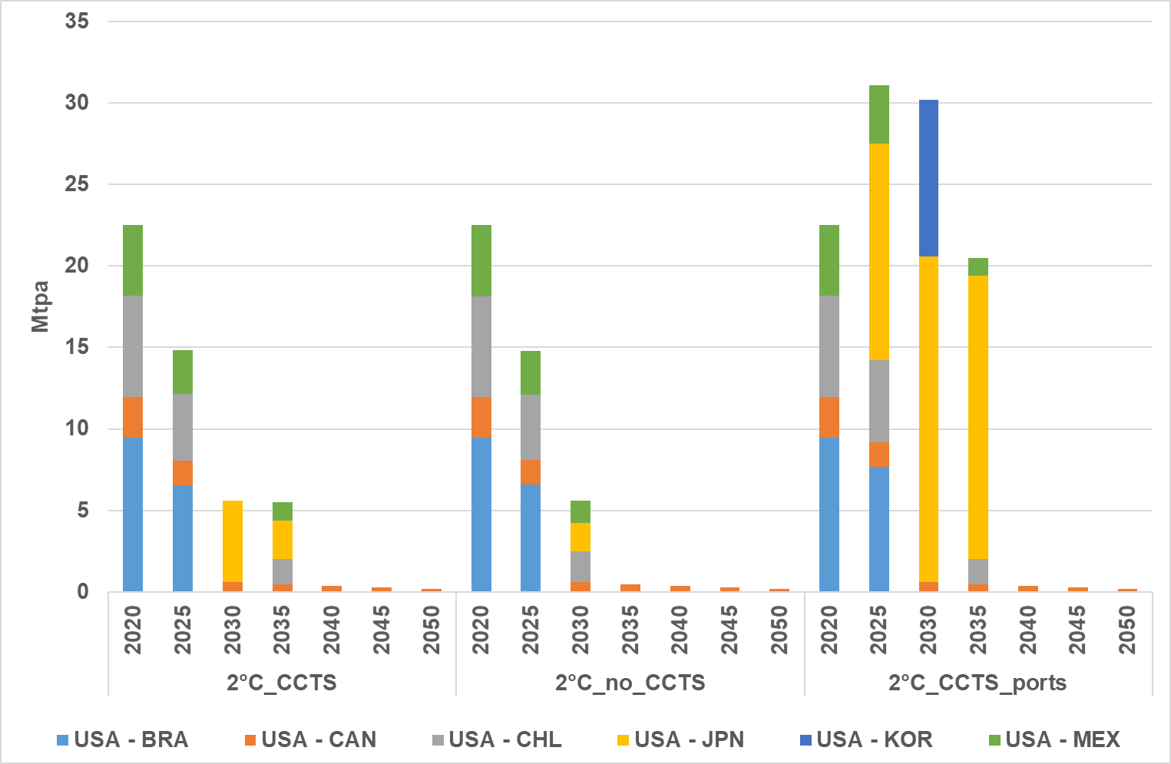
Figure S2: U.S. steam coal exports 2020 – 2050 in the ambitious climate policy pathway (all scenarios), model results

Table S3: World and U.S. CO₂ emissions from coal in the different scenarios, cumulative and by model year in Gt, model results
Scenario | World cum 2015-2050 | USA cum 2015-2050 | USA annual average (2015-2050) | USA 2015 | USA 2025 | USA 2030 | USA 2050
Rollback | 480 | 43.9 | 1.2 | 1.3 | 1.3 | 1.3 | 1.2
CPP | 473 | 37.7 | 1 | 1.3 | 1.2 | 1 | 0.9
Rollback_Ports | 480 | 43.2 | 1.2 | 1.3 | 1.2 | 1.3 | 1.2
2°C_CCTS | 214 | 12.5 | 0.3 | 1.3 | 0.6 | 0.2 | 0
2°C_No_CCTS | 214 | 12.5 | 0.3 | 1.3 | 0.6 | 0.2 | 0
2°C_CCTS_Ports | 214 | 12.5 | 0.3 | 1.3 | 0.6 | 0.2 | 0

References
Houser, Trevor, Jason Bordoff, and Peter Marsters. 2017. “Can Coal Make a Comeback?” New York, USA: Columbia Center for International Energy Policy, SIRA. http://energypolicy.columbia.edu/sites/default/files/energy/Center_on_Global_Energy_Policy_Can_Coal_Make_Comeback_April_2017.pdf.
IEA/OECD. 2016. World Energy Outlook 2016. World Energy Outlook. Paris, France: International Energy Agency, OECD Publishing. https://doi.org/10.1787/weo-2016-en.
NCC. 2018. “Advancing U.S. Coal Exports: An Assessment of Opportunities to Enhance Exports of U.S. Coal.” Washington DC, USA: National Coal Council (NCC). http://www.nationalcoalcouncil.org/studies/2018/NCC-US-Coal-Exports-2018.pdf.
U.S. DoE. 2017. “Staff Report on Electricity Markets and Reliability.” Washington DC, USA: U-S. Department of Energy. https://energy.gov/sites/prod/files/2017/08/f36/Staff%20Report%20on%20Electricity%20Markets%20and%20Reliability_0.pdf.

The White House. 2017. “Statement by President Trump on the Paris Climate Accord.” Whitehouse.Gov. June 1, 2017. https://www.whitehouse.gov/the-press-office/2017/06/01/statement-president-trump-paris-climate-accord, last accessed May 20, 2018.
Trump, Donald J. 2017. “Presidential Executive Order on Promoting Energy Independence and Economic Growth.” https://www.whitehouse.gov/presidential-actions/presidential-executive-order-promoting-energy-independence-economic-growth/, last accessed May 30, 2018.
Staff Report to the Secretary on Electricity Markets and Reliability (https://www.energy.gov/staff-report-secretary-electricity-markets-and-reliability, accessed on October 8, 2018).
“Standards of Performance for Greenhouse Gas Emissions From New, Modified, and Reconstructed Stationary Sources: Electric Utility Generating Units”, 80 Fed. Reg. 64509 (October 23, 2015). Also see EPA New Source Review: https://www.epa.gov/nsr/learn-about-new-source-review, last accessed January 26, 2019; for more details on this regulation. By end of 2018, there were first attempts of the Trump administration to water down this regulation. See Dennis, Brady, and Steven Mufson. (06.12.2018). “EPA Announces Plan to Ease Carbon Emissions Rule for New Coal Plants.” Washington Post Online. https://www.washingtonpost.com/energy-environment/2018/12/06/epa-announces-plan-ease-carbon-emissions-rule-new-coal-plants/, last accessed January 14, 2019; and Hankins, Meredith (21.08.2018), The Clean Power Plan Replacement Comes With a Major Change to NSR (Part 1). http://legal-planet.org/2018/08/21/the-clean-power-plan-replacement-comes-with-a-major-change-to-nsr-part-1/, last accessed September 3, 2018.
Wara, Michael (05.10.2017), The Trump Administration Moves to Guarantee Profits for Coal-fired and Nuclear Power Plants, http://legal-planet.org/2017/10/05/guest-blogger-michael-wara-the-trump-administration-moves-to-guarantee-profits-for-coal-fired-and-nuclear-power-plants/, last accessed May 21, 2018.
Farber, Dan (14.05.2018), Emergency Powers: A Two-Edged Sword, http://legal-planet.org/2018/05/14/emergency-powers-a-two-edged-sword/, last accessed: 05/21/2018.
John, Jeff St. (12.06.2018), FERC Commissioners Agree: No Grid Emergency Exists to Justify Coal, Nuclear Bailout. https://www.greentechmedia.com/articles/read/ferc-commissioners-agree-no-grid-emergency-exists, last accessed August 3, 2018.
26 U.S. Code § 45Q - Credit for carbon dioxide sequestration. So far, a tax credit of U.S-$ 20 was granted per metric ton of CO₂ captured and stored in secure geological storage, and a tax credit of U.S.-$ 10 for every metric ton of CO₂ used (e.g. in Enhanced Oil and Gas Recovery). However, the tax credit was limited to a maximum of 75 million metric tons of CO₂. Under the updated rule the support is increased: i) A tax credit for every metric ton of captured and permanently stored CO₂, starting at U.S.-$ 22.66 in the year 2018 and increasing linearly to U.S.-$ 50 by the end of the year 2026; ii) a tax credit for every metric ton of captured and used CO₂, starting at U.S.-$ 12.83 in the year 2018 and increasing linearly to U.S.-$ 35 by the end of the year 2026; iii) after the year 2026, these amounts are adjusted to inflation, but not further increased otherwise; iv) The cap at 75 million metric tons captured CO₂ is removed. The tax credit is received by each facility for up to twelve years, starting at the date of its initial operation; v) The new amounts of tax credits apply to CCTS equipment put in place on or after enactment of the Act. Facilities eligible for the tax credit are any industrial facility, such as power plants and others, and direct air capture facilities of which construction begins before January 1, 2024; some minimum size requirements apply. At the same time, governmental funding for research and development of CCTS was reduced. See: Chemnick, Jean (16.01.2018), Trump wants to lead on 'clean coal.' Here's what that means. https://www.eenews.net/stories/1060070967, last accessed August 17, 2018
The Stream Protection Rule was designed to “better protect water supplies, surface water and groundwater quality, streams, fish, wildlife, and related environmental values from the adverse impacts of surface coal mining operations and provide mine operators with a regulatory framework to avoid water pollution and the long-term costs associated with water treatment.” (Office of Surface Mining Reclamation and Enforcement (OSM) (20.12.2016), Stream Protection Rule, https://www.regulations.gov/document?D=OSM-2010-0018-10631, last accessed: 05/21/2018).
Lipton, Eric and Meier, Barry (06.08.2017), Under Trump, Coal Mining Gets New Life on U.S. Lands, https://www.nytimes.com/2017/08/06/us/politics/under-trump-coal-mining-gets-new-life-on-us-lands.html, last accessed: 05/21/2018.
The Resource Management Planning rule affirmed “the important role of other Federal agencies, State and local governments, Indian tribes, and the public during the planning process and (…) [enhanced] opportunities for public involvement and transparency during the preparation of resource management plans. (…) [It emphasized] the importance of evaluating the resource, environmental, ecological, social, and economic conditions at the onset of planning” (Bureau of Land Management (12.12.2016), Resource Management Planning, https://www.regulations.gov/document?D=BLM-2016-0002-0415, last accessed: 05/21/2018).
Ballotpedia (n.d.), Federal agency rules repealed under the Congressional Review Act. https://ballotpedia.org/Federal_agency_rules_repealed_under_the_Congressional_Review_Act?gclid=EAIaIQobChMItejb8M6e2QIVCIN-Ch1XSADXEAMYASAAEgIFPfD_BwE, last accessed: 05/21/2018.
U.S. Department of the Interior (07.08.2017), Interior Repeals Defective Federal Mineral Valuation Rule, https://www.doi.gov/pressreleases/interior-repeals-defective-federal-mineral-valuation-rule, last accessed: 05/29/2018.
Korte, Gregory (05.12.2017), Trump shrinks Bears Ears, Grand Staircase-Escalante monuments in historic proclamations, https://www.usatoday.com/story/news/politics/2017/12/04/trump-travels-utah-historic-rollback-national-monuments/919209001/, last accessed: 05/21/2018; Nordhaus, Hannah (02.02.2018), What Trump’s Shrinking of National Monuments Actually Means, https://news.nationalgeographic.com/2017/12/trump-shrinks-bears-ears-grand-staircase-escalante-national-monuments/, last accessed: 05/21/2018.
Hegyi, Nate (28.02.2018), Industry May Pay Less For Coal Dug Up On Federal Lands, http://kuer.org/post/industry-may-pay-less-coal-dug-federal-lands#stream/0, last accessed: 05/21/2018.
U.S. Coal Exports (22.05.2018), California judge ruling opens Oakland port to coal shipping. http://uscoalexports.org/2018/05/22/california-judge-opend-oakland-coal-shipping/, last accessed August 3, 2018.

