Supporting information
Table S1. PCR primers used in this study
Primers | Sequences (5′ to 3′)
TwUGT2-F | ATGACTCTGTTAGGCACGGGAACC
TwUGT2-R | TCATTCCAAAGCAGCCAAAAGATTT

Table S2. Other plant UGTs included in phylogenetic tree.
Gene name | Species | Type of Synthase | Genebank  accession number
Am4CGT | Antirrhinum majus | chalcone 4'-O-glucosyltransferase | BAE48239
Lv4CGT | Linaria vulgaris | chalcone 4'-glucosyltransferase | BAE48240
PlUGT1 | Pueraria montana var. lobata | isoflavone 7-O-glucosyltransferase | AGZ84545
PlUGT2 | Pueraria montana var. lobata | isoflavone 4' 7-O-glucosyltransferase | AMQ26112
GT04F14 | Pueraria montana var. lobata | isoflavone 7-O-glucosyltransferase | ADV71364
UBGT | Scutellaria baicalensis | flavonoid 7-O-glucosyltransferase | BAA83484
FaGT7 | Fragaria x ananassa | flavonol 3-O-glucosyltransferase | Q2V6J9
PpUFGT | Prunus persica | flavonoid 3-O-glucosyltransferase | ARW73634
pNgt2 | Ipomoea nil | coumarin glucosyltransferase | BAM63146
CsUGT2 | Citrus sinensis | terpenoid glycosyltransferase | ACS87991
EPGT1 | Eucalyptus perriniana | monoterpene glucosyltransferase | BAD90934
EPGT2 | Eucalyptus perriniana | monoterpene glucosyltransferase | BAD90935
UGT74M1 | Gypsophila vaccaria | triterpene carboxylic acid glucosyltransferase | ABK76266
UGT74T1 | Linum usitatissimum | lignan glucosyltransferase | AGD95008
UGT74S1 | Linum usitatissimum | lignan glucosyltransferase | AGD95005
AtSGT | Arabidopsis thaliana | sterol glucosyltransferase | CAB06082
SGTL1 | Withania somnifera | sterol glucosyltransferase | ABC96116
UGT52 | Dictyostelium discoideum | sterol glucosyltransferase | AAD28546
UGT51C1 | Candida albicans | sterol glucosyltransferase | AAD29571
UGT51B1 | Komagataella pastoris | sterol glucosyltransferase | AAD29570

Table S3. UPLC conditions of detecting sugar acceptors and corresponding glycosylated products in this study.
Chemical Component | Solvent A | Solvent B | Gradient
Quercetin and Isoquercitrin | 0.1% trifluoroacetic acid-water | Acetonitrile | 0-3.5 min: 95%(A)-95%(A)  3.5-4 min: 95%(A)-75%(A)  4 - 8 min: 75%(A)-45%(A)  8 -12 min: 45%(A)-40%(A)
Pinocembrin and Pinocembrin 7-O-beta-D-glucoside | 0.1% trifluoroacetic acid-water | Acetonitrile | 0-3.5 min: 95%(A)-95%(A)  3.5-4 min: 95%(A)-75%(A)  4 - 8 min: 75%(A)-45%(A)  8 -12 min: 45%(A)-40%(A)
Genistein | 0.1% trifluoroacetic acid-water | Acetonitrile | 0-3.5 min: 95%(A)-95%(A)  3.5-4 min: 95%(A)-75%(A)  4 - 8 min: 75%(A)-45%(A)  8 -12 min: 45%(A)-40%(A)
Liquiritigenin | 0.1% trifluoroacetic acid-water | Acetonitrile | 0-3.5 min: 95%(A)-95%(A)  3.5-4 min: 95%(A)-75%(A)  4 - 8 min: 75%(A)-45%(A)  8 -12 min: 45%(A)-40%(A)
Kaempferol | 0.1% trifluoroacetic acid-water | Acetonitrile | 0-3.5 min: 95%(A)-95%(A)  3.5-4 min: 95%(A)-75%(A)  4 - 8 min: 75%(A)-45%(A)  8 -12 min: 45%(A)-40%(A)
Phloretin | 0.1% trifluoroacetic acid-water | Acetonitrile | 0-3.5 min: 95%(A)-95%(A)  3.5-4 min: 95%(A)-75%(A)  4 - 8 min: 75%(A)-45%(A)  8 -12 min: 45%(A)-40%(A)
Daidzein | 0.1% trifluoroacetic acid-water | Acetonitrile | 0-3.5 min: 95%(A)-95%(A)  3.5-4 min: 95%(A)-75%(A)  4 - 8 min: 75%(A)-45%(A)  8 -12 min: 45%(A)-40%(A)
Luteolin | 0.1% trifluoroacetic acid-water | Acetonitrile | 0-3.5 min: 95%(A)-95%(A)  3.5-4 min: 95%(A)-75%(A)  4 - 8 min: 75%(A)-45%(A)  8 -12 min: 45%(A)-40%(A)
4-Methylumbelliferone | 0.1% trifluoroacetic acid-water | Acetonitrile | 0-3.5 min: 95%(A)-95%(A)  3.5-4 min: 95%(A)-90%(A)  4 - 8 min: 90%(A)-70%(A)  8 -12 min: 70%(A)-30%(A)
Nodakenitin | 0.1% trifluoroacetic acid-water | Acetonitrile | 0-3.5 min: 95%(A)-95%(A)  3.5-4 min: 95%(A)-80%(A)  4 -10 min:80%(A)-40%(A)  10-15 min:40%(A)-20%(A)
Arctigenin | 0.1% trifluoroacetic acid-water | Acetonitrile | 0-3.5 min: 95%(A)-95%(A)  3.5-4 min: 95%(A)-75%(A)  4 - 8 min: 75%(A)-45%(A)  8 -12 min: 45%(A)-40%(A)
Rhapontigenin | 0.1% trifluoroacetic acid-water | Acetonitrile | 0-3.5 min: 95%(A)-95%(A)  3.5-4 min: 95%(A)-75%(A)  4 - 8 min: 75%(A)-45%(A)  8 -12 min: 45%(A)-40%(A)
Triptolide | 0.1% trifluoroacetic acid-water | Acetonitrile | 0-3.5 min: 95%(A)-95%(A)  3.5-4 min: 95%(A)-90%(A)  4 - 7 min: 90%(A)-70%(A)  7 -12 min: 70%(A)-40%(A)  12 -13 min: 40%(A)-0%(A)  13 -18 min: 0%(A)-0%(A)
Celastrol | 0.1% trifluoroacetic acid-water | Acetonitrile | 0-3.5 min: 95%(A)-95%(A)  3.5-4 min: 95%(A)-90%(A)  4 - 7 min: 90%(A)-30%(A)  7 - 9 min: 30%(A) - 0%(A)  9 -15 min: 0%(A)-0%(A)
Triptophenolide | 0.1% trifluoroacetic acid-water | Acetonitrile | 0-3.5 min: 95%(A)-95%(A)  3.5-4 min: 95%(A)-70%(A)  4 - 7 min: 70%(A)-65%(A)  7 - 9 min: 65%(A) -25%(A)  9 -10 min: 25%(A)-0%(A)  10 -15 min: 0%(A)-0%(A)
Neotriptophenolide | 0.1% trifluoroacetic acid-water | Acetonitrile | 0-3.5 min: 95%(A)-95%(A)  3.5-4 min: 95%(A)-70%(A)  4 - 7 min: 70%(A)-65%(A)  7 – 9 min: 65%(A) -25%(A)  9 -10 min: 25%(A)-0%(A)  10 -15 min: 0%(A)-0%(A)

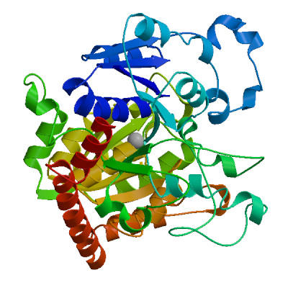
Fig. S1. The 3D structure prediction of TwUGT2 using homology-based modelling. The protein 5nlm.1. A (indoxyl UDP-glucosyltransferase) was used as a template for the 3D modelling of TwUGT2.

Fig. S2. Sodium dodecyl sulfate polyacrylamide gel electrophoresis (SDS-PAGE) electropherogram of recombinant protein expressed in E. coli BL21(DE3). M: Protein MW standard; TwUGT2: purified recombinant protein.

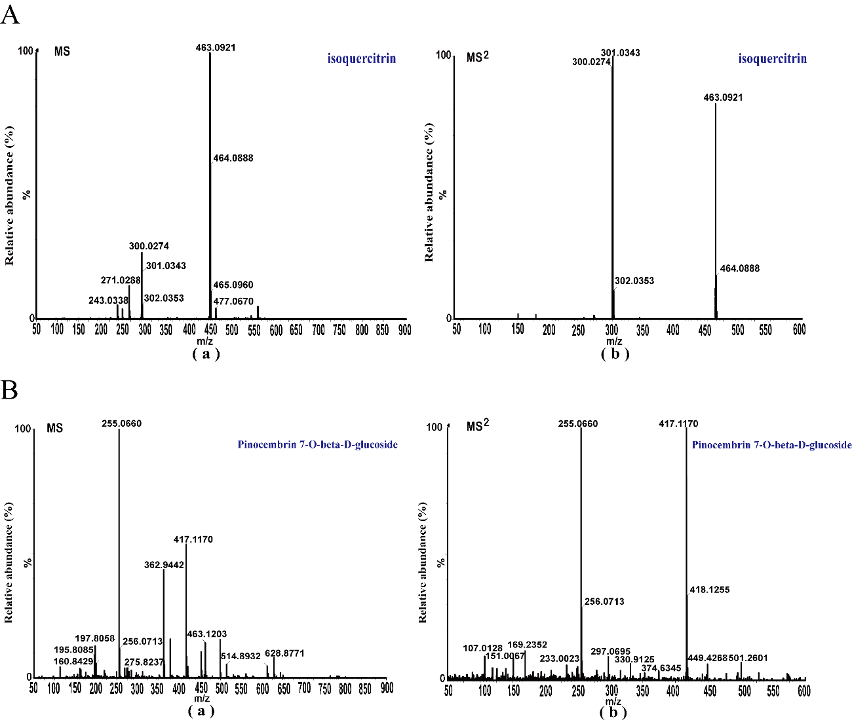

Fig. S3. MS and MS² of the authentic chemical standards: A (isoquercitrin) and B (pinocembrin 7-O-beta-D-glucoside). (a) MS of the authentic chemical standard; (b) MS² of the authentic chemical standard.

