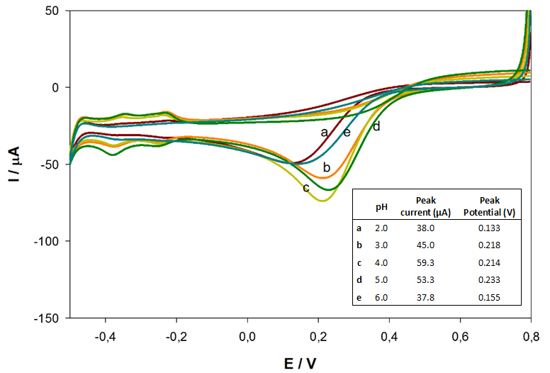
Fig S 1 Effect of CoOx deposition solution pH on the ORR signal recorded at pH 5.0 acetate buffer solution

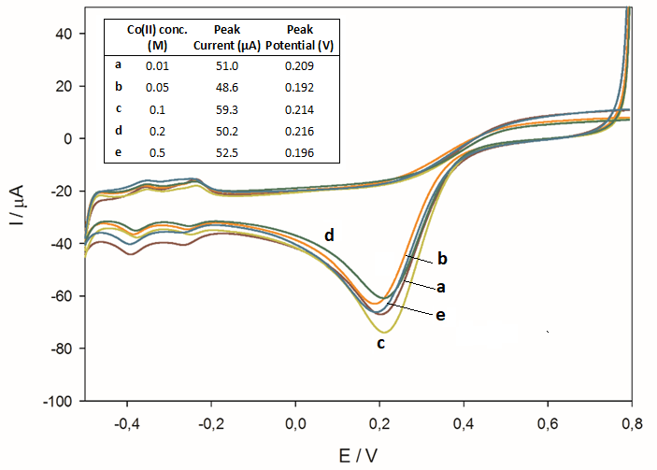
Fig S 2 Effect of Co (II) concentration in deposition solution on the subsequent recordings of ORR signal in pH 5.0 acetate buffer
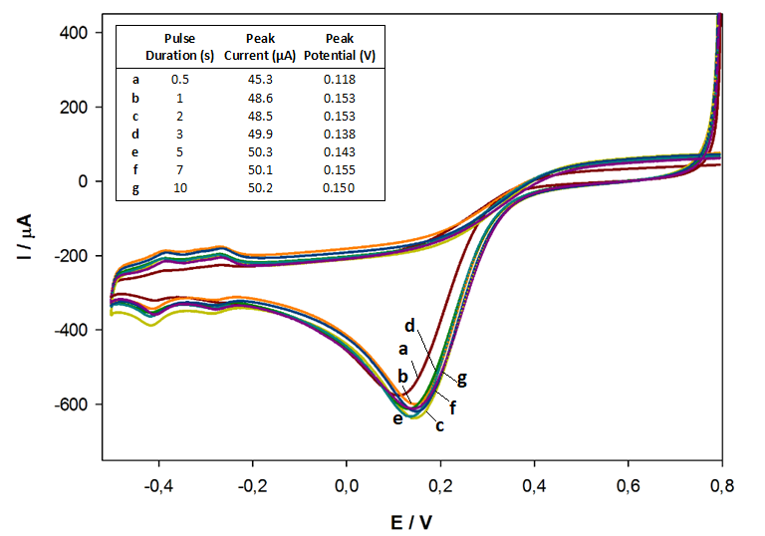
Fig S 3 Effect of pulse duration, applied during CoOx deposition, on ORR signal
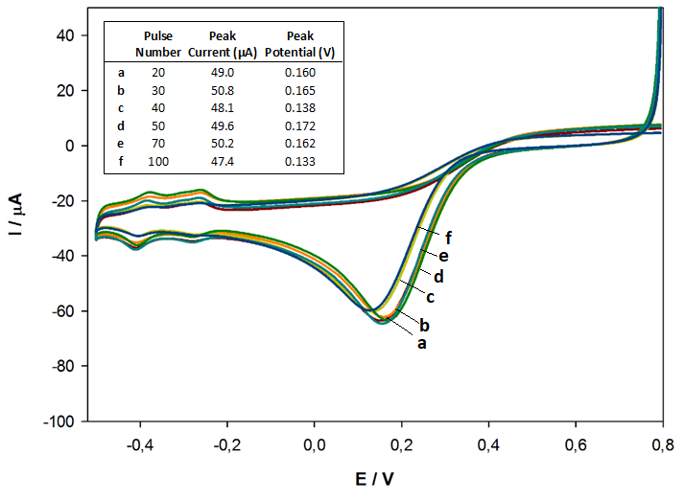
Fig S 4 Effect of pulse number applied during CoOx deposition, on ORR signal
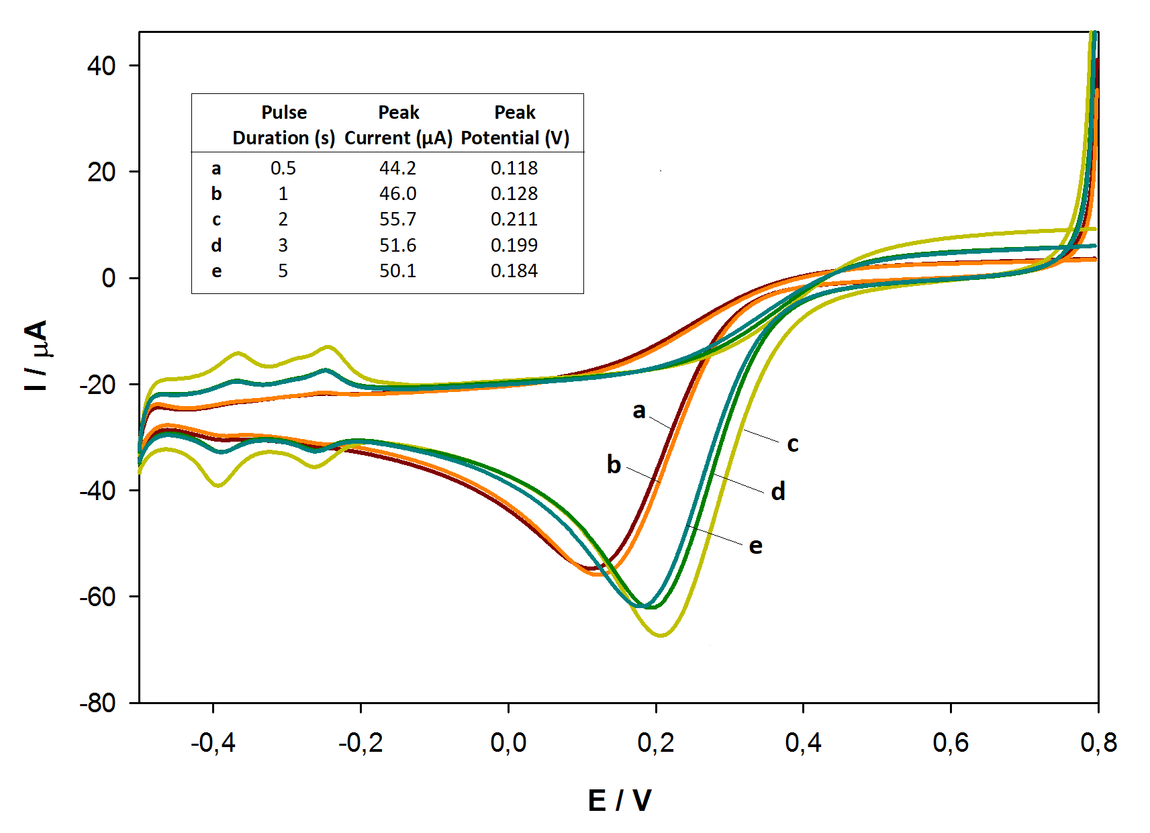
Fig S 5 Effect of pulse duration applied during Pt np deposition on CoOx film on subsequent recordings of ORR signal in pH 5.0 acetate buffer

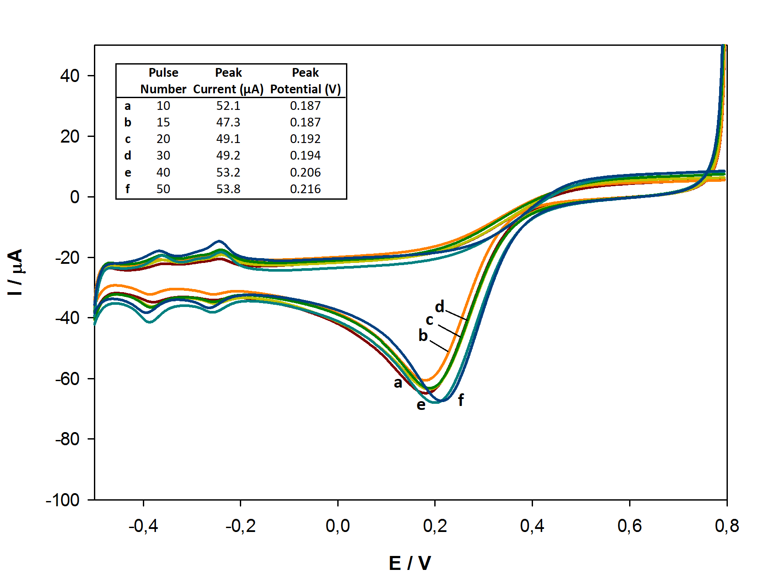
Fig S 6 Effect of pulse number in Pt np deposition step on CoOx film on subsequent recordings of ORR signal in pH 5.0 acetate buffer
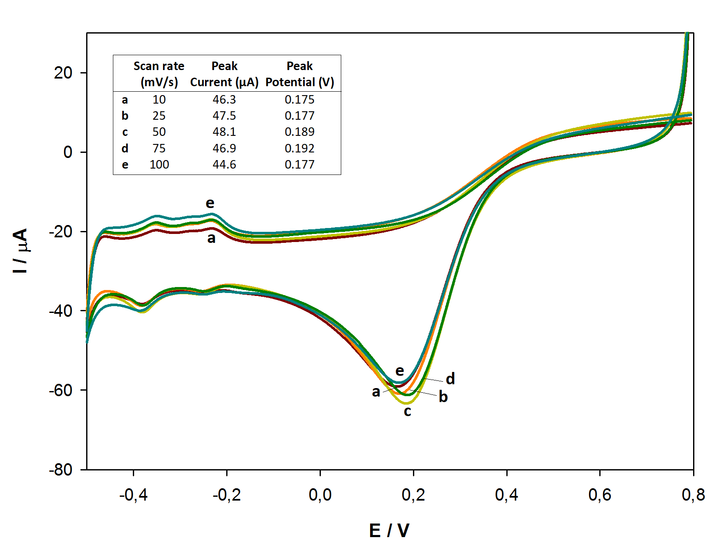
Fig S 7 Effect of scan rate used while cyclic voltammetric deposition of CoOx on subsequent recordings of ORR signal in pH 5.0 buffer solution
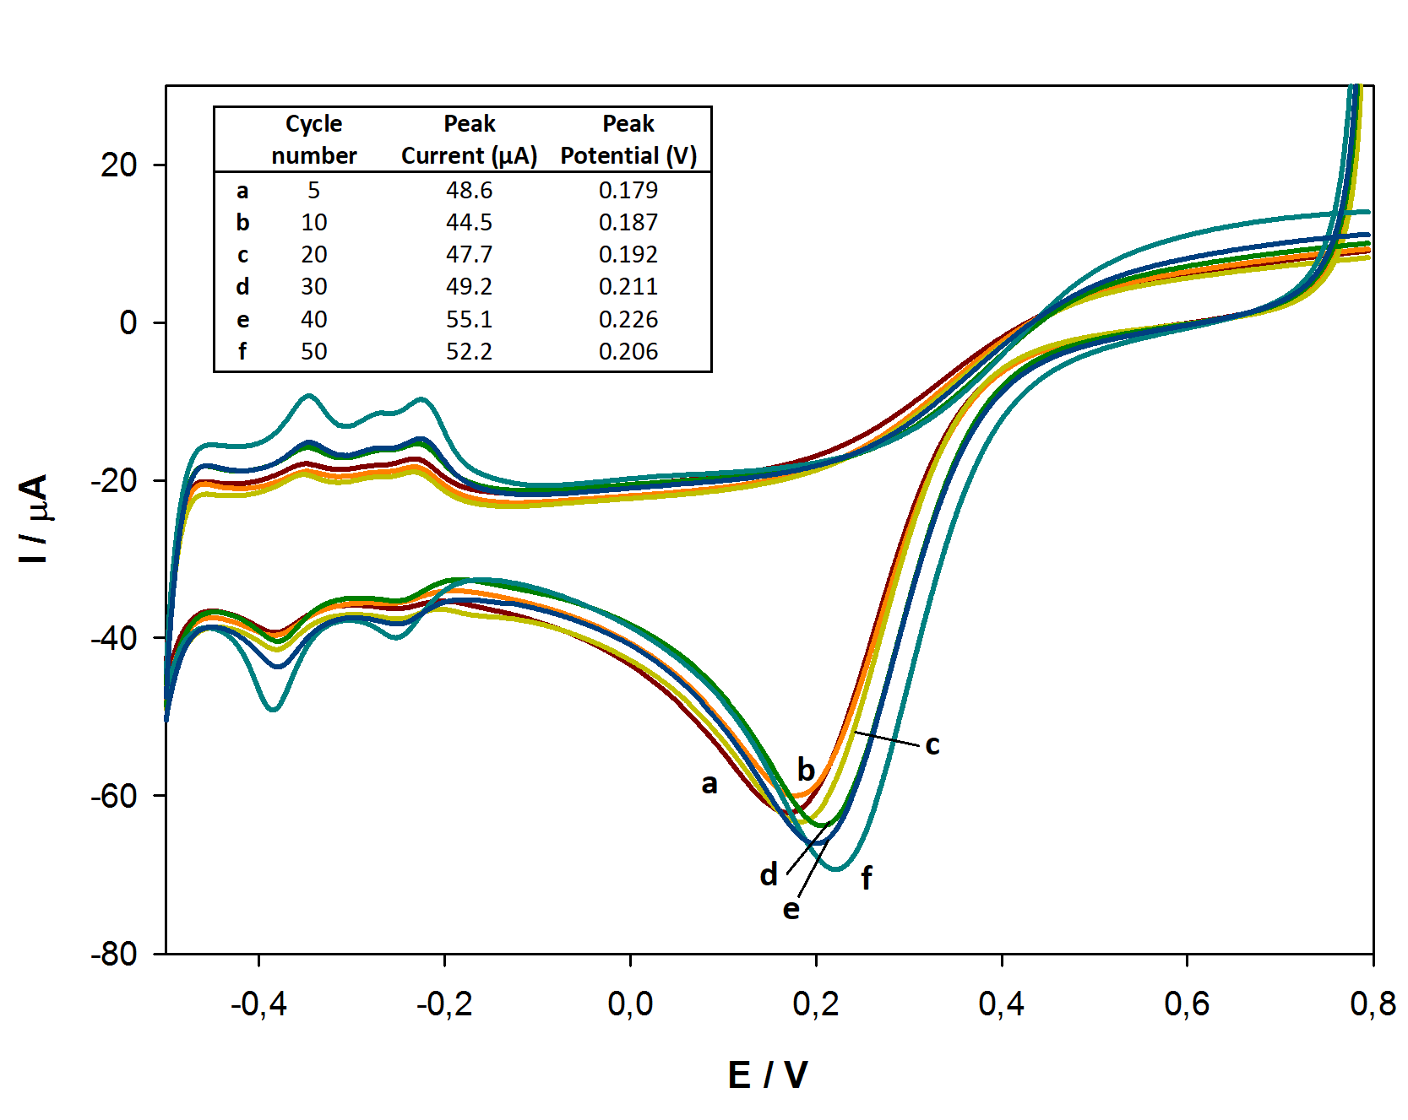
Fig S 8 Effect of cycle number in CV deposition of CoOx on subsequent recordings of ORR signal in pH 5.0 buffer solution
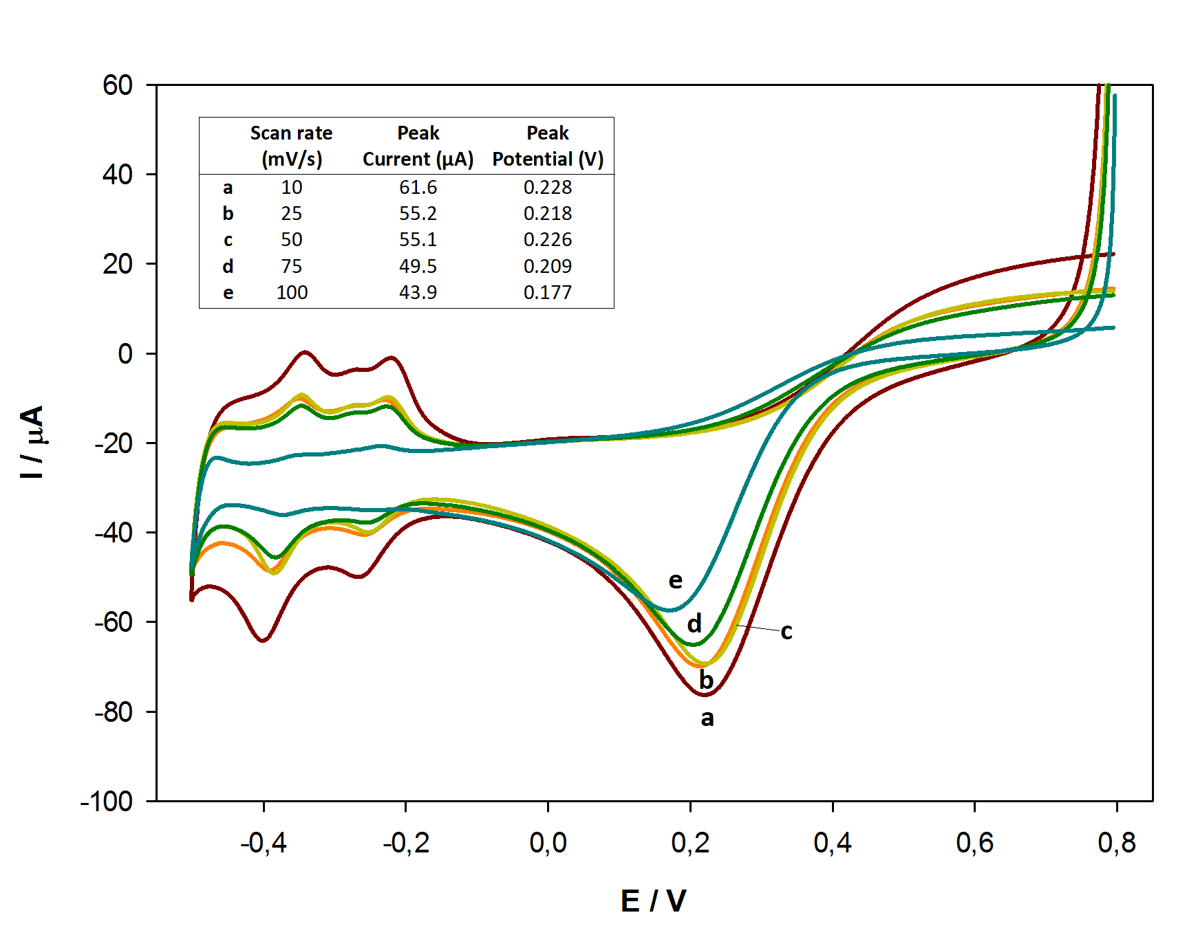
Fig S 9 Effect of scan rate in CV deposition of Pt np on the surface of CoOx film on subsequent recordings of ORR signal in pH 5.0 buffer solution

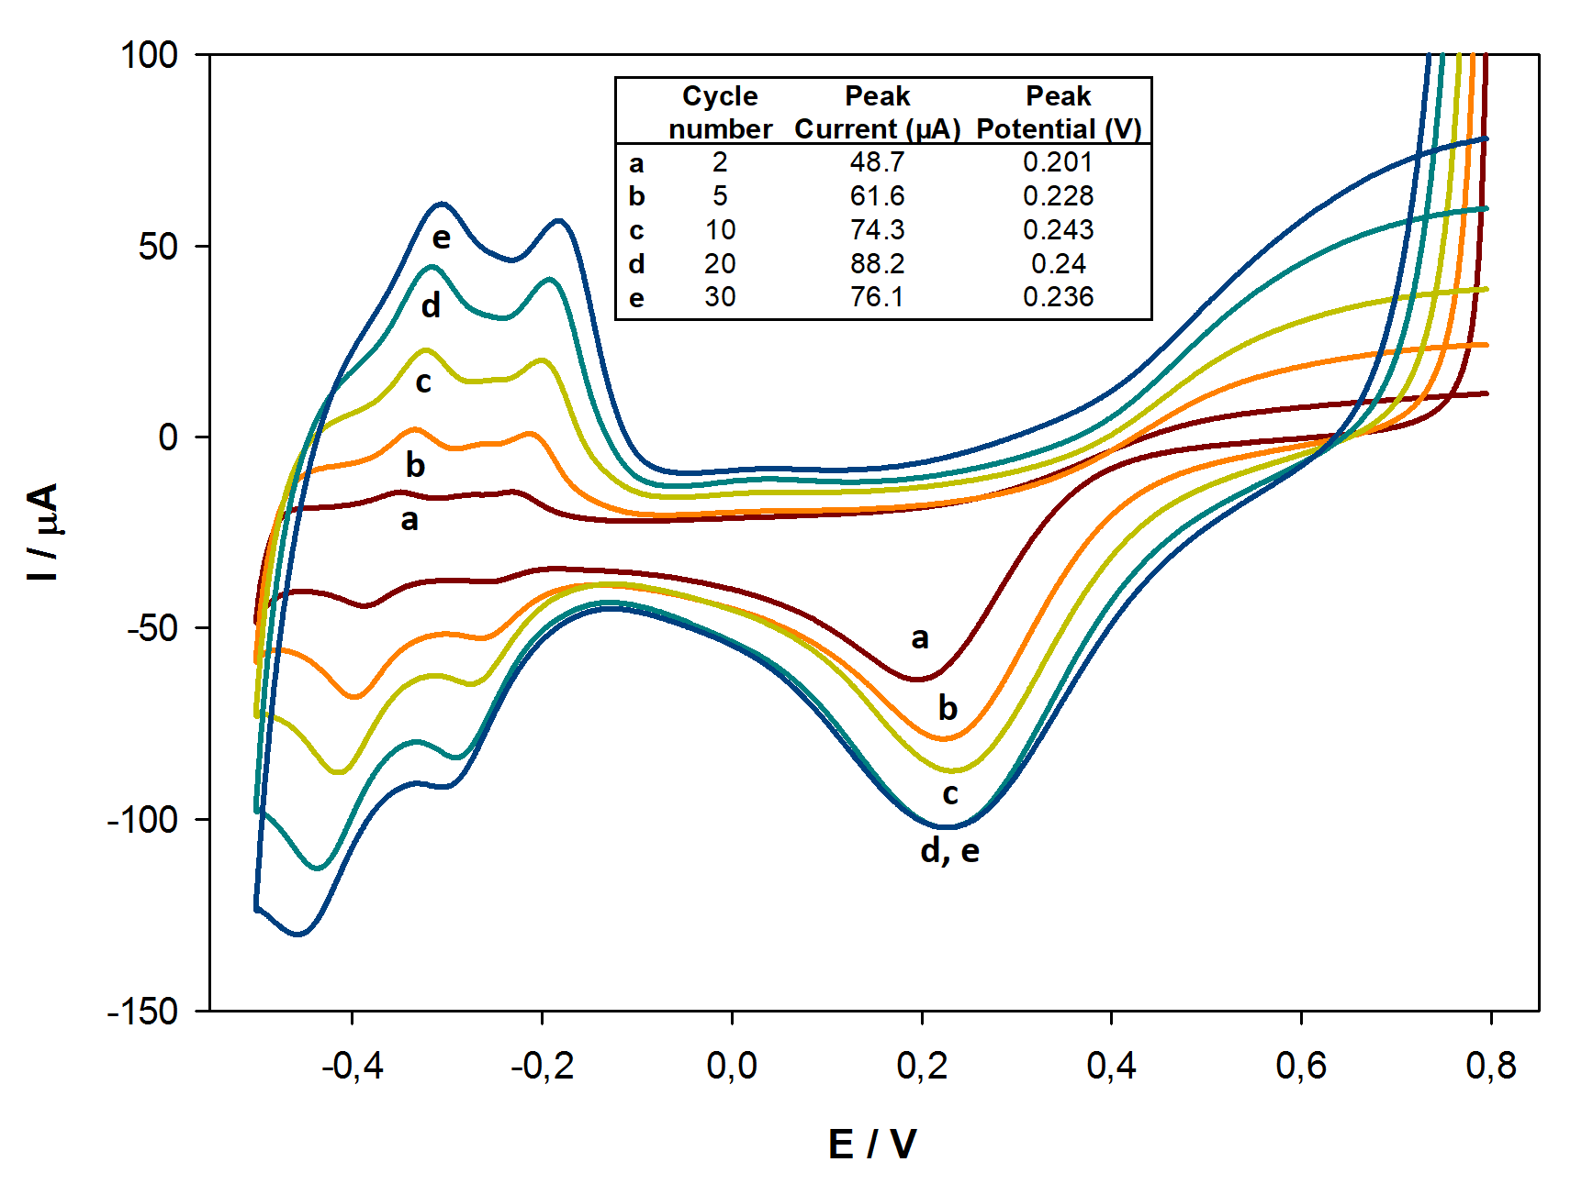
Fig S 10 Effect of cycle number used in CV deposition of Pt np on the surface of CoOx film on subsequent recordings of ORR signal in pH 5.0 buffer solution

