**Glutathione coated magnetic nanoparticles for one-pot synthesis of 1,4-dihydropyridine derivatives**

**Behrooz Maleki*,1,2 Hengameh Atharifar1, Oliver Reiser,2 Reihaneh Sabbaghzadeh3**

1Department of Chemistry, Hakim Sabzevari University, Sabzevar, 96179-76487, Iran

*E-mail: b.maleki@hsu.ac.ir, Tel: +98-5144013324 Fax: +98-514401300

2Institut fȕr Organische Chemie, Universität Regensburg, Universitätsstr. 31, 93053 Regensburg, Germany

3Department of Biology, Faculty of Science, Hakim Sabzevari University, Sabzevar, 96179-76487, Iran



**Fig. S1.** FT-IR spectra of Fe3O4 (KBr disk) (**a**), glutathione (**b**), and Fe3O4@glutathione (KBr disk)



**Fig. S2.** X-Ray diffraction pattern for the Fe3O4@glutathione

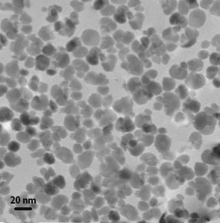

**Fig. S3.** TEM image of Fe3O4@glutathione

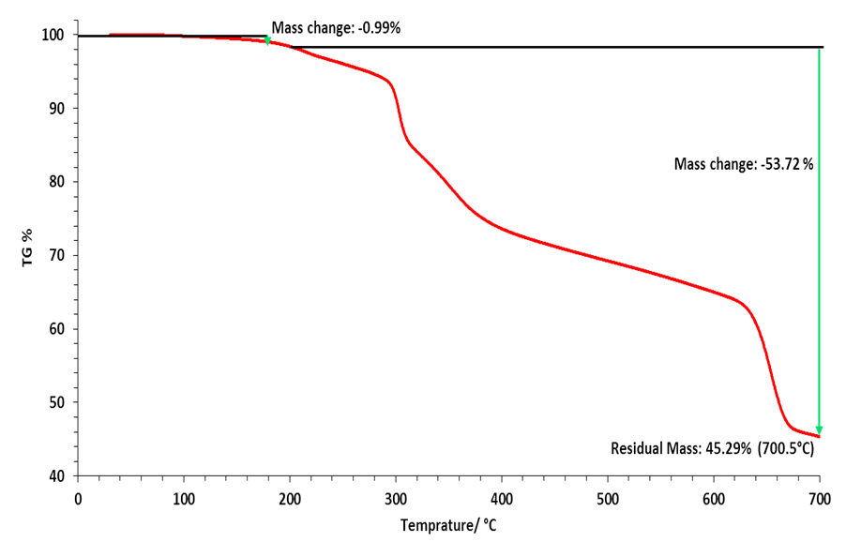

**Fig S4.** TGA of nano Fe3O4@glutathione

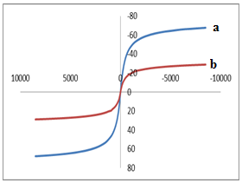

**Figure S5.** Vibrating sample magnetometry curves: (a) Fe3O4; (b) nano Fe3O4@glutathione

To verify the immobilization of modified Fe3O4, CHNS elemental analysis of the catalyst was conducted. The result confirms (C, 5.28%; N, 2.54%; H, 1.94%, S, 1.29% ) a large amount of organic groups was loaded onto the Fe3O4