SUPPORTING INFORMATION

Efficient anti-tumor nano-lipoplexes with unsaturated or saturated lipid induce differential genotoxic effects in mice

Hari Krishnareddy Rachamalla#, Sujan Kumar Mondal#, Shruti Deshpande,
Kathyayani Sridharan, Kalpana Javaji, Madan Mohan Chandra Sekhar Jaggarapu, Sudhakar Jinka, Vishnusravan Bollu, Sunil Misra*, Rajkumar Banerjee*

Applied Biology Division, CSIR-Indian Institute of Chemical Technology, Uppal Road, Hyderabad 500007, Telangana, India &Academy of Scientific & Innovative Research (AcSIR), CSIR-HRDC Campus, Ghaziabad-201 002, Uttar Pradesh, India.

Correspondence to:

Dr. Rajkumar Banerjee, Applied Biology Division,
CSIR – Indian Institute of Chemical Technology (CSIR-IICT), Uppal
Road, Tarnaka, Hyderabad 500 007, Telangana State, India. Tel: +91
4027191859. E-mail:banerjee@iict.res.in

Dr. Sunil Misra, Applied Biology Division,
CSIR – Indian Institute of Chemical Technology (CSIR-IICT), Uppal
Road, Tarnaka, Hyderabad 500 007, Telangana State, India. Tel: +91
4027191379. E-mail: smisra@iict.res.in

#Both the authors contributed equally

Materials and methods

Chemicals
DODEAC(or, D0), D1(Meka et al. 2016) cationic lipids and ESC8 (Scheme 1) (Sinha et al. 2011) were synthesized following previously established methods. MTT(3-(4,5-dimethylthiazol-2-yl)-2,5-diphenyltetrazolium bromide), dexamethasone, cholesterol, and RU486(mifepristone)were purchased from Sigma-Aldrich Co. (St. Louis, MO). Cyclophosphamide (CP) was procured from Zydus, Ahmedabad, India. 16:0 Lissamine Rhodamine PE were purchased from Avanti polar lipids. Inc, Alabama, USA. Giemsa stain and colchicine were procured from Loba Chemicals, Mumbai, India and cyclophosphamide (CP) from Zydus, Ahmedabad, India. All other laboratory chemicals/solvents were purchased either from SigmaSt. Louis,MO, USA or from Rankem Ltd. (Mumbai, India).

Biologicals
The Chinese hamster ovary (CHO), African green monkey kidney fibroblast like cell line (COS-1), Mouse melanoma (B16F10), Human pancreatic cancer (PANC-1, MIA PaCa-2) cell lines were procured from ATCC (Manassas, VA). Cells were grown in 10% fetal bovine serum and 0.005% antibiotics (penicillin, streptomycin and kanamycin)-supplemented DMEM medium maintained at 37 °C and in 5% CO₂incubator. Mouse anti-rabbitKi-67 antibody goat anti-mouse IgG-PE (sc-3738), and goat anti-rabbit IgG-FITC (sc-2012) were purchased from Santa Cruz Biotechnology. TUNEL Apoptosis Assay Kit was purchased form sigma St. Louis, MO, USA.

Plasmids and their maxi-preparation
Artificial miRNA plasmid construct (amiR-Hsp90 or Hsp90), which contains Hsp90 micro-RNA gene, and green fluorescent protein (eGFP) plasmid construct were made following the same method as described previously (Pore et al. 2013) using SurePrep Plasmid Maxi Kit [Catalogue number: NP-15161] which provides endotoxin free plasmids. Briefly, amiR-Hsp90 and eGFP plasmid were isolated by alkaline lysis procedure and the method involved treatment of bacterial cell lysates with phenol: chloroform: isoamyl alcohol (25:24:1) to remove unwanted proteins (endotoxins) associated with the plasmid. Further purification was done by PEG-8000 precipitation. The purities of plasmids were checked by A260/A280 (1.7−1.9) and 1% gel electrophoresis.

Preparation of liposomes
DXE and D1XE liposome was prepared following previous protocol (Mondal et al. 2016). The final concentrations of DODEAC, Cholesterol, dexamethasone and ESC8 in DXE and D1, Cholesterol, dexamethasone and ESC8 in D1XE were taken at 1:1:0.75:0.25 molar ratio respectively. 1 mM DXE and D1XE liposomes (with respect to cationic lipid, DODEAC and D1) were used for in vitro studies while for in vivo studies, 5 mM liposomes (with respect to cationic lipids, DODEAC and D1) were used. The ESC8 drug encapsulation efficiency was determined following previously established method (Mondal et al. 2016).

Lipoplex preparation and its treatment
For all the in vitro studies, 1mM DXE and D1XE liposomes prepared in autoclaved deionized water was used, while for in vivo studies, 5mM liposomes prepared in 5% glucose were used. Lipoplexes of DXE and D1XE liposomes respectively, with anti-miRHsp90 plasmid was prepared as per previous literature (Mondal et al. 2016). The charge ratio of cationic lipid to DNA was maintained at 2:1 for in vitro studies. Cytotoxicity and transfection studies were carried out in96-well and 24-well plates respectively, while cellular uptake studies were carried out on cover-slips placed in 6-well plate. For lipoplex formation, primarily Hsp90 plasmid was taken in serum-free media at a concentration of 0.3µg/well (dispersed in 50µL for 96-well plate) and 0.5µg/well (dispersed in 75µL for 6-well and 24-well plates respectively). Corresponding volumes of DXE and D1XE liposomes were dispersed in 50µL (for 96-well plate) and 75µL (for6-well and 24-well plates) in serum-free media. The liposomal and plasmid solutions were then mixed and the lipoplex complexation was achieved by incubating the mixture for 15min on a shaker at room temperature. Requisite volumes containing specified concentrations of lipoplexes were added to cells grown in complete media (500µl/well for 6-well and 24-well plate and 100µl/well for 96-well plate).
For in vivo studies, the charge ratio of cationic lipid to DNA was maintained at 6:1charge ratio (+/−). Volume of lipoplex corresponding to 40µg of plasmid was injected per animal.

Characterization of liposomes/lipoplexes
The hydrodynamic diameter, zeta potential and polydispersity index (PDI) of 5mM liposomes and lipoplexes (at lipid/DNA charge ratioof6:1) in water, plain DMEM and 10% serum containing DMEM were evaluated after 1:50 dilution using Lite SizerTM 500 Particle Analyzer, (Anton Paar). The refractive index and viscosity values for different media are respectively as follows: deionized water (1.3303, 0.0008903 Pa.s) , serum free media (1.3303, 0.0008903 Pa.s) and 10% serum-associated media (1.3300, 0.0009401 Pa.s). Z_{Ave} is in ‘Intensity’ parameters.

TEM Analysis
The size and morphological features of the 5mM liposomes were analyzed by TEM. Briefly, 5μL of 5mM liposomes was placed on a carbon-coated copper grid (glow-discharged for 45s using a Tolarno Havoc Evaporator) for 10 min. The excess sample was blotted with Whatman filter paper. The dried coated grids were vacuum-dried, and the electron micrographs of the liposomes were recorded with a FEI Tecnai 12 TEM instrument.

Reactive oxygen species (ROS) measurement
Chinese hamster ovary (CHO) cells were seeded at a density of two lakh cells/well in a 6-well plate. The cells were cultured in DMEM medium supplemented with 10% FBS and incubated at 37 °C in 5% CO₂. After 18 hours medium was replaced with fresh media followed by treated with corresponding lipoplexes for 24 hours, H₂O₂ was a positive control at 4 hours treatment. The medium was removed again. The fluorescent dye 2′,7′-dichlorodihydrofluorescein diacetate (DCF-DA, 20 μM) was added to the medium. The treated cells were then washed with cold PBS, and collected by trypsinization and centrifugation at 1500 rpm for 5 min, and the cell pellets were suspended in PBS The fluorescence intensity was analyzed by using BD FACS Canto II flowcytometer with 10,000 cell counts. The treatments were performed in triplicate wells under each group.

In vivo cytogenetic toxicity study
Swiss albino mice (4–5 weeks age) were procured from National Institute of Nutrition (NIN), Hyderabad, India and acclimatized for 2 more weeks at CSIR-IICT animal house prior to their utilization in the experiments. At the time of experimentation, the mice were aged between 6-8-weeks, so as to obtain a greater number of dividing cells in the bone marrow region (Balasubramanyam et al. 2009, Bollu et al. 2016, Grover et al. 2009). The experiment was performed under protocol approved by Institutional Animal Ethical Committee of CSIR-IICT, India. Herein, under each treatment group we kept 3 males and 3 females. For all genotoxicity related studies, three sample-slides were made per mice.

Mitotic chromosome aberration test

For mitotic metaphase chromosomal aberrations (CAs) and mitotic index (MI) studies, treatments on mice were done either single or multiple times for seven consecutive days and the bone marrow cells were isolated after a time-point of 24h either after single treatment or following the seventh dose. All the genotoxicity data were collected for male and female mice separately to understand the sex-specific susceptibility due to DXE-amiR-Hsp90 and D1XE-amiR-Hsp90 lipoplex treatments. Following this, from each group (3 males and 3 females) mice were injected intraperitoneally with 0.02% of colchicine. After one and half hours of colchicine treatment, the mice were sacrificed, bone marrow was extracted and chromosome slides were prepared following earlier published protocol (Choudhury et al. 2000). Briefly the bone marrow cells from the femur and tibia was extracted and incubated in hypotonic solution (0.9% sodium citrate) at 37°C for 20-25 minutes and centrifuged at 2000rpm for 5 minutes. After discarding the supernatant, the cell pellets were then re-suspended in fixative methanol/acetic acid (3:1 v/v). The chromosome preparation was done following the flame drying technique and finally stained with Giemsa. At least 300 well-spread mitotic metaphases were screened from each animal to record the types of chromosomal aberrations like chromatid (gaps & breaks), chromosome (gaps & breaks), fragments, minutes, pulverization and a typical exchange.

Mitotic index study
Mitotic index (MI) analysis was done to estimate in the changes in the rate of cell proliferation during the cell division in presence of the test chemicals. It is calculated by taking the ratio of number of dividing cells (prophase+metaphase+anaphase+telophase) to the total number of cells observed. For this study, the slides prepared for CA assay were used for the calculation of mitotic index from each animal. At least 2000 cells from each animal were scored for the estimate the MI.

In Vivo bone marrow cell cycle study
The cellular DNA content was measured by cell cycle assay. In vivo bone marrow cell cycle analysis was carried out following previous literature (Rithidech et al. 2008). In brief, the 4–5 weeks old female and male Swiss albino mice were injected i.p. with 0.9% NaCl (control), DXE-Hsp90 lipoplex (3.73 mg/kg b.w. with respect to ESC8 drug) and CP (40 mg/kg b.w.). After 30 h of injection, mice were colchicinized and sacrificed, and then bone marrow cells from tibia and femur was collected using ice cold PBS. Bone marrow cells were washed twice to remove the excess tissues by centrifugation at 2000 rpm for 5 min and fixed with 70 % ethanol at −20 °C for overnight.
Bone marrow cells were processed using following procedure before running FACS. Ethanol was removed and washed with 1X PBS. The cells were then suspended in 500 µL of PI staining solution (50 µg/mL Propidium iodide, 0.1 mg/mL RNAse, 0.05% Triton X-100) and incubate in dark for 40 min at 37 °C. After incubation cells were collected by centrifugation, washed with 1X PBS, re-suspended in 500 µL 1X PBS, and data was recorded using flow cytometer (FACS Canto II, Becton-Dickinson, San Jose, CA, USA) and were analyzed with FACS Diva software. A minimum of 10,000 events were gated per sample.

Micronucleus test
Treatments were done for seven consecutive days and the bone marrow cells were isolated from mice after a time-point of 30h following the seventh dose treatment, the rest 6 mice (3 male and 3 female) were used for the micronucleus test. Two separate sources i.e. from peripheral blood and bone marrow cells were selected to estimate and compare the percentage of MN formation in these two sources following the modified protocol (Misra and Choudhury 2006, Schmid 1975).

Bone marrow MN analysis
Seven consecutive doses followed by 30 h post-treatment, bone marrow was collected from the femur and incubated with 1% sodium citrate at 6–8 ⁰C. After incubation, the suspension was centrifuged at 1200 rpm for 5 min. After discarding the supernatant, the pallets were smeared on clean grease free slides and kept overnight at 37⁰C at 85% RH. Next day the slides were dipped in methanol for 5 min, air dried and stained with Giemsa for 10 min. Atleast 2000 polychromatic erythrocytes (PCE) per animal were screened to estimate the frequency of MN in the bone marrow PCEs.

Peripheral blood MN analysis
The blood was collected from each animal through retro-orbital root following proper anesthetic procedure and smeared on clean grease free slides and allowed to dry. All the slides were kept in the incubator at 37 °C at 85% RH overnight. Next day slides were fixed in methanol for 5 min, air dried and stained with 0.5% Giemsa for 10 min. At least 2000 PCE per animal were screened to estimate the occurrence of MNs.

Single cell gel electrophoresis (Comet) assay
Alkaline comet assay was performed to evaluate the DNA damaging potential of DXE-amiR-Hsp90 and D1XE-amiR-Hsp90 lipoplexes relative to positive and negative controls, cyclophosphamide (40mg/kg b.w.) and 0.9% NaCl in both male and female mice. The assay was performed as per the protocol described in (Gunasekarana et al. 2015). Peripheral blood and bone marrow cells were isolated and analyzed for DNA damage post 24h followed by lipoplex treatments for seven consecutive days. Peripheral blood cells were collected by retro-orbital puncture and mixed with EDTA (1.6 mg/ml of blood) to prevent coagulation. Bone marrow cells were extracted by femur and tibial flushing with Hanks' Balanced Salt Solution (HBSS) buffer containing 20mM EDTA and10% DMSO. The extracted cells were centrifuged at 2000 rpm for 5 min and the cell pellet was re-suspended in fresh HBSS. Both the peripheral blood and bone marrow cells were stored at -80 °C until further analysis. For the experiment, initially for cell lysis, a plain glass slide was primarily coated with 200μl of 1% normal melting agarose (NMA) and layered with 5μl of peripheral blood or bone marrow suspension mixed with 80μlof 0.5% low-melting point agarose (LMA). The slide was allowed to colon an ice tray for 10 min and finally covered with a third layer of 100μl of 0.5% LMA. It was allowed to stabilize by placing on the ice tray for further 10 min. The slides were then stored overnight at 4°C in lysing solution containing 2.5M NaCl, 100 mM disodium ethylene diamine tetra acetic acid [Na₂ EDTA], 10mM Tris (pH 10) (with 10% DMSO, and 1% Triton X-100 freshly added). Subsequently for DNA unwinding and conversion of alkali-labile sites to single strand breaks, the lysing solution was replaced with fresh chilled alkaline electrophoresis buffer (300mM NaOH, 1 mM Na2EDTA, and 0.2% DMSO, pH >13.5) and left undisturbed for 25 min at4°C. Further, electrophoresis was performed using the same buffer at 4°C for 25 minutes at 25 V and 300 mA. The slides were then neutralized by washing thrice with 0.4M Tris buffer (pH 7.5) to remove excess alkali, and then stained with 80μl ethidium bromide (10μg/ml) for 5 minutes to visualize DNA damage. At least, three slides per mouse were prepared and analysis was done for around 300 cells per treatment using LUCIA Comet Assay 64 bit on JENOPTIK ProgRes version 7.50 comet image acquisition software attached to Nikon fluorescent microscope (Model: ECLIPSE NI-U 940987) fitted with suitable filters. The parameter selected for quantification of DNA damage is percent tail DNA (percent tail DNA =100% – percent of head DNA), as determined by the software.

Cell viability assay
Cytotoxicity assay of the DXE-amiR-Hsp90 and D1XE-amiR-Hsp90 lipoplex were carried out by using 3-(4,5-dimethylthiazol-2-yl)-2,5-diphenyltetrazolium bromide (MTT). Briefly, 12−18 h before treatment CHO, COS-1, B16F10, PANC-1 and MIA PaCa-2 cells were plated in 96-well plate at 5000 cells/well density. After incubation cells were treated continuously for 48 h with DXE-amiR-Hsp90 and D1XE-amiR-Hsp90 lipoplexes. 10 μL of stock MTT reagent (3 mg/mL) was added to each well and incubated for 4 h under dark. The purple formazan crystals were dissolved in 50 μL DMSO : methanol (1:1, v/v) and absorbances of the resulting clear solutions were recorded at 570 nm using microplate reader (BioTeK Synergy H1 Hybrid Multi-Mode Reader). The results were expressed as percent cell viability using the formula: % cell viability = [A570 (treated cells) - background/A570(untreated cells) - background]×100. Each experiment was performed in triplicate. This in vitro cell viability study is performed at least two times for all the cells. The data so presented is a representative data obtained from cells plated in triplicate on a single day.

Transfection
Cells were seeded at a density of 50,000 cells/well in a 24-well plate usually 18–24 h before transfection. The transfection of cells with 0.5µg of eGFP plasmid were performed as described previously (Dharmalingam et al. 2017). For the RU486 pretreated experiments, cells were treated with RU486 (in dimethyl sulfoxide) in a final concentration of 100µmol/l for 2 h (Mukherjee et al. 2009). Thereby, the usual transfection procedure as described above was followed. The transfection values are reported as the average values of triplicate experiment performed in the same plate on the same day. To verify reproducibility, each transfection experiment in B16F10 cell was performed at least four times on four different days. Other cell-line data were the representative data of at least two transfection experiments. The day to-day variations in transfection efficiency were mostly within two to three folds and were dependent on cell condition.

Cellular uptake studies by confocal microscope
PANC-1and B16F10 cells were seeded on a cover slip placed into a six well plate 18 h prior to treatment. 1 mM DXE and D1XE Rhodamine-PE labeled liposome was dispersed in serum free media in final volume of 50 µL and it was then complexed with 0.5 µg/well (in 24 well plate) of anti-miRHsp90 plasmid which diluted in 50 µL serum free media. The charge ratio of cationic lipid to DNA was maintained at 4:1. The resultant mixture was shaken for 15 min at room temperature and then subsequently used for treatment. After 4 h, media was removed, the cells were washed thrice with PBS, and fixed with 4% paraformaldehyde in PBS for 20 min. The cover slip was finally mounted on a slide using mounting medium (Fluor shield with DAPI) and imaged under confocal microscope (Nikon Ti Eclipse). The cellular uptake data so presented is the representative data from one of the two independent experiments performed in different days.

In Vivo tumor model
For melanoma model 6 to 8 weeks old female C57BL/6J mice, were subcutaneously inoculated with 0.25 million B16F10 cells in the lower left abdomen. Eleven days following cell implantation, mice were randomly grouped and treatment was started. Each of the lipoplex treatment groups and untreated group contained 5 mice. The concentrations for the lipoplexes were initially optimized by (Mondal et al. 2016, Pore et al. 2013). 300µl of lipoplex was injected intra peritoneally comprising of 150µl of 5mM liposome and 150µl plasmid mix containing 40µg amiR-Hsp90 plasmid, corresponding to 6:1 charge ratio of liposome and plasmid. The effective concentration of ESC8 in the lipoplex was 3.47mg/kg b.w. and that of plasmid was 40µg per injection. The groups were as follows: a. mice intraperitoneally injected with 5% glucose (UT). b. mice intraperitoneally injected with 40μ g of anti-miRHsp90 plasmid complexed with DXE liposome. c. mice intraperitonially injected with 40μg of amiR-Hsp90 plasmid complexed with D1XE liposome. For in vivo melanoma tumor regression study, 6:1 charge ratio cationic lipid to DNA was used. Seven intraperitoneal injections were consecutively administered to mice for 7 days. Tumors were monitored by measuring size for B16F10 tumor. Tumor sizes were expressed in volume (mm³) and calculated by using the formula (0.5 × a × b²), where ‘a’ and ‘b’ represent the longest and the shortest dimension of the tumors respectively. B16F10 subcutaneous tumor experiment was terminated when tumor volume of the untreated group reached ~ 3500 mm³.All the live animal experiments were performed with protocols cleared by Institutional Animal Ethical Committee (IAEC) of CSIR-IICT, India.

TUNEL assay:
After completion of the melanoma model based in vivo study, one mouse from
each group was sacrificed for histological study. The tumors were frozen in Jung tissue
freeze medium (Leica Microsystem, Germany) followed by cryo-sectioning of 10 μm
thin sections using Leica CM1850 cryostat (Germany). The sections were fixed into 4%
formalin for 15 min and TUNEL assayed using Dead-End fluorometric apoptosis
detection kit (BD Biosciences) as per manufacturer’s protocol. Then the tissues were mounted with 4-6-diamidino-2-phenylidone (DAPI)-containing mounting medium and images were captured in Nikon confocal microscope at 10X magnification. Quantitative representation was done as percentage of DAPI-positive cells stained with TUNEL (for TUNEL-positive cells).

Ki-67 staining:
For Ki-67 staining, first tissue sections were incubated with mouse anti-rabbit
Ki-67 antibody (1:200, Thermo Scientific) and then stained with Cy-conjugated goat anti-
mouse secondary antibody (1:200, Jackson Immune Research). The Ki-67 stained
tissues were then mounted with DAPI containing mounting medium and observed under
Nikon confocal microscope at 10X magnification. The Ki-67 staining index (SI) was
represented as the percentage of DAPI positive cells that express Ki-67.

Statistical Analysis
Unpaired t-test was performed using Graph Pad Prism version 6.04 for Windows, Graph Pad Software, San Diego, CA. It was used to analyze the data followed by ‘‘One-way ANOVA’’ with Dunnett’s post-test.

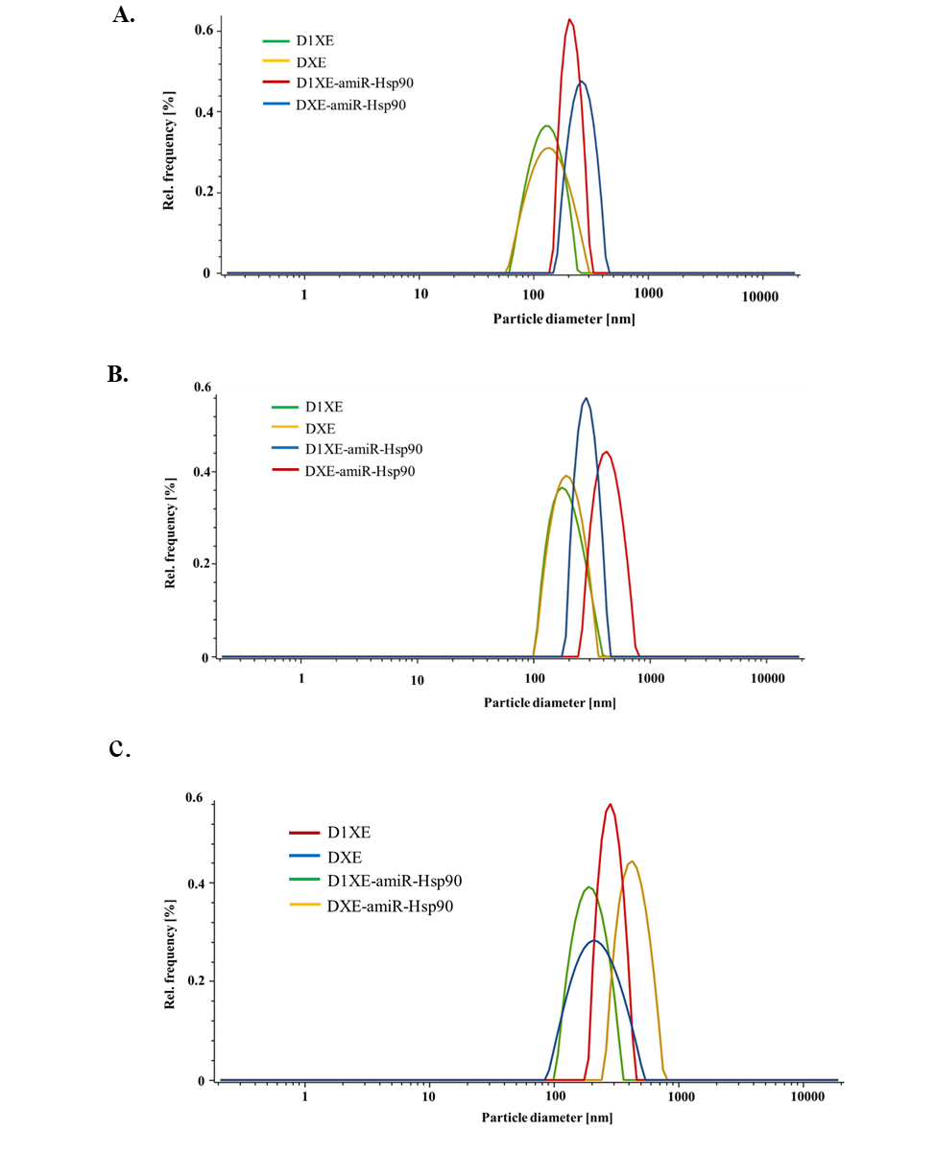

Figure S1. Hydrodynamic dynamic diameter histograms of DXE and D1XE liposomes and DXE-amiR-Hsp90 and D1XE-amiR-Hsp90 lipoplexes obtained by DLS in different media A) Water B) Serum free medium C) 10% Serum containing medium. Each formulation was prepared and characterized thrice. The data so represented is one of the representative histograms for each of the formulations.

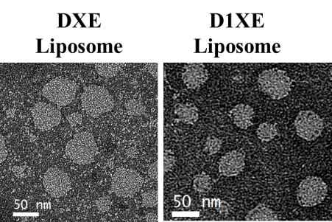

Figure S2: Determination of shape and particle size distribution of DXE and D1XE liposomes by using TEM.

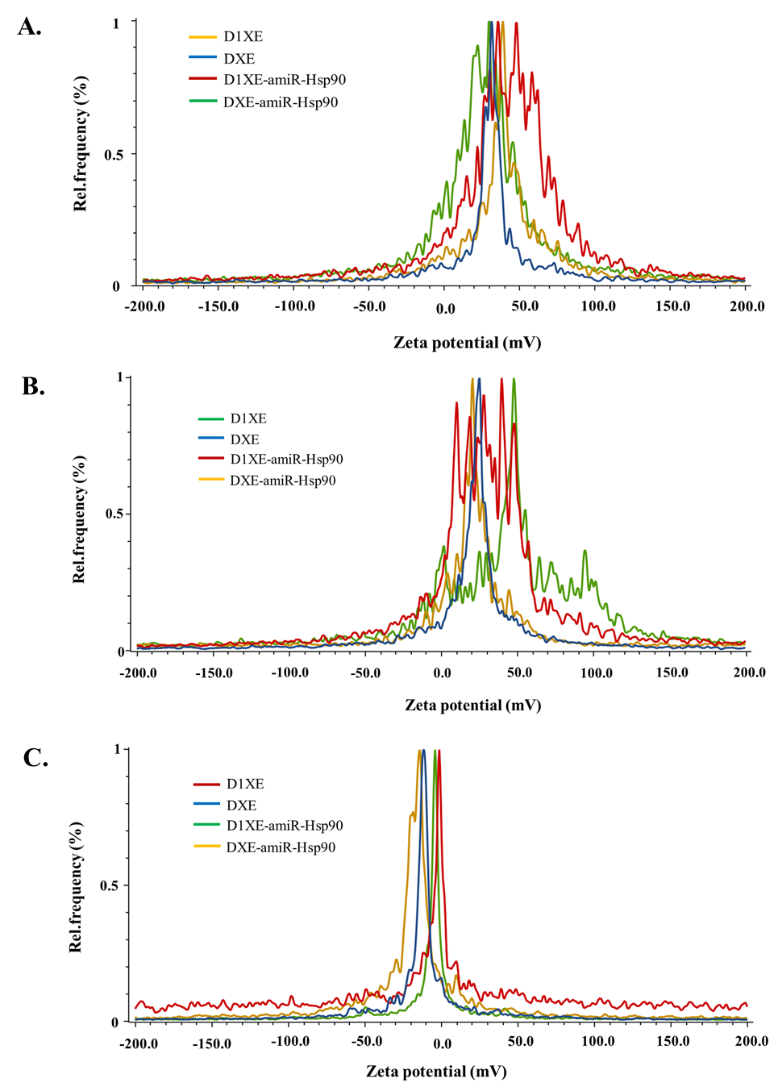
Figure S3. Zeta potential histograms of DXE and D1XE liposomes and DXE-amiR-Hsp90 and D1XE-amiR-Hsp90 lipoplexes obtained by DLS in different media A) Water B) Serum free medium C) Serum containing medium. Each formulation was prepared and characterized thrice. The data so represented is one of the representative histograms for each of the formulations.

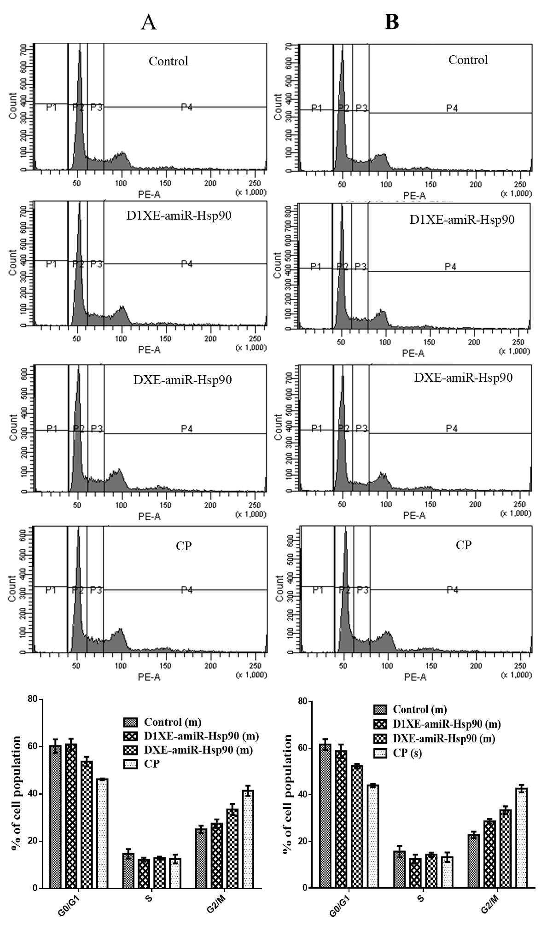

Figure S4: Cell cycle analysis of bone marrow cells isolated from female [panel (A)]and male [panel (B)] Swiss albino mice treated with 7 doses of control: 0.9% NaCl, D1XE-amiR-Hsp90, DXE-amiR-Hsp90 (3.73 mg/kg b.w. with respect to ESC8 drug), and single dose of CP (40 mg/kg b.w.). Each of the experiments was performed in triplicates using bone marrow cells isolated from each mouse in each treatment group. Representative histograms of the cell population-percentage in different phases of cell cycle from one of the experiments are shown. The graphs represent the average and standard deviation of data pooled from three experiments under each treatment group. P1, P2, P3 and P4 represents cells population in sub G0/G1, G0/G1, S and G2/M phase respectively. The graph indicates quantitation of histogram data assayed on isolated bone marrow cells from 3 respectively treated mice under each gender.

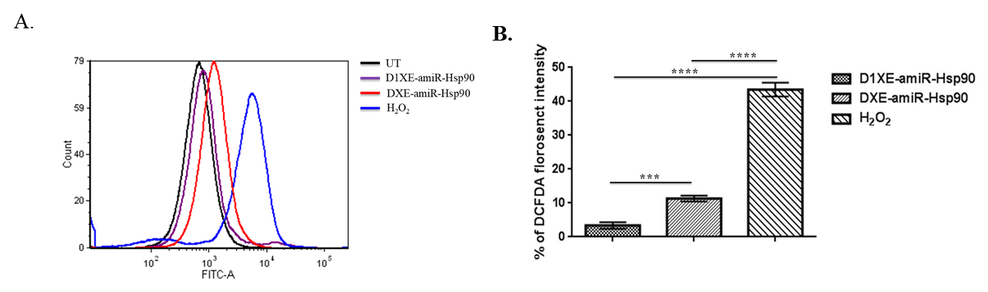

Figure S5. ROS induction potential of D1XE-amiR-Hsp90 and DXE-amiR-Hsp90 lipoplexes in CHO cell line. The histogram indicates the shift in DCFDA fluorescence produced by ROS. Treatments with D1XE-amiR-Hsp90 and DXE-amiR-Hsp90 lipoplexes were performed at 2:1 charge ratios for 24h, while the positive control H2O2 was treated at 250µM for 4h. A) FACS histogram data B). This experiment was performed single time in triplicate wells under each treatment group.

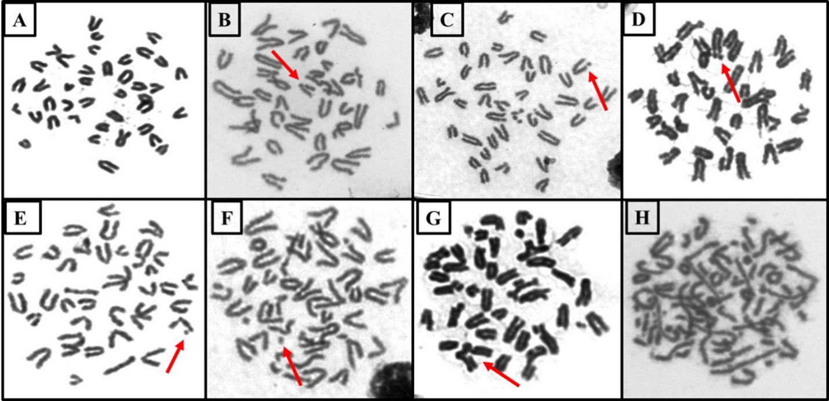
Figure S6. In vivo bone marrow chromosomal aberration assay: A total of 300 metaphase spreads per animal were observed in bone marrow cells of Swiss albino mice. Representative images of different types of chromosomal aberrations so observed are shown. A: represent the normal metaphase spread; B: chromatid gap; C: chromatid break; D: chromosome break; E: minutes; F: fragment; G: Translocation; H: pulverization.

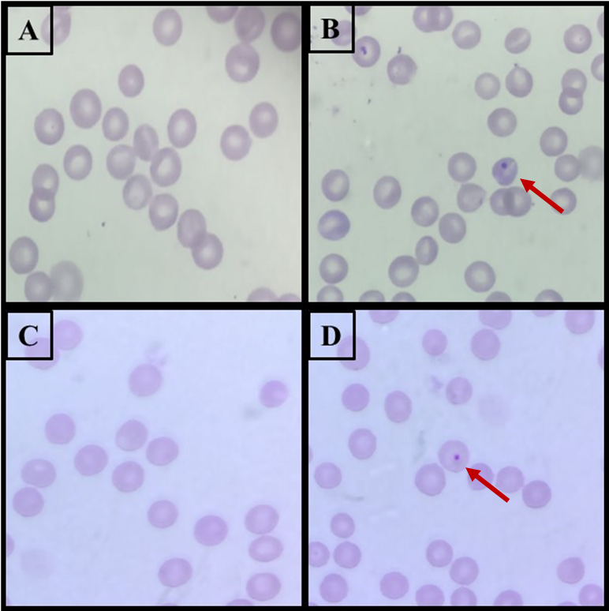
Figure S7. In vivo micronucleus assay of bone marrow and peripheral blood in Swiss albino mice: Atleast 2000 polychromatic erythrocytes (PCE) per animal were screened and representative images of micronucleated PCE of peripheral blood (A and B) and bone marrow (C and D) are shown. A and C represent normal PCE; B and D represent mono-nucleated PCE.

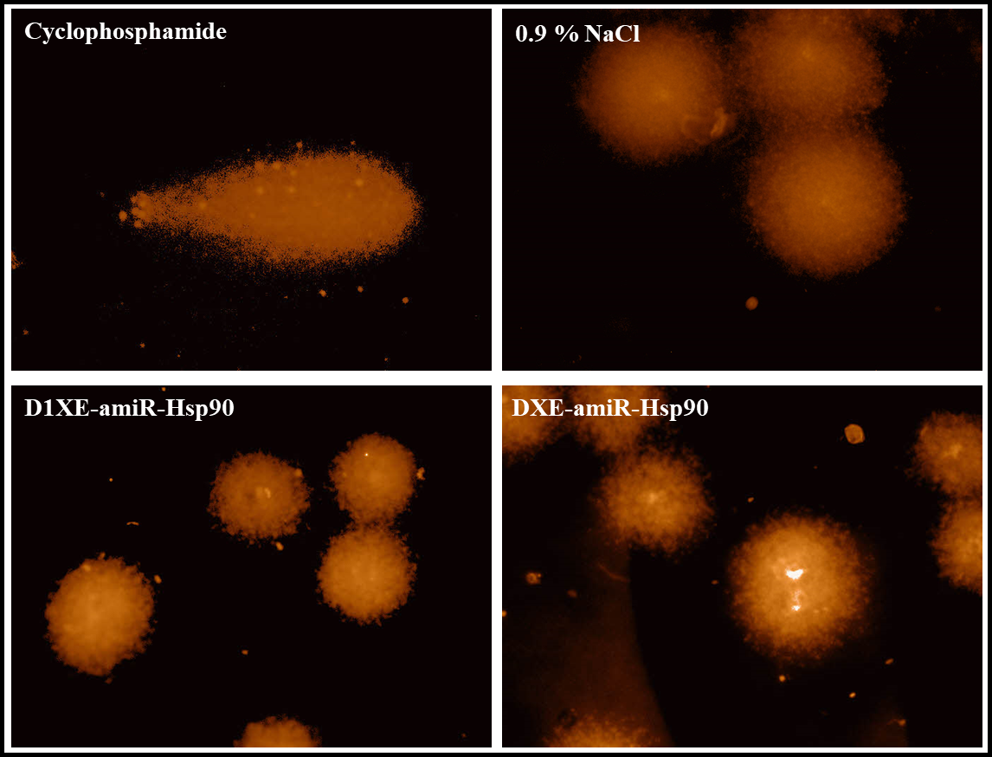

Figure S8. Comet Assay: The percentage of DNA damage in around 300 cells per treatment group was observed and representative images in different treated groups of Swiss albino mice are shown. Damaged DNA content was quantified as percent tail DNA.

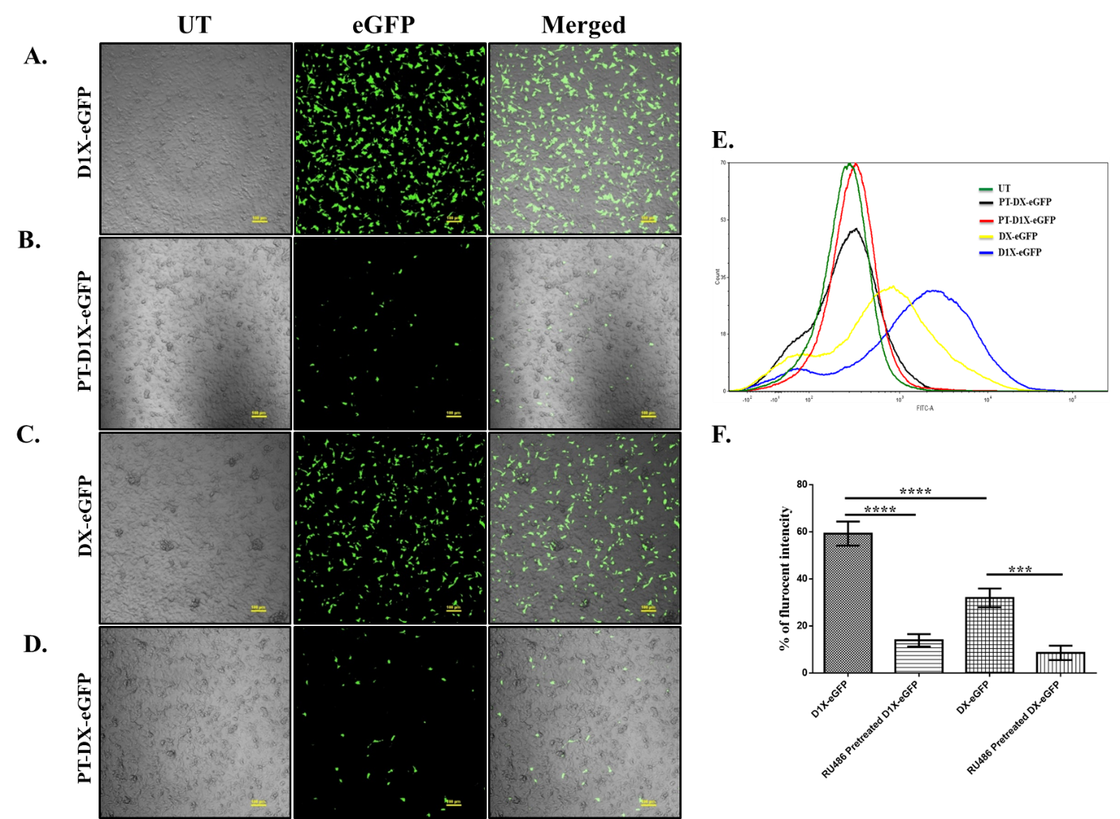

Figure S9. In vitro transfection efficiencies of DX and D1X liposomes and their quantification in B16F10 mouse melanoma cells after 48h of treatment. The transfection ability of the lipoplexes was dependent on the availability of cellular glucocorticoid receptor (GR) as evident from reduced cellular transfection seen in RU486-pretreated groups. A, C: Confocal microscopic images showing cells transfected with lipoplexes D1X-eGFP (A) and DX-eGFP (C). B, D: Confocal microscopic images showing cellular transfection by D1X-eGFP (B) and DX-eGFP (D) following pre-treatment with 25µM RU486 for 2 hours. E. Peak shifts of eGFP positive cells treated with D1X-eGFP and DX-eGFP lipoplexes compared to untreated cells, as analyzed by flow cytometry. F. Graphical representation of percentage fluorescence intensity in eGFP-positive cells treated with D1X-eGFP and DX-eGFP lipoplexes and their corresponding RU486-pretreated groups. **** p < 0.0001; *** p < 0.001. This experiment was performed four times on four different days and each experiment was performed in triplicate. The images (A-E) are representative pictures obtained under each treatment group. The graph represents the data obtained from cells plated in triplicate on a single day.

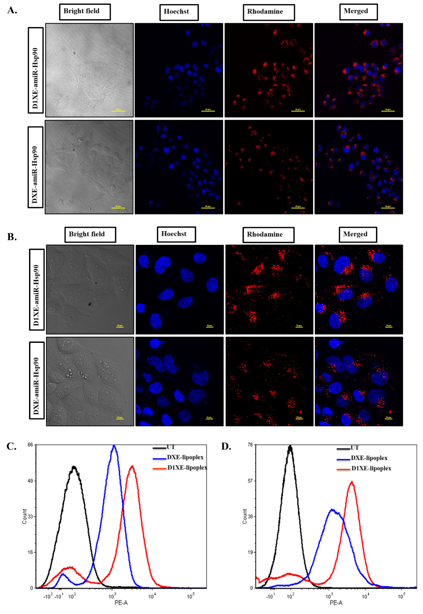

Figure S10. Cellular localization study: Confocal microscopic images of B16F10 (A) cell line and PANC-1 (B) treated with Rhodamine PE labelled DXE and D1XE lipoplexes; Quantification of Rhodamine PE localization B16F10 (C) and PANC-1 (D) by FACS. The cellular uptake data so presented is the representative data from one of the two independent experiments performed in different days.

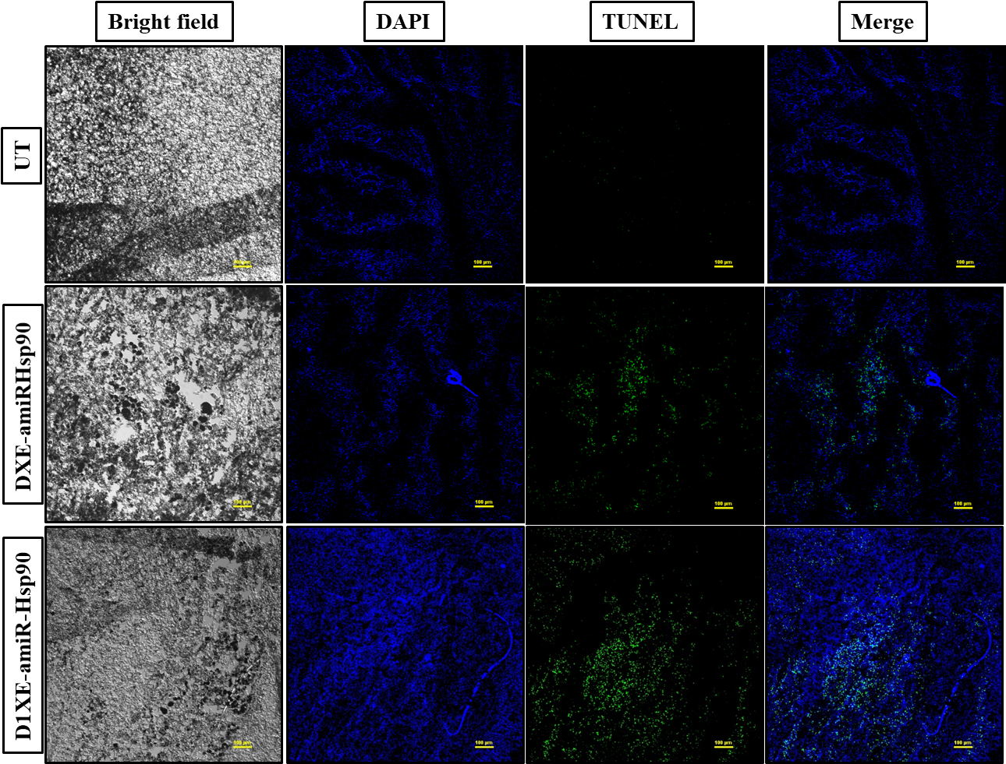

Figure S11. TUNEL study: Confocal microscopic pictures of 10μm thick melanoma tumor sections from UT (1st panel) group, DXE-amiR-Hsp90 (2nd panel) group and D1XE-amiR-Hsp90 (3rd panel) treated groups. The microscopic study was performed on multiple (> 7/tumor) tumor sections from tumors under each treatment group and representative images from one of the multiple tumor sections under each treatment group are presented.

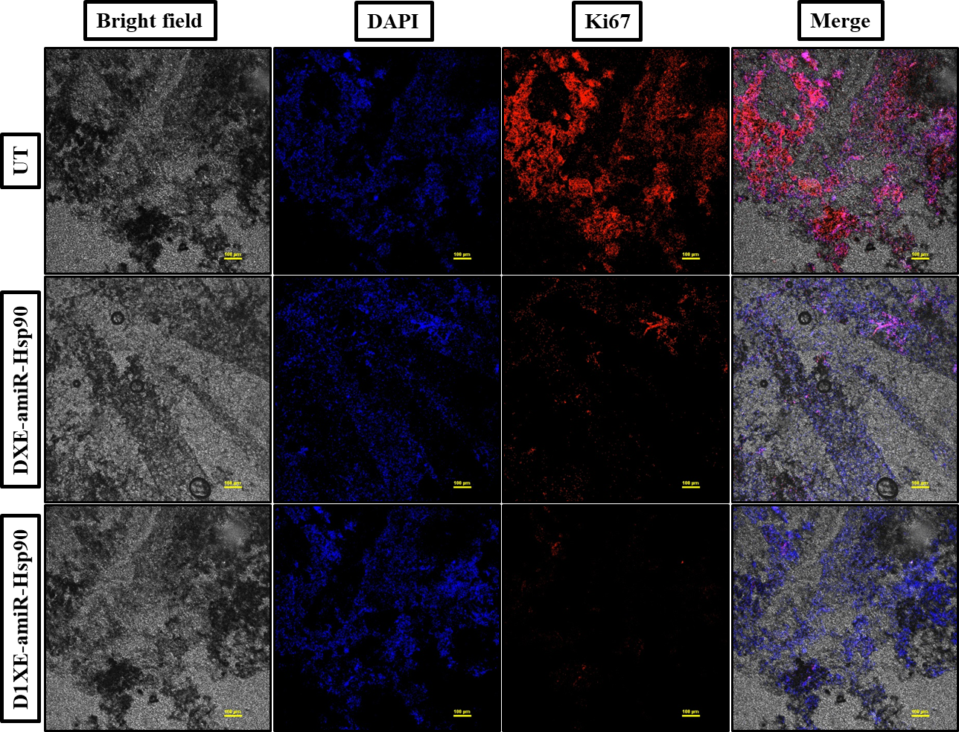
Figure S12. K_{i}67 staining assay: Confocal microscopic pictures of 10μm thick melanoma tumor sections from UT (1st panel) group, DXE-amiR-Hsp90 (2nd panel) group and D1XE-amiR-Hsp90 (3rd panel) treated groups. The microscopic study was performed in multiple sections (>7/tumor) of tumors under each treatment group and representative images obtained from one of the multiple sections are presented.

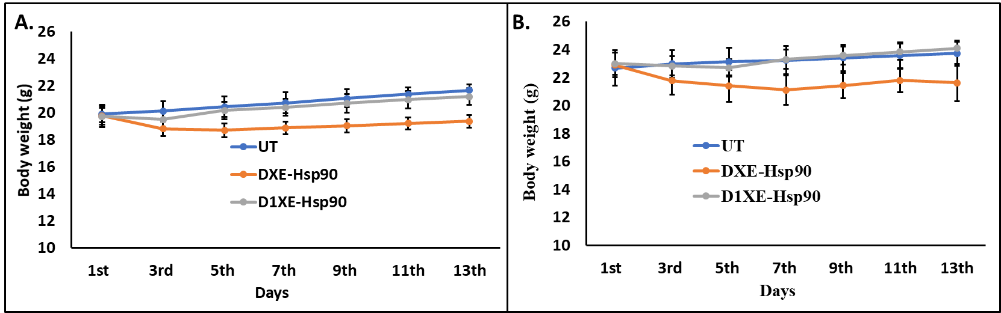
Figure S13. Body weight variations of female (A) and male (B) Swiss albino mice with different treatment groups. (n = 3 male and n = 3 female mice)

References:

Balasubramanyam A, Sailaja N, Mahboob M, Rahman MF, Misra S, Hussain SM, Grover P. 2009. Evaluation of genotoxic effects of oral exposure to aluminum oxide nanomaterials in rat bone marrow. Mutat Res 676:41-47.
Bollu VS, Nethi SK, Dasari RK, Rao SSN, Misra S, Patra CR. 2016. Evaluation of in vivo cytogenetic toxicity of europium hydroxide nanorods (EHNs) in male and female Swiss albino mice. Nanotoxicology 10:413-425.
Choudhury RC, Das B, Misra S, Jagdale MB. 2000. Cytogenetic toxicity of vincristine. Journal of environmental pathology, toxicology and oncology: official organ of the International Society for Environmental Toxicology and Cancer 19:347-355.
Dharmalingam P, Rachamalla HKR, Lohchania B, Bandlamudi B, Thangavel S, Murugesan MK, Banerjee R, Chaudhuri A, Voshavar C, Marepally S. 2017. Green Transfection: Cationic Lipid Nanocarrier System Derivatized from Vegetable Fat, Palmstearin Enhances Nucleic Acid Transfections. ACS Omega 2:7892-7903.
Grover P, Singh SP, Prabhakar PV, Reddy UA, Balasubramanyam A, Mahboob M, Rahman MF, Misra S. 2009. In vivo assessment of genotoxic effects of Annona squamosa seed extract in rats. Food and chemical toxicology 47:1964-1971.
Gunasekarana V, Raj GV, Chand P. 2015. A comprehensive review on clinical applications of comet assay. Journal of clinical and diagnostic research : JCDR 9:GE01-GE05.
Meka RR, Godeshala S, Marepally S, Thorat K, K. RRH, Dhayani A, Hiwale A, Banerjee R, Chaudhuri A, Vemula PK. 2016. Asymmetric cationic lipid based non-viral vectors for an efficient nucleic acid delivery. RSC Advances 6:77841-77848.
Misra S, Choudhury RC. 2006. Vitamin C modulation of cisplatin-induced cytogenotoxicity in bone marrow, spermatogonia and its transmission in the male germline of Swiss mice. Journal of chemotherapy 18:182-187.
Mondal SK, Jinka S, Pal K, Nelli S, Dutta SK, Wang E, Ahmad A, AlKharfy KM, Mukhopadhyay D, Banerjee R. 2016. Glucocorticoid Receptor-Targeted Liposomal Codelivery of Lipophilic Drug and Anti-Hsp90 Gene: Strategy to Induce Drug-Sensitivity, EMT-Reversal, and Reduced Malignancy in Aggressive Tumors. Mol Pharm 13:2507-2523.
Mukherjee A, Narayan KP, Pal K, Kumar JM, Rangaraj N, Kalivendi SV, Banerjee R. 2009. Selective Cancer Targeting via Aberrant Behavior of Cancer Cell-associated Glucocorticoid Receptor. Molecular Therapy 17:623-631.
Pore SK, et al. 2013. Hsp90-targeted miRNA-liposomal formulation for systemic antitumor effect. Biomaterials 34:6804-6817.
Rithidech KN, Golightly M, Whorton E. 2008. Analysis of cell cycle in mouse bone marrow cells following acute in vivo exposure to 56Fe ions. Journal of radiation research 49:437-443.
Schmid W. 1975. The micronucleus test. Mutat. Res. 31:9-15.
Sinha S, et al. 2011. A Lipid-Modified Estrogen Derivative that Treats Breast Cancer Independent of Estrogen Receptor Expression through Simultaneous Induction of Autophagy and Apoptosis. Molecular Cancer Research 9:364-374.

