Suplimentry materials

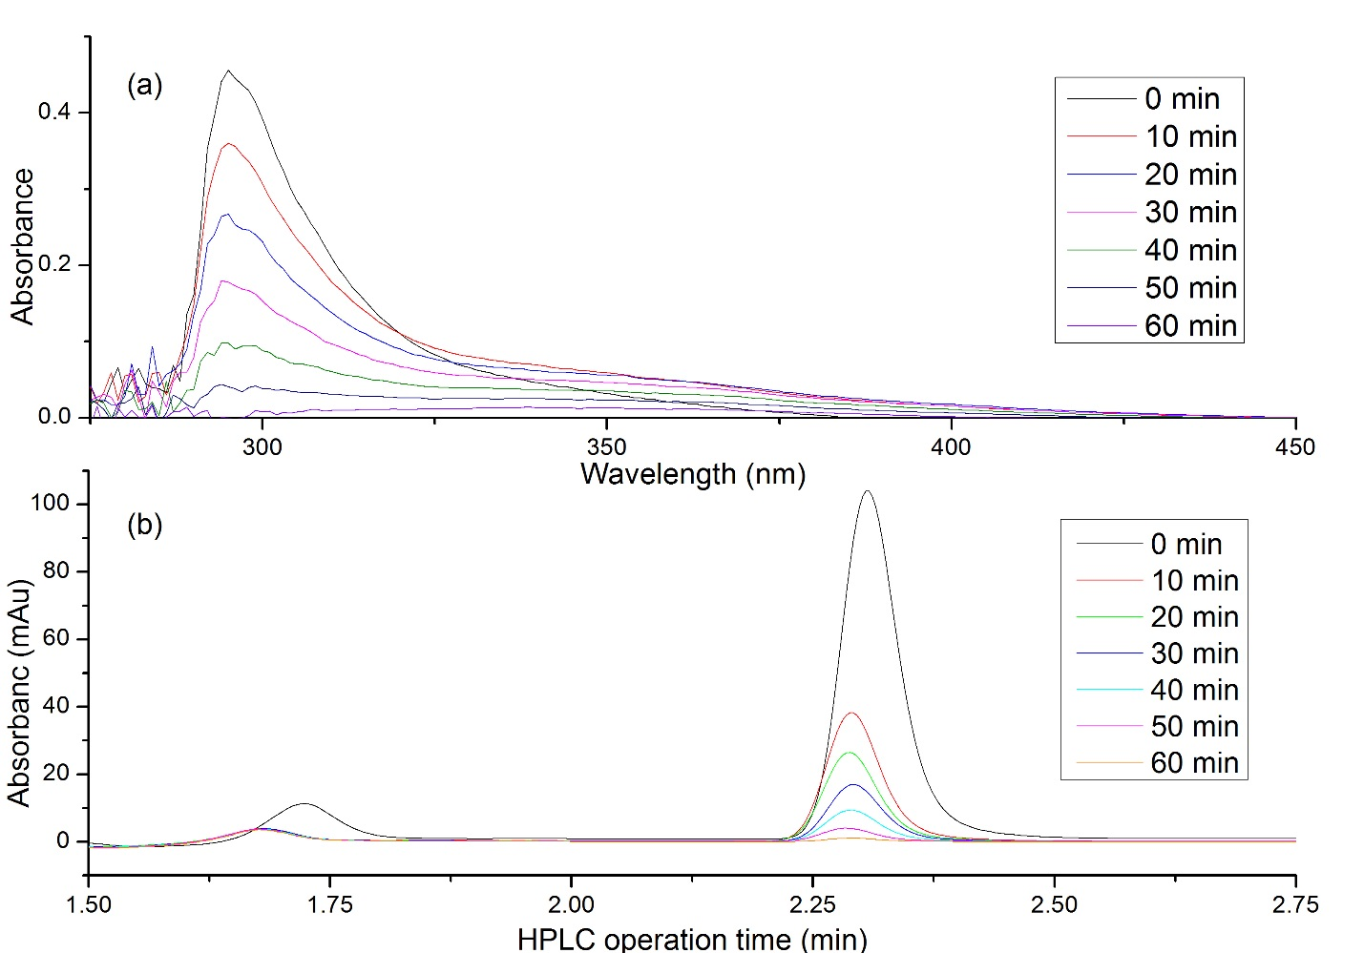
Figure S1. (a) Absorbance variation of NB by UV-Visible spectroscopy during 0-60 minutes of treatment time and (b) HPLC analysis of NB degradation at different times. Conditions for both experiments were; the NB initial concentration = 20 mg/L, applied voltage = 1.4 kV, O₂ concentration = 3 L/min, water flow rate = 1 m³/h and HPLC operation conditions were; injection volume of 20 μL, a flow rate of 1 mL/min, retention time of 10 minutes and the mobile phase consisted of 80% methanol and 20% water

Figure S2. LC-MS analysis of nitrobenzene degradation after 30 minutes. (a) refers to the peak retention times of the intermediates, (b) is the chromatograph of the intermediates, and (c) is the mass spectrum of the peak at retention time 1.30 minutes.

