Supporting data for “Discovery of New Butyrylcholinesterase Inhibitors via Structure-Based Virtual Screening”
Noor Atatreh¹, Sara AlRawashdah¹, Shaikha S. AlNeyadi³, Sawsan M. Abuhamdah^{1,2*}, Mohammad A. Ghattas^{1*}

¹ College of Pharmacy, Al Ain University of Science and Technology, Abu Dhabi, UAE, P.O. Box 112612. Tel: +971 (0) 2 4444696. Fax: +971 (0) 2 4444304
² Department of Biopharmaceutics and Clinical Pharmacy, Faculty of Pharmacy, The University of Jordan, Amman 11942, Jordan
3 Department of Chemistry, College of Science, UAE University Al-Ain, 15551 UAE

List of figures:

Figure 1. ¹H-NMR spectrum for compound 4

Figure 2. ¹H-NMR spectrum for compound 5

Figure 3. ¹H-NMR spectrum for compound 12

Figure 4. ¹H-NMR spectrum for compound 26

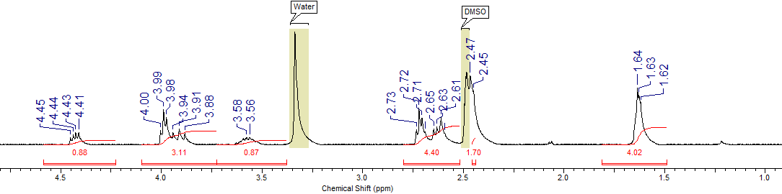
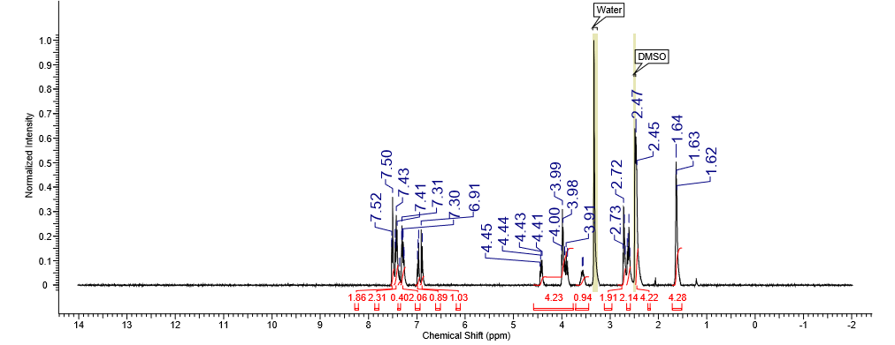

Figure 1. ¹H NMR spectra of compound 4 (NCS 602697) in DMSO-d₆ at 298 K
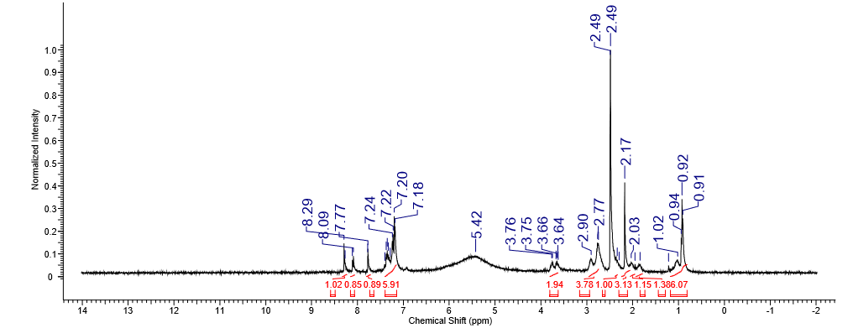
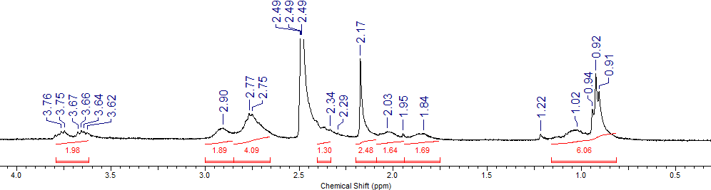

Figure 2. ¹H NMR spectra of compound 5 (NCS 11052) in DMSO-d₆ at 298

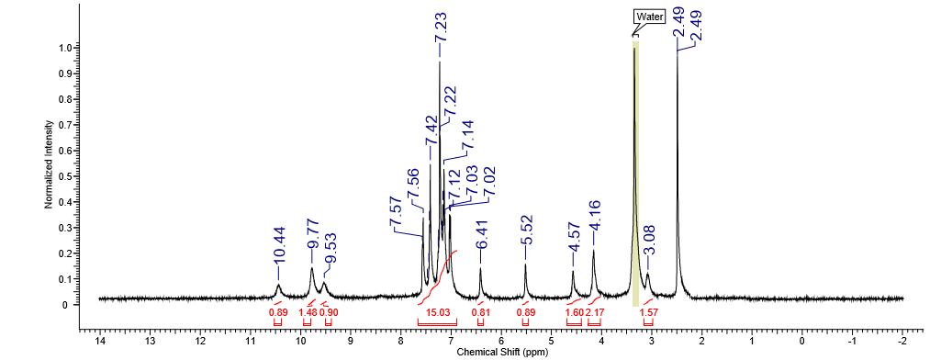

Figure 1. ¹H NMR spectra of compound 5 (NCS 11052) in DMSO-d₆ at 298 K

Figure 3. ¹H NMR spectra of compound 12 (NCS 39813) in DMSO-d₆ at 298 K
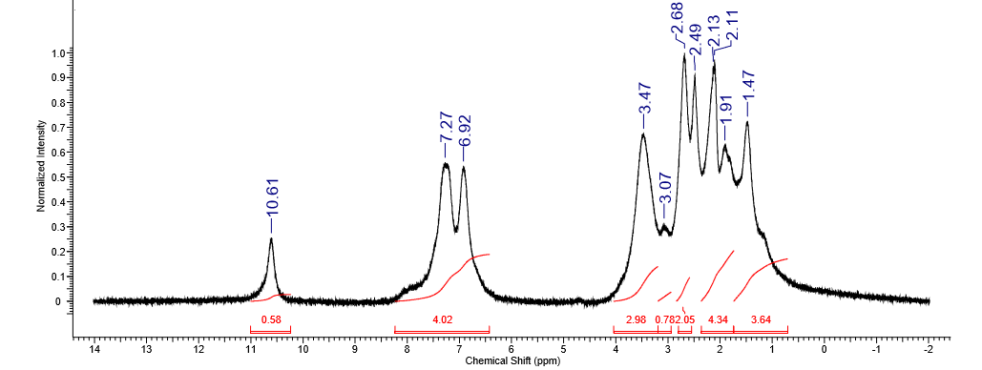

Figure 4. ¹H NMR spectra of compound 26 (NCS 135824) in DMSO-d₆ at 298 K

