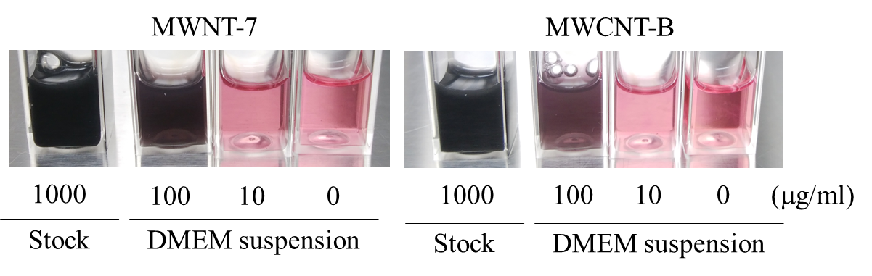

**Figure S1. Observation of the MWCNTs suspension.**

For preparation of stock suspension, the MWCNTs were suspended in 0.5% Pluronic F-68 solution at a concentration of 1.0 mg/ml and then suspended by sonication in a sonic bath. For *in vitro* experiments, the stock suspension was serial diluted by the culture medium. For in vivo experiments, the stock suspension was diluted by 0.5% Pluronic F-68 solution.

Horie et al. Figure S1

**Figure S2. Evaluation of sedimentation of the MWCNTs in culture medium suspension during incubation.** Stock solution of the MWCNT was diluted by 10% FBS supplemented RPMI 1640, 10% FBS supplemented DMEM, and 15% FBS supplemented Ham’s F-12K nutrient mixture medium. The medium suspension was transferred to 1.5 ml tube and incubated for 24 h in CO2 incubator (37 °C, 5% CO2 atmosphere). The suspension was collected at a position of 5 mm from the surface of the solutions in the static1.5 ml tube. The absorbance at 750 nm was measured at 0 h and 24 h after incubation, concentration of the MWCNT at 0 h (C0) and 24 h (C24) was estimated from standard curve. Sedimentation of the MWCNTs in medium suspension was estimated as percentage of C24 compared with the standardized C0 was 100%.　 \**p*<0.05, \*\**p* < 0.01 (vs. C0, Paired t-test)

Horie et al. Figure S2

