**Supplementary data**

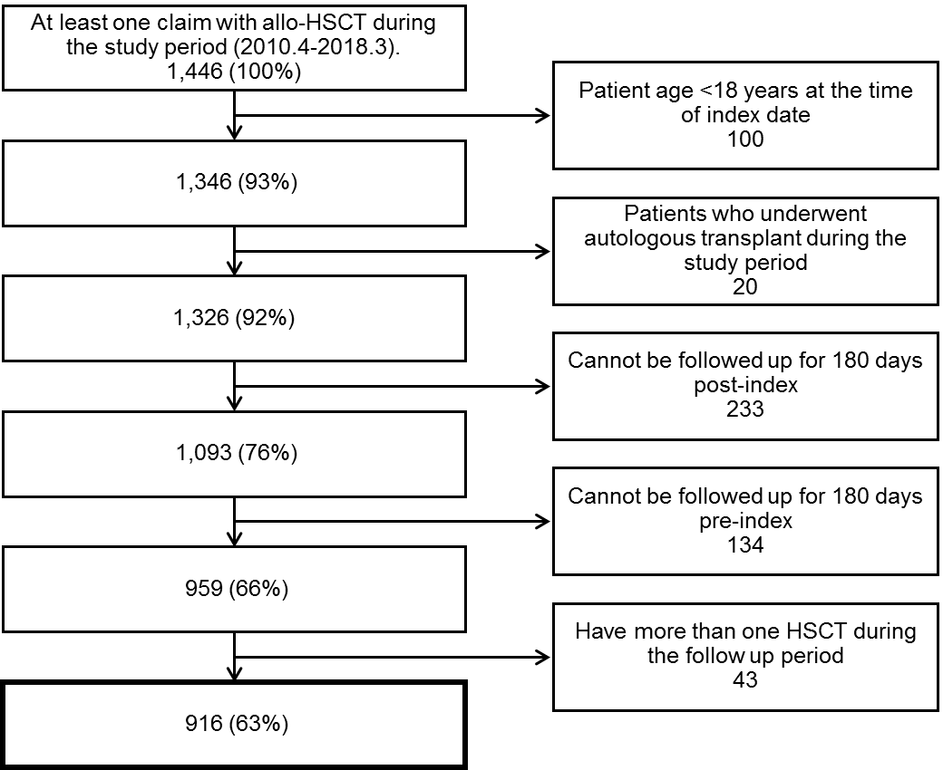

Supplementary Figure 1. Patient flow diagram of the study

|  |  |  |  |
| --- | --- | --- | --- |
|  | Class | | Component |
| Antimicrobials | IV Antifungal | | Fluconazole |
| Itraconazole |
| Voriconazole |
| Ambisome |
| Caspofungin |
| Micafungin |
| PO Antifungal | | Fluconazole |
| Itraconazole |
| Voriconazole |
| Carbapenems | | Imipenem |
| Meropenem |
| Doripenem |
| Biapenem |
| Other broad-spectrum antimicrobials | | Cefepime |
| Piperacillin sodium - Tazobactam |
| Anti-MRSA antimicrobials | | Vancomycin |
| Teicoplanin |
| Daptomycin |
| Immunosuppressant drugs | | Prednisolone | |
| Methylprednisolone | |
| Methylprednisolone sodium succinate | |
| Anti-thymoglobulin (ATG) | |
| Tacrolimus | |
| Cyclosporine | |
| Mycophenolate Mofetil | |

IV: intravenous; MRSA: methicillin-resistant *Staphylococcus aureus*; PO: per oral

Supplementary Table 1. List of antimicrobial and Immunosuppressant drugs

| **Category** | **CMV (-) a**  **N=177** | **CMV (+) b**  **N=739** | **p value** | **CMV (+)** | | |
| --- | --- | --- | --- | --- | --- | --- |
| **CMV (1) c**  **N=359** | **CMV (≥2) d**  **N=380** | **p value** |
| **Number of hospitalizations** | | | | | | |
| Mean ± SD | 1.2 ± 0.5 | 1.4 ± 0.7 | 0.0014 | 1.3 ± 0.6 | 1.4 ± 0.8 | 0.1802 |
| Median | 1 | 1 | 0.0003 | 1 | 1 | 0.4527 |
| **Total hospital days** | | | | | | |
| Mean ± SD | 55.9 ± 40.6 | 93.6 ± 43.7 | <.0001 | 88.4 ± 44.7 | 98.6 ± 42.2 | 0.0015 |
| Median | 47 | 86 | <.0001 | 79 | 94 | 0.0006 |
| **Number of patients who had readmission** | | | | | | |
| N (%) | 26 (14.7) | 207 (28.0) | 0.0003 | 97 (27.0) | 110 (29.0) | 0.5597 |
| **Number of patients who had outpatient visit** | | | | | | |
| N (%) | 96 (54.2) | 539 (72.9) | <.0001 | 248 (69.1) | 291 (76.6) | 0.0218 |
| CMV: cytomegalovirus; SD: standard deviation.  a having no CMV episode within 100 days post index date; b having at least one CMV episode within 100 days post index date; c having only one CMV episode within 100 days post index date; d having more than or equal to two CMV episodes within 100 days post index date. | | | | | | |

Supplementary Table 2. Summary of inpatient and outpatient encounters

| **Category** | **CMV (-) a**  **N=177** | **CMV (+) b**  **N=739** | **p value** | **CMV (+)** | | |
| --- | --- | --- | --- | --- | --- | --- |
| **CMV (1) c**  **N=359** | **CMV (≥2) d**  **N=380** | **p value** |
| **Medication (days)** | | | | | | |
| Ganciclovir |  |  |  |  |  |  |
| N (%) | 5 (2.8) | 515 (69.7) |  | 223 (62.1) | 292 (76.8) |  |
| Mean ± SD | 8.6 ± 6.0 | 26.2 ± 22.5 | 0.0809 | 23.5 ± 22.5 | 28.3 ± 22.3 | 0.0166 |
| Median | 11 | 20 | 0.021 | 17 | 24 | 0.0004 |
| Foscarnet |  |  |  |  |  |  |
| N (%) | 3 (1.7) | 366 (49.5) |  | 183 (51.0) | 183 (48.2) |  |
| Mean ± SD | 27.0 ± 18.1 | 33.2 ± 26.3 | 0.6815 | 36.3 ± 28.8 | 30.2 ± 23.2 | 0.0279 |
| Median | 29 | 26 | 0.847 | 29 | 24 | 0.1107 |
| Valganciclovir |  |  |  |  |  |  |
| N (%) | 8 (4.5) | 387 (52.4) |  | 144 (40.1) | 243 (63.9) |  |
| Mean ± SD | 11.3 ± 6.4 | 23.2 ± 20.3 | 0.0979 | 20.3 ± 19.0 | 24.9 ± 20.9 | 0.0288 |
| Median | 10 | 16 | 0.0693 | 14 | 19 | 0.0199 |
| Immunosuppressant drugs | | | | | | |
| N (%) | 177 (100) | 739 (100) |  | 359 (100) | 380 (100) |  |
| Mean ± SD | 101.5 ± 76.1 | 157.8 ± 75.2 | <.0001 | 151.4 ± 80.7 | 163.8 ± 69.2 | 0.025 |
| Median | 111 | 159 | <.0001 | 154 | 164 | 0.0057 |
| Antimicrobial | | | | | | |
| N (%) | 177 (100) | 739 (100) |  | 359 (100) | 380 (100) |  |
| Mean ± SD | 125.2 ± 78.3 | 192.7 ± 64.9 | <.0001 | 184.4 ± 69.6 | 200.6± 59.2 | 0.0007 |
| Median | 133 | 195 | <.0001 | 188 | 201 | 0.0007 |
| *IV Antifungal* | | | | | | |
| N (%) | 160 (90.4) | 672 (90.9) |  | 321 (89.4) | 351 (92.4) |  |
| Mean ± SD | 30.2 ± 23.4 | 56.0 ± 37.6 | <.0001 | 53.0 ± 36.7 | 58.8± 59.2 | 0.0439 |
| Median | 24.5 | 48 | <.0001 | 46 | 49 | 0.029 |
| *PO Antifungal* | | | | | | |
| N (%) | 127 (71.8) | 649 (87.8) |  | 312 (86.9) | 337 (88.7) |  |
| Mean ± SD | 100.5 ± 60.3 | 109.2 ± 50.8 | 0.0852 | 106.0 ± 55.1 | 112.3± 46.3 | 0.1147 |
| Median | 119 | 119 | 0.3395 | 117.5 | 121 | 0.3705 |
| *Carbapenems* |  |  |  |  |  |  |
| N (%) | 121 (68.4) | 504 (68.2) |  | 244 (68.0) | 260 (68.4) |  |
| Mean ± SD | 16.3 ± 11.9 | 24.6 ± 18.1 | <.0001 | 24.0 ± 18.1 | 25.1 ± 18.1 | 0.5076 |
| Median | 14 | 19 | <.0001 | 19 | 20 | 0.4964 |
| *Other broad-spectrum antimicrobials* | | | | | | |
| N (%) | 81 (45.8) | 426 (57.7) |  | 219 (61.0) | 207 (54.5) |  |
| Mean ± SD | 13.1 ± 12.0 | 23.2 ± 17.5 | <.0001 | 22.4 ± 17.1 | 24.1 ± 17.9 | 0.3229 |
| Median | 10 | 19 | <.0001 | 19 | 20 | 0.3107 |
| *Anti-MRSA antimicrobials* | | | | | | |
| N (%) | 112 (63.3) | 556 (75.2) |  | 262 (73.0) | 294 (77.4) |  |
| Mean ± SD | 13.7 ± 12.8 | 20.8 ± 16.2 | <.0001 | 20.4 ± 16.8 | 21.2 ± 15.7 | 0.5532 |
| Median | 11.5 | 16 | <.0001 | 15 | 16.5 | 0.1377 |
| **Blood products** | | | | | | |
| Red blood cells | | | | | | |
| N (%) | 119 (67.2) | 536 (72.5) |  | 261 (72.7) | 275 (72.4) |  |
| Mean ± SD | 7.1 ± 6.6 | 12.2 ± 11.0 | <.0001 | 12.0 ± 11.3 | 12.5 ± 10.7 | 0.5733 |
| Median | 5 | 9 | <.0001 | 9 | 9 | 0.3969 |
| Platelets | | | | | | |
| N (%) | 176 (99.4) | 732 (99.1) |  | 355 (98.9) | 377 (99.2) |  |
| Mean ± SD | 17.2 ± 16.5 | 29.2 ± 25.6 | <.0001 | 26.3 ± 22.5 | 31.9 ± 28.0 | 0.0028 |
| Median | 12 | 21 | <.0001 | 20 | 22 | 0.0112 |
| **Examination (number of times)** | | | | | | |
| Clinical examination | | | | | | |
| N (%) | 174 (98.3) | 738 (99.9) |  | 358 (99.7) | 380 (100) |  |
| Mean ± SD | 17.8 ± 11.6 | 34.1 ± 15.2 | <.0001 | 32.4 ± 15.2 | 35.8 ± 15.0 | 0.0021 |
| Median | 16 | 32 | <.0001 | 31 | 33 | 0.0062 |
| CMV: cytomegalovirus; HSCT: hematopoietic stem cell transplantations; IV: Intravenous; MRSA: methicillin-resistant *Staphylococcus aureus*; PO: per oral; SD: standard deviation  a having no CMV episode within 100 days post index date; b having at least one CMV episode within 100 days post index date; c having only one CMV episode within 100 days post index date; d having more than or equal to two CMV episodes within 100 days post index date. | | | | | | |

Supplementary Table 3. Summary of medication and examination use in 180 days after allo-HSCT

| **Category** | **CMV (-) a**  **N=177** | **CMV (+) b**  **N=739** | **p value** | **CMV (+)** | | |
| --- | --- | --- | --- | --- | --- | --- |
| **CMV (1) c**  **N=359** | **CMV (≥2) d**  **N=380** | **p value** |
| **X ray** | | | | | | |
| N (%) | 158 (89.3) | 671 (90.8) |  | 323 (90.0) | 348 (91.6) |  |
| Mean± SD | 6.7 ± 6.5 | 11.1 ± 10.6 | <.0001 | 10.9 ± 10.0 | 11.3 ± 11.1 | 0.6175 |
| Median | 4 | 8 | <.0001 | 8 | 8 | 0.872 |
| **CT scan** | | | | | | |
| N (%) | 121 (68.4) | 632 (85.5) |  | 297 (82.7) | 335 (88.2) |  |
| Mean± SD | 2.2 ± 1.6 | 4.5 ± 3.8 | <.0001 | 4.6 ± 3.7 | 4.3 ± 3.8 | 0.3072 |
| Median | 2 | 3 | <.0001 | 3 | 3 | 0.1942 |
| **Esophagogastroduodenoscopy (EGD)** | | | | | | |
| N (%) | 26 (14.7) | 145 (19.6) |  | 60 (16.7) | 85 (22.4) |  |
| Mean± SD | 1.1 ± 0.3 | 1.3 ± 0.5 | 0.1623 | 1.3 ± 0.5 | 1.2 ± 0.5 | 0.4572 |
| Median | 1 | 1 | 0.1836 | 1 | 1 | 0.3696 |
| **Colonoscopy** | | | | | | |
| N (%) | 7 (4.0) | 97 (13.1) |  | 42 (11.7) | 55 (14.5) |  |
| Mean± SD | 1.1 ± 0.4 | 1.3 ± 0.6 | 0.6579 | 1.3 ± 0.6 | 1.2 ± 0.7 | 0.5934 |
| Median | 1 | 1 | 0.7499 | 1 | 1 | 0.2626 |
| **Bronchoscopy** | | | | | | |
| N (%) | 1 (0.6) | 17 (2.3) |  | 9 (2.5) | 8 (2.1) |  |
| Mean± SD | 1.0 | 1.1 ± 0.2 | 0.8167 | 1.1 ± 0.3 | 1.0 ± 0.0 | 0.3624 |
| Median | 1 | 1 | 0.8084 | 1 | 1 | 0.3458 |
| **Retinal examination** | | | | | | |
| N (%) | 4 (2.3) | 42 (5.7) |  | 17 (4.7) | 25 (6.6) |  |
| Mean± SD | 1.8 ± 1.0 | 1.7 ± 1.3 | 0.9274 | 1.6 ± 1.1 | 1.8 ± 1.4 | 0.6697 |
| Median | 1.5 | 1 | 0.5736 | 1 | 1 | 0.8142 |
| **CMV antigenemia test** | | | | | | |
| N (%) | 147 (83.1) | 732 (99.1) |  | 352 (98.1) | 380 (100) |  |
| Mean± SD | 11.7 ± 8.2 | 19.9 ± 8.2 | <.0001 | 18.6 ± 8.9 | 21.1 ± 7.2 | <.0001 |
| Median | 11 | 20 | <.0001 | 19 | 21.5 | <.0001 |
| CMV: cytomegalovirus; CT: computed tomography; HSCT: hematopoietic stem cell transplantations; SD: standard deviation.  a having no CMV episode within 100 days post index date; b having at least one CMV episode within 100 days post index date; c having only one CMV episode within 100 days post index date; d having more than or equal to two CMV episodes within 100 days post index date. | | | | | | |

Supplementary Table 4. Details of number of clinical examinations in 180 days after allo-HSCT

| **Category** | **CMV (-)a**  **N=97** | **CMV (+)b**  **N=582** | **p value** | **CMV (+)** | | | |
| --- | --- | --- | --- | --- | --- | --- | --- |
| **CMV (1)c**  **N=262** | | **CMV (≥2)d**  **N=320** | **p value** |
| Number of hospitalizations | | | |  | | | |
| Mean ± SD | 1.3 ± 0.6 | 1.4 ± 0.7 | 0.0955 | 1.4 ± 0.7 | | 1.4 ± 0.8 | 0.7816 |
| Median | 1 | 1 | 0.0622 | 1 | | 1 | 0.7023 |
| Total hospital days | | | |  | | | |
| Mean ± SD | 74.1 ± 39.7 | 96.4 ± 43.9 | <.0001 | 94.7 ± 43.8 | | 97.8 ± 44.0 | 0.4041 |
| Median | 65 | 87 | <.0001 | 85 | | 90 | 0.403 |
| Number of patients who had readmission | | | |  | | | |
| N (%) | 21 (21.7) | 182 (31.3) | 0.0553 | 85 (32.4) | | 97 (30.3) | 0.5813 |
| Number of patients who had outpatient visit | | | | | | | |
| N (%) | 93 (95.9) | 518 (89.0) | 0.0368 | 238 (90.8) | | 280 (87.5) | 0.2001 |
| **Medication (days)** | | | | | | | |
| Ganciclovir |  |  |  |  | |  |  |
| N (%) | 5 (5.5) | 410 (70.5) |  | 167 (63.4) | | 243 (75.94) |  |
| Mean ± SD | 8.6 ± 6.0 | 27.0 ± 22.9 | 0.0739 | 25.4 ± 24.1 | | 28.1 ± 22.1 | 0.234 |
| Median | 11 | 21 | 0.016 | 17 | | 24 | 0.0225 |
| Foscarnet |  |  |  |  | |  |  |
| N (%) | 3 (3.1) | 270 (46.4) |  | 123 (47.0) | | 147 (46.0) |  |
| Mean ± SD | 27.0 ± 18.1 | 36.4 ± 26.6 | 0.5409 | 41.87 ± 28.3 | | 31.9 ± 24.3 | 0.002 |
| Median | 29 | 29 | 0.667 | 38 | | 25 | 0.0018 |
| Valganciclovir |  |  |  |  | |  |  |
| N (%) | 7 (7.2) | 362 (62.2) |  | 130 (49.6) | | 232 (72.5) |  |
| Mean ± SD | 9.6 ± 4.7 | 23.6 ± 20.5 | 0.0713 | 21.18 ± 19.6 | | 25.0 ± 21.0 | 0.0914 |
| Median | 10 | 17 | 0.0314 | 15 | | 18.5 | 0.0713 |
| Immunosuppressant drugs | | | | | | | |
| N (%) | 97 (100) | 582 (100) |  | 262 (100) | | 320 (100) |  |
| Mean ± SD | 158.5 ± 50.8 | 175.3 ± 69.0 | 0.0222 | 178.1 ± 70.4 | | 173.0 ± 68.0 | 0.3729 |
| Median | 165 | 170 | 0.0492 | 170 | | 170.5 | 0.7072 |
| Antimicrobial | | | | | | | |
| N (%) | 97 (100) | 582 (100) |  | 262 (100) | | 320 (100) |  |
| Mean ± SD | 178.3 ± 50.4 | 205.0 ± 55.9 | <.0001 | 204.6 ± 54.0 | | 205.2 ± 57.5 | 0.8956 |
| Median | 183 | 203 | <.0001 | 227 | | 237.5 | 0.3838 |
| *IV Antifungal* | | | | | | | |
| N (%) | 82 (84.5) | 520 (89.4) |  | 229 (87.4) | | 291 (91.0) |  |
| Mean ± SD | 35.0 ± 25.0 | 55.4 ± 38.3 | <.0001 | 53.8 ±38.4 | | 56.6 ± 38.2 | 0.4039 |
| Median | 28.5 | 47.5 | <.0001 | 45 | | 48 | 0.2647 |
| *PO Antifungal* | | | | | | | |
| N (%) | 93 (96.0) | 550 (94.5) |  | 252 (96.2) | | 298 (93.1) |  |
| Mean ± SD | 130.1± 38.0 | 121.0 ± 43.0 | 0.053 | 122.0 ± 45.2 | 120.3 ± 41.1 | | 0.7146 |
| Median | 136 | 127.5 | 0.0588 | 129.5 | 126 | | 0.4259 |
| *Carbapenems* |  |  |  |  |  | |  |
| N (%) | 54 (56.0) | 365 (62.7) |  | 160 (61.1) | 205 (52.5) | |  |
| Mean ± SD | 16.3 ± 10.2 | 22.9 ± 16.9 | 0.0058 | 22.9 ± 17.5 | 23.0 ± 16.5 | | 0.9843 |
| Median | 14 | 18 | 0.0055 | 18 | 18 | | 0.8942 |
| *Other broad-spectrum antimicrobials* | | | | | | | |
| N (%) | 47 (48.45) | 322 (55.33) |  | 154 (58.78) | | 168 (52.50) |  |
| Mean ± SD | 15.2 ± 14.0 | 23.5 ± 18.3 | 0.0028 | 23.7 ± 18.7 | 23.4 ± 18.0 | | 0.8831 |
| Median | 13 | 19 | 0.0003 | 18.5 | 19 | | 0.9503 |
| *Anti-MRSA antimicrobials* | | | | | | | |
| N (%) | 53 (54.5) | 413 (71.0) |  | 175 (66.8) | 238 (74.4) | |  |
| Mean ± SD | 14.0 ± 8.5 | 19.4 ± 14.6 | 0.0079 | 18.9 ± 15.2 | 19.76 ± 14.3 | | 0.5694 |
| Median | 13 | 15 | 0.0125 | 14 | 16 | | 0.0951 |
| **Blood products** | | | | | | | |
| Red blood cells | | | | | | | |
| N (%) | 64 (66.0) | 420 (72.2) |  | 189 (72.1) | 231 (72.2) | |  |
| Mean ± SD | 12.9 ± 13.4 | 20.3 ± 18.4 | 0.0022 | 19.3 ±18.5 | 21.1 ± 18.3 | | 0.3271 |
| Median | 9.5 | 14 | <.0001 | 14 | 16 | | 0.2235 |
| Platelets | | | | | | | |
| N (%) | 96 (99.0) | 575 (98.8) |  | 258 (98.5) | 317 (99.1) | |  |
| Mean ± SD | 155.5 ± 162.4 | 259.6 ± 250.3 | <.0001 | 226.1 ± 220.5 | 286.8 ± 269.3 | | 0.0037 |
| Median | 110 | 190 | <.0001 | 172.5 | 200 | | 0.0025 |
| **Examination (number of times)** | | | | | | | |
| Clinical examination | | | | | | | |
| N (%) | 97 (100) | 582 (100) |  | 262 (100) | | 320 (100) |  |
| Mean ± SD | 97.8 ± 43.9 | 140.7 ± 55.7 | <.0001 | 135.6 ± 51.0 | | 145.0 ±59.0 | 0.0445 |
| Median | 93 | 133 | <.0001 | 130 | | 135 | 0.1129 |
| CMV: cytomegalovirus; HCRU: healthcare resource utilization; HSCT: hematopoietic stem cell transplantations; IV: Intravenous; MRSA: methicillin-resistant *Staphylococcus aureus*; PO: per oral; SD: standard deviation.  a having no CMV episode within 100 days post index date; b having at least one CMV episode within 100 days post index date; c having only one CMV episode within 100 days post index date; d having more than or equal to two CMV episodes within 100 days post index date. | | | | | | | |

Supplementary Table 5. Sensitivity analysis of HCRU in 180 days after allo-HSCT (patients who died within 180 days post-transplant were excluded)