Supplementary figures and legends
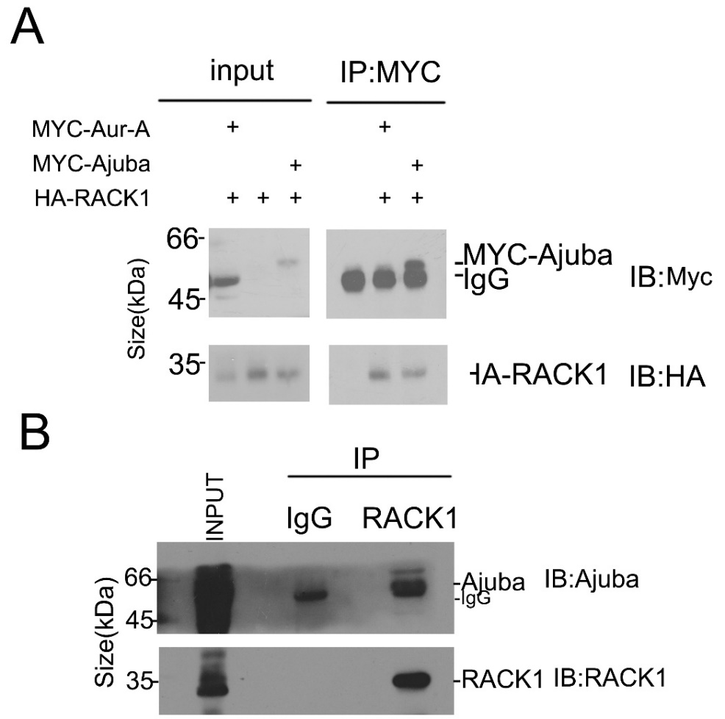
Bai et al., supplementary figure S1

Supplementary Figure 1 RACK1 is an interactor of Ajuba
- RACK1 interacts with Aurora-A in vivo. 293T cells were transfected with Myc-Ajuba plus HA-RACK1 or Myc-Aurora-A plus HA-RACK1 and cell lysates were analyzed by immunoprecipitation (IP: Myc) and western blotting with anti-Myc or HA antibodies respectively. Whole-cell lysates were blotted and shown as the input. Aurora-A is blocked by the heavy chain of the antibody.
- RACK1 interact with Ajuba in vivo at the endogenous protein level. HeLa cells lysates were subjected to immunoprecipitation using antibody of RACK1. Whole –cell lysates and precipitates were blotted using Ajuba and RACK1 antibodies.
Bai et al., supplementary figure S2

Supplementary Figure 2 RACK1 and Aurora-A knock down efficiency
- Western blot of Aurora-A using lysates from HeLa cells treated with control siRNA or Aurora-A siRNA, actin serves as internal control.
- Western blot of RACK1 using lysates from HeLa cells treated with control siRNA or RACK1 siRNA, actin serves as internal control.

Bai et al., supplementary figure S3
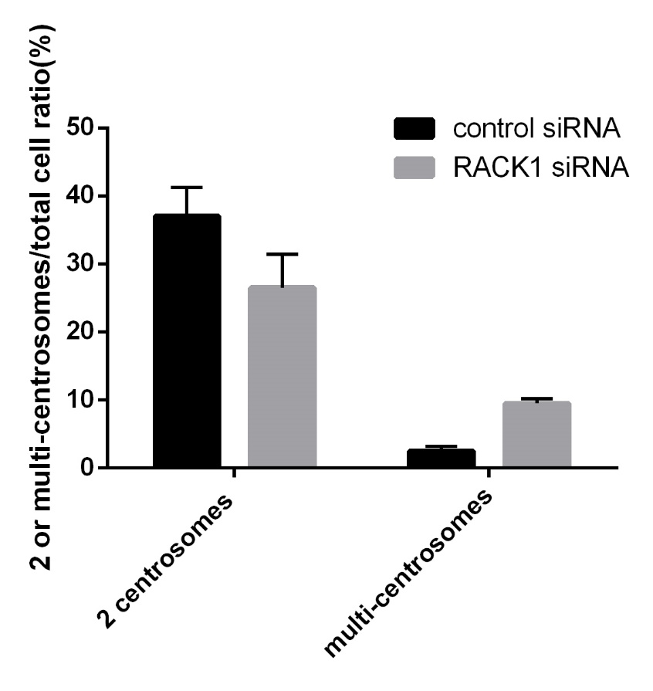

Supplementary Figure 3. RACK1 is essential for bipolar spindle assembly. Hela cells treated with control siRNA or RACK1 siRNA were synchronized by using double thymidine block, and then analyzed by Immunofluorescence staining using indicated antibodies. The percentages of cells with 2 or multiple centrosomes were quantified.

