Bacterial Insights into the Formation of Opaline Stromatolites from the Chimalacatepec Lava Tube System, Mexico
Maira N. Luis-Vargasª, Rafael A. López-Martínezª, Alfredo R. Vilchis-Nestor^{b}, Raquel Dazaª and Rocio J. Alcántara-Hernández^{b}*

ªInstituto de Geología, Universidad Nacional Autónoma de México, Ciudad de México, México; ^{b}Centro Conjunto de Investigación de Química Sustentable, Universidad Autónoma del Estado de México, Toluca, México.

*Corresponding author: Rocio J. Alcántara-Hernández. Instituto de Geología, Universidad Nacional Autónoma de México, Ciudad Universitaria, Av. Universidad 3000, Del. Coyoacan, 04510, Mexico City, Mexico, E-mail: ralcantarah@geologia.unam.mx, rocio.alcantara.h@gmail.com

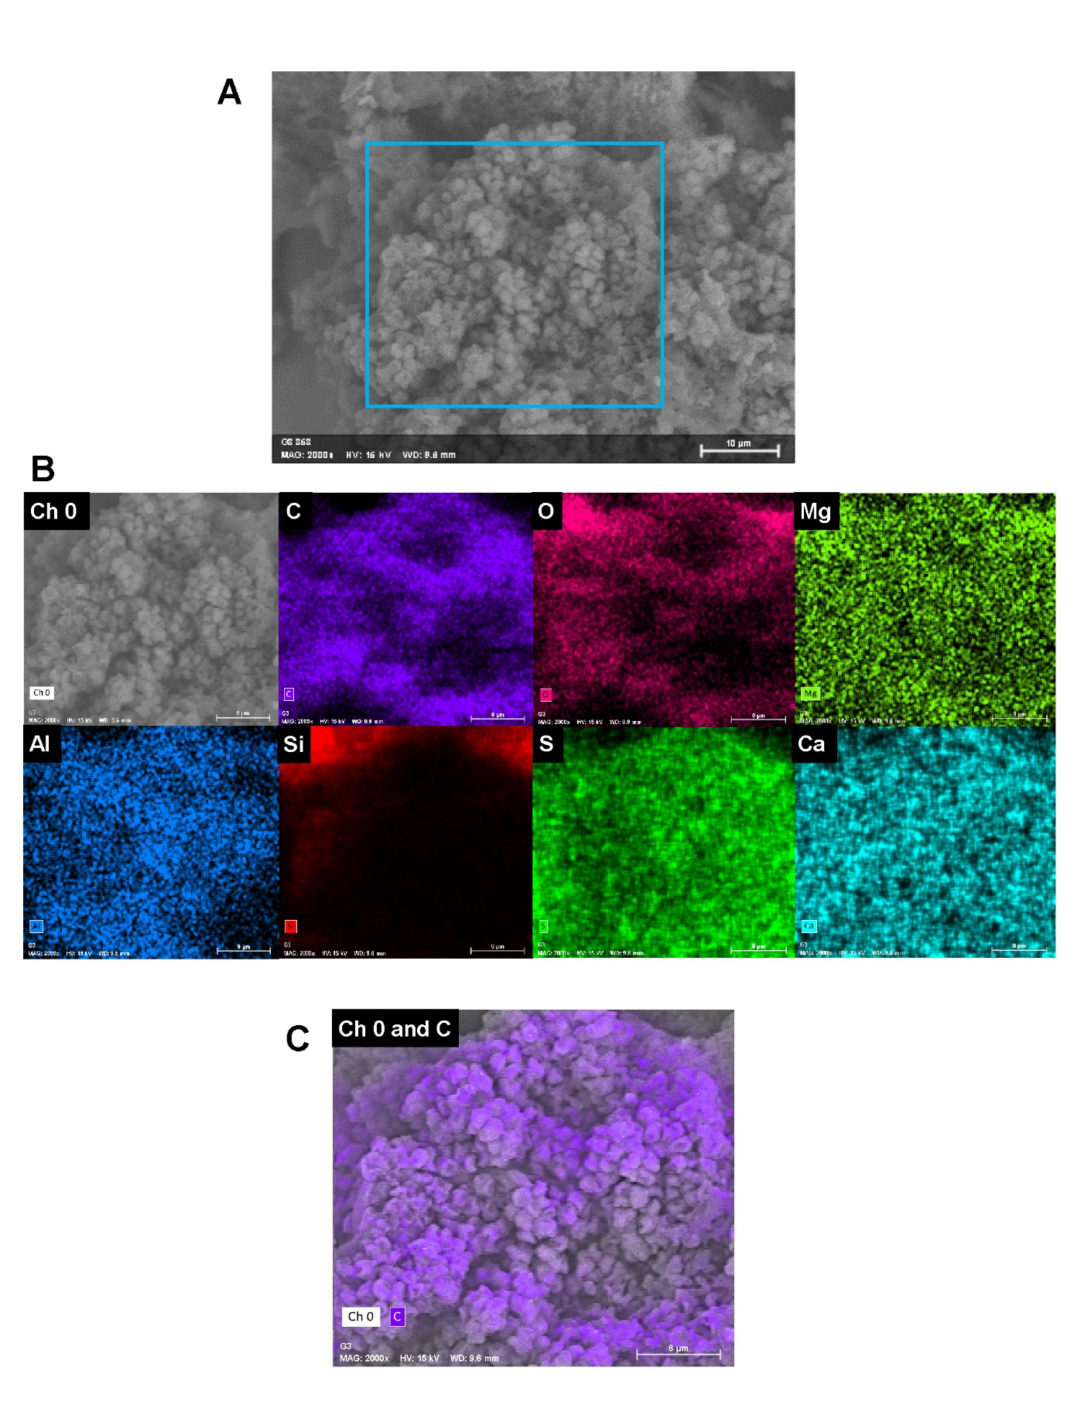

Figure S1. EDS elemental mapping of a representative microbial cluster in a siliceous stromatolite. A. SEM image. B. The corresponding elemental mapping of C, O, Mg, Al, Si, S, and Ca, respectively. C. Merge-image of the SEM micrograph and the EDS mapping of the carbon.

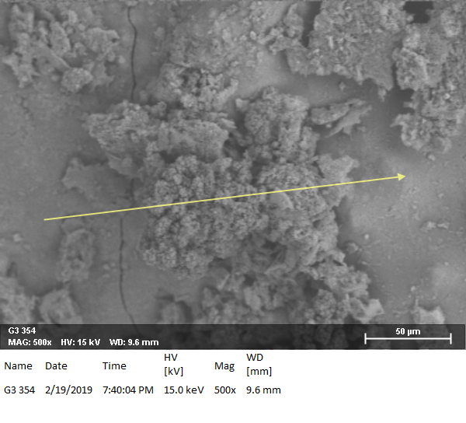
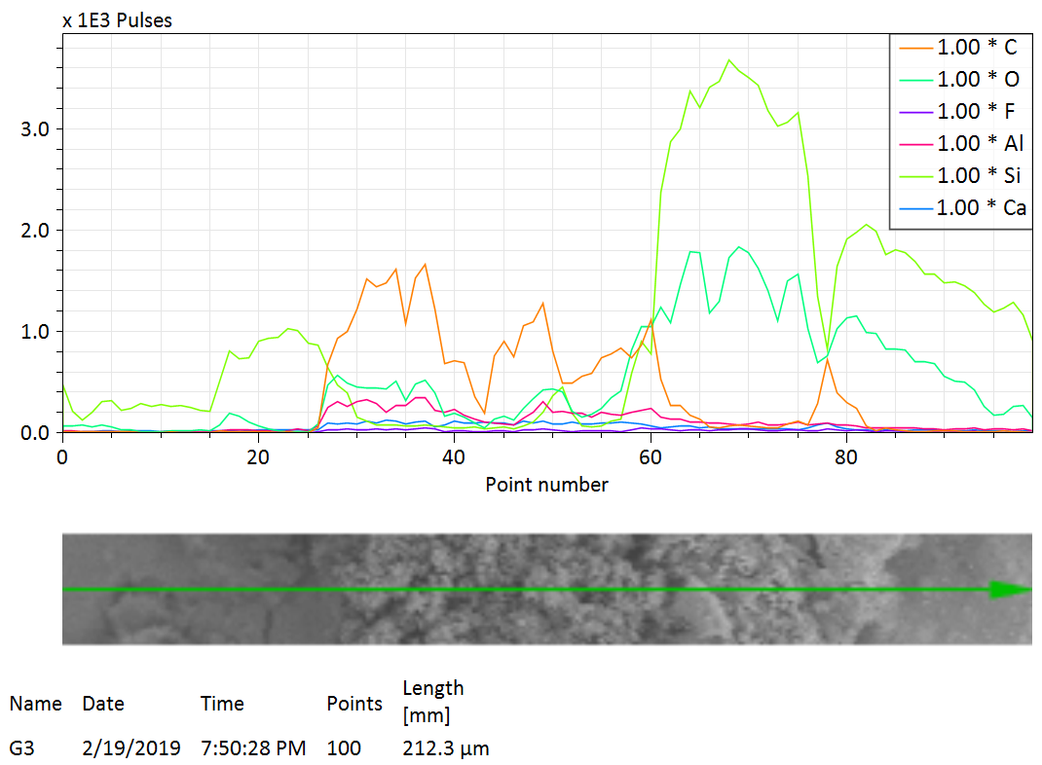

Figure S2. SEM micrograph with EDS linescan along the yellow arrow (upper image) of a microbial cluster within a siliceous stromatolite. The cluster is surrounded by a siliceous (Si-O) matrix, while the cluster display shows a higher content of C, as can be observed in the plot where the carbon concentration profile is enlarged when the microbial cluster is scanned.

