Figure S1: Hierarchical cluster analysis of proteins in BAL fluid of mice exposed to various graphene based materials, MWCNTs, and carbon black at (A) day 1 and (B) day 28 post-exposure timepoints. Vehicle or physiological dispersion media (DM); Pristine graphenes of various lateral dimensions (Gr1 – 1 µm; Gr5 – 5 µm; Gr20 – 20 µm); a graphene oxide (GO – 5 µm); reduced graphene-oxide (rGO – 5 µm); Mitsui-7 (MW-#5); pristine as-produced MWCNT (MW-#3, MW-#2) and their polymer-coated counterparts (MW-#3-PC, MW-#2-PC) from two different sources; carbon black (CB – is Printex 90 Degussa).
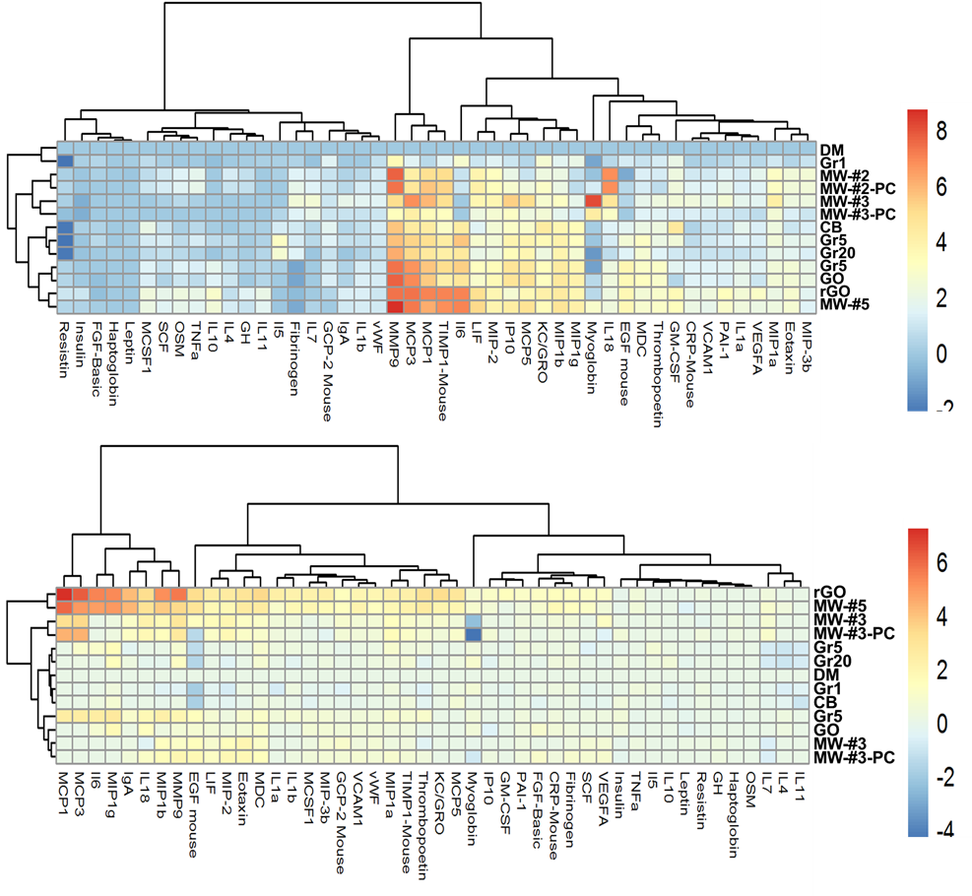

Figure S2: Hierarchical cluster analysis of proteins in BAL fluid of mice exposed to various graphene based materials and MW-#5 at day 1, 28 and 60 post-exposure timepoints. Vehicle or physiological dispersion media (DM); Pristine graphenes of various lateral dimensions (Gr1 – 1 µm; Gr5 – 5 µm; Gr20 – 20 µm); a graphene oxide (GO – 5 µm); reduced graphene-oxide (rGO – 5 µm); Mitsui-7 (MW-#5); pristine as-produced MWCNT (MW-#3, MW-#2) and their polymer-coated counterparts (MW-#3-PC, MW-#2-PC) from two different sources; carbon black (CB – is Printex 90 Degussa).
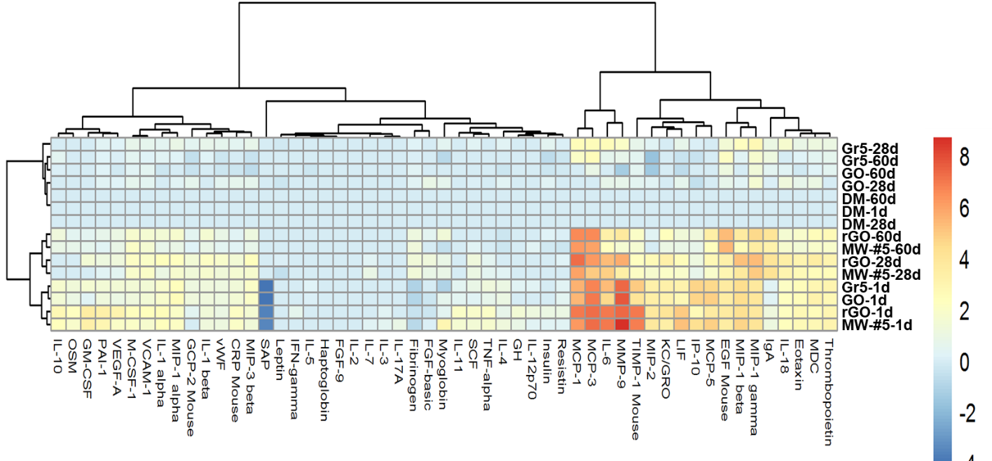

Table S1. Characteristics of the various carbon-based Nanomaterials evaluated in this study. These physical chemical properties of nanomaterials were previously published as part of other studies (Erdely et al., 2013, Roberts et al., 2016, Bishop et al., 2017, Roberts et al., 2018)
Particle | Primary Particle Size | Density  (g/ml) | Specific Surface Area  (m²/g) | Mean Agglomerate Size in DM Following Sonication (μm) | Zeta Potential in DM (mV)
CB | 15-20 nm | 0.180 | 334.0 ± 2.9 | 1.16 ± 1.18 | -12.6 ± 0.6
Gr1 | 1-2 μm lateral,1-2 nm thickness | 0.200 | 747.1 ± 4.4 | 1.60 ± 1.58 | -15.1 ± 0.8
Gr5 | 5 μm lateral,7 nm thickness | 0.190 | 106.5 ± 1.1 | 4.30 ± 4.32 | -14.9 ± 0.8
Gr20 | 20 μm lateral,7 nm thickness | 0.070 | 115.5 ± 8.4 | 7.28 ± 13.4 | -17.1 ± 1.2
GO | 5 μm lateral,7 nm thickness | 0.420 | N.D. | 4.89 ± 6.55 | -14.1 ± 1.1
rGO | Not Reported | 0.003 | 650 | 4.07 ± 3.89 | -12.5 ± 0.7
MW#2 | Not Reported | 0.007±0.000 | 219 | Length: 1.0 ± 2.0  Width: 0.020 ± 1.695 | -13.4 ± 1.4
MW-#2-PC | Not Reported | 0.103±0.002 | 139 | Length: 0.7 ± 1.7  Width: 0.015 ± 1.254 | -13.4 ± 1.4
MW#3 | Not Reported | 0.087±0.000 | 212 | Length: 1.4 ± 2.3  Width: 0.014 ± 1.575 | -12.1 ± 0.6
MW-#3-PC | Not Reported | 0.156±0.003 | 140 | Length: 1.2 ± 2.5  Width: 0.014 ± 1.589 | -11.9 ± 0.5
MW#5 | Not Reported | 0.019 | ~26 | Length: 6.5 ± 4.1  Width: 0.4 ± 0.9 | -13.4 ± 1.4

Note: Density and primary particle size were measured by the tap density method. Specific surface area was measured by BET method for all particles with the exception of GO (N.D., not determined) as per recommendation due to potential reactivity in the assay (1-3 measures per sample ± standard error). Mean agglomeration in DM was determined morphometrically using point count methods microscopically for the Gr5, Gr20 , GO, and rGO samples, and both microscopically and with validation by dynamic light scattering for the smallest particles CB and Gr1 particles. Point counts are the mean of ~200-500 counts per sample ± standard deviation. Agglomerates ranged in size up to 2, 2, 60, 300, 40, and 70 μm for CD, Gr1, gr5, gr20, GO, and rGO, respectively. Zeta is reported as the average of two separate measures per sample. Zeta is reported as the average of two separate measures per sample.

Table S2. Details of the external test datasets for validating the classification models of exposure to CNMs. The reported low and high dose levels correspond to 4µg and 40µg for oropharyngeal aspiration exposures of each material considered (Roberts et al., 2016, Yanamala et al., 2018)
Dataset Name  (Exposure method) | Sample Size  (Class1, Class2) | Control | Dose | Group1  Materials  (Mitsui-7) | Group2  Materials  (Gr5)
Testset1  (Aspiration) | 20  (10, 10) | DM | High | MW#5  (24h, 28d) | --
Testset2  (Aspiration) | 25  (10 , 15) | DM | Low, High | -- | Gr5  (24h, 28d)
Testset3  (Aspiration) | 35  (10,15) | -- | Low and/or High | MW#5  (24h, 28d) | Gr5  (24h, 28d)

