Supplementary material

A RAPID HPLC-PDA SURVEY OF COMMONLY PRESCRIBED ANTIDEPRESSANTS AND CAFFEINE IN SLUDGE FROM SEWAGE TREATMENT PLANTS AND RIVER SEDIMENTS

Ismael L. COSTA JUNIORª; Christiane S. MACHADOª; Adelmo L. PLETSCH^{b}; Yohandra R. TORRESª;

ª Department of Chemistry, State University of the Central West, Guarapuava, PR, Brazil.
^{b} Department of Chemistry, Federal Technological University of Paraná, Campus Medianeira, Medianeira, PR, Brazil.

Table S1. Characterization of sample points
Sample | Photo | Coordinates | Height (m) | Depth (m) | Description
S1 | 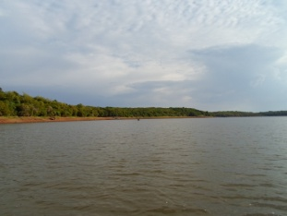 | S 24°30’55.2’’  W 54°13’1.3” | 241 | 3 | Mouth of Arroio Fundo River in Entre Rios do Oeste, PR
S2 | 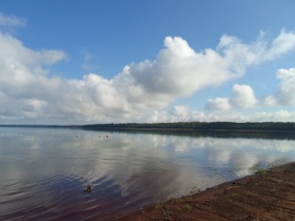 | S 25°13’51.3’’  W 54°13’25.7” | 226 | 1 | Mouth of Ocoi River in São Miguel do Iguaçu, PR
S3 | 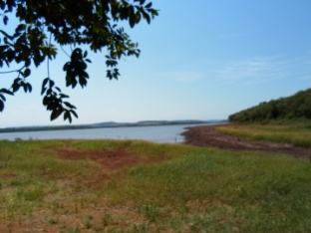 | S 24°50’52.0’’  W 54°19’25.0” | 212 | 1 | Launch region of a STP at the Itaipu Reservoir in Santa Helena, PR
S4 | 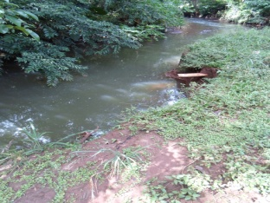 | S 25°17’10.0’’  W 54°06’7.4” | 306 | 0,5 | After the STP sewerage site in Medianeira, PR in the Alegria River
L1 | 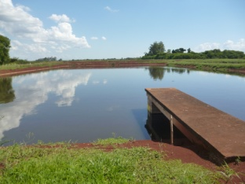 | S 24°51’20.3’’  W 54°19’23.8” | 243 | 1 | Inlet anaerobic pond, STP, Santa Helena, PR.
L2 | 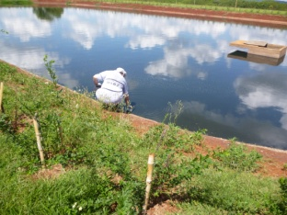 | S 24°51’17.0’’  W 54°19’22.8” | 250 | 1 | Outlet facultative pond, STP, Santa Helena, PR.
L3 | 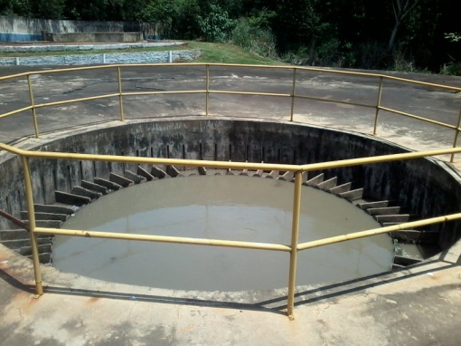 | S 25°17’11.2’’  W 54°6’5.0” | 306 | 0,5 | Inside the reactor AFBR, STP, Medianeira, PR.
L4 | 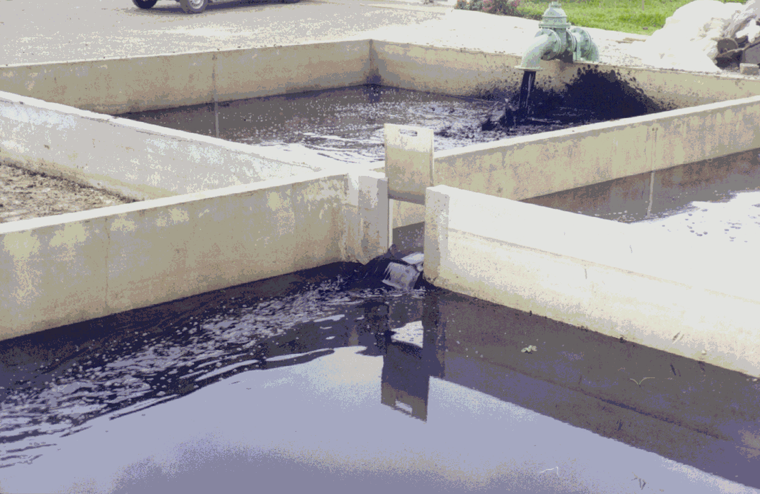 | S 25°17’11.2’’  W 54°6’5.0” | 306 | 0,2 | Drying bed, AFBR, STP, Medianeira, PR.

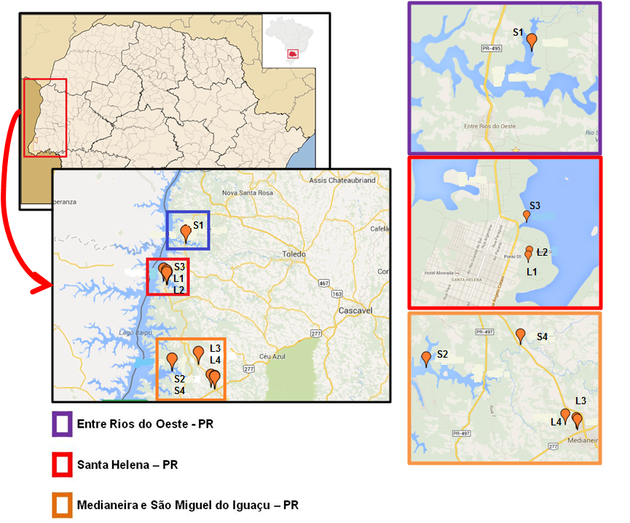
Figure S.18 – Geographical location of collection points

1 Corresponding author: Avenue Brasil, 4232 CEP 85884-000 Medianeira - PR – Brazil. +55 (45) 3240-8000 - Fax : +55 (45) 3240-8101 E-mail Address: ismael@utfpr.edu.br

