Supplementary Material A - Registration and Contouring
For each patient, 13 CBCTs (all daily scans from the first week of treatment, and then weekly) were rigidly registered to the planning CT and connected dose matrix using the clinically recorded 3D treatment shifts (only translations). Dose distributions at each CBCT were a rigid translation of the dose matrix at the planning CT, assuming that variations in dose distributions are negligible due to the interfractional changes in the patient’s anatomy under strict full bladder/empty rectum protocol. This assumption was based on results from a previous study where dose distributions were recalculated on a set of worst-case scenarios with respect to varying anatomies, where only differences up to 2% were observed [22]; similar findings were also reported by Sharma et al. using a larger cohort of patients [21]. Contouring and registration of the rectum were performed in MIM Maestro v.6.5.4 (Mim Software Inc., Cleveland, OH, USA) following our previously used workflow [23, 24].
On each CBCT and planning CT the rectum was manually contoured (including contents) from the slice above the anal canal to the slice below the recto-sigmoid flexure, contours were reviewed and approved by the responsible radiation oncologist. For each patient, the rectum at the planning CT and registered CBCTs was virtually unfolded using the posterior point of each contour slice, and finally normalised to a common frame of 200x200 pixels. More detailed information can be found in [14], and also similar methodologies were used in previous studies by Tucker et al. and Buettner et al. [9, 25].
Finally, accumulated DSMs were calculated as the sum of the extracted daily maps, where each daily map was previously converted to EQD_{2Gy} [26], assuming an α/β = 3 Gy [27]. To minimize the effect of daily screening during the first week and then weekly, each DSM was weighted according to the applicable number of fractions.

Supplementary Material B - DSM permutation t-test
Permutation t-tests were performed to compare population averaged accumulated and planned DSMs. In brief, this method allowed for a pixel-wise comparison between the observed difference between population-average DSM and the distribution of this difference at the resampled set. The resampled set was given by all difference maps extracted at each permutation of patient labels (with and without toxicity). The associated p-value at each pixel was given by the proportion of times that each pixel showed higher values in the observed map compared to the resampled set. This method has been described in detail by Chen et al. [28] and also previously used to report spatial dose differences at the planning CT DSMs between patients presenting with and without GI toxicity following RT for prostate cancer [13, 29]. In this study, the total number of permutations was set to 1000 and the statistical significance level at 5%.

Supplementary Material C - DSM-based metrics
For each patient, rectal DSM-based metrics accounting for both dose level and spatial information were extracted, and compared between cases and controls. For each patient, and both the accumulated and planned DSM map, we extracted the dose widths of the entire DSM, dose widths of the inferior part of the DSM as well as DSH points for the isodose levels between 30 and 70 Gy (in 5 Gy steps). Since multiple comparisons are performed (n = 30), it could be considered to interpret the results using a stricter significance level for the p-values.
The dose widths were used previously [11, 15] to study the associations between spatial dose metrics and GI toxicity. In brief, the dose width for a given isodose level was defined as the projection in the horizontal axis of the lateral extent of the ellipse fitted to the binary mask created for that dose level. Finally, all dose metrics extracted from the DSMs were compared between cases and controls using a two-way ANOVA test accounting for the matching information, and between planned and accumulated using paired t-test.

Supplementary Material D - Validation of NTCP model for mild symptoms
These data set has been also used to validate a previously developed normal tissue complication probability model (NTCP) for six mild GI symptoms associated with defecation urgency, obstruction and fecal leakage [14]. This previous model was based on rectal DSM metrics, and provides risk estimations for different symptoms based on patient reported outcomes. The resulting NTCPs were compared between cases and controls using a two-way ANOVA test accounting for the matching information of the spatial metrics extracted from the accumulated DSM. NTCPs were calculated using the published regression coefficients for each endpoint, and applied to the DSM-based metrics extracted for the patients included in this study. The statistical analysis was performed in Stata 13.1 (StataCorp, College Station, TX, USA) and in Matlab R2018a (The MathWorks Inc., Natick, MA, USA).
The NTCP values assessed for four symptoms (“Defecation Urgency” and “Fecal Leakage”) out of the six symptoms were significantly higher for cases compared to controls (p = .01). The largest difference was observed for the symptom “need of immediate toilet visit due to urgency - Defecation Urgency II” and “involuntary gas discharge - Fecal Leakage I” , where the median NTCP for cases was 42% (range: 32-56% ) and 28% (range: 18-40%) compared to 29% (range: 16-46%) and 16%(range: 10-31%) for controls (Suppl. Fig. 1).
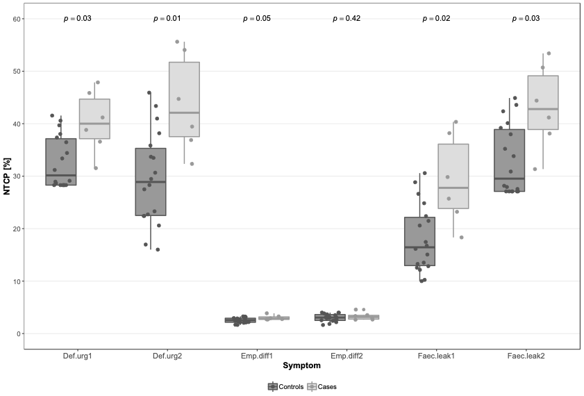

Supplementary figure 1. Comparison of the NTCPs between cases and controls for the six symptoms related to patients quality of life.
Supplementary Material E - Comparison of rectal volumes
Differences in delivered vs. planned rectal volumes were not significantly different nor for the entire population, neither for cases and controls (Suppl. fig. 2).

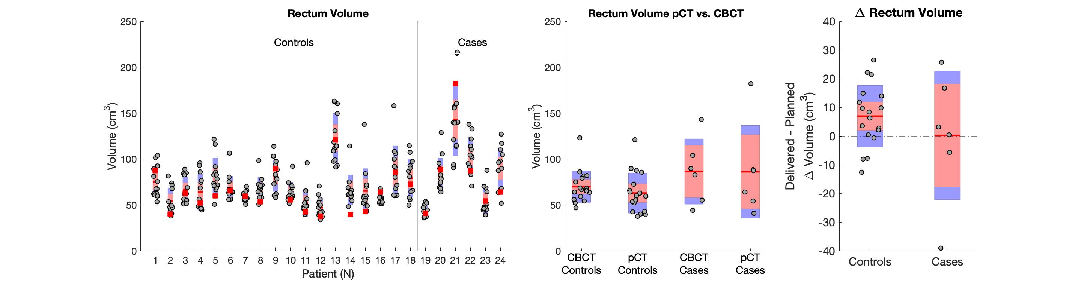

Supplementary figure 2. Left panel: Box-plots for planned (red squares) and daily (grey dots) rectal volume for cases and controls. Mid panel: weighted average during treatment and planned rectal volume for cases and controls. Right panel: Box-plot of the difference between planned and weighted average during treatment rectal volume for cases and controls.

