Supplementary Information for
Optimizing Photoacoustic Cells for Sensitive Measurements of Aerosol Light Absorption using a Finite Element Model. Part 1: Single-Resonator Cells
Michael I. Cotterell,^{1,2} Gareth P. Ward,³ Alastair P. Hibbins,³ Jim M. Haywood,^{1,2} Andy Wilson² and
Justin M. Langridge²
¹College for Engineering, Mathematics and Physical Sciences, University of Exeter, Exeter, EX4 4QF, United Kingdom.
²Observation Based Research, Met Office, Exeter, EX1 3PB, United Kingdom.
³Electromagnetic and Acoustic Materials Group, Department of Physics and Astronomy, University of Exeter, Exeter, EX4 4QF, United Kingdom.
Author for correspondence: m.cotterell@exeter.ac.uk

S1.1. Choice of mesh parameters for 2D axisymmetric model calculations
For the simulations reported in the main text using a 2D axisymmetric model geometry, a free triangular mesh was used to capture bulk processes with a maximum element size of 4.57 mm (~ λ/50 with λ the acoustic wavelength) and a minimum element size of 1.27 mm (~ λ/180). The maximum element growth rate, curvature factor and resolution of narrow regions were set to 1.1, 0.2 and 1.0 respectively. We included corner refinement using an element size-scaling factor of 0.25. Importantly, we used a boundary layer mesh to resolve finely the damping effects occurring in the thermal and viscous boundary layers over characteristic length scales δ_{T} and δ_{v}. Our boundary mesh was composed of 15 layers with an initial layer thickness automatically selected by the mesh algorithm. The stretching factor for boundary elements was set to 1.05 and we selected the maximum layer decrement in corner settings to equal 300.

S.2. Choice of mesh parameters for 3D model calculations
For the bulk mesh, the maximum and minimum element size were set to 9.1 and 1.5 mm respectively. The maximum element growth rate, curvature factor and resolution of narrow regimes were set to 1.7, 0.3 and 0.7 respectively. This free triangular mesh used corner refinement with an element size scaling factor of 0.35. The boundary layer mesh used a maximum layer decrement of 300, 7 layers to resolve the boundary, a scaling factor of 1.05 and the first-layer thickness was calculated automatically.
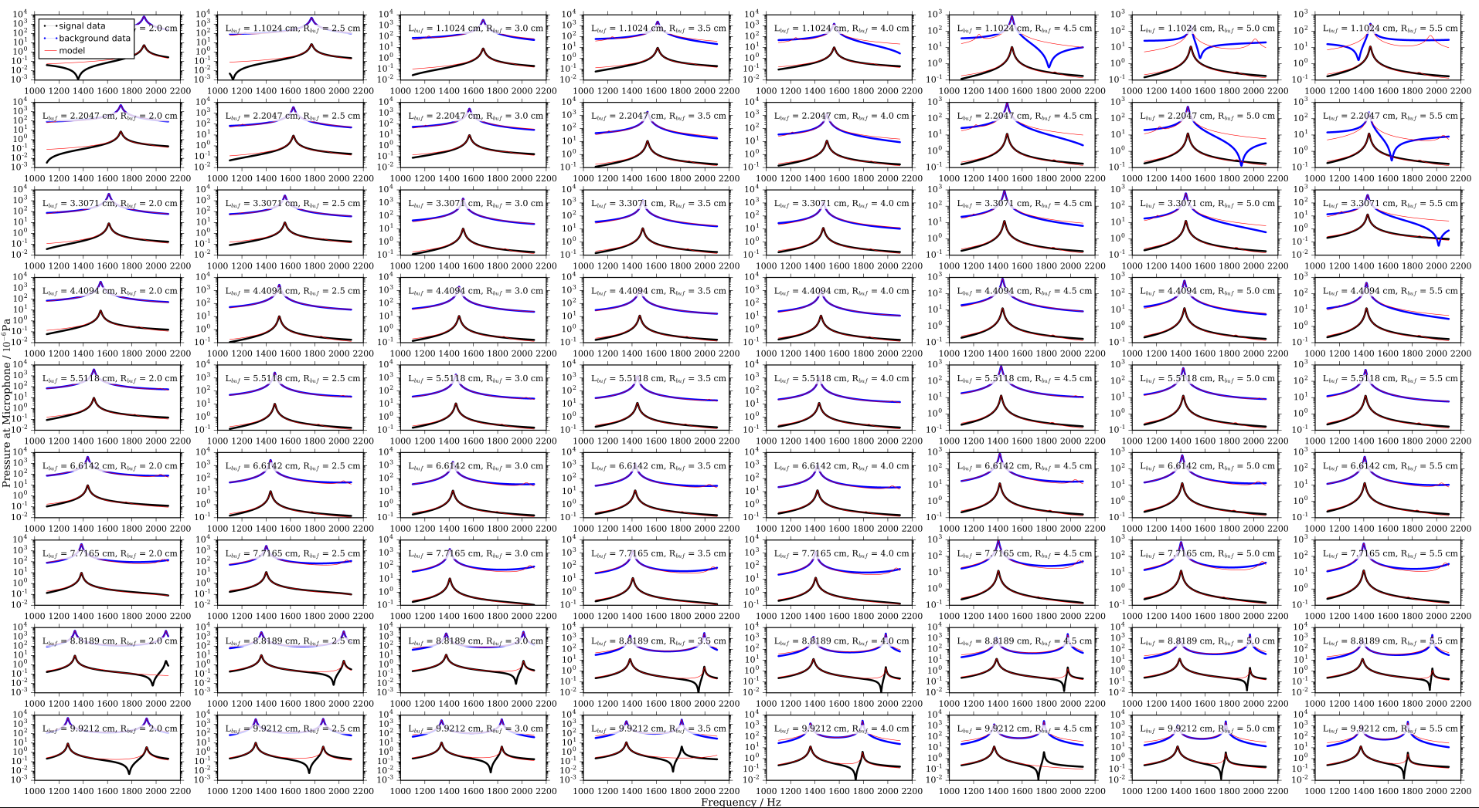
Figure S1: FEM predictions of the $\left|p_{sig}\left({\vec{r}}_{M},ω\right)\right|$ (black points) and $\left|p_{bck}\left({\vec{r}}_{M},ω\right)\right|$(blue points) for a single-resonator PA cell with l_{res} = 11.0 cm, r_{res} = 1.0 cm, while l_{buf} and r_{buf} were varied (with each plot labelled with the respective l_{buf}, r_{buf} values). The red curves represent the best-fit of a double-Lorentzian distribution.
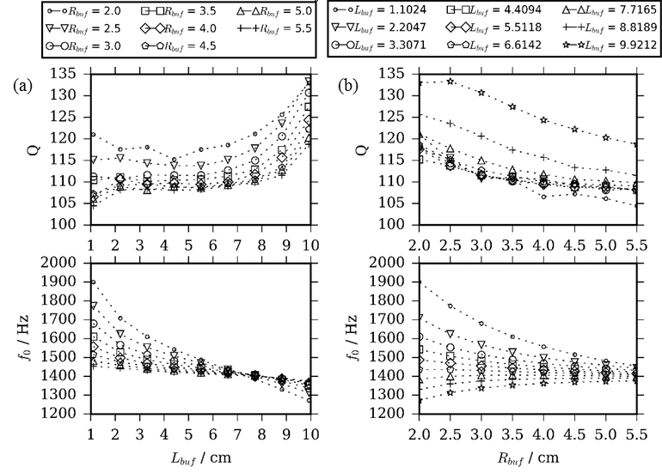
Figure S2: The best fit Q and f for the n = 1 mode. (a) Varying l_{buf} with different r_{buf} series; (b) varying r_{buf} with different l_{buf} series. For these simulations, r_{res} = 1.0 cm and l_{res} = 11.0 cm.
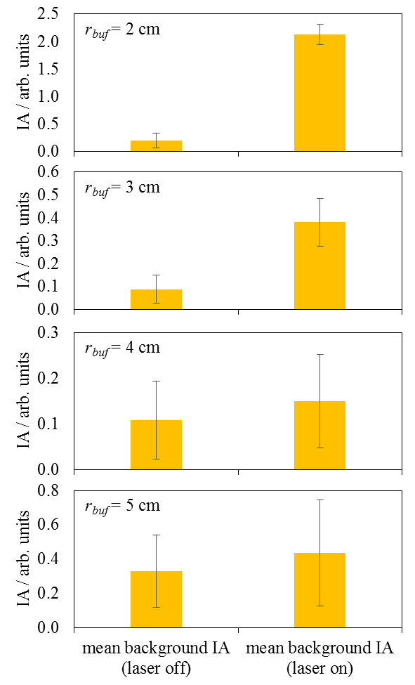
Figure S3: For our laboratory PA cell and for r_{buf} values in the range 2 – 5 cm, we compare measurements of the mean IA for background noise in the output microphone response with the laser off with the IA measured for when the laser was on for a cell devoid of any light absorbing sample. The relevant geometric parameters that describe our measurement cell, and those used in our FEM model, are: l_{res} = 11.2 cm, r_{res} = 1.1 cm, l_{buf} = 5.5 cm, l_{win} = 1.0 cm, r_{win} = 1.0 cm.

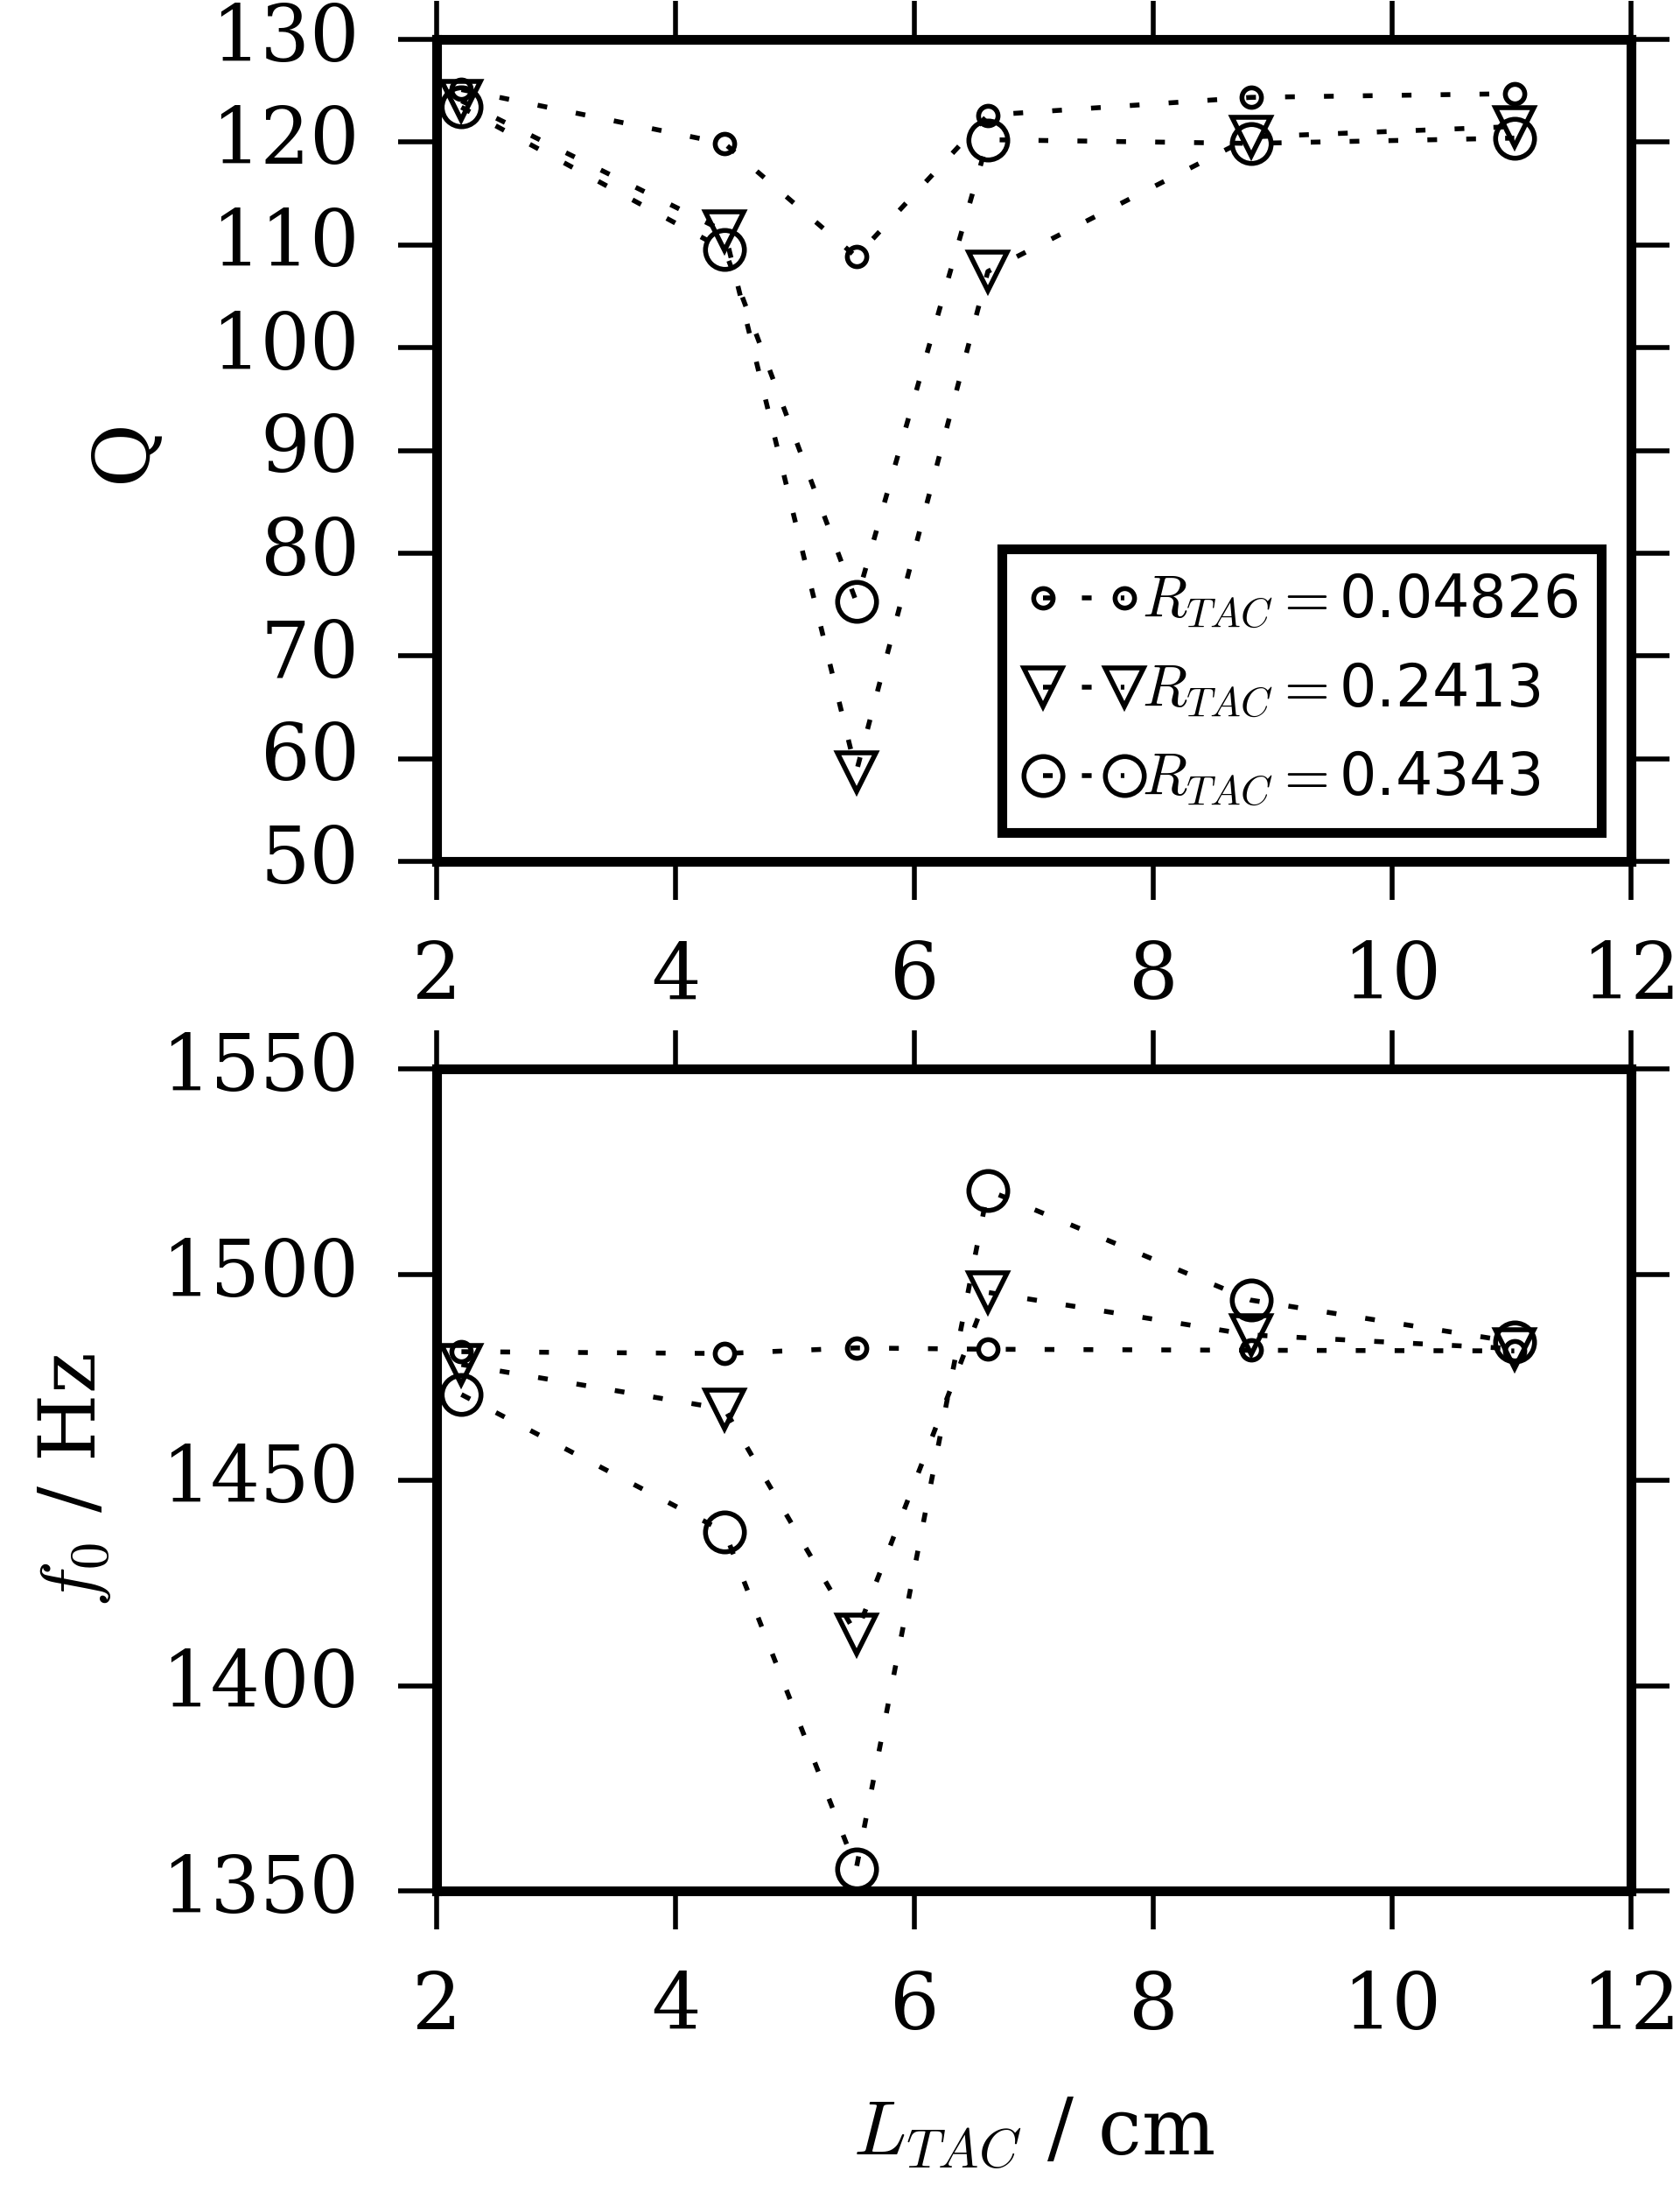
Figure S4: For an aerosol PAS cell with TACs excited by sample heating, (a) the Q factor and (b) the f_{n} with variation in l_{TAC}, as determined from fitting the frequency-dependent microphone response $p_{sig}\left({\vec{r}}_{M}, ω\right)$ to a Lorentzian function. Different data series correspond to different r_{TAC} values. Lines are to guide the eye only.

