Two new tanshinone diterpene derivatives from the rhizomes of Salvia miltiorrhiza and their antiviral activities
Zhao-Kun Yin, Zi-Ming Feng, Jian-Shuang Jiang, Xu Zhang, Pei-Cheng Zhang*, and Ya-Nan Yang*
State Key Laboratory of Bioactive Substance and Function of Natural Medicines, Peking Union Medical College and Institute of Materia Medica, Chinese Academy of Medical Sciences, Beijing 100050, China

Supporting Information

Table of Contents
Figure S1. ¹H NMR spectrum of compound 1 in CDCl₃ (500MHz) 1
Figure S2. ¹³C NMR spectrum of compound 1 in CDCl₃ (125 MHz) 1
Figure S3. HSQC spectrum of compound 1 in CDCl₃ (500MHz) 2
Figure S4. HMBC spectrum of compound 1 in CDCl₃ (500MHz) 2
Figure S5. UV spectrum of compound 1 3
Figure S6. IR spectrum of compound 1 3
Figure S7. HR-ESI-MS spectrum of compound 1 4
Figure S8. ¹H NMR spectrum of compound 2 in CDCl₃ (500MHz) 5
Figure S9. ¹³C NMR spectrum of compound 2 in CDCl₃ (125MHz) 5
Figure S10. HSQC spectrum of compound 2 in CDCl₃ (500MHz) 6
Figure S11. HMBC spectrum of compound 2 in CDCl₃ (500MHz) 6
Figure S12. UV spectrum of compound 2 7
Figure S13. IR spectrum of compound 2 7
Figure S14. HR-ESI-MS spectrum of compound 2 8

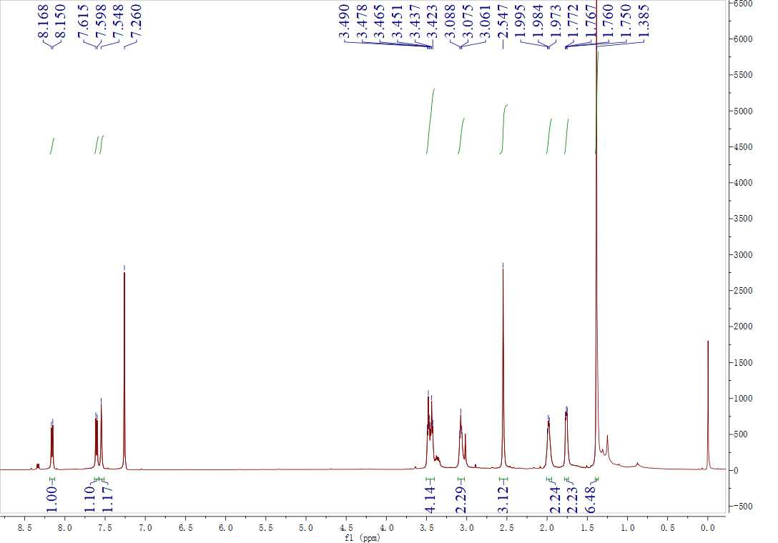

Figure S1. ¹H NMR spectrum of compound 1 in CDCl₃ (500MHz)
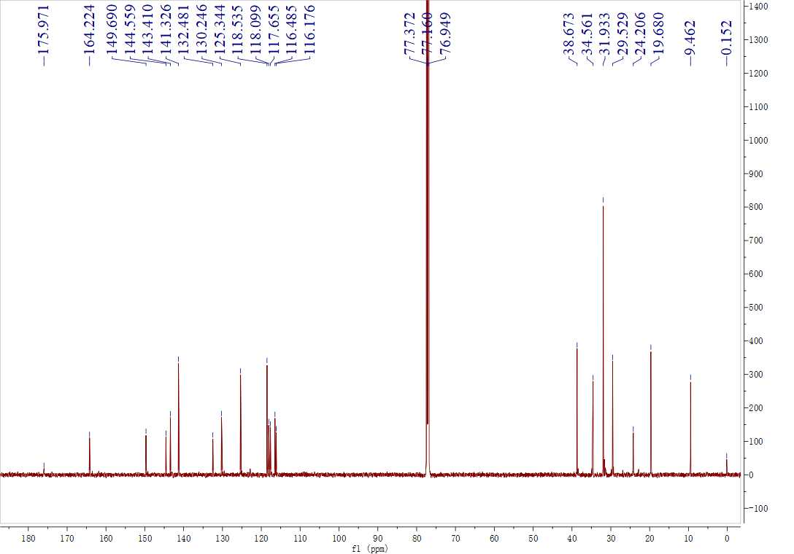

Figure S2. ¹³C NMR spectrum of compound 1 in CDCl₃ (125 MHz)

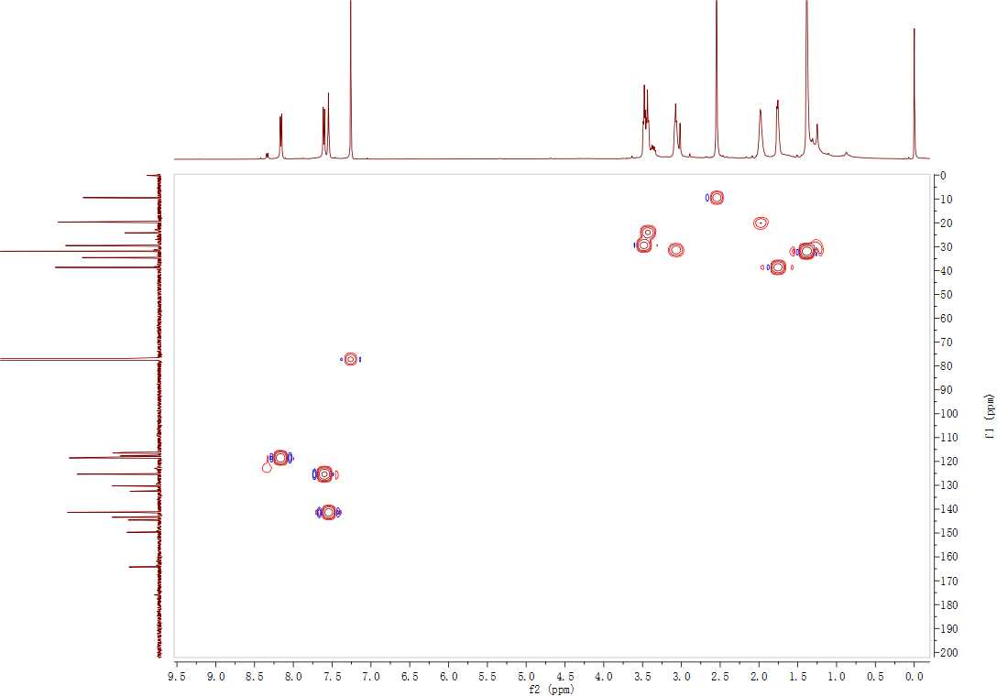

Figure S3. HSQC spectrum of compound 1 in CDCl₃ (500MHz)
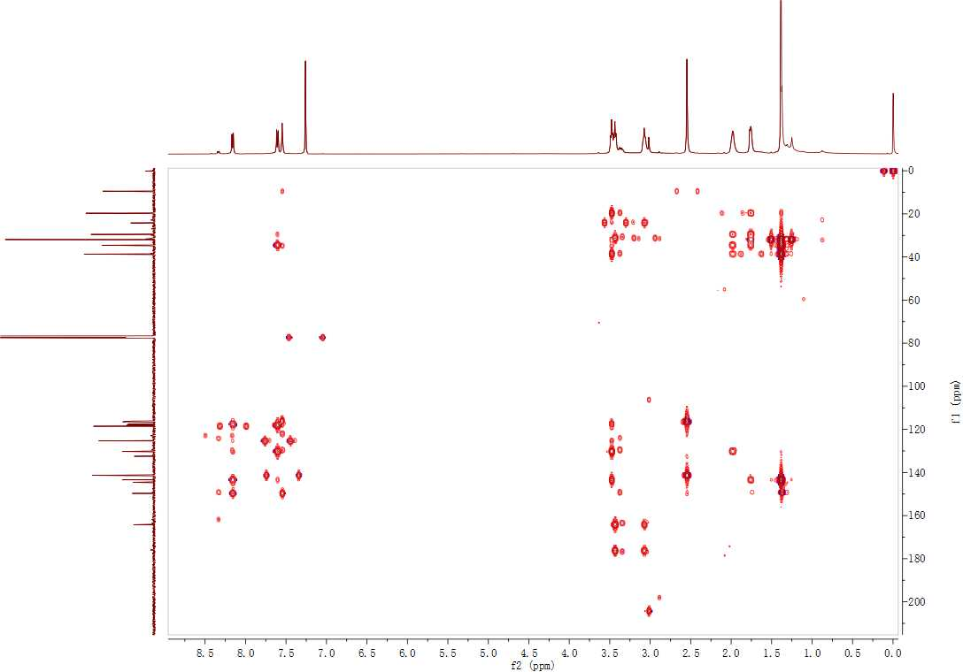

Figure S4. HMBC spectrum of compound 1 in CDCl₃ (500MHz)

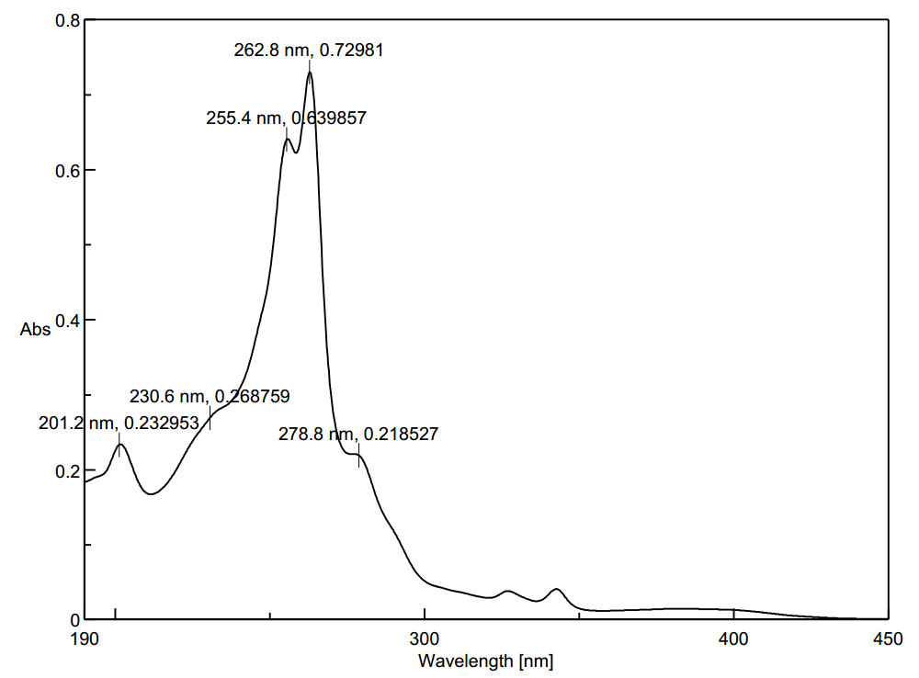

Figure S5. UV spectrum of compound 1
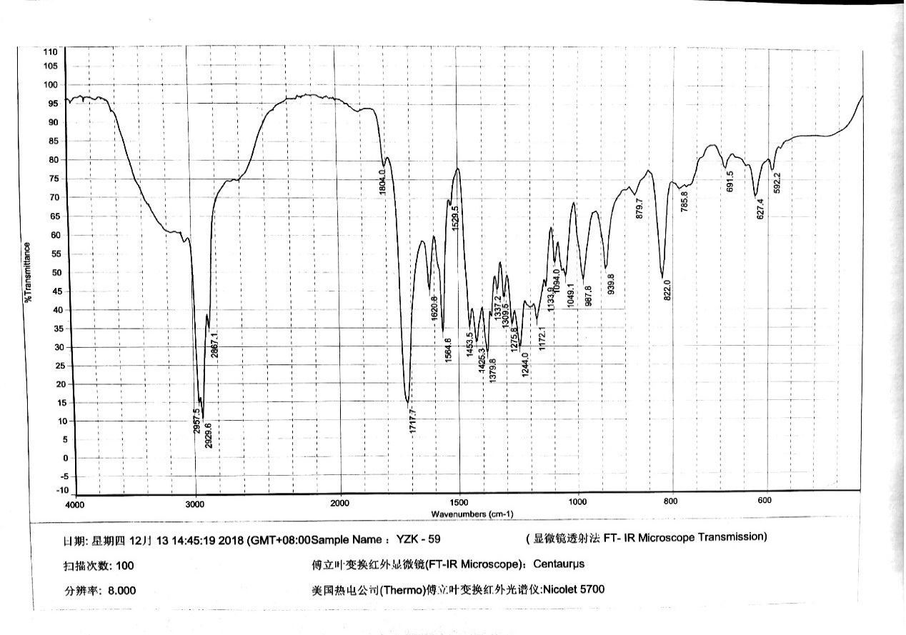

Figure S6. IR spectrum of compound 1

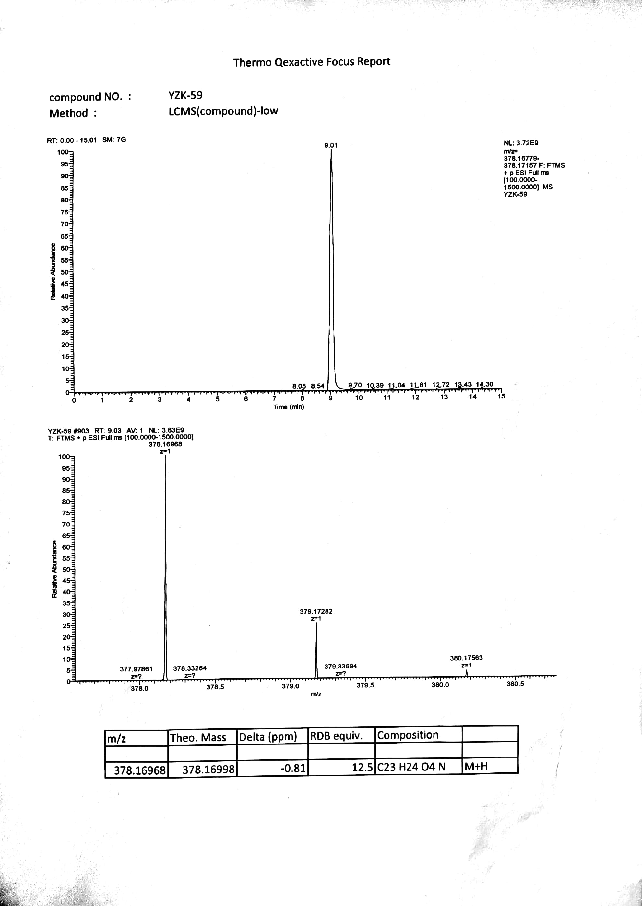

Figure S7. HR-ESI-MS spectrum of compound 1

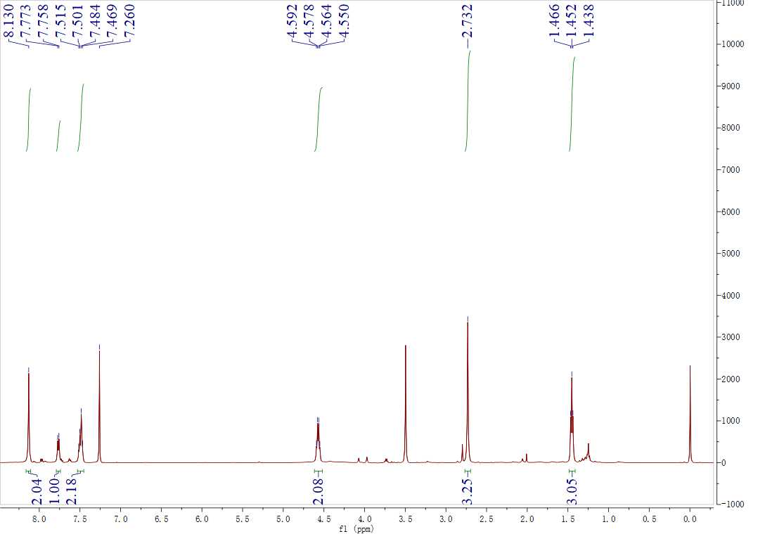

Figure S8. ¹H NMR spectrum of compound 2 in CDCl₃ (500MHz)
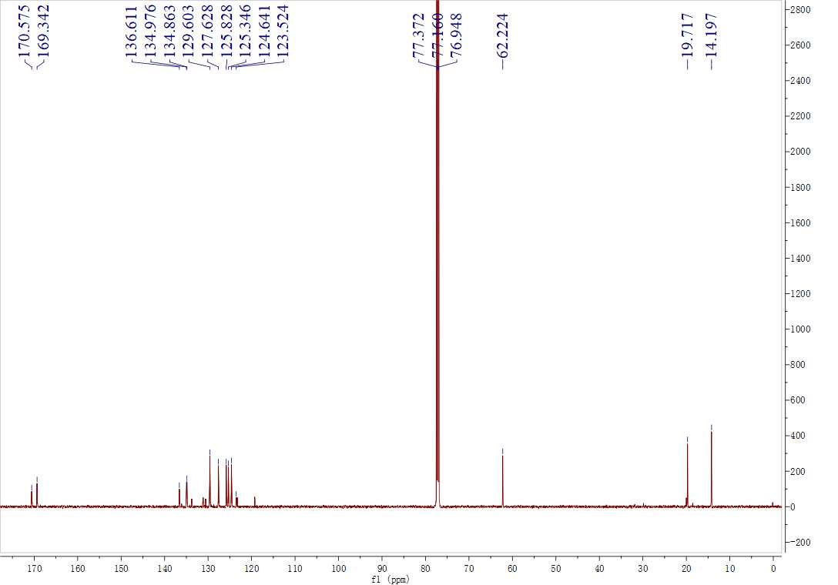

Figure S9. ¹³C NMR spectrum of compound 2 in CDCl₃ (125MHz)

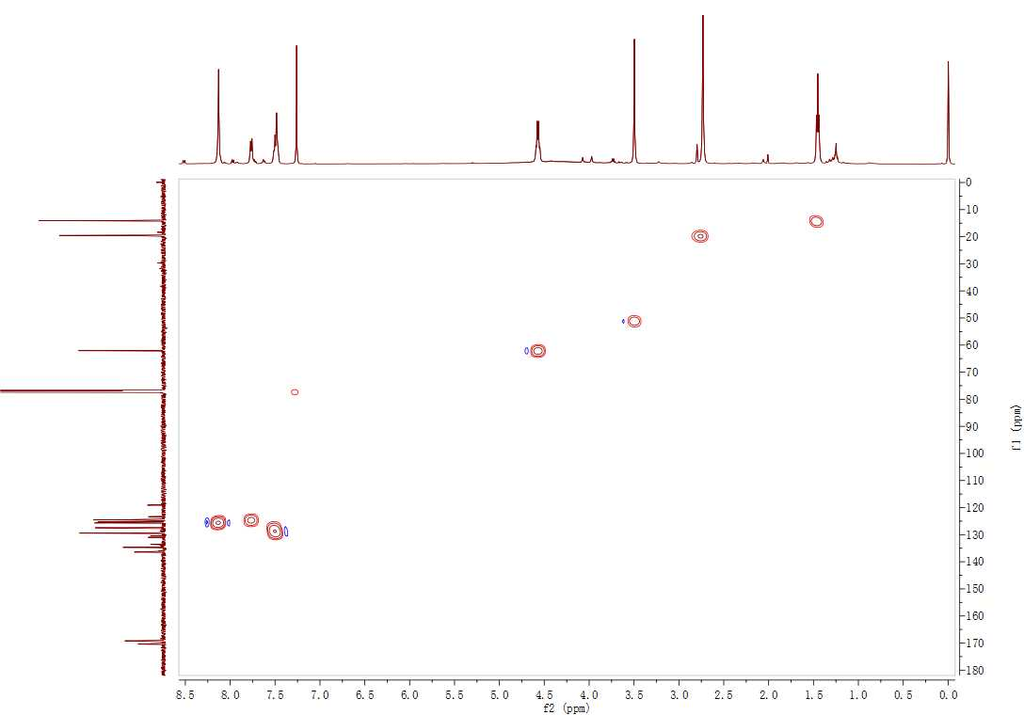

Figure S10. HSQC spectrum of compound 2 in CDCl₃ (500MHz)
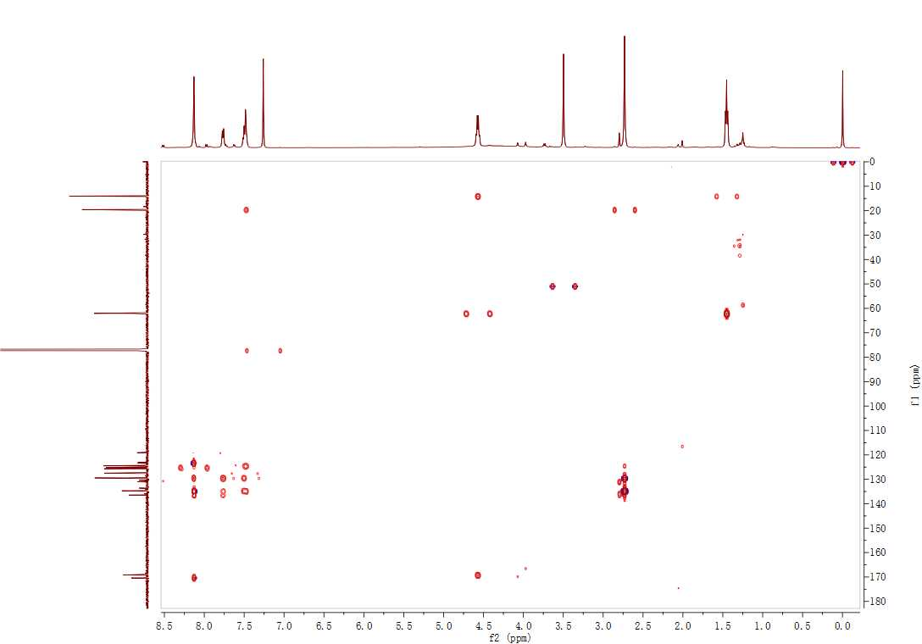

Figure S11. HMBC spectrum of compound 2 in CDCl₃ (500MHz)

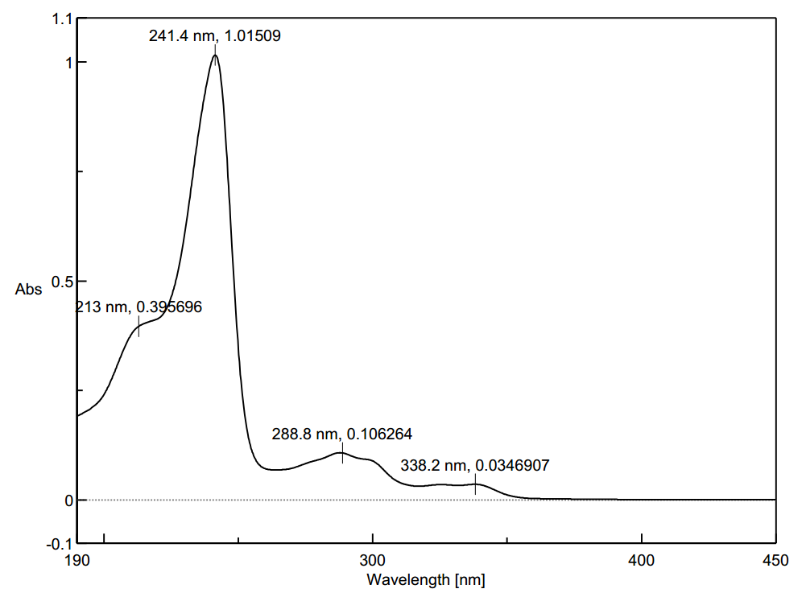

Figure S12. UV spectrum of compound 2
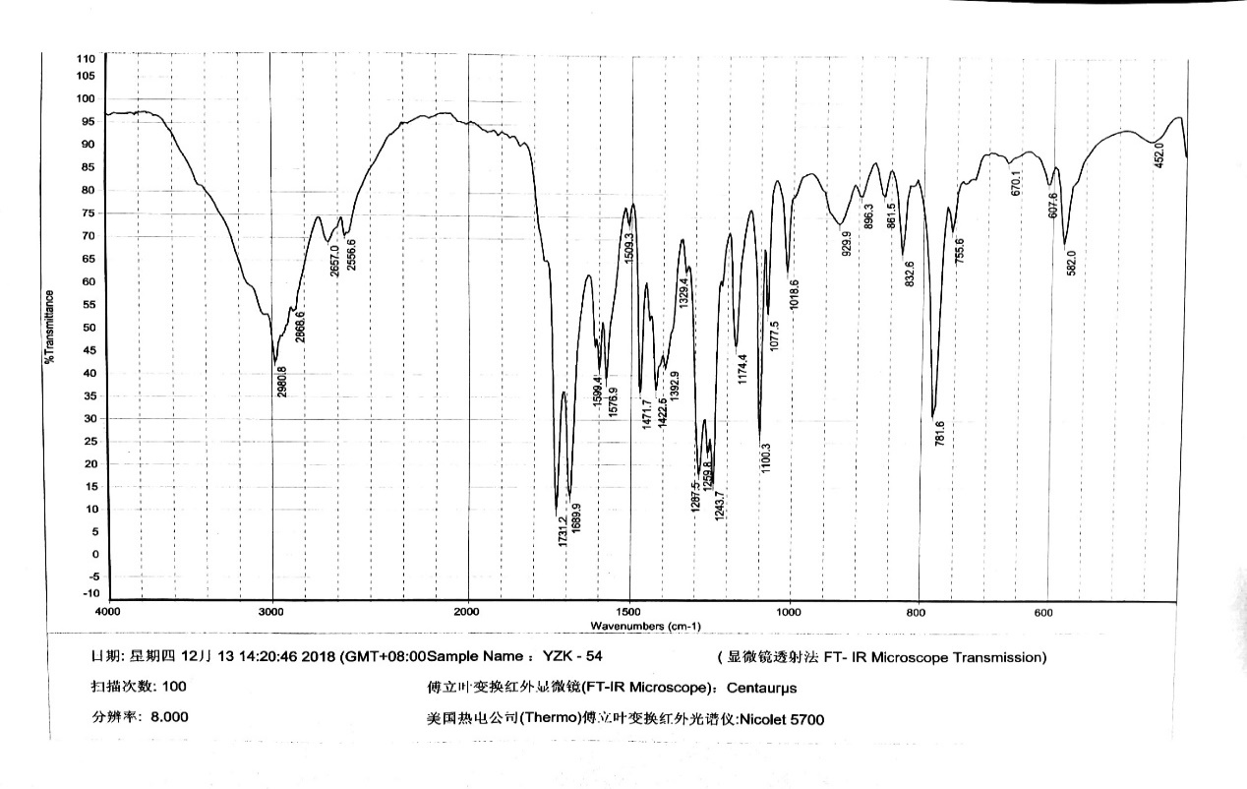

Figure S13. IR spectrum of compound 2

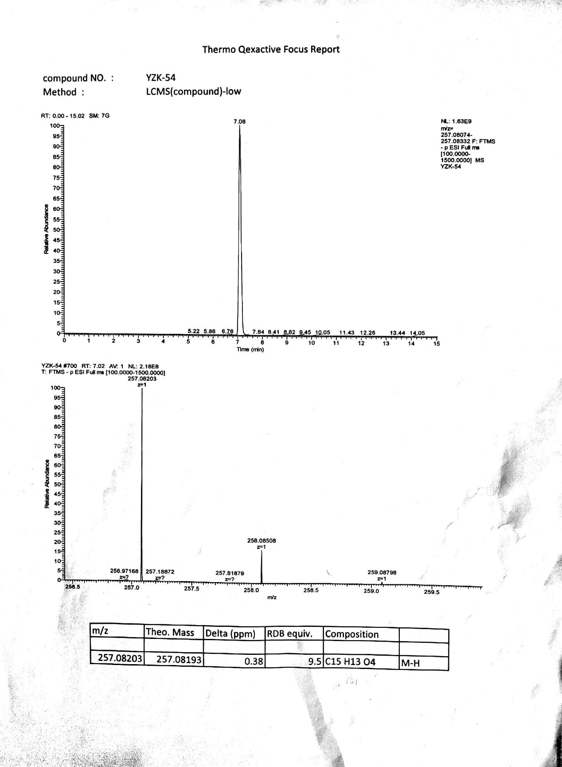

Figure S14. HR-ESI-MS spectrum of compound 2

