Supporting information
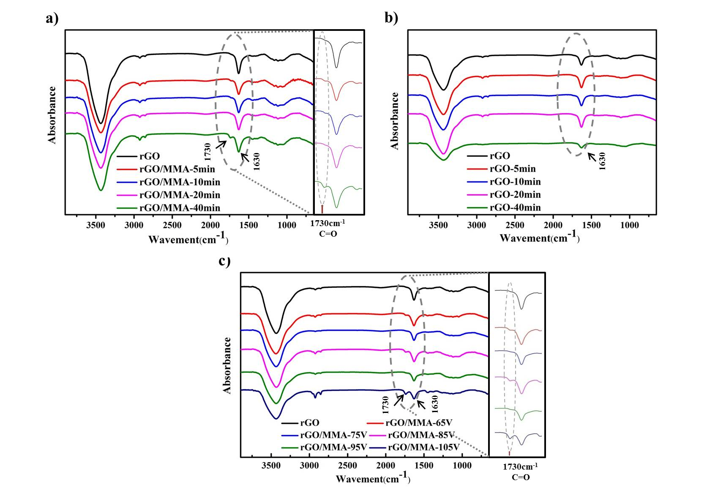
Figure S1. FTIR spectra of (a) rGO/MMA and (b) rGO treated at the input voltages of 85 v for 0, 5, 10, 20 and 40min, and (c) rGO/MMA treated for 40 min at the input voltages of 65, 75, 85, 95 and 105 v.
Figure S1a showed FTIR spectra of rGO, rGO/MMA-5min, rGO/MMA-10min, rGO/MMA-20min and rGO/MMA-40min. Obvious peaks at 1630 cm⁻¹ which were attributed to C=C stretching vibration from unoxidized graphitic domains could be observed in Figure S1a. Besides, a narrow vibrational band at 1730 cm⁻¹ due to the C=O stretching vibrations was observed, which disappeared at the spectrum of rGO in Figure S1a (Same phenomenon of rGO was also found in Figure S1c). In fact, the reaction atmosphere for plasma polymerization was strict controlled with high-purity argon gas. So the introduction of C=O to rGO after plasma process could be only caused by plasma charge or pPMMA deposits. To investigate which was the main factor, control experiments were carried out. rGO was treated for 5, 10, 20 and 40 min at 85 v in Ar atmosphere without MMA monomer injected. FTIR spectra of the samples were shown in Figure S1b. No peaks were observed at 1730 cm⁻¹. So it was easy to find that pPMMA, rather than plasma discharge, was the reason for the peak at 1730 cm⁻¹. The vibrational band of C=O at 1730 cm⁻¹ was taken as a characteristic peak for the existence of pPMMA deposits.

Table S1. The C/O ratios of rGO/MMA-85v, rGO/MMA-95v and rGO/MMA-105v
 | C(%) | O(%) | C/O
rGO/MMA-85v | 67.05 | 32.95 | 2.03
rGO/MMA-95v | 66.74 | 33.26 | 2.01
rGO/MMA-105v | 66.37 | 33.63 | 1.97

In addition to the sample of rGO/MMA-85v, it was interesting to find that C/O ratios of samples processed at 95 and 105 v also kept at about 2 at Table S1. It was different from the C/O ratio of MMA (2.50). The mainly reason for it was the complex environment of plasma discharge and the complicated process of plasma polymerization which leaded to irregular structures of pPMMA.[1]
Figure S2. AFM images of (a) rGO, (b) rGO/MMA-85v and (c) rGO/MMA-85v-w. Insets are the magnification of samples.

Table S2 Mw, Mn and D (Mw/Mn) of pPMMA
 | Mw | Mn | PDI (Mw/Mn)
pPMMA | 3466 | 1112 | 3.12
Chromatography (GPC) was also carried out to characterize the molecular weight and molecular weight distribution of pPMMA. The Mw of pPMMA was 3466 and it had a molecular weight distribution of 3.12.

[1] Friedrich J. Mechanisms of Plasma Polymerization - Reviewed from a Chemical Point of View. Plasma Process Polym. 2011; 8(9): 783-802.

