Supplementary material S1-S3
S1 Characterisation of production systems generated by K-means Clustering
Between April and May 2014, the vegetation structure was measured on 144 selected plots (see also Liebig et. al for a detailed description on the selection procedure). A GPS (Garmin eTrex) was used to measure the altitude and plot boundary coordinate. The plot boundary coordinates were used to calculate the plot sizes, which ranged between 0.01–1.55 ha. The number of coffee bushes, banana mats and stems, and shade trees were documented per plot and the number per hectare were calculated. All shade tree species were identified and the number of species per plot calculated. The canopy closure was estimated using a Forestry Suppliers spherical crown densiometer (convex model A) according to Lemmon (1957) at four positions within the plot. The slope as well as slope aspect was measured using a Suunto Tandem Global Compass/Clinometer. Via structured farmer interviews, further data farm and plot level data on coffee production were recorded, including coffee age of the coffee bushes, yield, coffee management, perceived occurrence and impact of coffee pests and diseases, and livelihood characteristics. The typology of coffee production systems was based on variables related to vegetation structure, including shade tree and banana densities per unit area, shade tree species diversity and canopy closure. The variables were standardized and K-means clustering was applied. Using a one-way ANOVA (with Tukey’s post hoc test), the variables were compared between the resulting coffee systems. Data analysis was done using R statistics (R Core Team, 2014).

S2 References for conceptual model illustrating potential relationships between components of the environment, coffee production system, microclimatic indicators, coffee productivity and coffee pests and diseases
1 | Rahn Eric, et al. “Sustainable intensification of coffee agro-ecosystems in the face of climate change 2 along the slopes of Mt. Elgon, Uganda”, (in preparation)
2 | De Bauw, Pieterjan, et al. "Soil fertility gradients and production constraints for coffee and banana on volcanic mountain slopes in the East African Rift: A case study of Mt. Elgon." Agriculture, Ecosystems & Environment 231 (2016): 166-175.
3 | Florinsky, Igor V., and Galina A. Kuryakova. "Influence of topography on some vegetation cover properties." Catena 27.2 (1996): 123-141.
4 | Lin, Brenda B. "Agroforestry management as an adaptive strategy against potential microclimate extremes in coffee agriculture." Agricultural and Forest Meteorology 144.1 (2007): 85-94.
5 | Hardwick, Stephen R., et al. "The relationship between leaf area index and microclimate in tropical forest and oil palm plantation: Forest disturbance drives changes in microclimate." Agricultural and Forest Meteorology 201 (2015): 187-195.
6 | Tscharntke, Teja, et al. "Multifunctional shade‐tree management in tropical agroforestry landscapes–a review." Journal of Applied Ecology 48.3 (2011): 619-629.
7 | Avelino, Jacques, G. Martijn Ten Hoopen, and Fabrice AJ DeClerck. "Ecological mechanisms for pest and disease control in coffee and cacao agroecosystems of the neotropics." Ecosystem Services from Agriculture and Agroforestry Measurement and Payment. London: Earthscan (2011): 91-117.
8 | De Beenhouwer, Matthias, Raf Aerts, and Olivier Honnay. "A global meta-analysis of the biodiversity and ecosystem service benefits of coffee and cacao agroforestry." Agriculture, Ecosystems & Environment 175 (2013): 1-7.
9 | Cerda, Rolando, et al. "Effects of shade, altitude and management on multiple ecosystem services in coffee agroecosystems." European Journal of Agronomy 82 (2017): 308-319.
10 | Soto-Pinto, L., I. Perfecto, and J. Caballero-Nieto. "Shade over coffee: its effects on berry borer, leaf rust and spontaneous herbs in Chiapas, Mexico." Agroforestry systems 55.1 (2002): 37-45.
11 | Morais, Heverly, et al. "Microclimatic characterization and productivity of coffee plants grown under shade of pigeon pea in Southern Brazil." Pesquisa agropecuária brasileira 41.5 (2006): 763-770.
12 | Siles, Pablo, Jean-Michel Harmand, and Philippe Vaast. "Effects of Inga densiflora on the microclimate of coffee (Coffea arabica L.) and overall biomass under optimal growing conditions in Costa Rica." Agroforestry Systems 78.3 (2010): 269-286.
13 | Barradas, V. L., and L. Fanjul. "Microclimatic characterization of shade and open–grown coffee." Coffee arabica (1986).
14 | Avelino, Jacques, Laetitia Willocquet, and Serge Savary. "Effects of crop management patterns on coffee rust epidemics." Plant pathology 53.5 (2004): 541-547.
15 | Staver, Charles, et al. "Designing pest-suppressive multistrata perennial crop systems: shade-grown coffee in Central America." Agroforestry Systems 53.2 (2001): 151-170.
16 | Mayoli, Rose N., and K. M. Gitau. "The effects of shade trees on physiology of Arabica coffee." African Journal of Horticultural Science 6 (2012).
17 | Bedimo, JA Mouen, et al. "Effect of temperatures and rainfall variations on the development of coffee berry disease caused by Colletotrichum kahawae." Crop Protection 31.1 (2012): 125-131.
18 | López-Bravo, D. F., E. de M. Virginio-Filho, and Jacques Avelino. "Shade is conducive to coffee rust as compared to full sun exposure under standardized fruit load conditions." Crop Protection 38 (2012): 21-29.
19 | Vaast, Philippe, et al. "Fruit thinning and shade improve bean characteristics and beverage quality of coffee (Coffea arabica L.) under optimal conditions." Journal of the Science of Food and Agriculture 86.2 (2006): 197-204.
20 | Lock Charles GW (1888) Coffee: Its Culture and Commerce in All Countries. E & FN Spon, London, England
21 | Beer, J., et al. "Shade management in coffee and cacao plantations." Agroforestry systems 38.1-3 (1997): 139-164.
22 | Avelino, Jacques, et al. "Topography and crop management are key factors for the development of American leaf spot epidemics on coffee in Costa Rica." Phytopathology 97.12 (2007): 1532-1542.
23 | Avelino, Jacques, et al. "Landscape context and scale differentially impact coffee leaf rust, coffee berry borer, and coffee root‐knot nematodes." Ecological applications 22.2 (2012): 584-596.
24 | Vilchez, Sergio, et al. "Relative influence of plot and landscape scale factors on coffee berry borer abundance: a variation partitioning hierarchical approach." Proceedings, 24th International ScientifiColloquium on Coffee, Association Scientifique Internationale du Café (ASIC), San José, Costa Rica. 2013.
25 | Chaplin‐Kramer, Rebecca, et al. "A meta‐analysis of crop pest and natural enemy response to landscape complexity." Ecology letters 14.9 (2011): 922-932.
26 | Perfecto, Ivette, and John Vandermeer. "Spatial pattern and ecological process in the coffee agroforestry system." Ecology 89.4 (2008): 915-920.
27 | Jackson, Doug, Jane Skillman, and John Vandermeer. "Indirect biological control of the coffee leaf rust, Hemileia vastatrix, by the entomogenous fungus Lecanicillium lecanii in a complex coffee agroecosystem." Biological Control 61.1 (2012): 89-97.
28 | Nathan, Ran, et al. "Long‐distance biological transport processes through the air: can nature's complexity be unfolded in silico?." Diversity and Distributions 11.2 (2005): 131-137.
29 | Wright, Thomas E., et al. "Edge microclimate of temperate woodlands as affected by adjoining land use." Agricultural and Forest Meteorology 150.7 (2010): 1138-1146.

S3a-b Selection procedure for micro-climatic variables
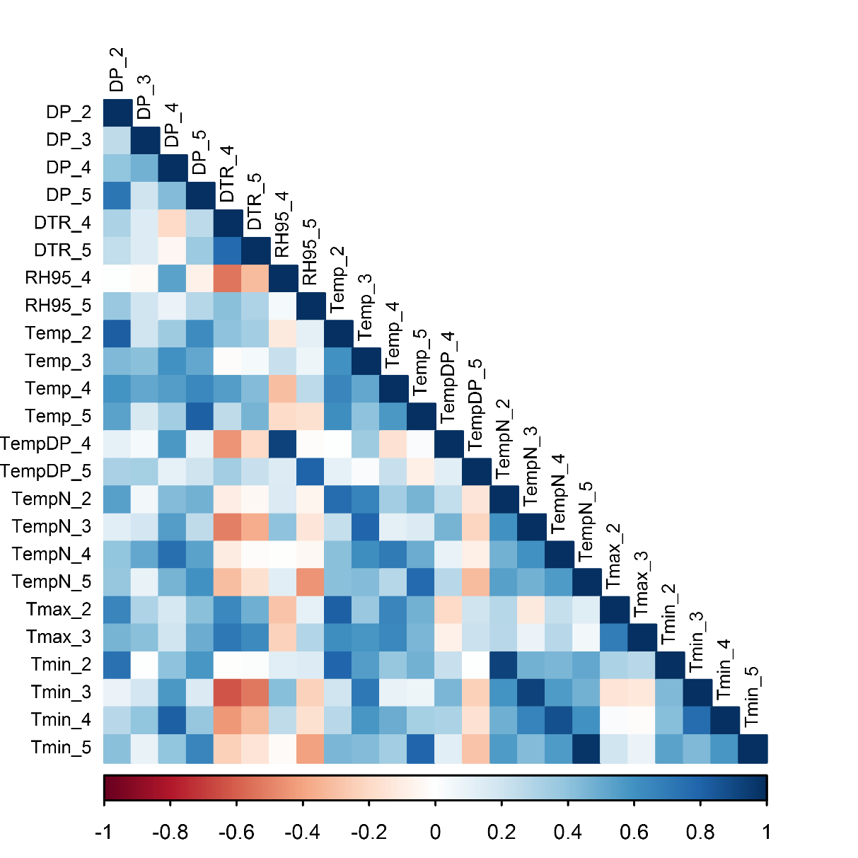
S3a Selection procedure for micro-climatic variables and respective time periods to use in piecewise SEM. Visualization of the correlation coefficients matrix between micro-climatic variables and respective periods, related with CLRmax (verified by plotting CLRmax against each potential micro-climatic variable. Out of the initial number of 63 variables, 24 showed a relationship with CLRmax). Numbers refer to monitoring dates: (2) May/June, (3) July/August, (4) September, (5) October / November}
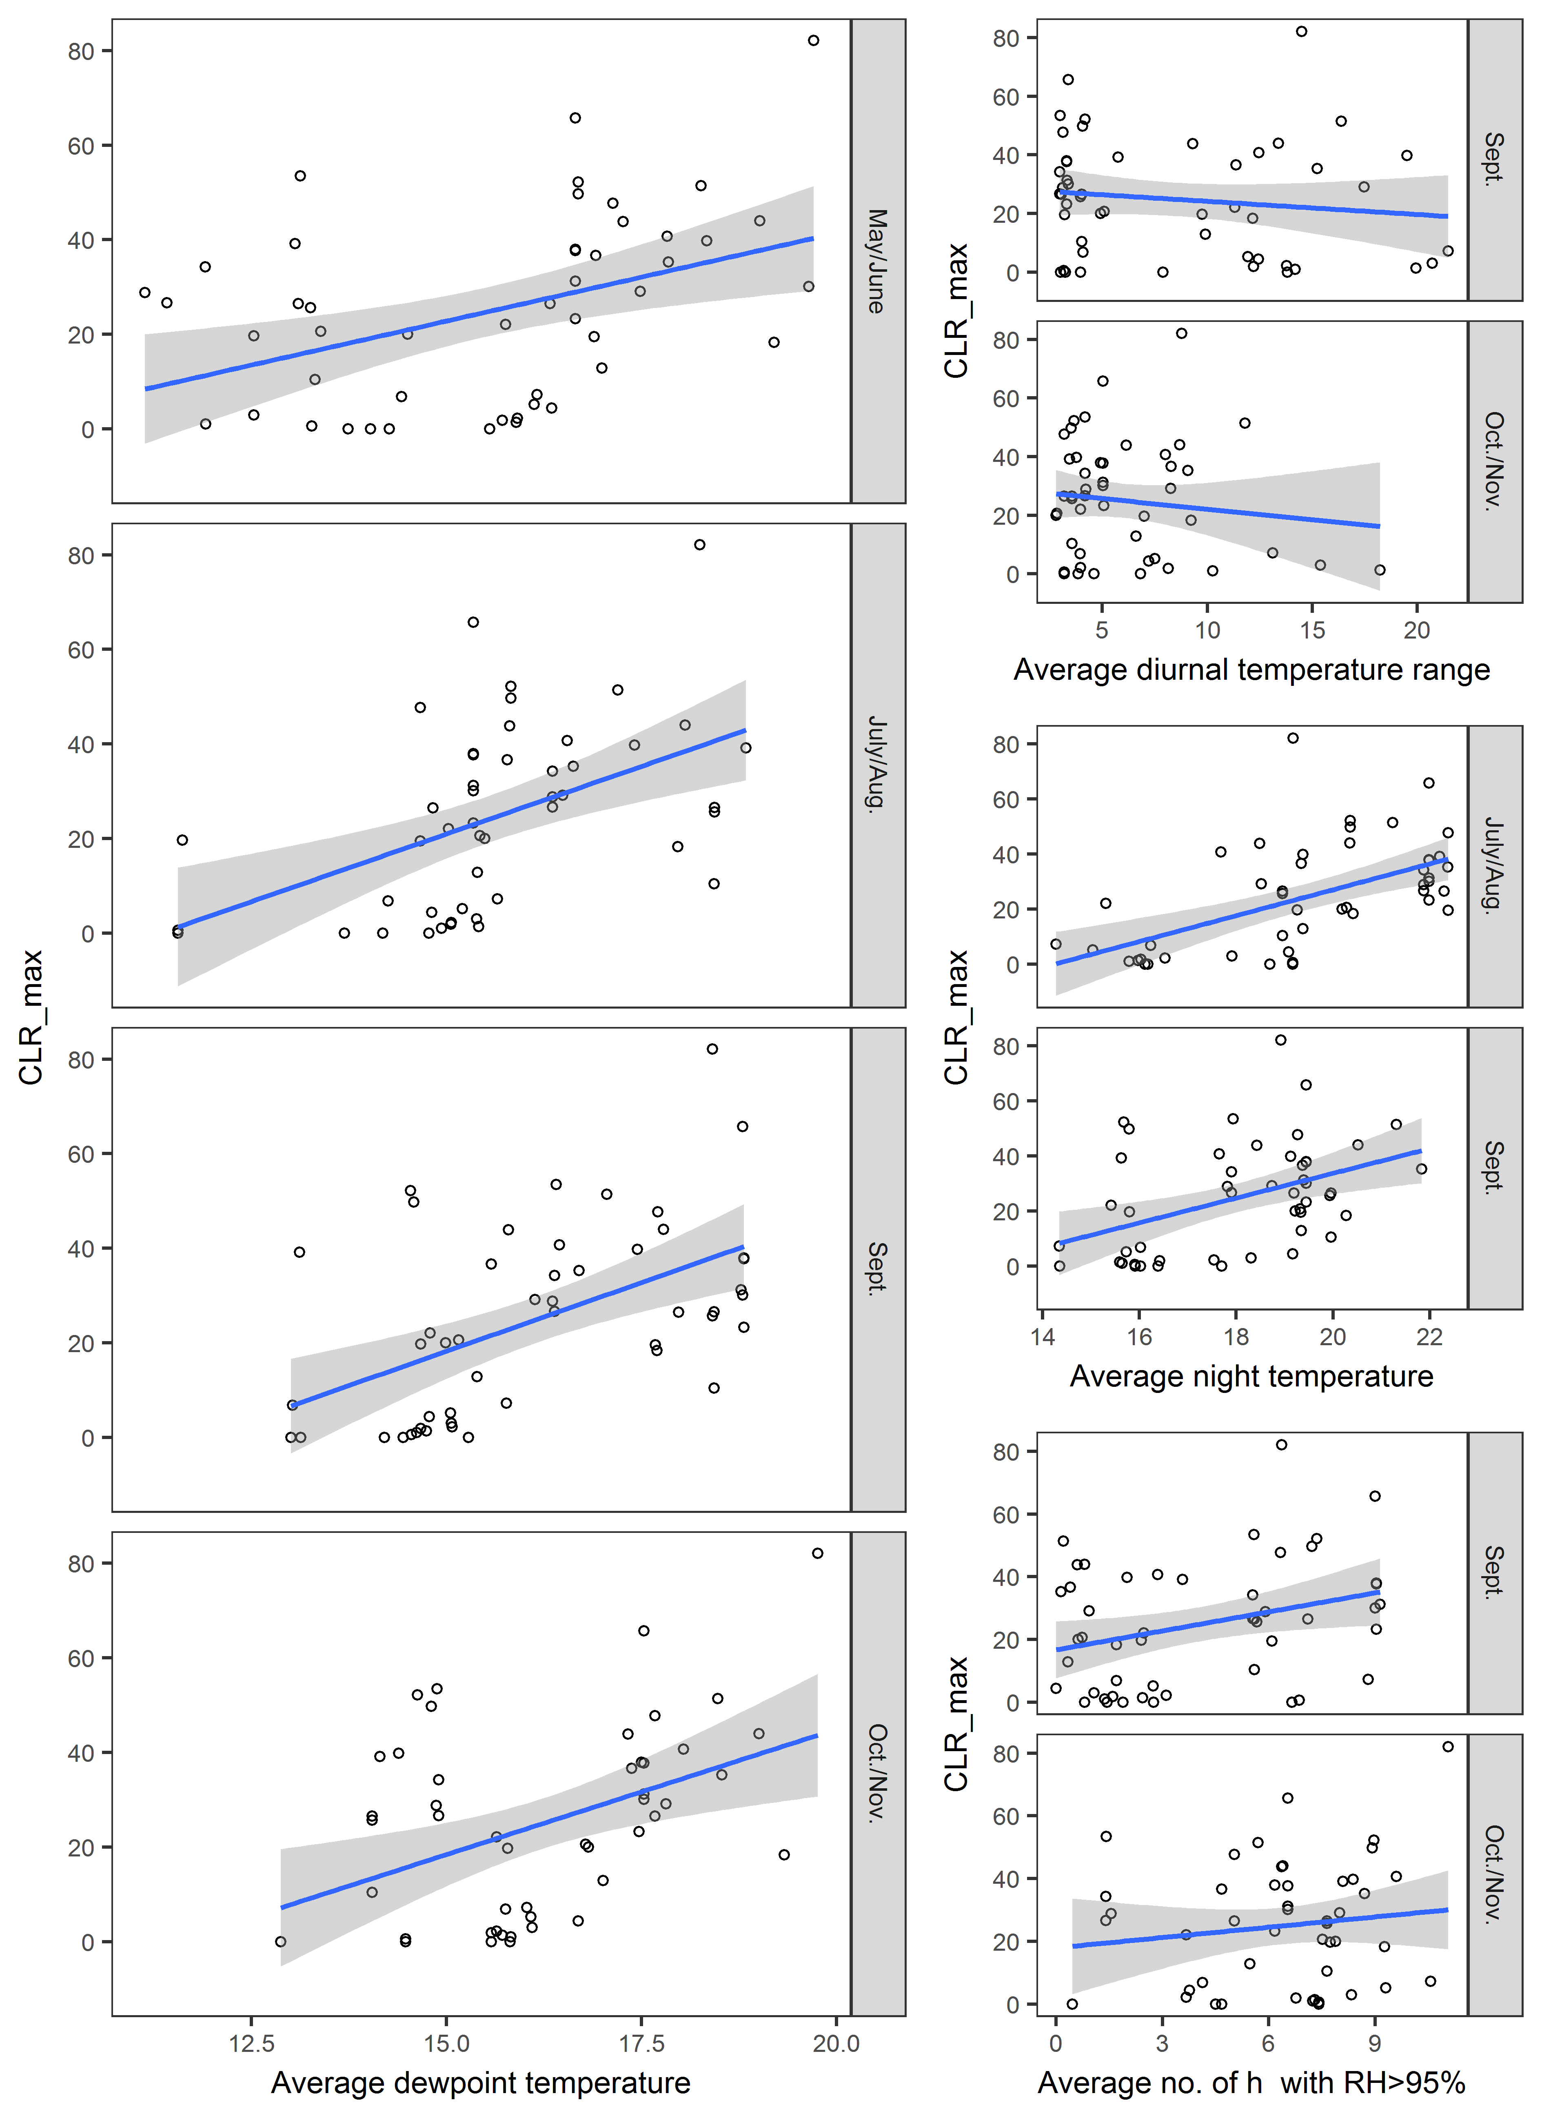
S3b Selection procedure for micro-climatic variables and respective time periods to use in piecewise SEM. Remaining 10 variables after exclusion of highly correlated variables (identified via significant tests of the correlation coefficients) showing its relationship with CLR_{max}. Since time periods within a variable of micro-climate were autocorrelated among themselves, they were joined to one variable (e.g. dew point temperature of the four time periods were joined to dew point temperature for the period between May- November), resulting in a final number of four micro-climatic variables used in the piecewiseSEM

