Supplementary Material

cis-fac-dichlorotetrakis(dimethylsulfoxide)ruthenium(II) precursor and different oximes as sources of nitrosyl ligand

R.Y. AL-SHAWAFY, ABDELRAHMAN A. DAHY, I. WARAD and REFAAT M. MAHFOUZ*

S3.4 Determination of Kinetic and Thermodynamic Parameters of the Thermal Decomposition
The Horowitz and Metzger equation, C_{s} = (n)^{1/1-n}, where C_{s} is the weight fraction of the substance present at the DTG peak temperature T_{s}, is given as:
C_{s} = Eq. S1
and was used for the determination of the values of the reaction order (n). Here W_{s} stands for the remaining weight of the substance at a given temperature T_{s}, i.e., the DTG peak temperature, W_{i} and W_{f} are the initial and final weights of the substance, respectively. The values of C_{s} for the thermal decomposition of complexes are not in the range 0.30–0.39, which indicate that the decomposition is not first-order kinetics [S1]. For a first order and not first order process the Horowitz and Metzger equations may be written in the form:
n =1 Eq. S2
n ≠1 Eq. S3
where α is the fraction decomposition at time t and is given by:
Eq. S4
(m_{o} is the mass at the beginning of the decomposition steps, m_{t} is the mass at time t, m_{f} is the mass at the end of the decomposition steps).
R is the gas constant (8.314 JK⁻¹ mol⁻¹), E_{a} is the activation energy in J mol⁻¹, θ (T−T_{s}) K.
φ is the heating rate and T_{s} temperature at DTG peak. A is Arrhenius constant (sec⁻¹).
The kinetic parameters were calculated from the plots of the left-hand side of Eqs. (S2) and (S3) with θ.
The correlation coefficient r (0.95-0.99) is computed using the least-square method for Eqs. (S2) and (S3). The E_{a} values were calculated from the slope of the decomposition step curve and the A value was determined from the intercept.
The activation entropy ΔS*, the activation enthalpy ΔH* and the free energy of activation ΔG* were calculated using the following equations [S2-S4].
Eq. S5
ΔH* = E_{a} − nRT Eq. S6
ΔG* = ΔH*− T_{s} ΔS* Eq. S7
K = Boltzmann constant (1.3086× 10⁻²³), h = Plank constant (6.626× 10⁻³⁴).

References
[S1] H.H. Horowitz, G. Metzger. Anal. Chem., 35, 1464 (1963).
[S2] R.H. Abu-Eittah, N.G. Zaki, M.M.A. Mohamed, L.T. Kamel. J. Anal. Appl. Pyrolysis, 77, 1 (2006).
[S3] C.J. Marmion, T. Murphy, J.R. Docherty, K.B. Nolan. Chem. Commun., 13, 1153 (2000).

[S4] R. Mahfouz, E. Al-Frag, M.R.H. Siddiqui, W.Z. Al-kiali, O. Karama. Arab. J. Chem., 4, 119 (2011).
Table S1. The weight in grams and the corresponding molar ratio for the metal precursor, cis-[RuCl₂(DMSO)₄], P, and the used ligands, benzohydroxamic acid (BHA), 1', anti-diphenylglyoxime (H₂dpg), 2', and dimethylglyoxime (H₂dmg), 3'.
Complexes | Precursor gm (mmol) | Used Ligand/gm (mmol)
1  2  3 | 0.100(1)  0.100(1)  0.100(1) | 0.054 (2)  0.097 (2)  0.047 (2)

Table S2. Some analytical data of complexes.
Complex | Molecular formula | F. Wt M.W | M. p ºC | Color | Elemental analysis  (found) calc.% |  |  | Λm  (Ohm⁻¹cm²mol⁻¹)
 |  |  |  |  | C H N
P  1  2  3 | C₈H₂₄S₄O₄Cl₂Ru  C₁₃H₂₄NS₃O₅C_{l2}Ru  C₂₀H₃₀N₃S₃O₆C_{l2}Ru  C₁₀H₂₅N₃S₃O₆C_{l2}Ru | 484  572  676  551 | 190  95  140  150 | Yellow  Dark  brown  Brown  Yellowish  brown | (19.8)  19.8  (28.1)  27.2  (40.0)  39.4  (24.0)  21.7 | (4.9)  4.9  (3.5)  4.2  (4.0)  4.4  (4.7)  4.5 | −  (4.0)  4.9  (6.9)  6.2  (9.0)  7.6 | 67.5  75.1  68.2  66.6

Table S3. FT-IR spectral data of the ligands and complexes.
Complexes  and  Compounds∗ | ν  (N≡O) | ν  (SO_{S-bonded}) | ν  (SO_{O-bonded}) | ν  (C=O) | ν  ( C=N,  C-N) | ν  (OH) | ν  (NH) | ν  (Ru-N_{Nitrosyl}) | ν  Ru−O | ν  Ru−S
P  1''  1  2''  2  3''  3 | -  -  1846 s  -  1869 s  -  1878 m | 1095, 1122s  -  1096s  -  1086s  -  1073 s | 920m  -  919m  -  886w  -  - | -  1646s  1638m  -  -  -  - | -  1560s  1476w  1629m  1623m  1690w  1639w | -  2750br  -  3270s  3153m  3207s  1630w | -  3295s  3232br  -  -  -  - | -  -  693m  -  690m  -  678m | 477w  -  474w  -  513w  -  - | 425m  -  424m  -  425m  -  436m
* s = strong, m = medium, w = weak, br = broad

Table S4. ¹H NMR spectral data (δ, ppm) of the ligands and complexes.
Complexes and  Compounds | CH₃  (DMSO-S) | CH₃  (DMSO-O) | H(NH) | H(OH) | H(aromatic) | H(aliphatic)
P  1''  1  2''  2  3''  3 | 3.53-3.20 (18H)  -  3.30-3.50 (12H)  -  3.20-3.46 (12H)  -  3.10-3.39 (18H) | 2.74 (6H)  -  2.60 (6H)  -  2.54 (6H)  -  - | -  11.20 (1H)  13.50 (1H)  -  -  -  - | -  9.27 (1H)  -  11.60 (2H)  12.00 (1H)  11.30 (2H)  13.10 (1H) | -  7.40-7.70 (5H)  7.40-8.00 (5H)  7.44 (10H)  7.10-7.70 (10H)  -  - | -  -  -  -  -  1.89 (6H)  1.90-2.10 (6H)

Table S5. The electronic data of complexes P, 1, 2 and 3.
Complex | λ_{max}, nm (ε, L mol⁻¹ cm⁻¹) | Assignment
P  1  2  3 | 260 (53300), 313 (2400), 360 (3100)  250 (89200), 280 (28000), 320 (1000)  248 (94100), 260 (90800), 448 (22500)  247 (78400), 258 (72900), 370 (71600) | π→π*, dπ→π* (MLCT).  π→π*, dπ→π* (MLCT).  π→π*, dπ→π* (MLCT).  π→π*, dπ→π* (MLCT).

2400
4000
3600
3200
2800
2400
2000
1800
1600
1400
1200
1000
800
600
400.0
cm⁻¹
%T
2998.00
2917.83
1431.45
1404.44
1308.49
1108.19
1095.9
1019.70
984.26
974.26
946.89
920.85
711.54
676.64
477.33
425.66
Figure S1. The FT-IR spectrum of the investigated complex 1.

4400.0
4000
3600
3200
2800
2400
2000
1800
1600
1400
1200
1000
800
600
400.0
cm⁻¹
%T
3153.76
3056.67
2919.35
1869.80
1623.99
1376.25
1309.75
1266.38
1180.41
1159.53
1086.47
1015.76
969.26
908.81
886.42
768.82
747.88
730.42
690.48
607.15
513.36
425.93
Figure S2. The FT-IR spectrum of the investigated complex 2.

4000.0
3600
3200
2800
2400
2000
1800
1600
1400
1200
1000
800
600
400.0
cm⁻¹
%T
3433.03
3221.05
3002.66
2917.93
2746.38
1878.51
1437.91
1348.63
1320.02
1192.50
1146.57
1073.78
1042.32
1016.36
970.05
712.74
678.61
619.09
443.97
436.28
1630.02
Figure S3. The FT-IR spectrum of the investigated complex 3.
2400
4000
3600
3200
2800
2400
2000
1800
1600
1400
1200
1000
800
600
400.0
cm⁻¹
%T
2998.00
2917.83
1431.45
1404.44
1308.49
1108.19
1095.9
1019.70
984.26
974.26
946.89
920.85
711.54
676.64
477.33
425.66
Figure S4. The FT-IR spectrum of the precursor complex P.

4000
3600
3200
2800
2400
2000
1800
1600
1400
1200
1000
800
600
400.0
cm⁻¹
%T
3295.32
3061.45
2750.76
1646.98
1560.43
1490.57
1315.63
1163.53
1077.67
1040.40
1022.56
898.23
797.05
706.08
690.25
518.02
429.11
Figure S5. The FT-IR spectrum of the precursor complex 1'.
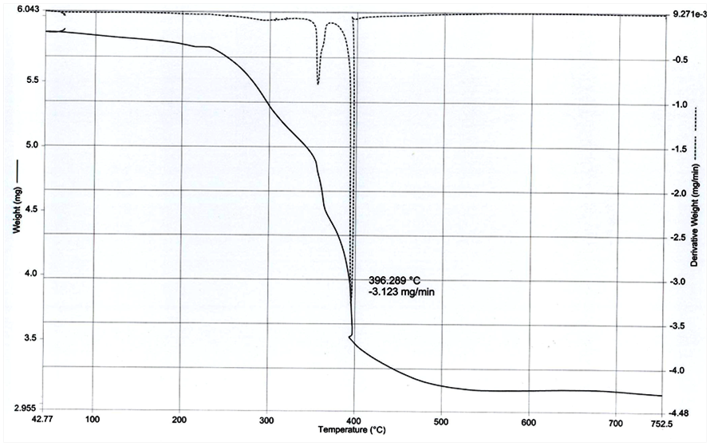
Figure S6. Typical TG/DTG curves of complex 1.

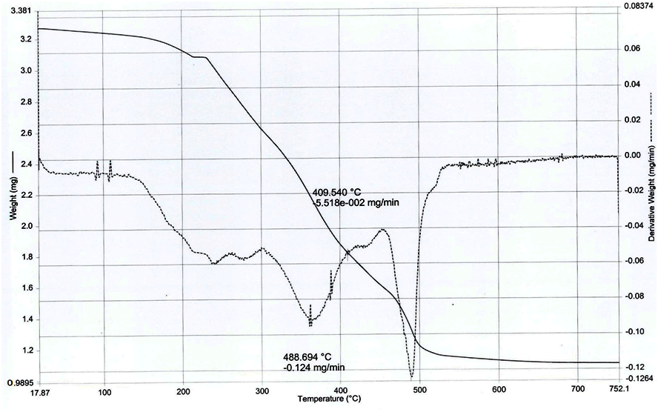
Figure S7. Typical TG/DTG curves of complex 2.
4400.0
4000
3600
3200
2800
2400
2000
1800
1600
1400
1200
1000
800
600
400.0
cm⁻¹
%T
1140.25
621.40
Figure S8. The FT-IR spectrum of RuO₂.

