Supplementary Material

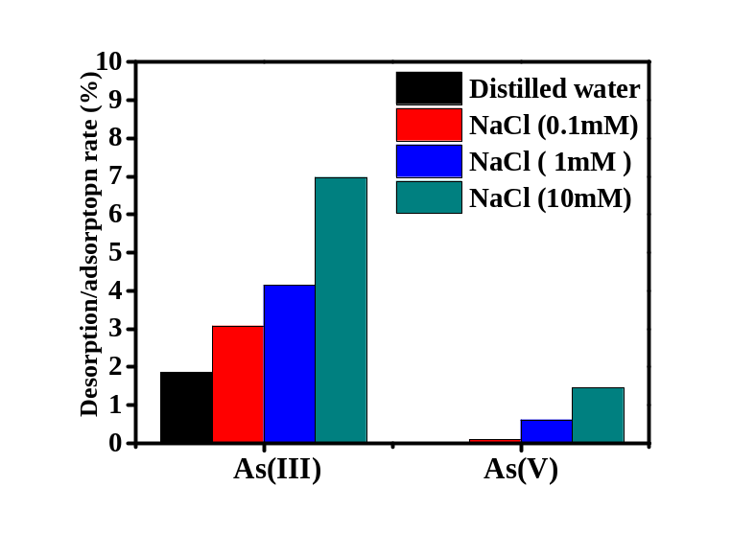
Figure S1. Desorption rate of arsenic-loaded MR-δ-Bi₂O₃ (Experiment conditions: dose of As-loaded MR-δ-Bi₂O₃: 400 mg L⁻¹; temperature: 25 ± 1℃; time: 24 h).
Figure S2. Bi 4f after arsenic uptake: (a) Bi 4f after As(III) uptake; (b) Bi 4f after As(V) uptake.

