**Supporting Information**

**Side-Chain Effects on the Capacitive Behavior of Ionic Liquids in Microporous Electrodes**

Alejandro Gallegos1, Cheng Lian2, Boris Dyatkin3,§, Jianzhong Wu1

1*Department of Chemical and Environmental Engineering, University of California, Riverside, CA 92521, USA*

2*State Key Laboratory of Chemical Engineering, East China University of Science and Technology, Shanghai 200237, PR China*

3*A.J. Drexel Nanomaterials Institute and the Department of Materials Science and Engineering, Drexel University, Philadelphia, PA 19104, USA*

§*Present Address: U.S. Naval Research Laboratory, Washington, DC 20375, USA*

In Supporting Information, we explain the molecular model in more details and key equations from the classical density functional theory.

1. ***Primitive model of electric double layer***

The pair potential between charged beads is that same as that in the primitive model for electrolyte solutions



where  is the center-to-center distance,  is the elementary charge,  is the permittivity of the free space,  is the dielectric constant of the background and is set to unity as all interactions within the model have been accounted for explicitly, and  and  are the diameter and the valence of particle , respectively.

The coarse-grained porous electrode is modeled as a slit pore which is a common choice when describing the pore size distribution in amorphous materials1. We assume that the polarizability effect or electronic screening is relatively minor, since carbon materials have a dielectric constant similar to that of a typical ionic liquid 2, 3. To be more specific, the effect of a sharp dielectric discontinuity that occurs between the surface and the ionic liquid can be quantified by the image factor where  and  is the surface and liquid dielectric permittivity, respectively4. The similarity in dielectric constant of the carbon electrode and ionic liquid lead to the factor being close to zero and as such, there is only a relatively minor effect on the resulting ion distributions. Because the electrode is modeled as a slit pore with two symmetric hard walls, the non-electrostatic component of the external potential for all species is represented by



where *H* is the surface-to-surface separation (viz., the pore width) and  is the perpendicular distance from the surface.

1. ***Classical density functional theory (cDFT)***

The theoretical details of classical density functional theory (cDFT) have been well reported in previous publications5, 6. Given the number densities of each ionic species in the bulk, the pore size, and the surface electrical potential, we solve for the one-dimensional density profiles of the cations and anions inside the slit pore by minimizing the reduced grand potential which is given as



where ,  is the Boltzmann constant,  = 298 K is the absolute temperature,  represents the coordinates specifying the positions of each segment in the cation,  is the chemical potential of anions,  is the chemical potential of the cations, where  represents the external potential acting on an individual segment, and  is the total intrinsic Helmholtz energy. The number densities of the segments of the cations are calculated from



where  is the Dirac-delta function. The intrinsic Helmholtz energy  includes an ideal-gas contribution and an excess contribution due to the intermolecular interactions 



where  stands for the bonding potential of the segments in the cation. In this coarse-grained model, we account for the contributions of ionic excluded volume effects, chain connectivity, and electrostatic correlations to the excess Helmholtz energy. The detailed expression for each term can be found elsewhere 5.

In evaluating the Coulomb energy, we calculate the mean electrostatic potential from the ionic density distributions using the Poisson equation



From the ion distributions and the electric potential profiles, we can readily calculate the surface charge density of the electrode by imposing the electroneutrality condition



The integral capacitance is calculated from



where  is the surface electrical potential and  is the potential at which the electrode has zero charge.

1. ***Additional results***

Table S1. The capacitance for H/ = 1.1 at different applied potentials for the five chain lengths (n) considered.

|  |  |  |  |  |  |  |  |
| --- | --- | --- | --- | --- | --- | --- | --- |
| **Capacitance (F/cm2) for H/ = 1.1** | | | | | | | |
| **n** |  | **0** | **1** | **2** | **3** | **4** | **5** |
| **Applied Potential (V)** | **-1.50** | 12.29 | 10.92 | 9.15 | 7.88 | 6.91 | 6.16 |
| **-1.00** | 12.37 | 12.89 | 12.85 | 11.61 | 10.31 | 9.28 |
| **-0.75** | 12.38 | 12.92 | 13.16 | 13.27 | 13.16 | 12.51 |
| **1.00** | 12.32 | 12.96 | 13.41 | 13.83 | 14.23 | 14.63 |
| **1.50** | 12.15 | 12.43 | 12.33 | 12.25 | 12.19 | 12.15 |
| **2.25** | 8.80 | 8.67 | 8.61 | 8.56 | 8.53 | 8.50 |

Table S2. The capacitance for three different neutral chain lengths (*n* = 0, 1, and 2) as a function of the pore size for an applied surface potential of -1.0 V and +1.0 V.

|  |  |  |  |  |  |  |
| --- | --- | --- | --- | --- | --- | --- |
| **H/sigma** | **Capacitance (F/cm2)** | | | | | |
| **= - 1.0 V** | | | **= + 1.0 V** | | |
| **n = 0** | **1** | **2** | **n = 0** | **1** | **2** |
| **1.1** | 12.38 | 12.91 | 12.87 | 12.34 | 12.98 | 13.42 |
| **1.2** | 9.04 | 9.30 | 9.41 | 8.92 | 9.22 | 9.41 |
| **1.3** | 7.47 | 7.60 | 7.64 | 7.34 | 7.52 | 7.63 |
| **1.4** | 6.64 | 6.69 | 6.67 | 6.68 | 6.79 | 6.83 |
| **1.5** | 6.21 | 6.19 | 6.09 | 6.38 | 6.34 | 6.21 |
| **1.6** | 5.96 | 5.82 | 5.62 | 6.03 | 5.82 | 5.61 |
| **1.7** | 5.67 | 5.55 | 5.54 | 5.60 | 5.47 | 5.30 |
| **1.8** | 5.50 | 5.82 | 5.92 | 5.41 | 5.57 | 5.86 |
| **1.9** | 6.00 | 6.69 | 6.54 | 5.94 | 6.55 | 7.12 |
| **2.0** | 7.15 | 7.65 | 7.42 | 7.22 | 7.91 | 8.35 |
| **2.2** | 9.80 | 10.20 | 9.60 | 9.74 | 9.88 | 10.00 |
| **2.4** | 12.47 | 12.00 | 10.78 | 12.32 | 12.39 | 12.07 |
| **2.6** | 13.08 | 12.86 | 12.07 | 13.19 | 13.10 | 12.74 |
| **2.8** | 10.41 | 10.56 | 10.46 | 10.38 | 10.80 | 10.87 |
| **3.0** | 9.49 | 9.54 | 9.41 | 9.59 | 9.65 | 9.68 |
| **3.5** | 10.56 | 10.53 | 10.03 | 11.14 | 10.80 | 10.56 |
| **4.0** | 12.08 | 12.51 | 11.65 | 11.93 | 12.01 | 12.04 |

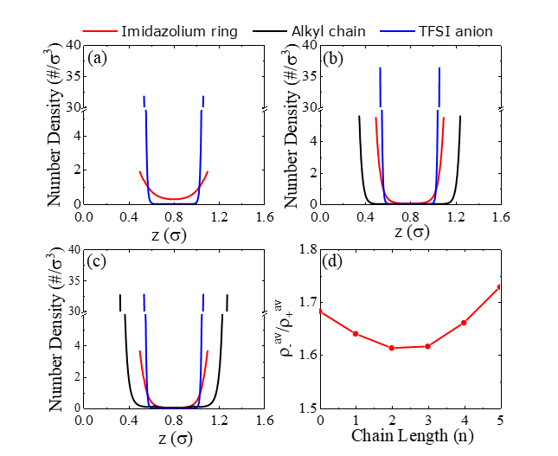

Figure S1. The number density profiles for *n* = 0 (a), 2 (b), and 5 (c) confined in a 1.60 micropore with an applied surface potential of  = +1.0 V. (d) The ratio of anions to cations inside the micropore.

**References**:

1. Laudisio, G.; Dash, R. K.; Singer, J. P.; Yushin, G.; Gogotsi, Y.; Fischer, J. E., Carbide-Derived Carbons:  A Comparative Study of Porosity Based on Small-Angle Scattering and Adsorption Isotherms. *Langmuir* **2006,** *22* (21), 8945-8950.

2. Kondrat, S.; Kornyshev, A., Superionic state in double-layer capacitors with nanoporous electrodes. *Journal of Physics: Condensed Matter* **2010,** *23* (2), 022201.

3. Kondrat, S.; Georgi, N.; Fedorov, M. V.; Kornyshev, A. A., A superionic state in nano-porous double-layer capacitors: insights from Monte Carlo simulations. *Physical Chemistry Chemical Physics* **2011,** *13* (23), 11359-11366.

4. Wang, Z.-Y., Image-induced overcharging in the weakly charged surfaces. *Journal of Statistical Mechanics: Theory and Experiment* **2016,** *2016* (4), 043205.

5. Li, Z.; Wu, J., Density Functional Theory for Planar Electric Double Layers:  Closing the Gap between Simple and Polyelectrolytes. *The Journal of Physical Chemistry B* **2006,** *110* (14), 7473-7484.

6. Li, Z.; Wu, J., Density-functional theory for the structures and thermodynamic properties of highly asymmetric electrolyte and neutral component mixtures. *Physical Review E* **2004,** *70* (3), 031109.