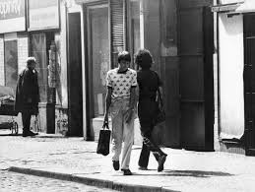
Jiří Kovanda, Contact, action in Prague, September 3, 1979

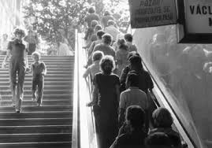
Jiří Kovanda, Untitled, action in Prague, 1977

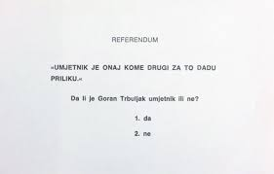

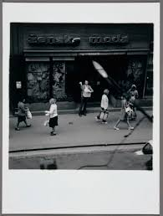
Goran Trbuljak, Referendum, action on Ilica Street, Zagreb, Yugoslavia, 1972
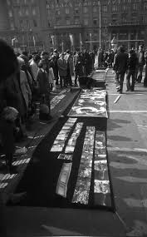
Group of Six Artists, Exhibition-Action, action on Republic Square, Zagreb, Yugoslavia, September 25, 1975.

