Figure A1: Thoracic deflection contours at the upper and lower levels (top and bottom rows) for the oblique test without the airbag. Deformed contours are shown in blue and undeformed contours are shown in black color.
Figure A2: Thoracic deflection contours at the upper and lower levels (top and bottom rows) for the oblique test with the airbag. Deformed contours are shown in blue and undeformed contours are shown in black color.
Figure A3: Thoracic deflection contours at the upper and lower levels (top and bottom rows) for the pure lateral test without the airbag. Deformed contours are shown in blue and undeformed contours are shown in black color.
Figure A4: Thoracic deflection contours at the upper and lower levels (top and bottom rows) for the pure lateral test with the airbag. Deformed contours are shown in blue and undeformed contours are shown in black color.
Figure A5: Sled pulse

Table A1: Test Matrix
ID | Impact type | Airbag
1 | Oblique | No
2 | Oblique | Yes
3 | Oblique | No
4 | Oblique | Yes
5 | Pure lateral | No
6 | Pure lateral | Yes

Figure A1
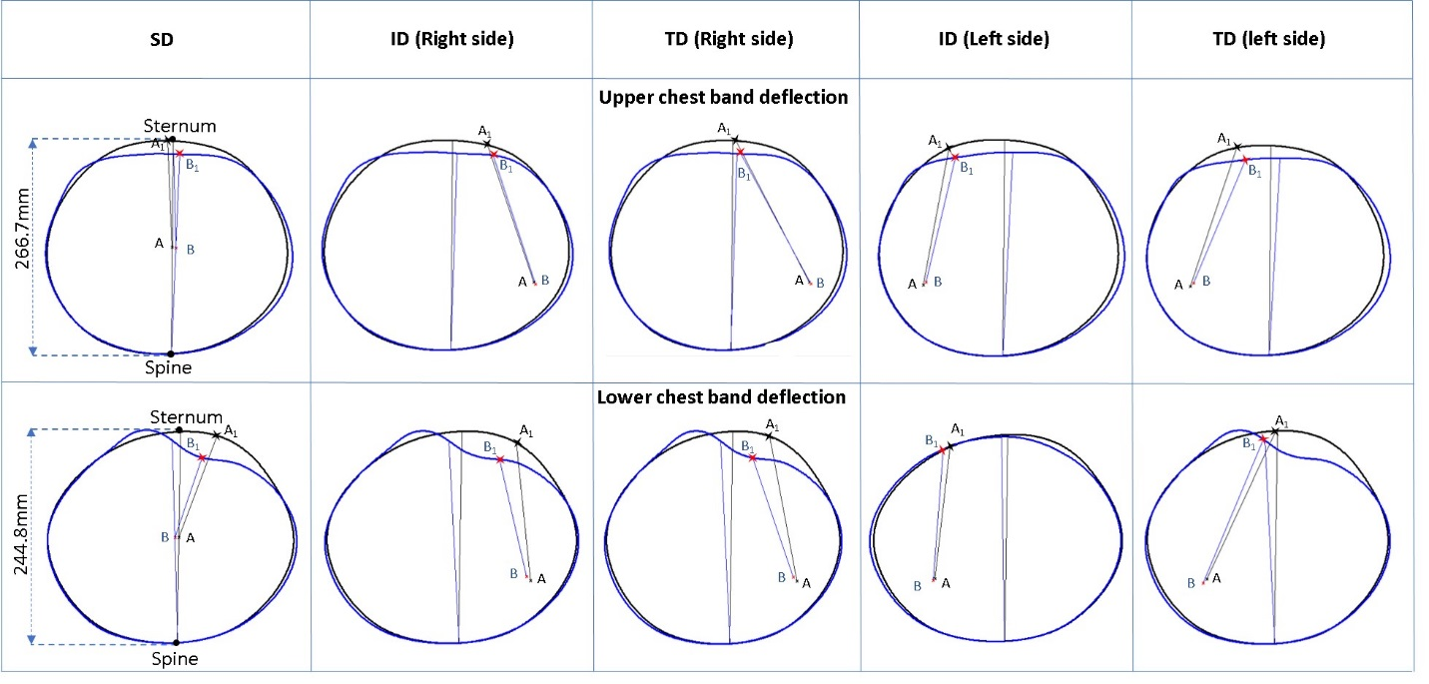

Figure A2

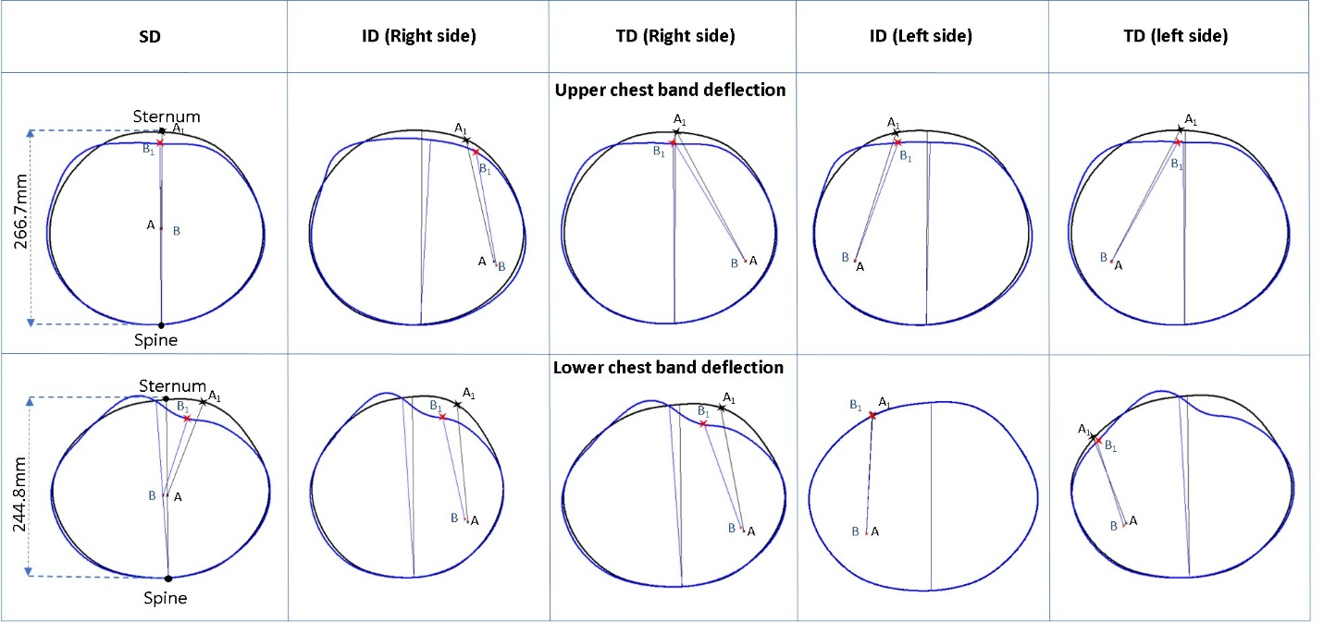

Figure A3
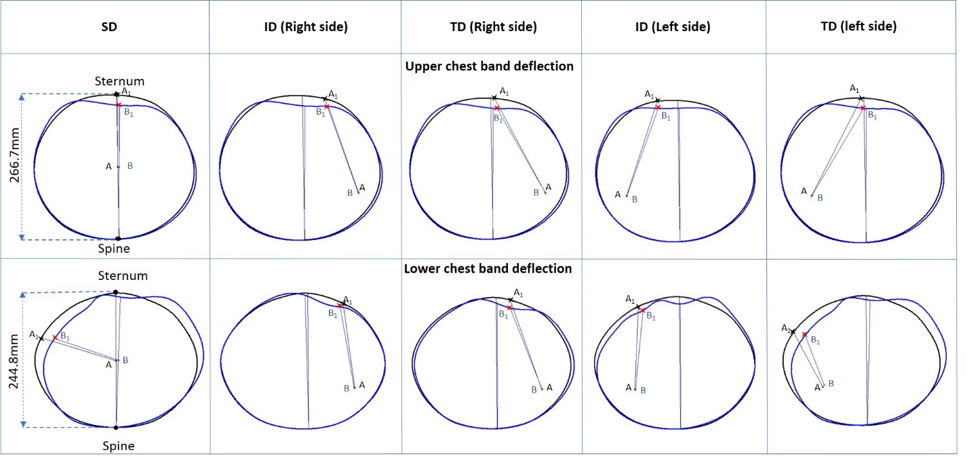

Figure A4
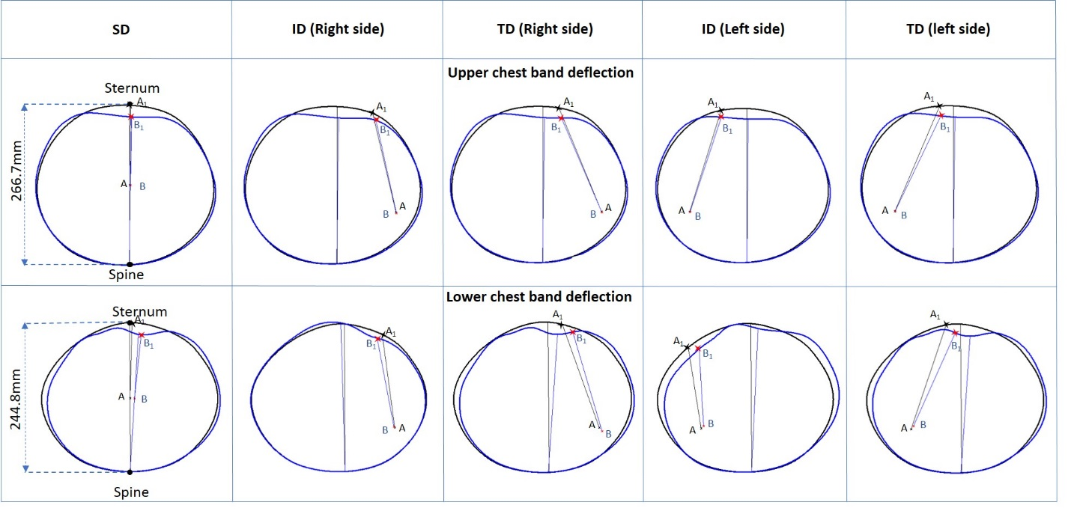

Figure A5

