# Appendix

Table A-1. Coefficients of friction

|  |  |  |  |
| --- | --- | --- | --- |
|  | Dry | Wet | Snow/Ice |
| Asphalt | 0.65 | 0.5 | 0.2 |
| Concrete | 0.75 | 0.6 | 0.2 |
| Dirt | 0.2 | 0.2 | 0.2 |

Table A-2. Impacted object distribution in remaining crashes based on reaction time

|  |  |  |  |  |
| --- | --- | --- | --- | --- |
|  | Guardrail | Traffic Barrier | Pole | Tree |
| No LDW/LDP | 13.8% | 2.4% | 48.2% | 15.3% |
| LDW 1.36s | 16.6% | 2.9% | 47.4% | 15.2% |
| LDW 0.38s | 12.3% | 3.9% | 52.9% | 11.8% |
| LDP 0.0s | 25.1% | 3.9% | 44.0% | 13.9% |

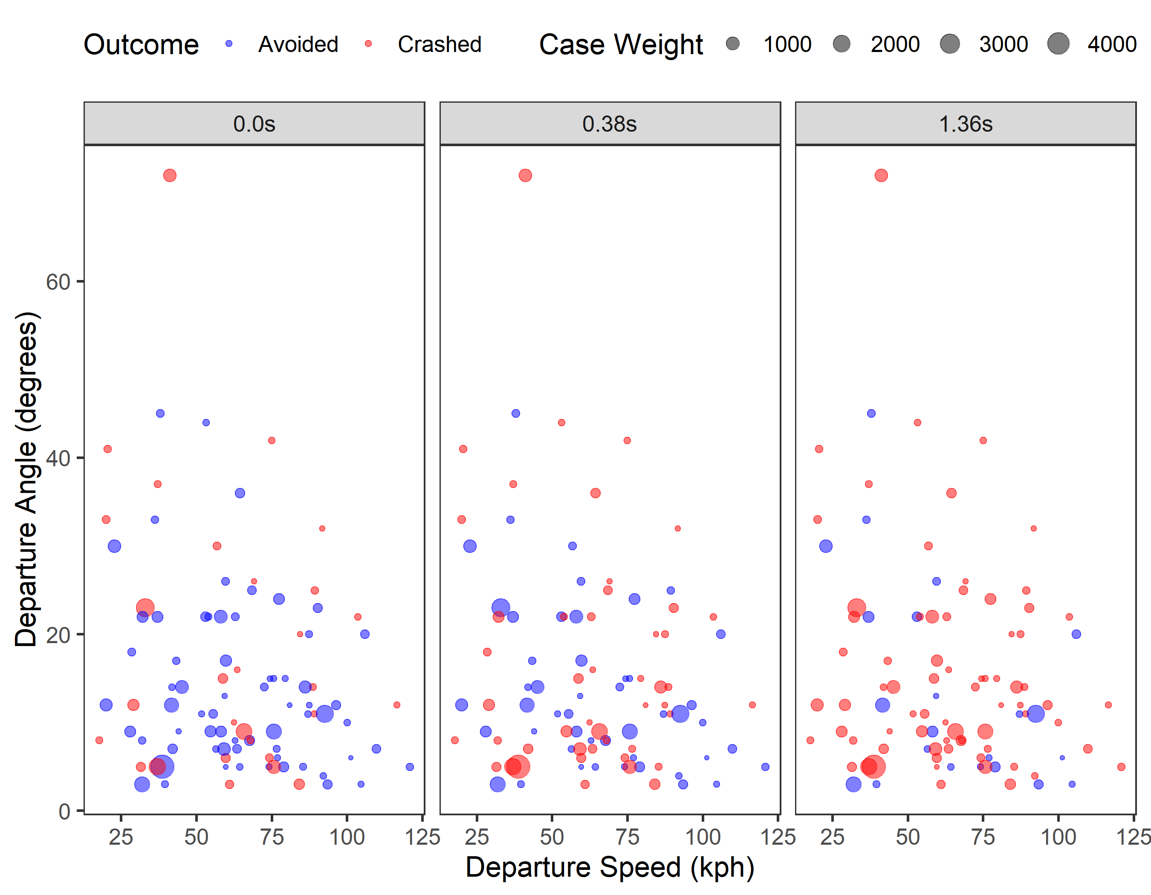

Figure A-1. Predicted crash outcome for LDW/LDP applicable drift-out-of-lane road departure crashes based on departure speed and the departure angle.

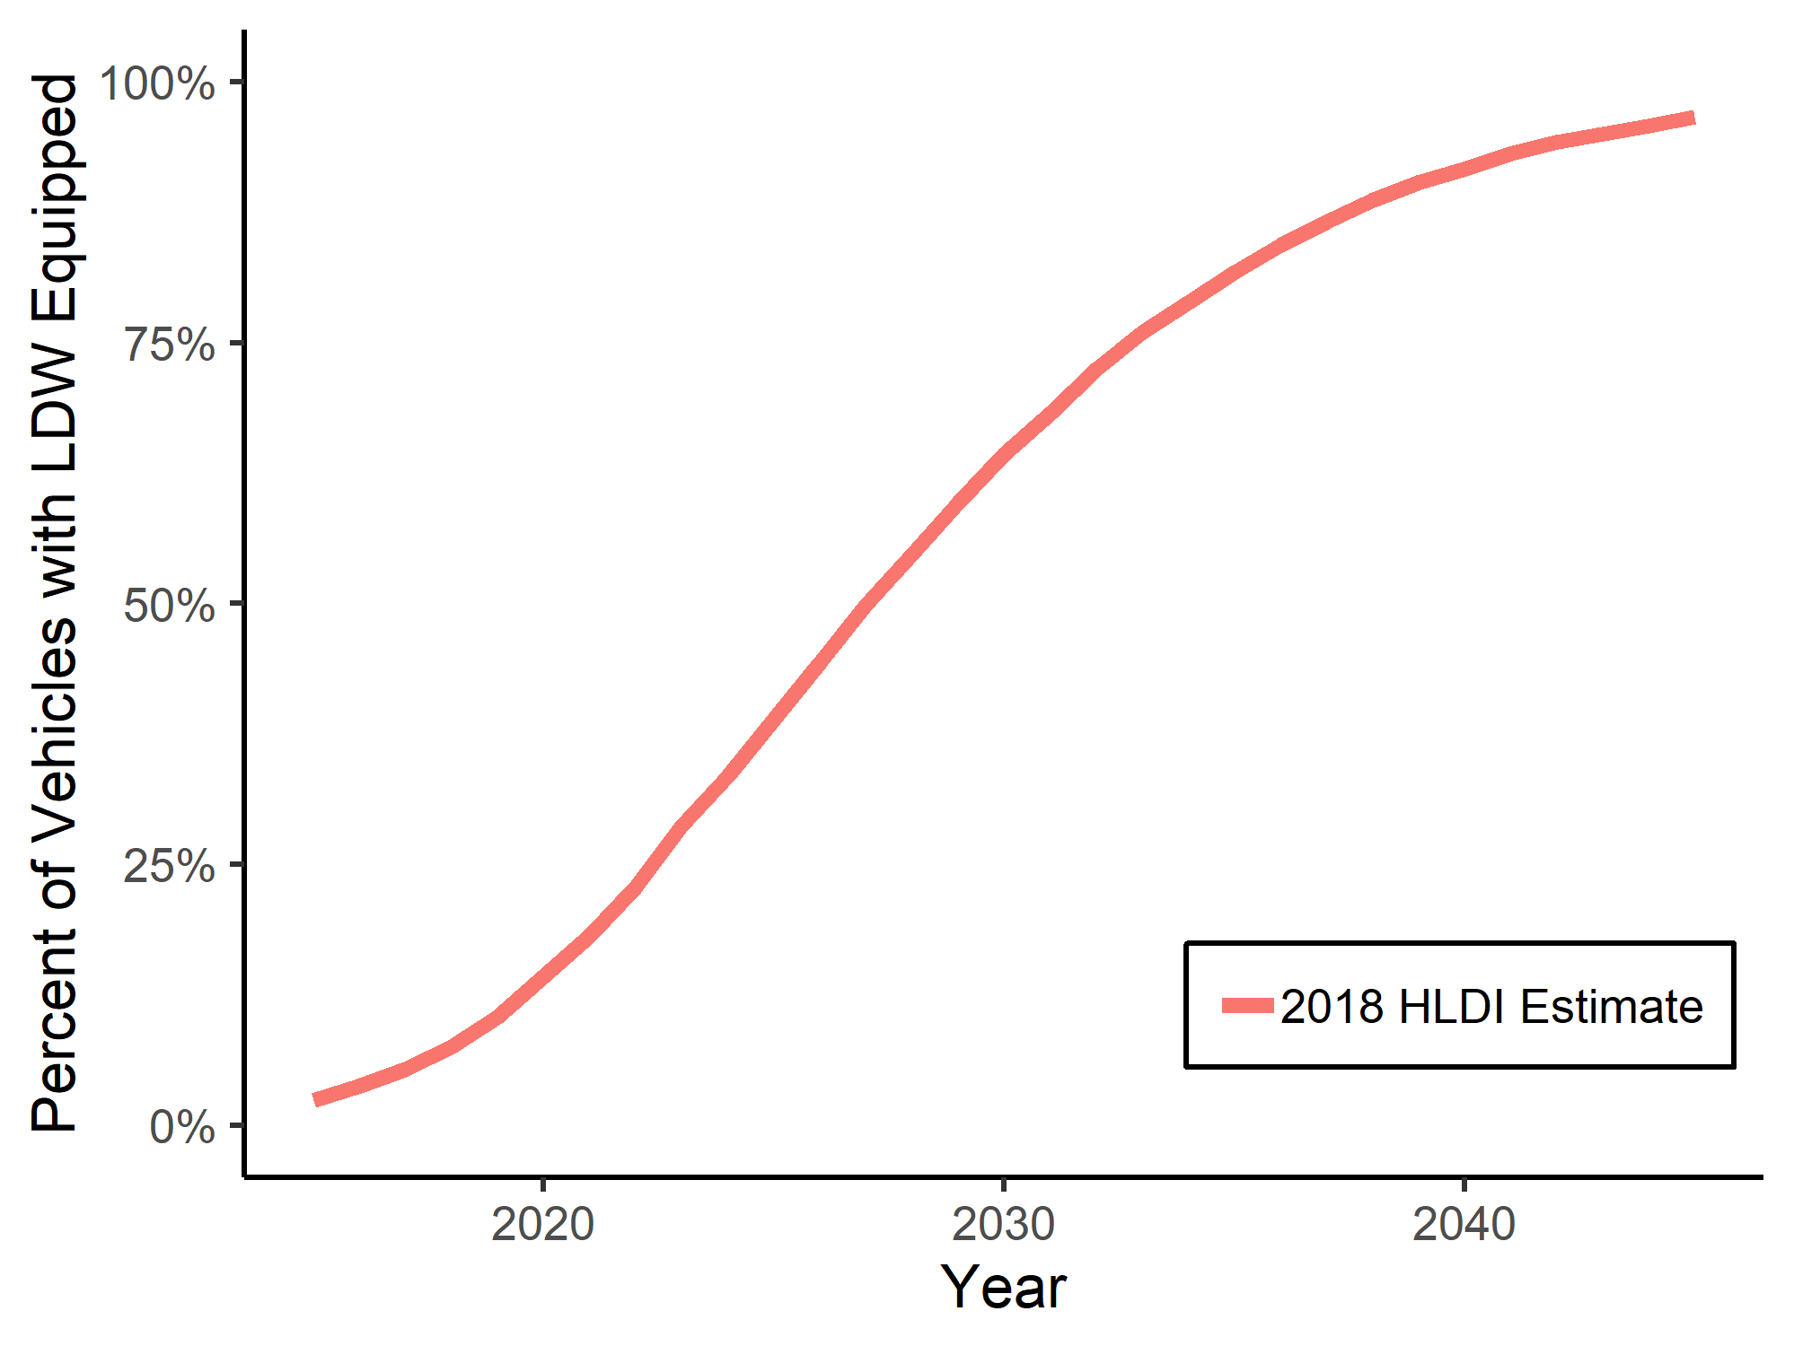

Figure A-2. HLDI prediction of LDW market penetration

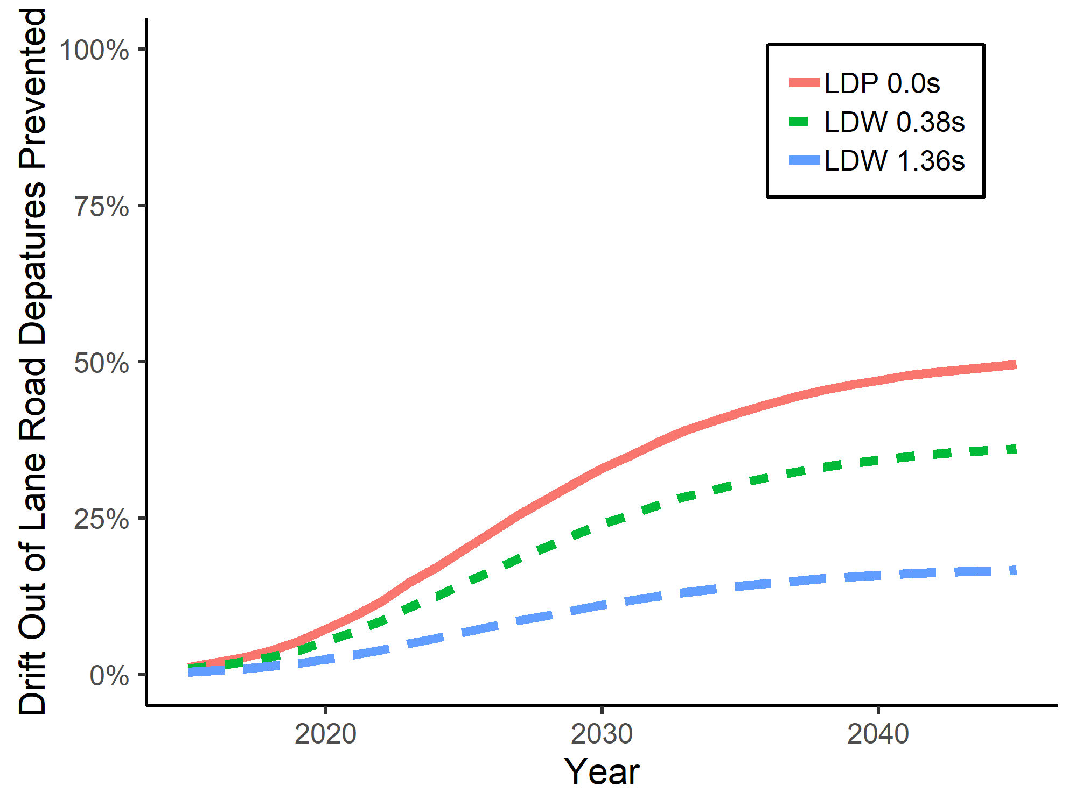

Figure A-3. LDW/LDP benefits over time based on market penetration