Appendix A

Comparison of FARS, GES, and PCDS full databases (not target populations).
Variable | FARS Cases | FARS Percent | GES Cases | GES Percent | GES Weighted Cases | GES Weighted Percent | PCDS Cases | PCDS Percent
Total Cases | 30446 | 100 | 11897 | 100 | 374645 | 100 | 549 | 100
Gender
Male | 21153 | 69.48 | 6835 | 57.45 | 209773 | 55.99 | 288 | 52.46
Female | 9242 | 30.36 | 5062 | 42.55 | 164872 | 44.01 | 257 | 46.81
Age
Child | 1608 | 5.3 | 2004 | 16.86 | 56539 | 15.1 | 154 | 28.04
Adult | 22289 | 73.18 | 8079 | 67.89 | 257107 | 68.63 | 326 | 59.41
Senior | 6316 | 20.72 | 1342 | 11.29 | 43003 | 11.47 | 69 | 12.56
Lighting
Daylight | 7128 | 23.41 | 6570 | 55.22 | 209700 | 55.97 | 355 | 64.66
Dark-Not Lighted | 10484 | 34.43 | 1123 | 9.44 | 34690 | 9.26 | 32 | 5.83
Dark-Lighted | 11281 | 37.05 | 3663 | 30.79 | 112915 | 30.14 | 125 | 22.77
Dawn | 467 | 1.53 | 155 | 1.3 | 4469 | 1.19 | 14 | 2.55
Dusk | 631 | 2.07 | 304 | 2.56 | 11177 | 2.98 | 23 | 4.19
Other | 455 | 1.5 | 82 | 0.69 | 1694 | 0.45 | NA | NA
Weather
Clear | 22187 | 72.87 | 8984 | 75.51 | 276820 | 73.89 | 458 | 83.42
Rain | 2409 | 7.91 | 1250 | 10.51 | 40645 | 10.85 | 83 | 15.12
Cold related | 317 | 1.04 | 160 | 1.35 | 8050 | 2.15 | 6 | 1.09
Cloudy | 4547 | 14.93 | 1450 | 12.19 | 47723 | 12.74 | NA | NA
Other | 4951 | 16.26 | 1503 | 12.64 | 49129 | 13.12 | 2 | 0.36
Crash Location
Non-Junction | 20746 | 68.14 | 5056 | 42.5 | 156072 | 41.66 | 221 | 40.26
Intersection | 3346 | 10.99 | 1701 | 14.3 | 62412 | 16.66 | 49 | 8.93
Intersection Related | 4688 | 15.4 | 4481 | 37.66 | 137555 | 36.72 | 213 | 38.8
Other | 1666 | 5.47 | 659 | 5.57 | 18606 | 4.96 | 66 | 12.03

Appendix B

Pedestrian Injury Model
The pedestrian injury model was developed using the Maximum Abbreviated Injury Scale (MAIS) coding from PCDS (PCDS injury coding used AIS-90). PCDS was used for this assessment because GES and FARS do not report injury severity using AIS. AIS ranges from 1-6, AIS = 1 indicating minor injury and AIS = 6 indicating maximal injury. For this study, an MAIS score of 3 or higher, including fatalities, (MAIS3+F) injury curve and a fatal injury curve were developed for pedestrians struck by cars and LTVs separately. This approach was followed because injuries sustained from being struck by a car and a LTV are expected to be different due to different striking geometries and heights (Lefler et al. 2004).
A logistic model was fit to the weighted PCDS data using impact speed and age as co-variables. The glm (generalized linear model) function in the R computing programming language was used to fit the data to the equations $8$ and $9$, shown below (R Core Team 2017). In the equations below v is the impact speed in kilometers/hour and a, b, and c are coefficients calculated from the logistic model. P is the probability of a fatality or injury. The model coefficients were calculated separately for cars and LTVs and are shown in Table 1.
$\begin{aligned}P_{fatal}\left(v,age\right)= \frac{1}{1+\exp\left(-a_{fatal}-b_{fatal}*v-c_{fatal}*age\right)} \#\left( seq eq 8\right)\end{aligned}$
$$\begin{aligned}P_{injury}\left(v,age\right)= \frac{1}{1+\exp\left(-a_{injury}-b_{injury}*v-c_{injury}*age\right)} \#\left( seq eq 9\right)\end{aligned}$$
Table 2. Pedestrian injury model coefficients
Vehicle Type | Severity | a | b | c
Car | Fatal | -8.119 | 0.0968 | 0.0364
LTV | Fatal | -7.264 | 0.0752 | 0.0527
Car | Injury (MAIS3+F) | -4.897 | 0.0940 | 0.0284
LTV | Injury (MAIS3+F) | -4.036 | 0.0851 | 0.0223

Figure 1A and Figure 2A show the fatality and injury risk curves compared to Rosén et al. (2010). Rosén’s curves were developed using data from GIDAS. The curves developed using PCDS were shifted to the left of the Rosén curves which indicates a larger risk at the same impact speed. Surprisingly, the car and LTV curves were not significatly different from each other. This may be due to small sample sizes or differences in injuries between car and LTV struck pedestrians that are not evident when using MAIS. A injry specific analysis may show greater differences between cars and LTVs that are not evident in these curves.
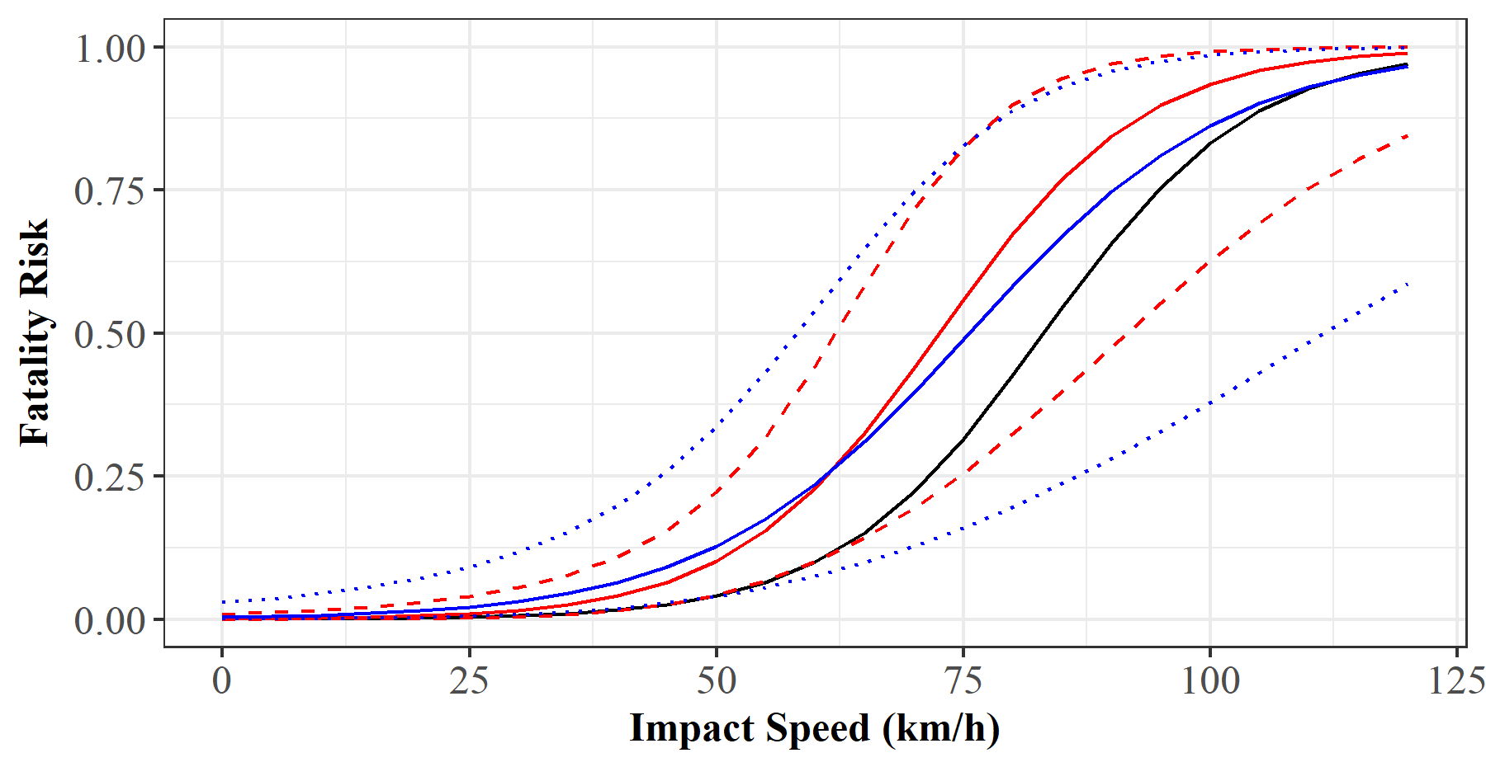
Figure 1A. Fatality risk curve for cars (red) and LTVs (blue) compared to Rosen (2010)(black). The fatality risks are shown in relation to impact speed assuming a pedestrian age of 30. The dotted and dashed lines correspond to a 95% confidence interval.
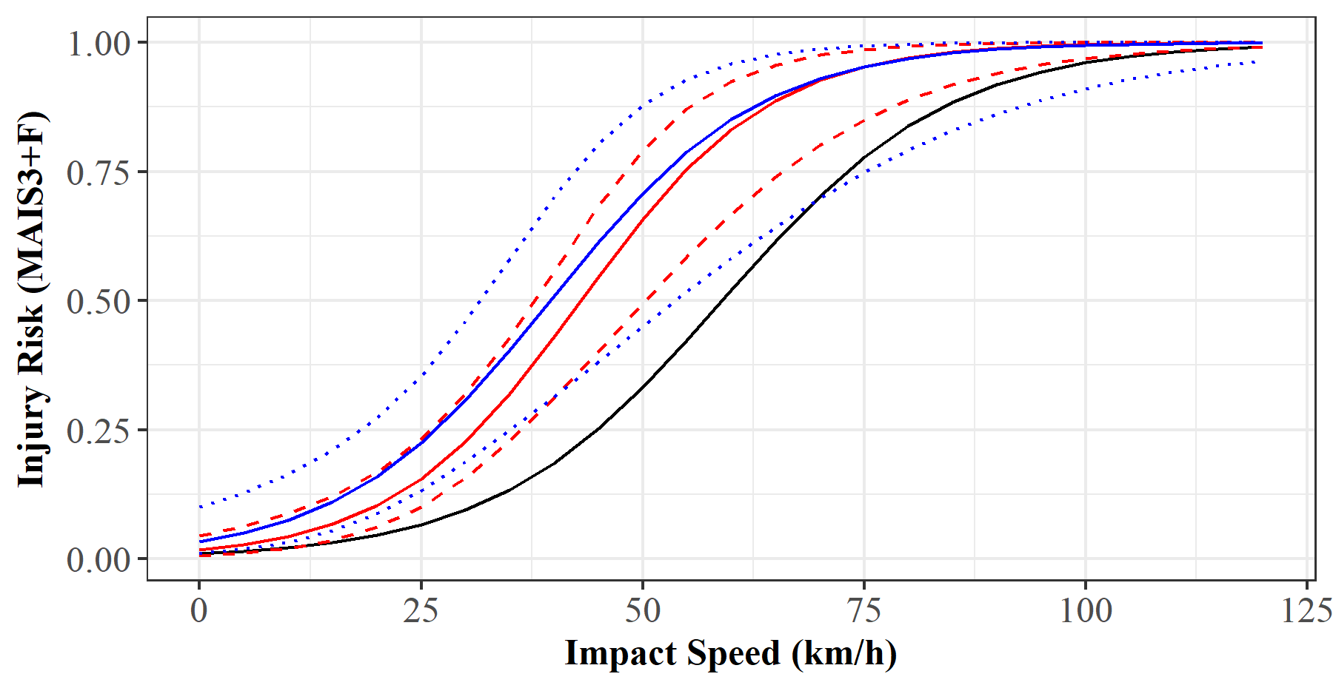
Figure 2A. MAIS3+F injury risk curve for cars (red) and LTVs (blue) compared to Rosen (2010)(black). The injury risks are shown in relation to impact speed assuming a pedestrian age of 30. The dotted and dashed lines correspond to a 95% confidence interval.

