Supplementary Material

Syntheses, structural characterization, DNA-cleavage and antioxidant features of the new tetra-substituted organo-soluble non-peripherally Co^{II}, Cu^{II}, Zn^{II} and Mg^{II} phthalocyanines

HALISE YALAZAN, BURAK BARUT, GÜLPINAR SARKI, BEYTULLAH ERTEM*, YASEMIN ÜNVER, ARZU ÖZEL and HALIT KANTEKIN

1.1. Chemicals and instrumentation
Pyridine, p-toluenesulfonyl chloride, 4-morpholinoaniline (1), conc. HCl, anhydrous Na₂SO₄, dimethylformamide (DMF), dichloromethane (DCM), ethanol (EtOH), dimethyl sulfoxide (DMSO), tetrahydrofuran (THF), anhydrous K₂CO₃, pentan-1-ol, ethyl acetate (EtOAc), chloroform (CHCI₃), n-amyl alcohol, 1,8-diazabicyclo[5.4.0]undec-7-ene (DBU), anhydrous CoC1₂, anhydrous CuC1₂, anhydrous MgC1₂, anhydrous Zn(CH₃COO)₂ [Zn(OAc)₂], silica gel plates with UV indicator (60 F₂₅₄), tetramethylsilane (Me₄Si), acetic acid, agarose, bromophenol blue, ethylenediaminetetraacetate (EDTA), ethidium bromide (EB), glycerol, hydrogen peroxide (H₂O₂), gallic acid (GA), supercoiled pBR322 plasmid DNA and 2,2-diphenyl-1-picrylhydrazyl (DPPH) were purchased from commercial suppliers.
All reactions were carried out under a dry nitrogen flow and compounds 5-8 were synthesized by using standard Schlenk techniques. 3-Nitrophthalonitrile 3 [S1] was synthesized as stated in the article procedure. All chemicals and reagents were of reagent grade quality and used as purchased from Sigma-Aldrich. Pyridine, DMF, and n-amyl alcohol were dried and purified according to the reported procedure [S2] before use. All reactions were monitored with thin layer chromatography (TLC) using 0.25 mm silica gel plates with UV indicator (60 F₂₅₄). Column chromatography was carried out on basic alumina columns with the indicated eluents.
¹H and ¹³C NMR spectra were recorded on a Bruker Ascend 400 and Agilent 400 NMR spectrometers with CDCl₃ as the NMR solvent and chemical shifts were reported (δ) relative to Me₄Si (tetramethylsilane, δ = 0 ppm) as the internal standard. The electronic absorption spectrum (UV–vis) was measured on a Perkin–Elmer Lambda 25 and Schimadzu 2101 UVPc UV/Vis spectrophotometer by using a 1 cm path length quartz cell at room temperature. FT–IR spectra were recorded on a Perkin–Elmer Spectrum One FT–IR spectrometer (ATR sampling accessory). FT–IR spectra were recorded in 4000–600 cm⁻¹ spectral range. All samples were dripped on ATR crystal and measured directly. LECO TruSpec Micro instrument was used to obtain the elemental analysis data of the synthesized compounds. The photocleavage studies were performed using a General Electric quartz line lamp (300 W) and glass cut off filters (Schott). The DNA cleavage experiments were visualized using BioRad Gel Doc XR system and the results were calculated by Image Lab Version 4.0.1 Software.

1.2. DNA cleavage studies
The stock solutions of 5-8 were prepared in DMSO (10%) and stored at room temperature. The DNA cleavage properties of the compounds were monitored by agarose gel electrophoresis using supercoiled pBR322 plasmid DNA without or with irradiation. Supercoiled pBR322 plasmid DNA was treated with varying concentrations (12.5 and 25 µM) of compounds in the buffer containing 50 mM Tris-HCl pH 7.0. All samples were incubated at 37 °C for 30 min. After that, loading buffer [bromophenol blue, xylene cyanol, glycerol, ethylenediaminetetraacetic acid (EDTA), and sodium dodecyl sulfate] was added and the mixtures were loaded on 0.8% agarose gel with ethidium bromide staining in TAE buffer (Tris-acetic acid-EDTA). Electrophoresis was performed at 100 V for 90 min and the resulting image was photographed by BioRad Gel Doc XR system and analyzed using Image Lab Version 4.0.1 Software [S3].
For oxidative cleavage studies, supercoiled pBR322 plasmid DNA and 5-8 were treated by adding oxidative agent H₂O₂ without/with irradiation at 700 nm (17.5 mW/cm², 15 min) and analyzed according to the procedure described above [S4].

1.3. DPPH (2,2-diphenyl-1-picrylhydrazyl) radical scavenging assay
The DPPH radical scavenging effects of 5-8 were evaluated using the method described by Blois and compared to GA as the standard [S5]. The methanolic DPPH solution (0.2 mM) was treated with various concentrations of compounds. The mixtures were incubated for 30 min at room temperature in the dark. After incubation, the absorbance of the extract (A_{compound}) was measured at 517 nm. Assay mixture without compound was used as a control (A_{control}). The inhibition percentage was calculated using formula 1 against compounds concentrations.

Formula 1. $Scavenging effects (\%)=\left[\frac{\left(A_{control }- A_{compound}\right)}{A_{control}}\right] ×100$.

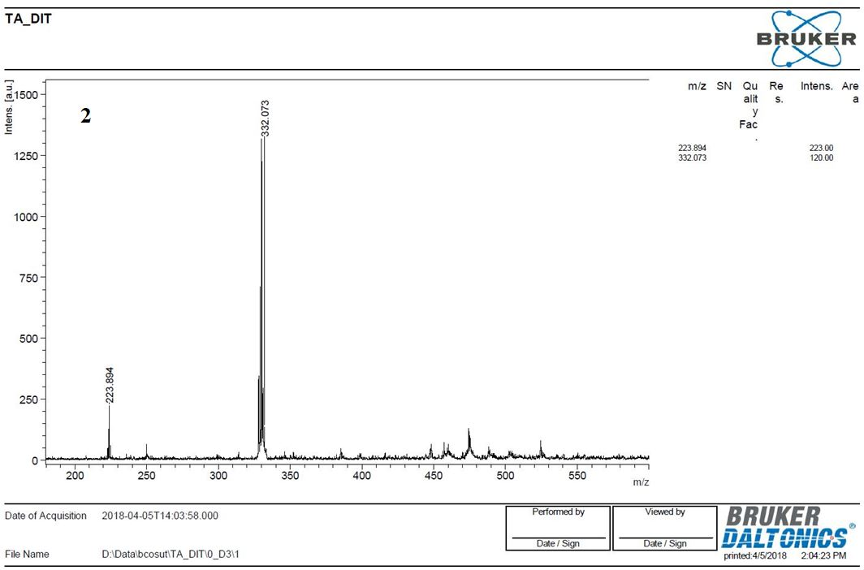

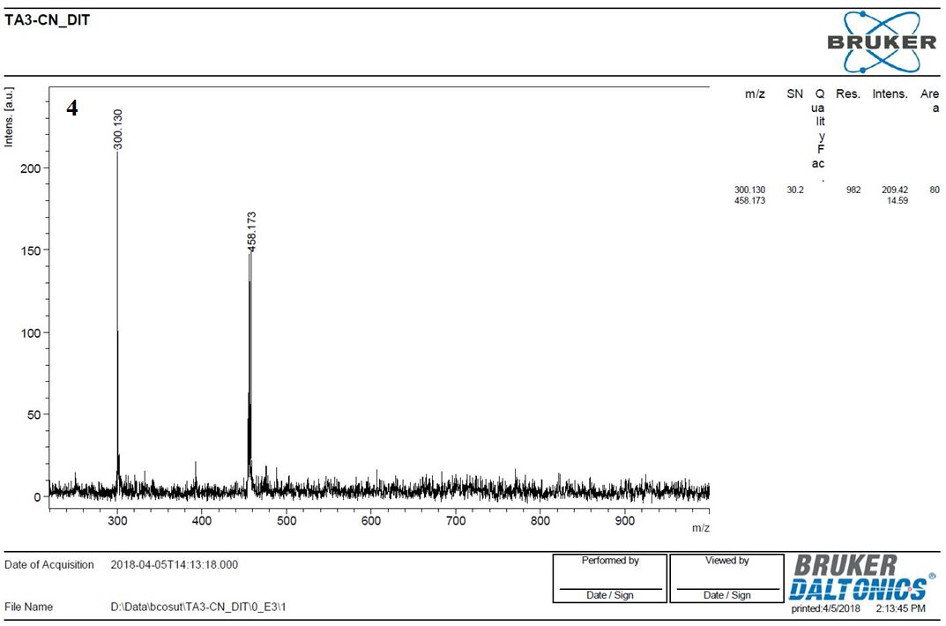
Figure S1. MALDI-TOF mass spectra of 2 and 4.

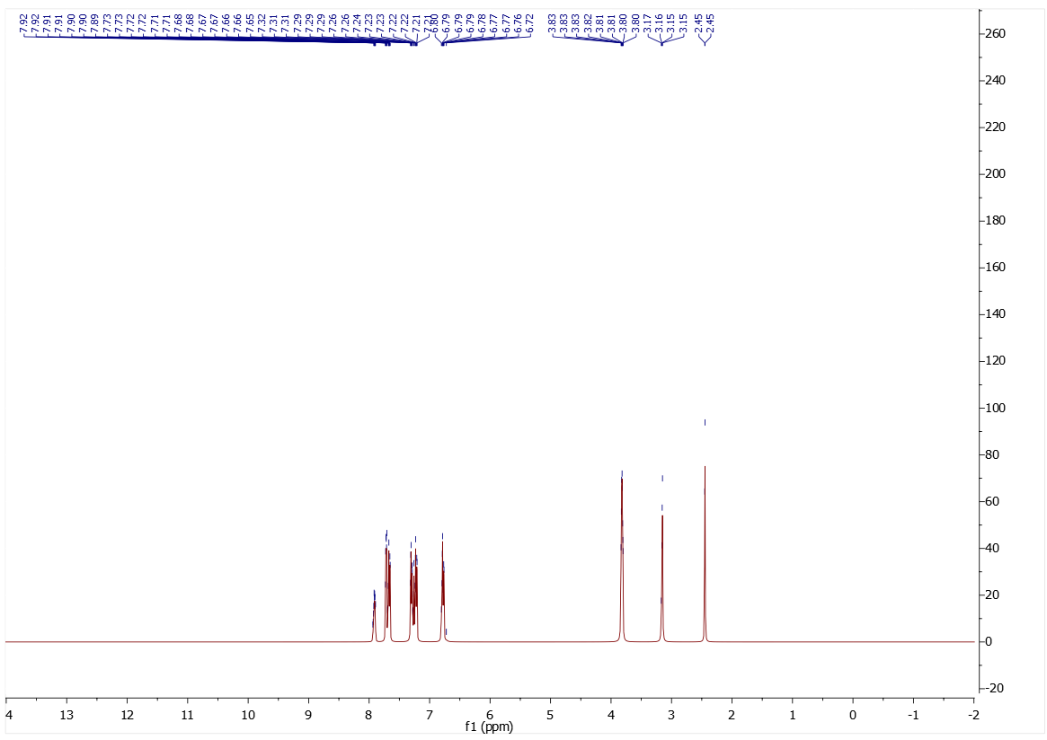

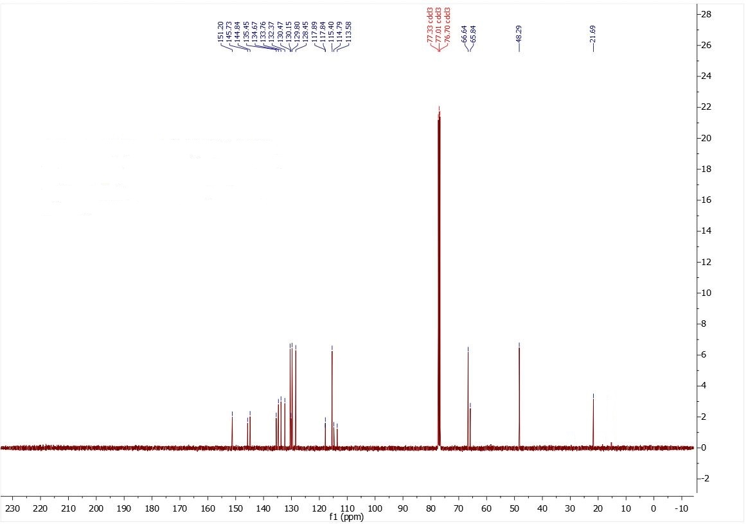
Figure S2. ¹H- and ¹³C-NMR spectra of 4 in CDC1₃.
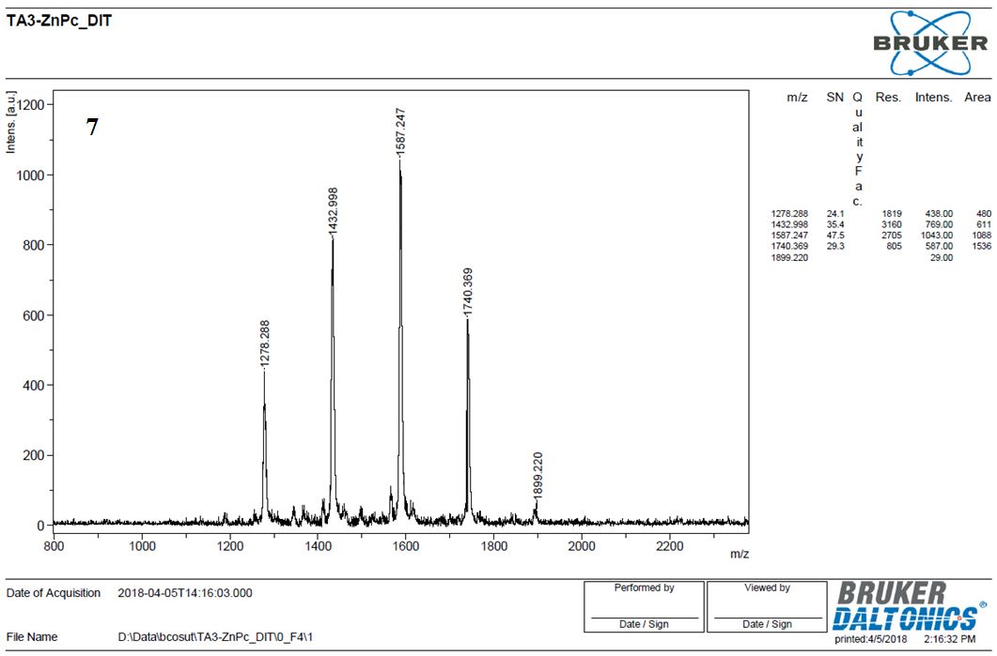

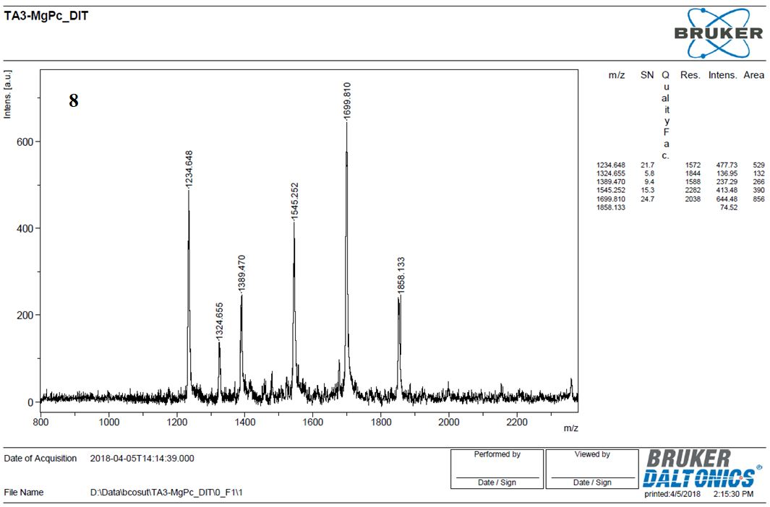
Figure S3. MALDI-TOF mass spectra of 7 and 8.
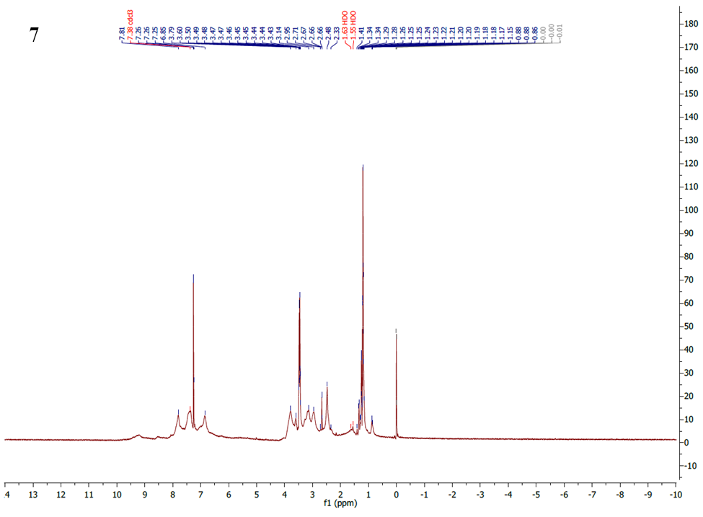

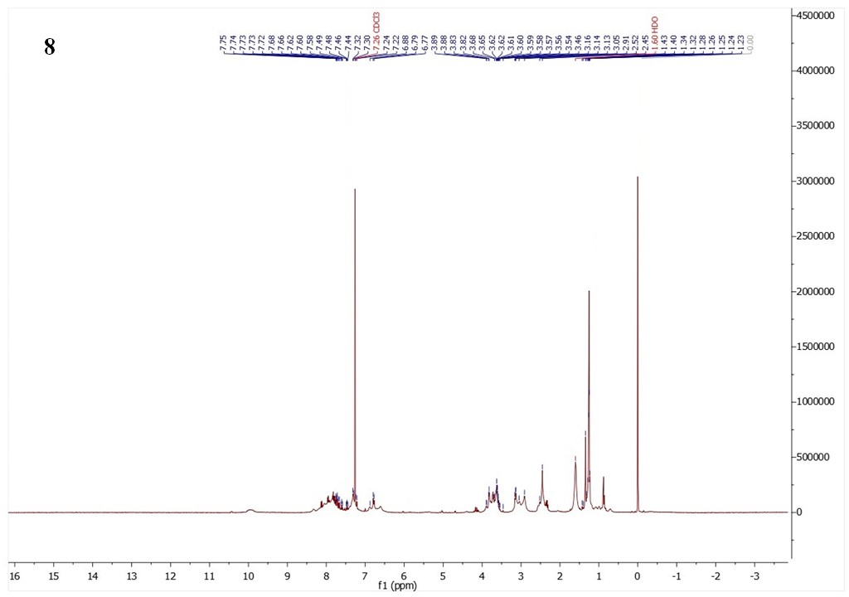
Figure S4. ¹H-NMR spectra of 7 and 8 in CDC1₃.
References
[S1] R.D. George, A.W. Snow. J. Heterocycl. Chem., 32, 495 (1995).
[S2] D.D. Perrin, W.L.F. Armarego, Purification of Laboratory Chemicals, Second Edn., Pergamon Press, Oxford (1989).
[S3] X.B. Fu, J.J. Zhang, D.D. Liu, Q.Q. Gan, H.W. Gao, Z.W. Mao, X.Y. Le. J. Inorg. Biochem., 143, 77 (2015).
[S4] B. Barut, Ü. Demirbaş, A. Özel, H. Kantekin. Int. J. Biol. Macromol., 105, 499 (2017).
[S5] M.S. Blois. Nature, 181, 1199 (1958).

