**Supplementary Information**

**Table S1** Summery of the optical, photoelectronic and DFT calculation results

|  |  |  |  |  |  |  |  |  |
| --- | --- | --- | --- | --- | --- | --- | --- | --- |
| Compound | IP(eV) | $λ_{max}^{}$ (nm)a） |  | EHOMO (eV) | |  | ELUMO (eV) | |
| Exp.b) | Calcd.d) | Exp.c) | Calcd.d) |
| **Dibenzo-CDI 1** | 6.22 | 606 | 2.04 | -6.22 | -2.98 | -4.18 | -2.98 |
| **Dibenzo-CDI 2** | 6.24 | 606 | 2.04 | -6.24 | -2.98 | -4.20 | -2.98 |
| **Dibenzo-CDI 3** | 6.21 | 581 | 2.13 | -6.21 | -6.21 | -4.08 | -2.92 |
| a)The optical bandgap was calculated according to $E_{g}^{opt}=$ 1240/; b) EHOMO = -IP; c) Estimated from the empirical equation ELUMO = IP - $E_{g}^{opt}$; d) Determined from DFT calculation at the B3LYP/6-31G(d) level using the Gaussian 09 program package. | | | | | | | | |





**Figure S1** DSC curves of **Dibenzo-CDI 1, 2**, **3** (Note: These figures are from our previously reported work “J. Org. Chem. 78 (2013) 4857”.**)**

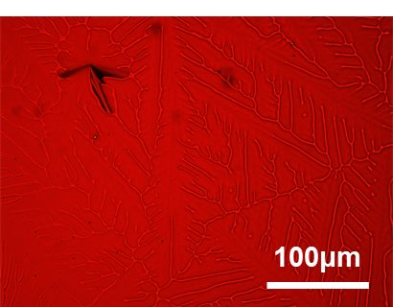

**Figure S2** Optical micrograph of **Dibenzo-CDI 3** at 190℃

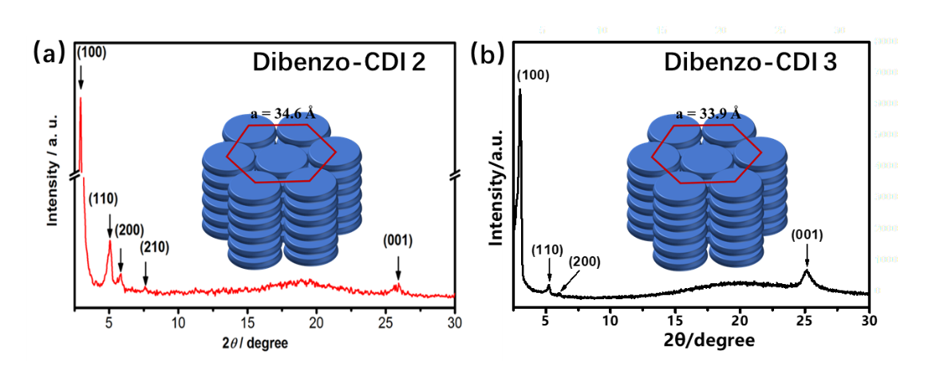

**Figure S3** XRD diffraction patterns of (a) **Dibenzo-CDI 2** at 120℃ and (b) **Dibenzo-CDI 3** at 190℃. The insets are the schematic diagrams of molecular stackings.

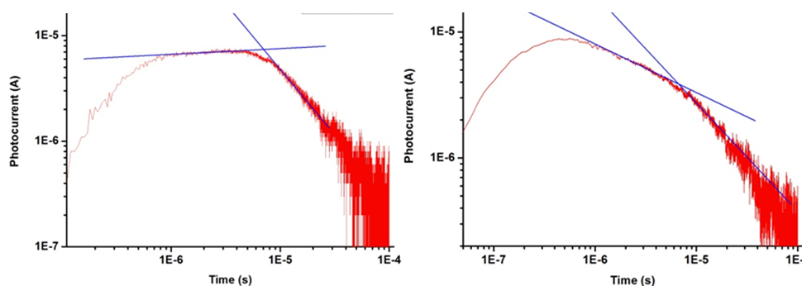

**a)**

**b)**

**Figure S4** Photocurrents of **Dibenzo-CDI 1** at (a) 170 ℃, (b) 80 ℃.

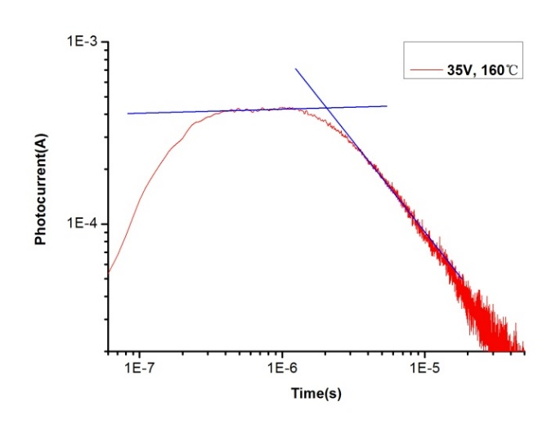

**Figure S5** Photocurrents of **Dibenzo-CDI 2** at 150 ℃.

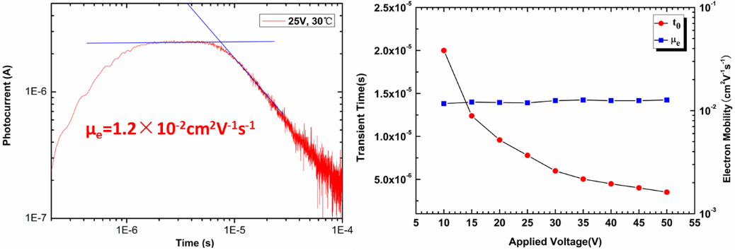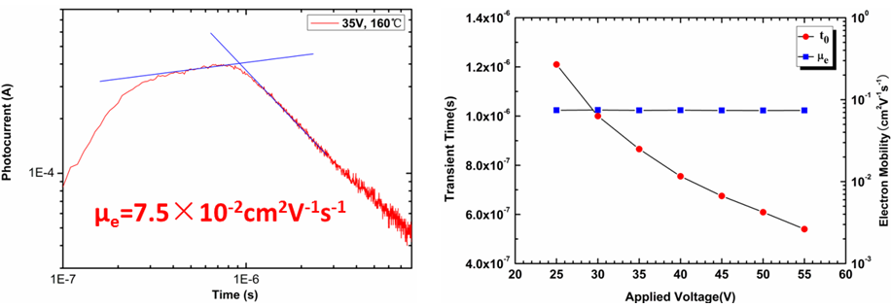

**Figure S6** Photocurrents of **Dibenzo-CDI 3** at 30 ℃ and 160 ℃,respectively.