Supplementary material.
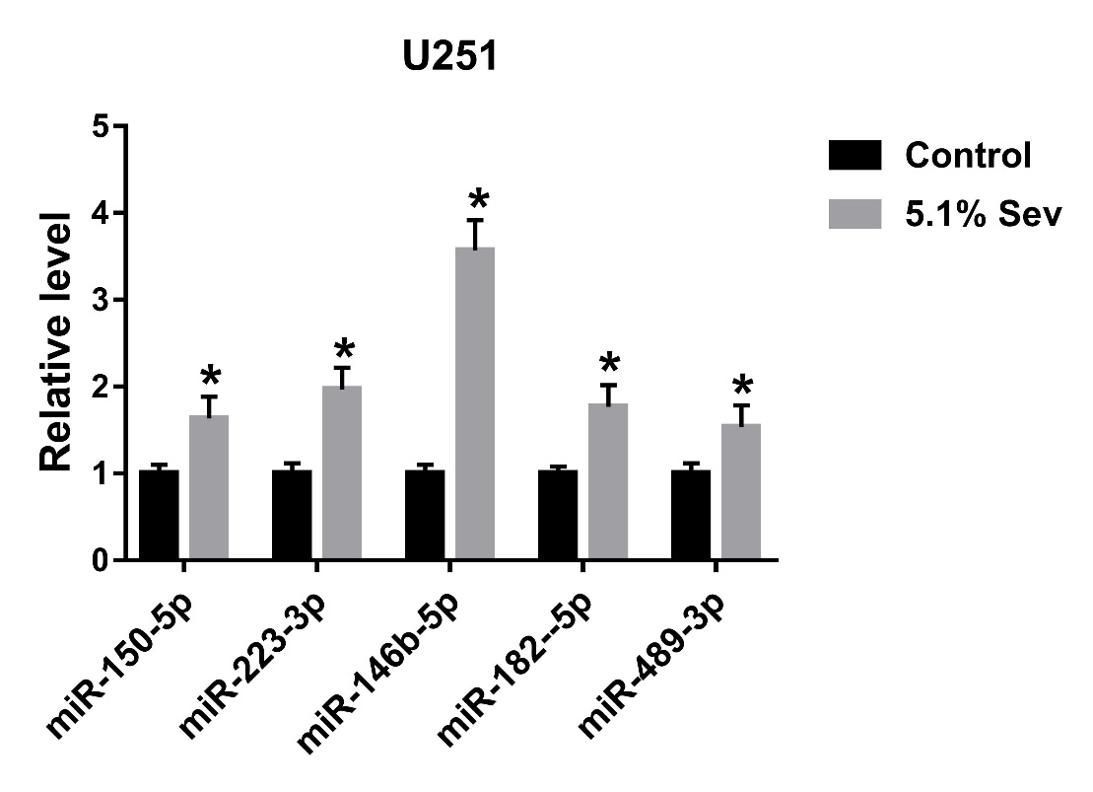

Supplementary Figure. The expression levels of five miRNAs down-regulated in glioma were measured in U251 cells after treated with 5.1% sevoflurane by qRT-PCR. *P<0.05, compared with Control group.

