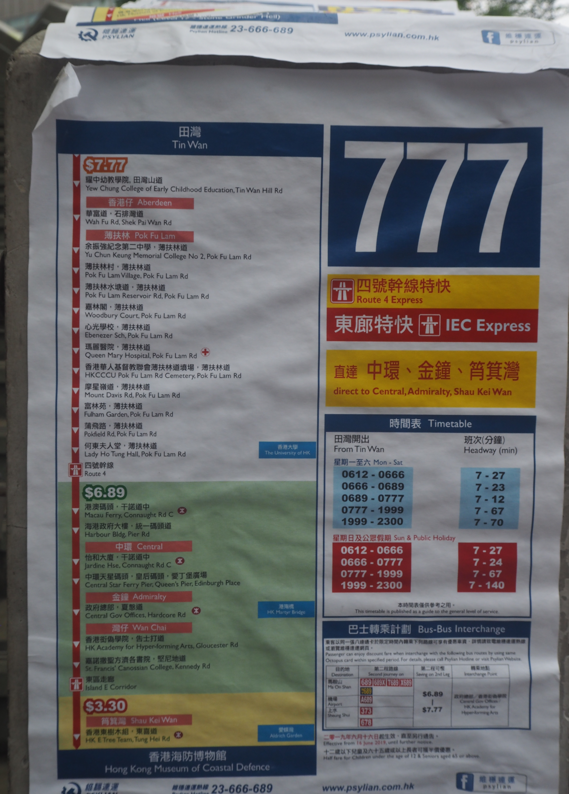

The "777" bus route was renamed by protesting Hong Kongers and directed toward the city's chief executive, Carrie Lam, in the summer of 2019. Photo taken by the author in Hong Kong, June 2019

