Characterization of poly (AN-co-ST/Py) copolymer

TGA analysis
In the present work, the thermal analysis was applied since it plays an important role in studying polymeric materials [14].The thermal stability of the poly (AN-co-St/Py) nanofibers was analyzed by thermogravimetry under N₂ atmosphere, from room temperature to 600 ºC at a heating rate of 10 ºC min⁻¹. The result in Figure 2 shows no mass loss and thermal stability below 306 ºC for Poly (AN-co-St/Py). The loss below 100°C is attributed to the moisture and hygroscopic water [15]. The Pyrrole fragment was firstly lost at 345 ºC while the 2nd loss stage corresponding to acrylonitrile started at 443 ºC. TGA thermogram showed styrene to be the last stable part by applying heat to Poly (AN-co-St/Py).
Figure 1: TGA thermogram of Electrospun Poly (St-co-AN/Py) nanofibers

FTIR- analysis
Figure 2 presents the FTIR spectra of poly (St-co-AN/Py). The characteristic peaks at 858 cm⁻¹ and 586 cm⁻¹ are distinctive for the (C-C) and (C-H) stretch of the aromatic benzene ring of styrene, respectively [14]. The presence of peaks at 1660 cm⁻¹represents (C=C) and 2490 cm⁻¹ are attributed to C-N stretch assigned to Py ring vibrations [16]. Broad peak around 3425 cm⁻¹ corresponding to hydroxyl group evaluation due to partial hydrolysis during the polymerization process. As previously reported, this indicated that the copolymerization process has been done via the breakdown of double bonds in third monomers (AN), (St) and (Py).
Figure 2: FT-IR Spectra of Electrospun Poly (St-co-AN/Py) Nanofibers.

Fibers morphology and diameter distribution.
Figure 3, reveals the distinctive SEM photographs of poly (AN-co-ST/Py) nanofibers since it displayed a randomly oriented morphology. The viscoelastic property of the injected solution has not a sufficient resistance to sustain the liquid jet elongation, evaluated from the electrostatic force. Hence, shrunken droplets with irregular beads were demonstrated. It is clear that the rheological behavior of poly (AN-co-ST/Py) has a great effect on its elasticity which is a vital control parameter during the initial electrospinning stage. The average diameter of poly (AN-co-ST/Py) was calculated, in the range of 377± 96 nm.
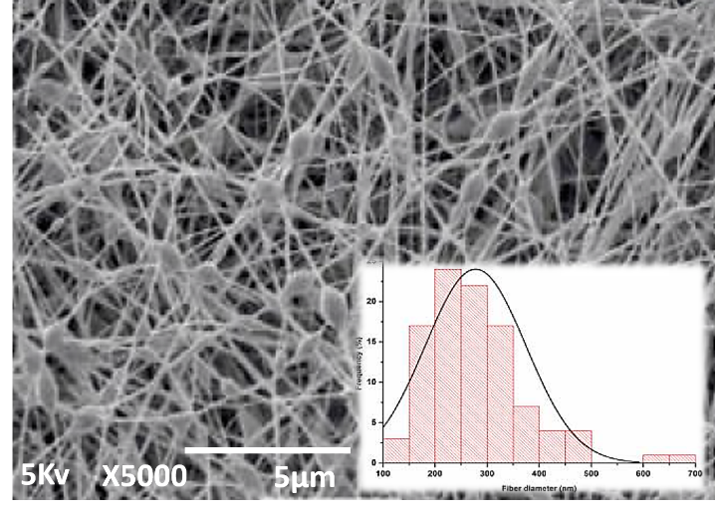
Figure 3: SEM morphology and the average diameter of electrospun poly (AN-co-ST/Py) fiber

