Supplementary Information

Exclusion criteria
Patients were to be excluded if they met any of the following criteria:
1. Patients who experienced Investigator-reported drug-related SAEs in the VOLTAIRE-RA study.
2. American College of Rheumatology functional Class IV or wheelchair/bed bound.
3. Primary or secondary immunodeficiency (history of, or currently active).
4. Positive QuantiFERON® test.
5. Known clinically significant coronary artery disease or significant cardiac arrhythmias or severe congestive heart failure (New York Heart Association Classes III or IV), or interstitial lung disease observed on chest X-ray.
6. Anaphylactic reaction or hypersensitivity to adalimumab received in the VOLTAIRE-RA study.
7. History or recent evidence of cancer including solid tumors, hematologic malignancies, and carcinoma in situ (except participants with previously resected and cured basal or squamous cell carcinoma, treated cervical dysplasia, or treated in situ Grade 1 cervical cancer within 5 years prior to the Screening visit).
8. Positive serology for HBV or HCV.
9. Patients who were expecting to receive any live virus or bacterial vaccinations during the trial, or up to 3 months after the last dose of trial drug.
10. Any treatment (including biologic therapies) that, in the opinion of the Investigator, may have placed the patient at unacceptable risk during the trial.
11. Patients with a significant disease other than RA and/or a significant uncontrolled disease (such as, but not limited to, nervous system, renal, hepatic, endocrine, or gastrointestinal disorders). A significant disease was defined as a disease which, in the opinion of the Investigator, might have (i) put the patient at risk because of participation in the trial, or (ii) influenced the results of the trial, or (iii) caused concern regarding the patient's ability to participate in the trial.
12. Premenopausal (last menstruation 1 year prior to Screening), sexually active women who were pregnant or nursing, or were of childbearing potential and not practicing an acceptable method of birth control, or did not plan to continue practicing an acceptable method of birth control throughout the trial (acceptable methods of birth control were intrauterine devices, surgical sterilization, double barrier, or vasectomized partner).
13. Current inflammatory joint disease other than RA (e.g. gout, reactive arthritis, psoriatic arthritis, seronegative spondyloarthropathy, Lyme disease) or other systemic autoimmune disorder (e.g. systemic lupus erythematosus, inflammatory bowel disease, pulmonary fibrosis, or Felty syndrome, scleroderma, inflammatory myopathy, mixed connective tissue disease, or any overlap syndrome). Secondary Sjögren syndrome or secondary limited cutaneous vasculitis with RA was permitted.
14. Any planned surgical procedure, including bone/joint surgery/synovectomy (including joint fusion or replacement), for the duration of the trial.
15. Known active infection of any kind (excluding fungal infections of nail beds), or any major episode of infection requiring hospitalization or treatment with IV anti-infectives within 4 weeks of the Screening visit or completion of oral anti-infectives within 2 weeks of the Screening visit.
16. Serious infection or opportunistic infection during the VOLTAIRE-RA study.
17. Any acquired neurological, vascular, systemic, or demyelinating disorder that might have affected any of the efficacy assessments, in particular, joint pain and swelling (e.g. Parkinson’s disease, cerebral palsy, diabetic neuropathy) that occurred during the VOLTAIRE-RA study.
18. Currently active alcohol or drug abuse.
19. Treatment with IV Gamma Globulin or the Prosorba® Column during Trial 1297.2.
20. Planned treatment with IV, intramuscular, intra-articular, and parenteral corticosteroids.
21. Aspartate aminotransferase (AST) or alanine aminotransferase (ALT) >1.5× upper limit of normal (ULN).
22. Hemoglobin <8.0 g/dL.
23. Platelets <100,000/μL.
24. Leukocyte count <4000/μL.
25. Creatinine clearance <60 mL/min.
26. Patients who were participating in another clinical trial other than VOLTAIRE-RA.

Table S1. Frequency of overall TEAEs by system organ class and preferred term with an incidence ≥5% (SAF).
n (%) | Group A  (N = 225) | Group B  (N = 102) | Group C  (N = 103)
≥ 1 TEAE | 116 (51.6) | 34 (33.3) | 43 (41.7)
Infections and infestations | 63 (28.0) | 20 (19.6) | 22 (21.4)
Upper respiratory tract infection | 9 (4.0) | 2 (2.0) | 6 (5.8)
Metabolism and nutrition disorders | 11 (4.9) | 3 (2.9) | 7 (6.8)
Gastrointestinal disorders | 15 (6.7) | 3 (2.9) | 5 (4.9)
Skin and subcutaneous tissue disorders | 11 (4.9) | 4 (3.9) | 9 (8.7)
Musculoskeletal and connective tissue disorders | 21 (9.3) | 6 (5.9) | 10 (9.7)
General disorders and administration site conditions | 26 (11.6) | 5 (4.9) | 6 (5.8)
Investigations | 18 (8.0) | 3 (2.9) | 6 (5.8)
Percentage of patients was calculated relative to the number of patients in the SAF.
ALT: alanine aminotransferase; AST: aspartate aminotransferase; SAF: safety analysis set; TEAE: treatment-emergent adverse event.

Table S2. Overview of further selected adverse events of interest (SAF).
Patients with ≥ 1 other safety endpoint, n (%) | Group A  (N = 225) | Group B  (N = 102) | Group C  (N = 103)
Infection | 63 (28.0) | 20 (19.6) | 22 (21.4)
Serious infection | 8 (3.6) | 1 (1.0) | 2 (1.9)
Hypersensitivity reaction | 5 (2.2) | 4 (3.9) | 4 (3.9)
Drug-induced liver injury | 0 | 0 | 0
Injection site reaction | 20 (8.9) | 4 (3.9) | 6 (5.8)
Anaphylactic reaction | 0 | 0 | 0
SAF: safety analysis set.

Figure S1. Mean DAS28-CRP scores changes from baseline at weeks 62, 74, and 98 (FAS, LOCF).
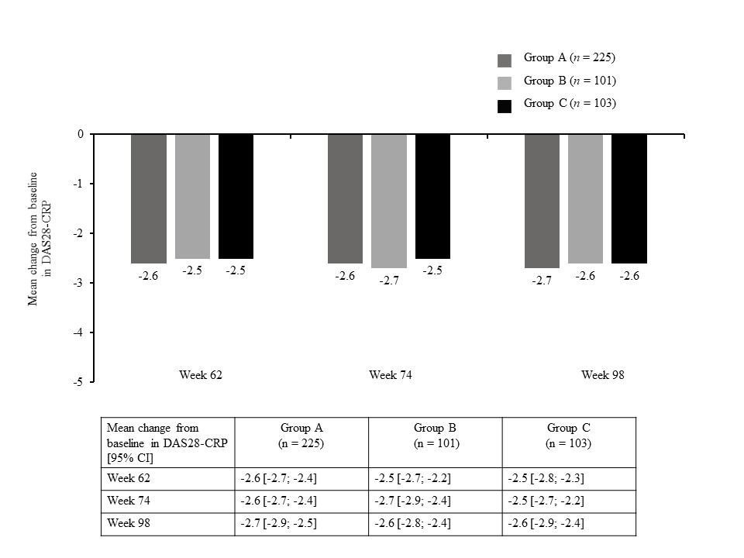
CI: confidence interval; CRP: C-reactive protein; DAS: Disease Activity Score; FAS: full analysis set; LOCF: last observation carried forward.

Figure S2. Geometric mean drug plasma concentration–time profiles by treatment group over time (PKFS).
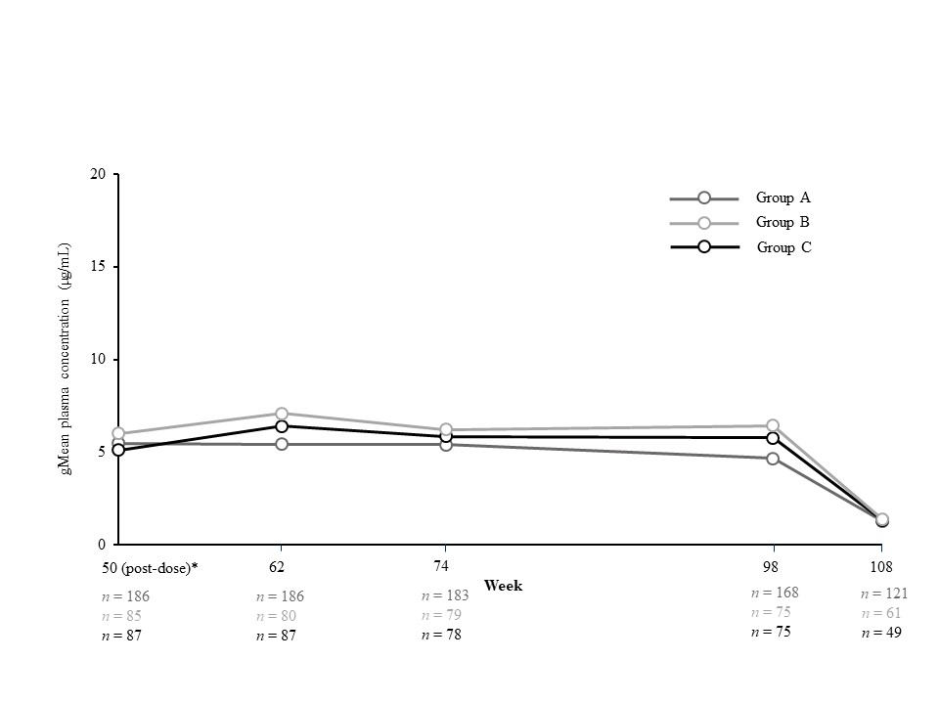

gMean: geometric mean; PKFS: pharmacokinetic full analysis set.

Figure S3. Drug plasma concentrations per treatment group by ADA titer groups (FAS).
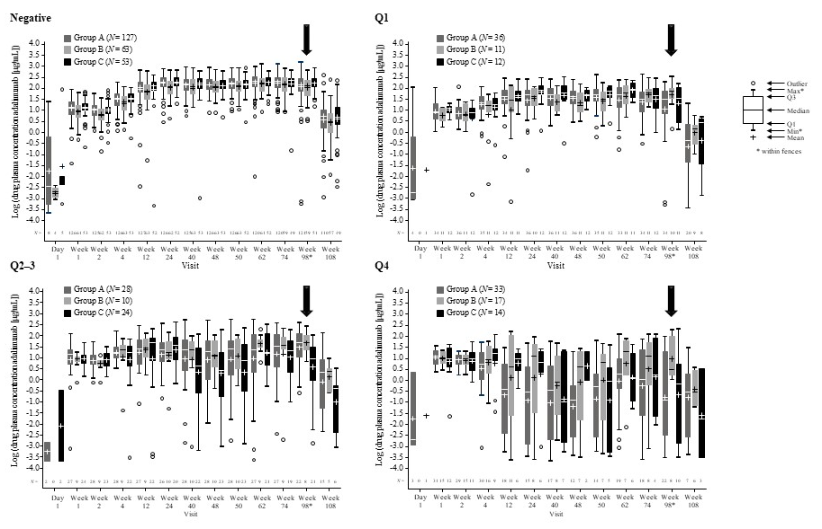
* End of treatment was at week 98; vertical arrow indicates end of treatment.
ADA: antidrug antibody; FAS: full analysis set; N: number of patients in the analysis set; n: number of patients contributing to at least one non-missing observation; Q = quartile.

