Supplementary material for
“Alternatively spliced variants of the 5’-UTR of the ARPC2 mRNA regulate translation by an internal ribosome entry site (IRES) element harboring a guanine-quadruplex motif”

Munir A. Al-Zeer¹; Mariola Dutkiewicz ²; Annekathrin von Hacht¹; Denise Kreuzmann¹; Viola Röhrs¹; Jens Kurreck^{1,}*
A
B
Figure S1. (A) Schematic representation of alternatively spliced ARPC2 5’-UTRs: One splice variant (ARPC2 5’-UTR1) contains a G-rich sequence with the potential to form a G-quadruplex, while the other splice variant lacks this sequence (ARPC2 5’-UTR2). (B) Both 5’-UTR variants are expressed in HEK 293 cells as demonstrated by RT-PCR (+: including reverse transcription prior to PCR; -: no reverse transcription).

The following primers were used for the PCR reactions:
ARPC2 GQ-UTR fw: GTGGGTGTGAGAGCGGAAGTG
ARPC2 GQ-UTR rev: GCCTGAACCCGCCTGC
ARPC2 GQ-UTR2 fw: CTCCCTTACCCACCCTCACC
ARPC2 GQ-UTR2 rev: ACTGCTTCCGGTTTGTTTCC
ARPC2 CDR fw: AGAAGAGGGCAAGGAAGGAG
ARPC2 CDR rev: TGGCTAAAGAGGACCTGTGG

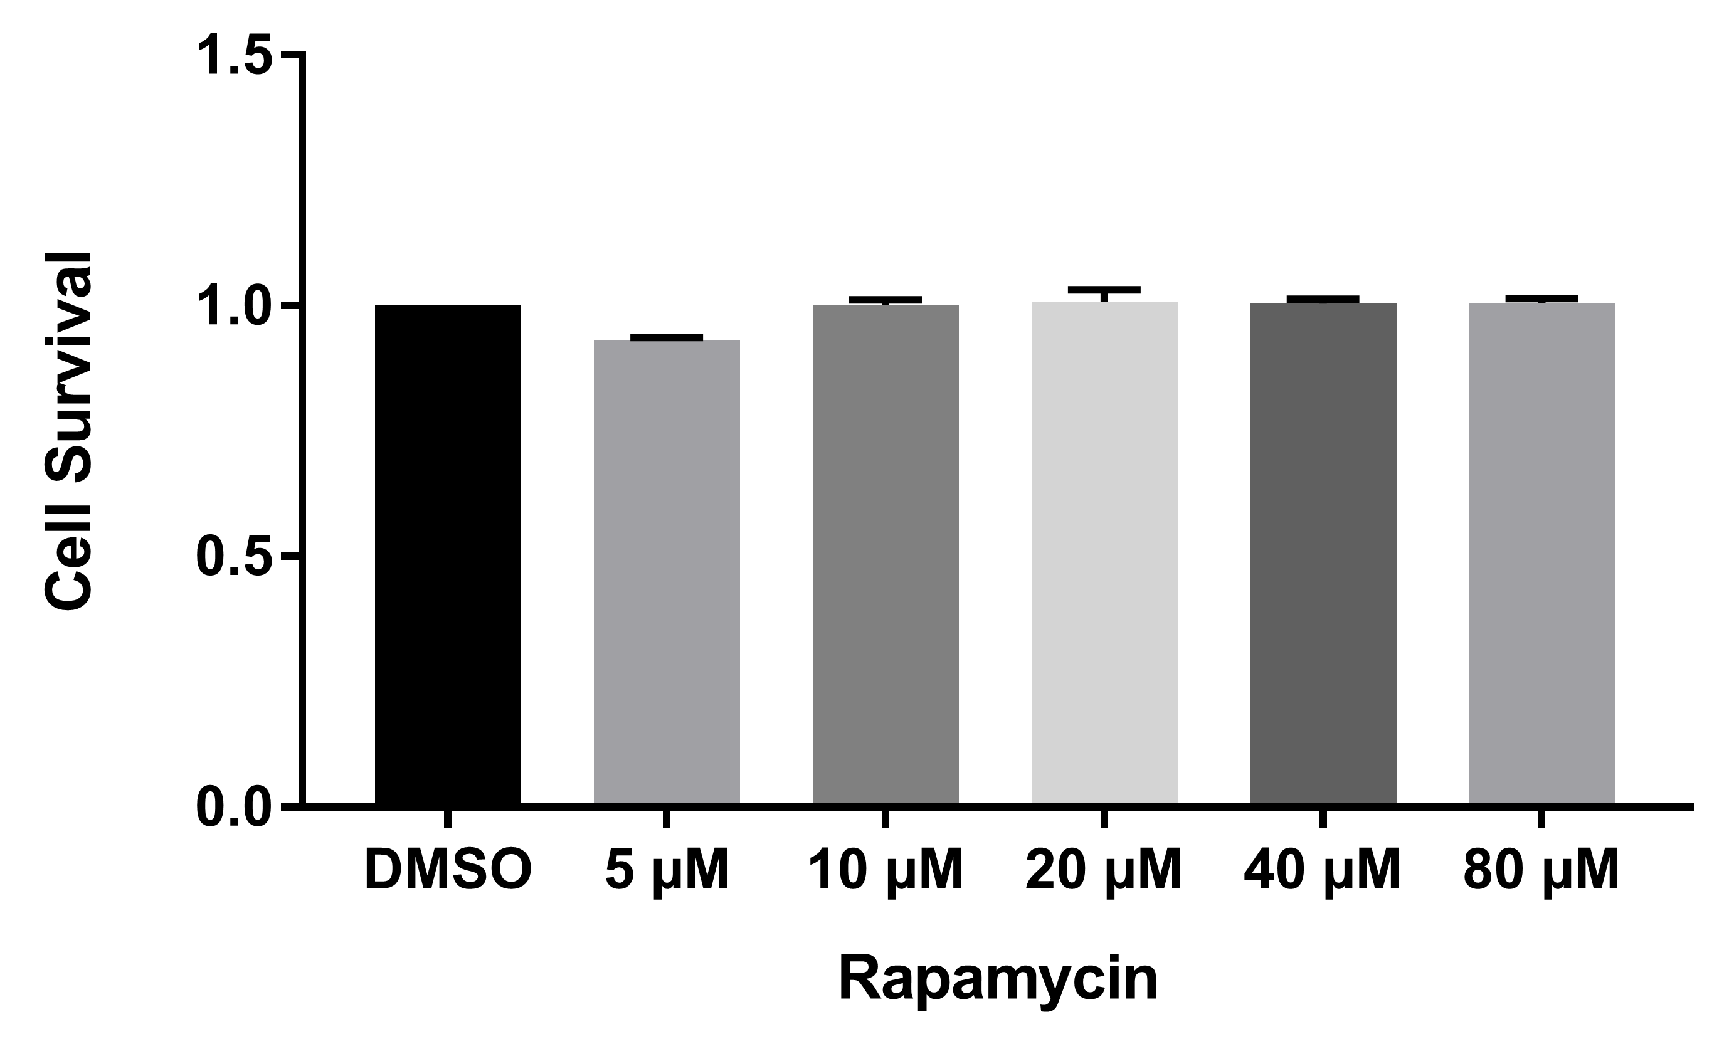

Figure S2. Monolayers of HEK293 cells were treated with rapamycin for 24 h before measuring lactate dehydrogenase (LDH) released into the medium as a measure of cell toxicity. LDH release was measured with the LDH Detection Kit (Roche, Grenzach, Germany), according to the manufacturer´s instructions. The absorbance was measured at A492 nm with a reference of A620 nm with the Sunrise Absorbance Microplate Reader (Tecan, Männedorf, Switzerland). Values were normalized to the DMSO-treated control. All Data represent averages ± SD of three independent experiments.

Figure S3. Analysis of the RNA secondary structure of the ARPC2 5’-UTR1 and its mutated variant. A, C and E show results for the long 5’-UTR1 structure harboring the putative G-quadruplex structure (GQ); whereas B, D and F show the mutated sequence that is not capable of forming a G-quadruplex structure. The RNAs were tested using NAI (A, B), Pb²⁺ (A, B, E, F) and DMS (C, D) in vitro. Autoradiograms show results of reverse transcription reaction (A-D) or the 5'-radiolabeled products (E, F). The extension primers were radioactively labeled. The chemically modified (or cleaved) nucleotide positions are indicated on the right side of the A, U, G, C-sequencing lines; N: reaction line with 200 mM NAI, Pb²⁺: reaction line with 0.25 – 2 mM AcOPb, 0: incubation control without Pb²⁺; D: reaction line with 0.3% DMS; Ci: incubation control without DMS or NAI; T1: guanine leader; L: formamide leader.

