Supporting Information

**Development of a novel three- dimensional microfluidic paper-based analytical device (3D-μPAD) for chlorpyrifos detection, using graphene quantum-dot capped gold nanocomposite for colorimetric assay**

Warinporn Chungchaia, b, Maliwan Amatatongchaia, b*, Rattapol Meelapsomb, c, Ketsarin Seebunruenga, Saksri Suparsorn,a, b and Purim Jarujamrusa, b

*aDepartment of Chemistry and Center of Excellence for Innovation in Chemistry,*

*Faculty of Science, Ubon Ratchathani University, Ubon Ratchathani 34190, Thailand.*

*bNanomaterial Science, Sensor & Catalysis for Problem-Based Projects, Faculty of Science, Ubon Ratchathani University, Ubon Ratchathani 34190, Thailand.*

*cDepartment of Science and Mathematics, Faculty of Science and Health Technology, Kalasin University, Kalasin, Thailand*

*To whom correspondence should be addressed.

Fax: 66 4528 8379; Tel: 66 4535 3401-4 ext. 4576;

E-mail: maliwan.a@ubu.ac.th *(M. Amatatongchai)*

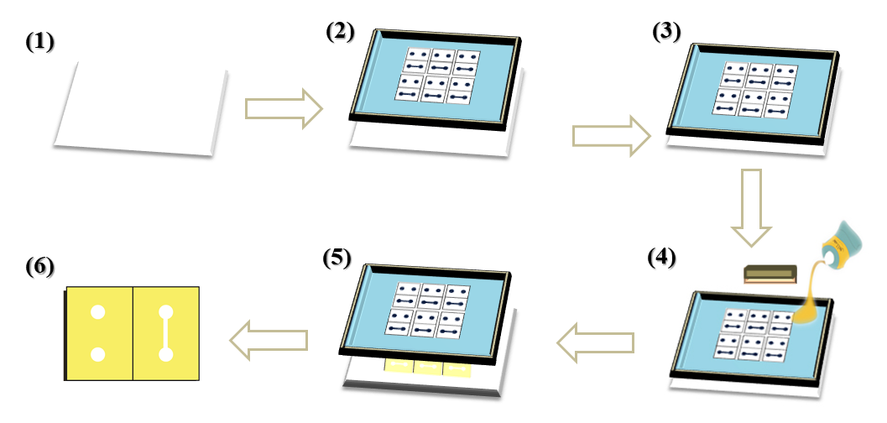

**(a)**

**(b)**

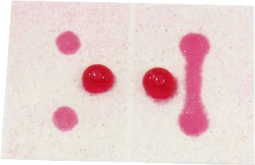

hydrophobic

**Top view**

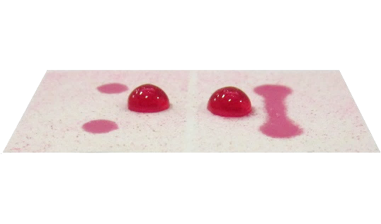

hydrophilic

**Side view**

5 ± 0.5 mm

5 ± 0.45 mm

2 ± 0.2 mm

5 ± 0.4 mm

5 ± 0.45 mm

8 ± 0.5 mm

5 ± 0.5 mm

5 ± 0.45 mm

**Fig. S1** (a) Fabrication of the chlorpyrifos 3D-µPAD by using one-step polymer screen printing; (1) Position a sheet of Whatman No.4 filter paper, (2) Place the wooden-framed woven mesh screen (888.32 mesh (60T) nylon mesh) on the paper, (3) Position the screen pattern to contact the paper surface, (4) squeeze RL solution through the screen to penetrate to the bottom of the paper, creating a patterned hydrophobic barrier, (5) remove paper from the screen, the patterned paper is ready for use, and (6) Cut out individual fabricated devices piecewise. (b) Photograph of the screen-printed 3D-µPAD: demonstration of hydrophilic and hydrophobic zones on the paper by applying a drop of colored food dye to the surface.

Top

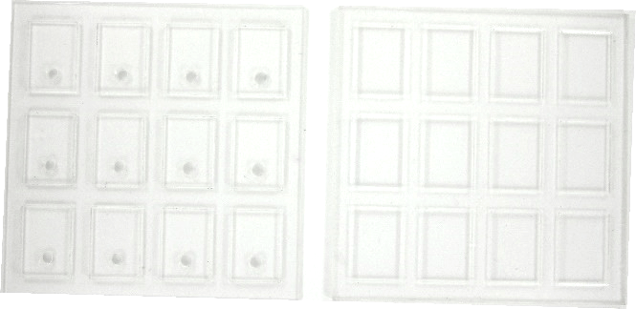

Bottom

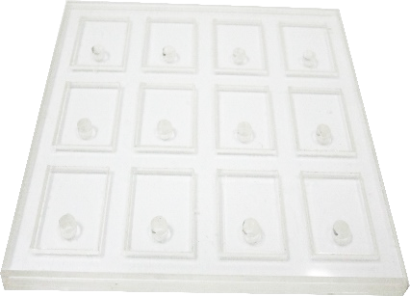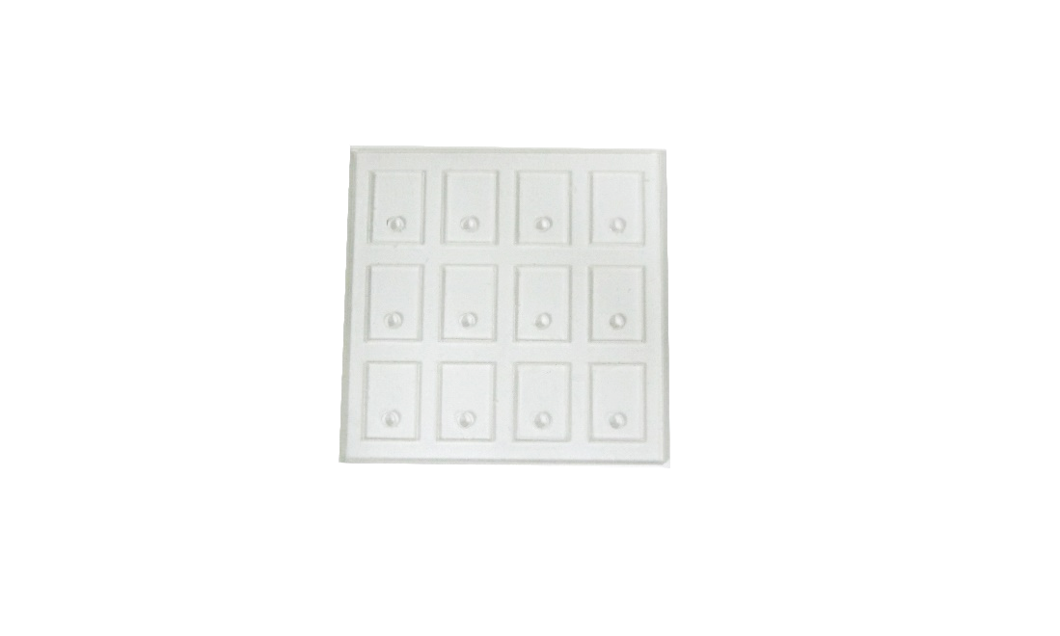

Top view

Side view

**Fig. S2** acrylic block**.**

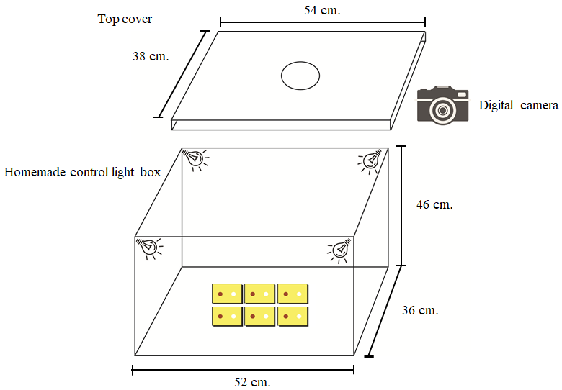

**Fig. S3** Homemade control light box. An Image is captured by using a digital camera set to automatic mode.

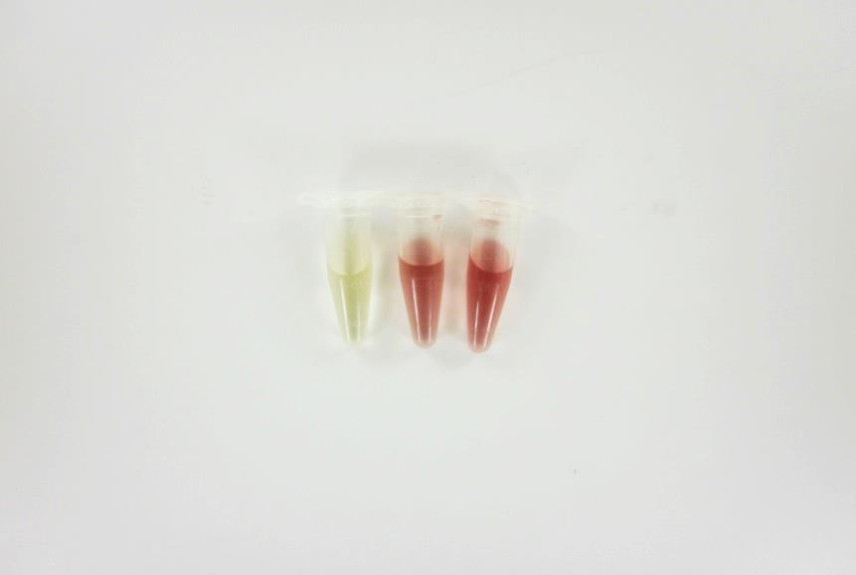

**a**

**b**

**c**



**Fig. S4** Absorbance spectra of (a) GQDs, (b) GQDs-AuNPs, and (c) cit-AuNPs. Inset shows the respective images.



**Fig. S5** FT-IR spectra of GQDs-AuNPs, GQDs, and AuNPs.



Cucumber

Chlorpyrifos

**B)**



Chlorpyrifos

**A)**

Lettuce

**Fig. S6** Example of the HPLC chromatograms of A) lettuce sample (black line) and spiked lettuce samples (red and blue lines), B) cucumber sample (black line) and spiked cucumber samples (red and blue lines), the green arrows indicated the chlorpyrifos signals. Separation was carried out at the following conditions: C-18 column; VertiSepTM UPS ( 4.6 x 250 mm, 5.0 µm), isocratic elution with acetonitrile: water ( 90:10 v/v) mobile phase, 1.0 mL min-1 flow rate, 20 µL injection volume, detection at 219 nm absorbance, and column temperature of 25 °C.

The vegetable samples (cucumber, radish, lettuce, carrot, cabbage, celery, and tomato) and the samples spiked with chlorpyrifos standards were analyzed by HPLC. The results indicate that chlorpyrifos was not found in any of the analyzed samples