Supplementary Material

Synthesis, Colloidal-Chemical and Petroleum Collecting Properties of New Counterion Coupled Gemini Surfactants Based on Hexadecylbis(2-hydroxypropyl)amine and Dicarboxylic Acids

Physico-chemical indices and spectral data
Cocogem surfactant prepared from succinic acid is a white substance in solid state with melting point 35-38 °C. It is soluble in water and many organic solvents such as ethanol, but insoluble in hexane. IR, cm⁻¹: 3368 ν (OH), 2921 and 2852 ν (CH), 2400-2600 (NH⁺), 1581 ν_{as} (COO⁻), 1372 ν_{s} (COO⁻), 1460 and 1287 δ (CH), 1063 ν (C−N), 719 δ (CH₂)_{n} (Fig. S4). ¹H-NMR, (300.18 MHz, D₂O), δ (ppm): 0.79 (CH₃), 1.02-1.11 (CH−CH₃), 1.19 (CH₂ chain), 1.83 (CH₂−CH₂−N⁺H), 2.12 (CH₂−COO⁻) 2.83-2.93 (N⁺H−CH₂), 3.99 (CH−OH) (Fig. S5).¹³C-NMR, (75.49 MHz, D₂O), δ (ppm): 13.9 (CH₃), 20.3-20.6 (CH₃−CH), 22.7−32.1 (alkyl group CH₂), 61.2-62.2 (N⁺−CH₂−CH₂), 63.2-66.0 (N⁺−CH₂−CH−OH), 171.5 (COO⁻) (Fig. S6).
Cocogem surfactant prepared from adipic acid is a white substance in solid state with melting point 48-52 °C. It is soluble in water and many organic solvents such as ethanol, acetone, isopropanol, but partially soluble in hexane. IR, cm⁻¹: 3311 ν (OH), 2920 and 2852 ν (CH), 1561 ν_{as} (COO⁻), 1407 ν_{s} (COO⁻), 1461 and 1331 δ (CH), 1081 ν (C−N), 719 δ (CH₂)_{n} (Fig. S7). ¹H-NMR, (300.18 MHz, D₂O), δ (ppm): 0.76 (CH₃), 1.02-1.13 (CH−CH₃), 1.17 (CH₂ chain), 1.45 (CH₂−CH₂−COO⁻), 1.58 (CH₂−CH₂−N⁺H), 2.09 (CH₂−COO⁻), 2.96-3.08 (N⁺H−CH₂), 4.04-4.06 (CH−OH) (Fig. S8). ¹³C-NMR, (75.49 MHz, D₂O), δ (ppm): 13.9 (CH₃), 20.3-20.7 (CH₃−CH), 22.7−30.1 (alkyl group CH₂), 36.6 (CH₂−COO⁻), 60.5-62.5 (N⁺−CH₂−CH−OH), 181.3 (COO⁻) (Fig. S9).
Cocogem surfactant prepared from sebacic acid is a viscous liquid of yellow color which reminds glue. It is soluble in water and many organic solvents such as ethanol, acetone, isopropanol, but partially soluble in hexane. IR, cm⁻¹: 3348 ν (OH), 2922 and 2853 ν (CH), 1566 ν_{as} (COO⁻), 1405 ν_{s} (COO⁻), 1459 (CH), 1067 ν (C−N), 721 δ (CH₂)_{n} (Fig. S10). ¹H-NMR, (300.18 MHz, D₂O), δ (ppm): 0.79 (CH₃), 1.02-1.12 (CH−CH₃), 1.17-1.23 (CH₂ chain), 1.47 (CH₂−CH₂−COO⁻) 1.82 (CH₂−CH₂−N⁺H), 2.06 (CH₂−COO⁻) 3.03-3.55 (N⁺H−CH₂), 4.05 (CH−OH) (Fig. S11). ¹³C-NMR, (75.48 MHz, D₂O), δ (ppm): 13.9 (CH₃), 20.2-20.7 (CH₃−CH), 22.7−30.0 (alkyl group CH₂), 54.5-55.5 (N⁺−CH₂−CH₂), 60.2-64.1 (N⁺−CH₂−CH−OH), 180.0 (COO⁻) (Fig. S12).
Cocogem surfactant prepared from maleic acid is a white substance in solid state with melting point 44-47 °C which is insoluble in hexane, but very soluble in water. IR, cm⁻¹: 3368 ν (OH), 2921 and 2852 ν (CH), 1581 ν_{as} (COO⁻), 1358 ν_{s} (COO⁻), 1460 and 1289 δ (CH), 1063 ν (C−N), 719 δ (CH₂)_{n} (Fig. S13). ¹H-NMR, (300.18 MHz, D₂O), δ (ppm): 0.77 (CH₃), 1.02-1.11 (CH−CH₃), 1.18 (CH₂ chain), 2.01 (CH₂−CH₂−N⁺H), 2.92 (N⁺H−CH₂), 3.98 (CH−OH), 6.0 (CH=CH) (Fig. S14). ¹³C-NMR, (75.49 MHz, D₂O), δ (ppm): 13.9 (CH₃), 20.3-20.6 (CH₃−CH), 22.7−29.9 (alkyl group CH₂), 60.4 (N⁺−CH₂−CH₂), 133.7 (CH=CH), 171.4 (COO⁻) (Fig. S15).
Cocogem surfactant prepared from fumaric acid is of white color and is in solid state with the melting point 73-75 °C. It has the same solubility properties as previous surfactants given above. IR, cm⁻¹: 3350 ν (OH), 2920 and 2851 ν (CH), 1572 ν_{as} (COO⁻), 1358 ν_{s} (COO⁻), 1463 δ (CH), 1093 ν (C−N), 718 δ (CH₂)_{n} (Fig. S16). ¹H-NMR, (300.18 MHz, D₂O), δ (ppm): 0.76-0.78 (CH₃), 1.02-1.12 (CH−CH₃), 1.18 (CH₂ chain), 1.46 (CH₂−CH₂−N⁺H), 2.98-3.10 (N⁺H−CH₂), 4.05 (CH−OH), 6.11 (CH=CH) (Fig. S17). ¹³C-NMR, (75.49 MHz, D₂O), δ (ppm): 13.9 (CH₃), 20.2-20.6 (CH₃−CH), 22.6−32.0 (alkyl group CH₂), 59.9-60.5 (N⁺−CH₂−CH₂), 61.5-62.5 (N⁺−CH₂−CH−OH), 181.9 (COO⁻) (Fig. S18).
Cocogem surfactant prepared from isophthalic acid is a highly viscous liquid of yellow color and soluble in many solvents excluding hexane where it has low solubility. IR, cm⁻¹: 3305 ν (OH), 2922 and 2852 ν (CH), 1559 ν_{as} (COO⁻), 1427 ν_{s} (COO⁻), 1461 and 1365 δ (CH), 1076 ν (C−N), 745 δ (CH₂)_{n} (Fig. S19). ¹H-NMR, (300.18 MHz, D₂O), δ (ppm): 0.80 (CH₃), 1.01-1.12 (CH−CH₃), 1.14-1.20 (CH₂ chain), 1.87 (CH₂−CH₂−N⁺H), 2.96-3.57 (N⁺H−CH₂), 3.99-4.04 (CH−OH) (Fig. S20). ¹³C-NMR, (75.48 MHz, D₂O), δ (ppm): 13.7 (CH₃), 20.1-20.5 (CH₃−CH), 22.4−31.8 (alkyl group CH₂), 54.8 (N⁺-CH₂−CH₂), 61.3-62.9 (N⁺−CH₂−CH−OH), 131.4-136.9 (benzene ring CH=CH), 173.2 (COO⁻) (Fig. S21).
Cocogem surfactant prepared from tartaric acid has white color and is in solid state with 55-57 °C melting point temperature. It has high solubility in water, ethanol and in some other organic solvents, but not in hexane. IR, cm⁻¹: 3314 ν (OH), 2916 and 2840 ν (CH), 1599 ν_{as} (COO⁻), 1398 ν_{s} (COO⁻), 1462 δ (CH), 1070 ν (C−N), 719 δ (CH₂)_{n} (Fig. S22). ¹H-NMR, (300.18 MHz, D₂O), δ (ppm): 0.8 (CH₃), 1-1.06 (CH−CH₃), 1.2 (CH₂ chain), 1.88 (CH₂−CH₂−N⁺H), 2.1-2.5 (N⁺H−CH₂), 2.96 (CH−OH) (Fig. S23). ¹³C-NMR, (75.48 MHz, D₂O), δ (ppm): 13.9 (CH₃), 20.3-20.7 (CH₃−CH), 22.7−32.0 (alkyl group CH₂), 59.8-60.2 (N⁺−CH₂−CH₂), 61.4-62.2 (N⁺−CH₂−CH−OH), 177.9 (COO⁻) (Fig. S24).

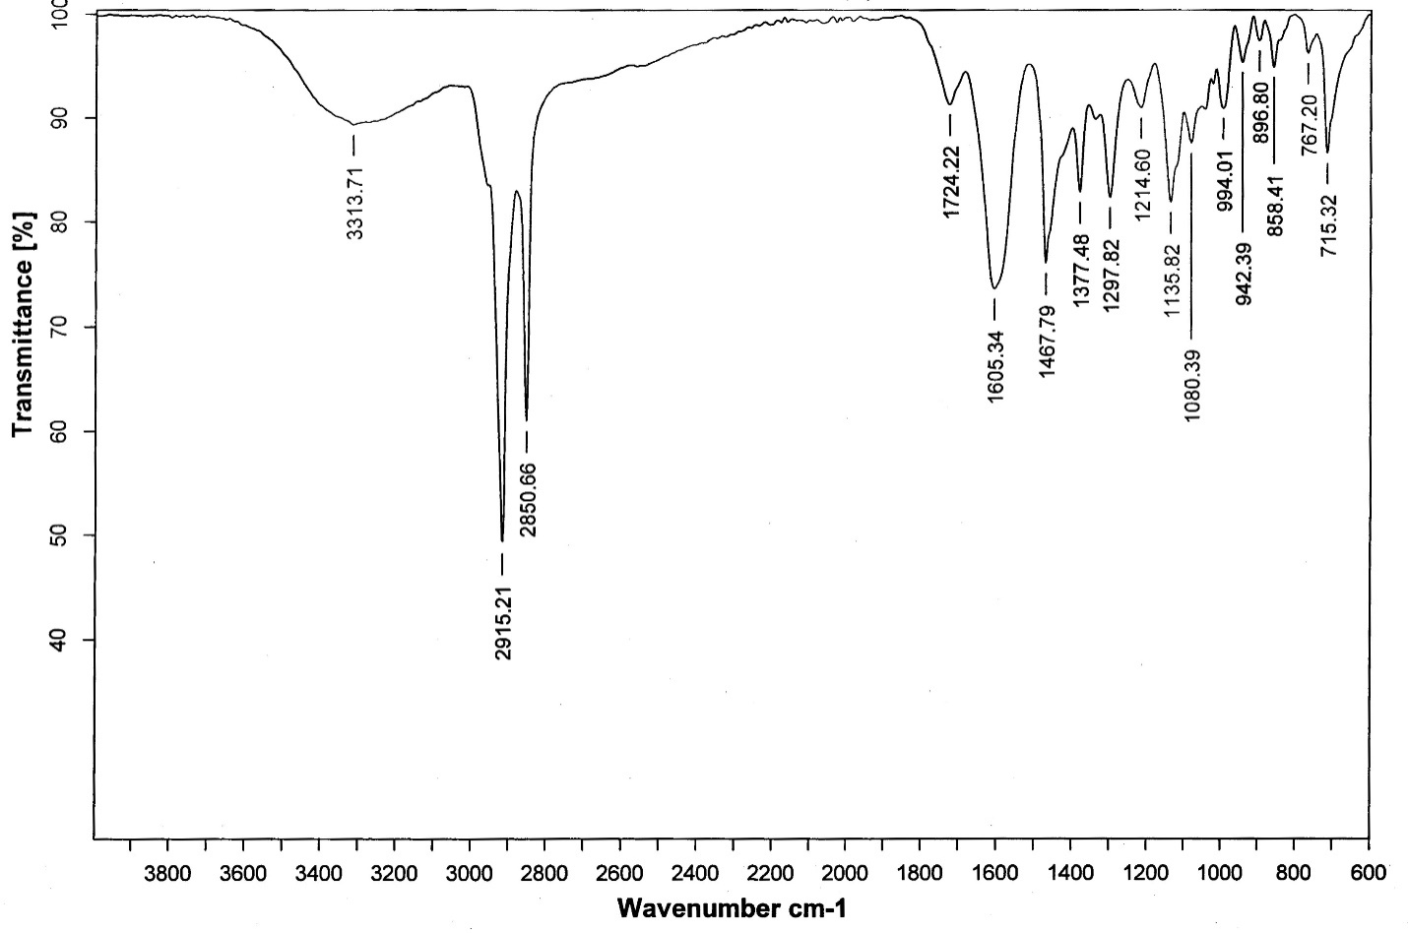
Fig.S1. IR spectrum of the hexadecylbis(2-hydroxypropyl)ammonium oxalate

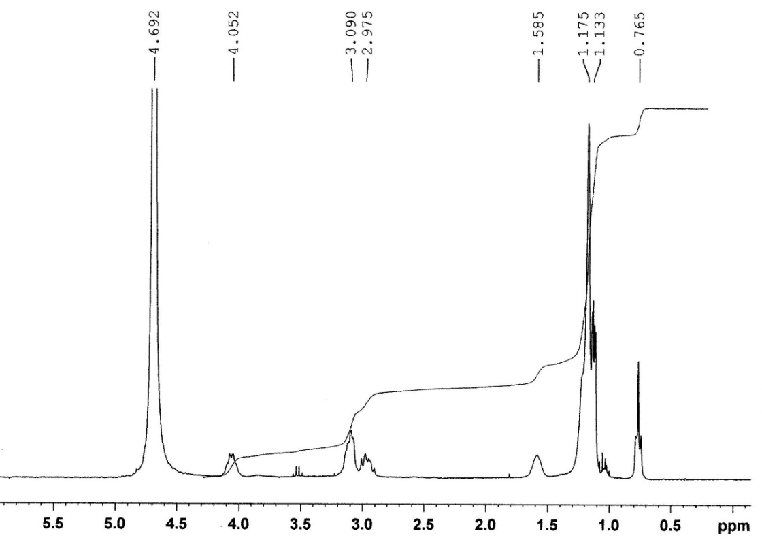
Fig.S2. ¹H-NMR spectrum of the hexadecylbis(2-hydroxypropyl)ammonium oxalate
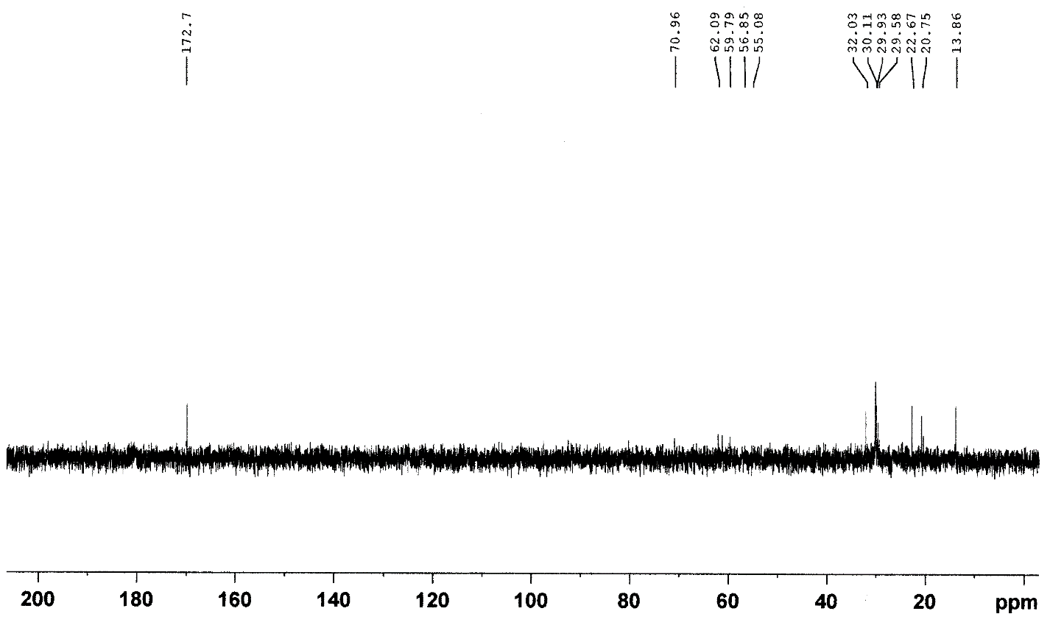
Fig.S3. ¹³C-NMR spectrum of the hexadecylbis(2-hydroxypropyl)ammonium oxalate

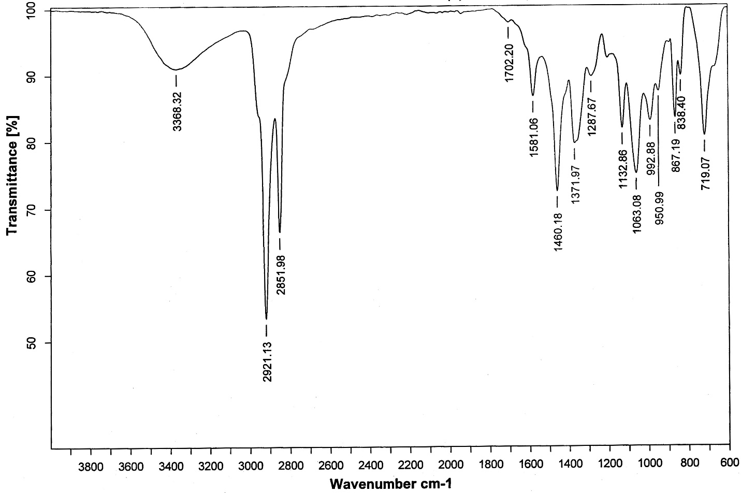
Fig.S4. IR spectrum of the hexadecylbis(2-hydroxypropyl)ammonium succinate

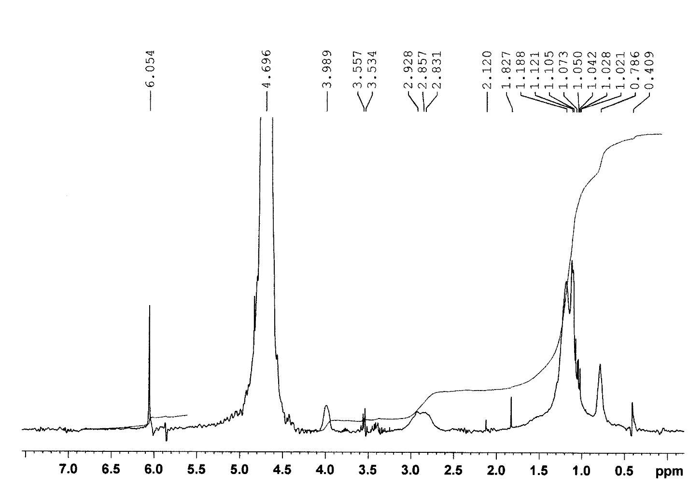
Fig.S5. ¹H-NMR spectrum of the hexadecylbis(2-hydroxypropyl)ammonium succinate

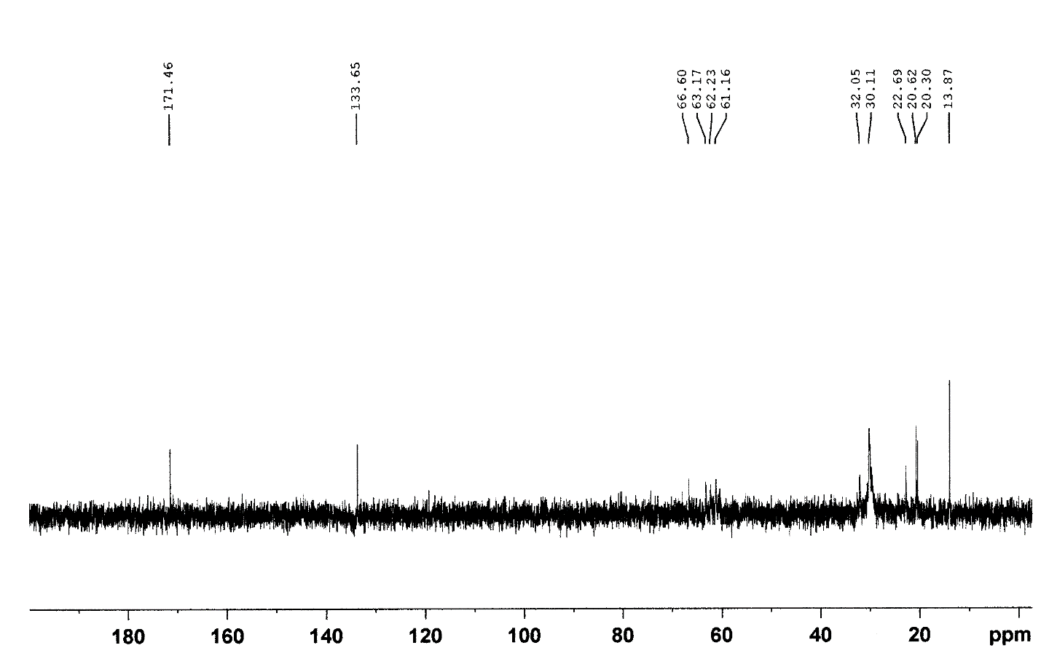
Fig.S6. ¹³C-NMR spectrum of the hexadecylbis(2-hydroxypropyl)ammonium succinate
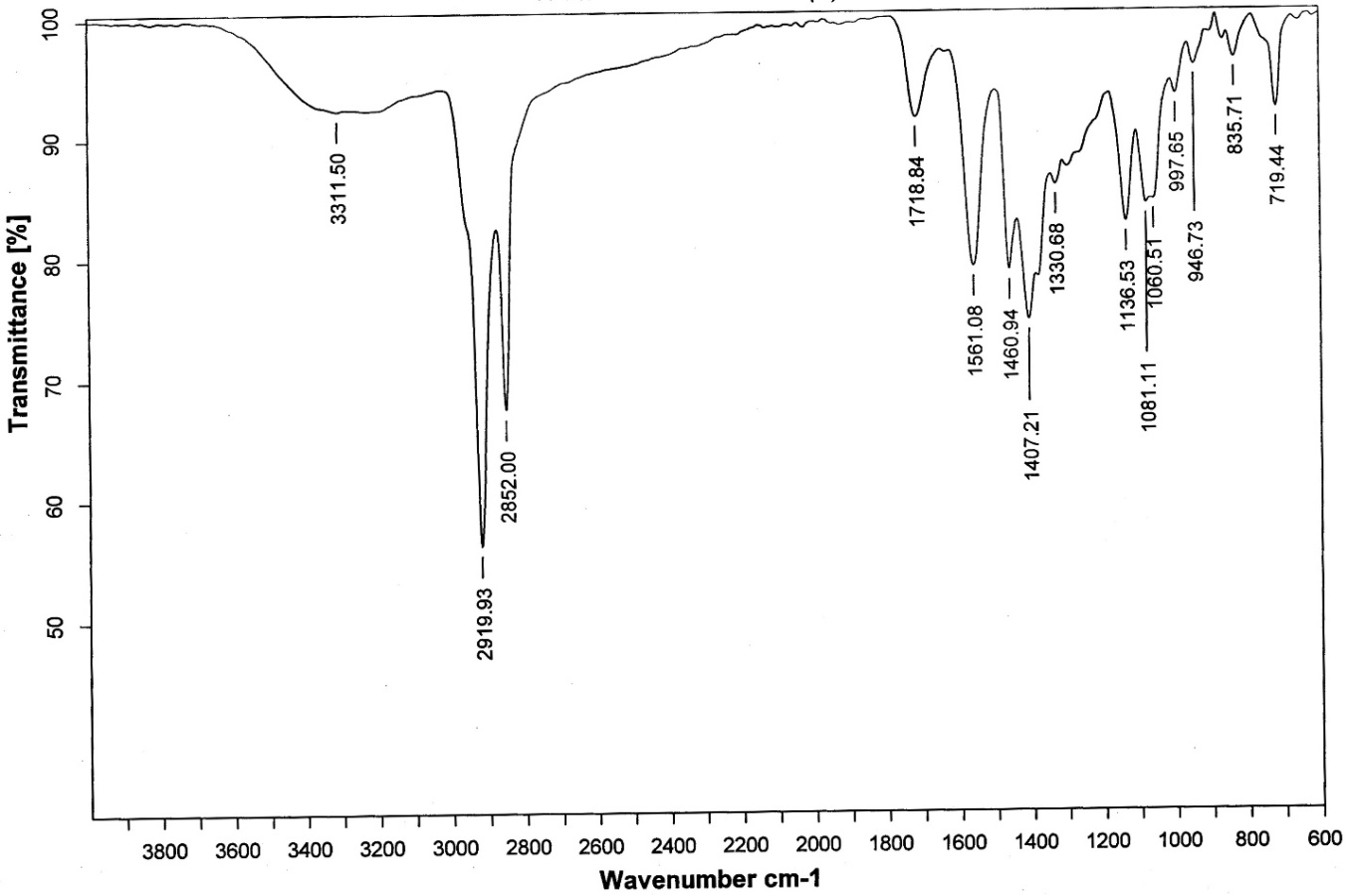
Fig.S7. IR spectrum of the hexadecylbis(2-hydroxypropyl)ammonium adipinate

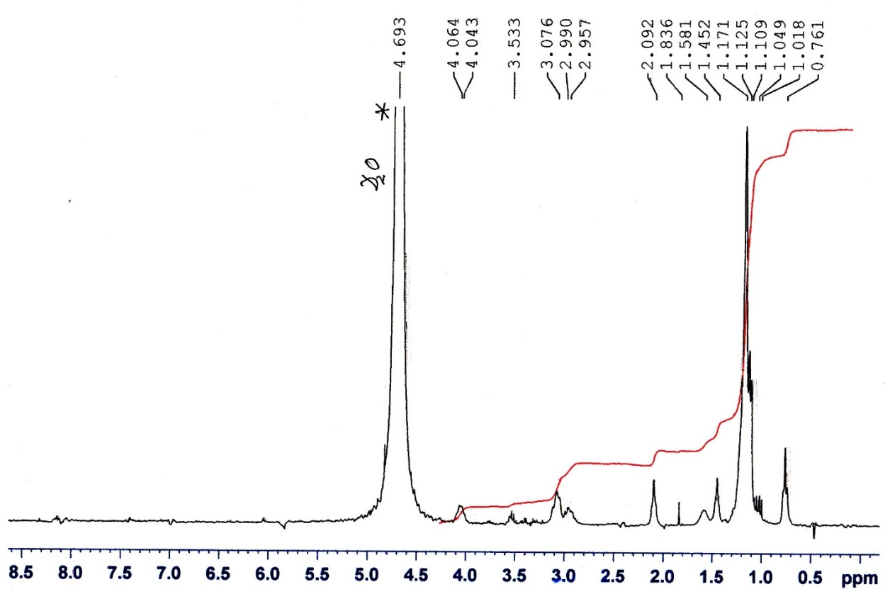
Fig.S8. ¹H-NMR spectrum of the hexadecylbis(2-hydroxypropyl)ammonium adipinate
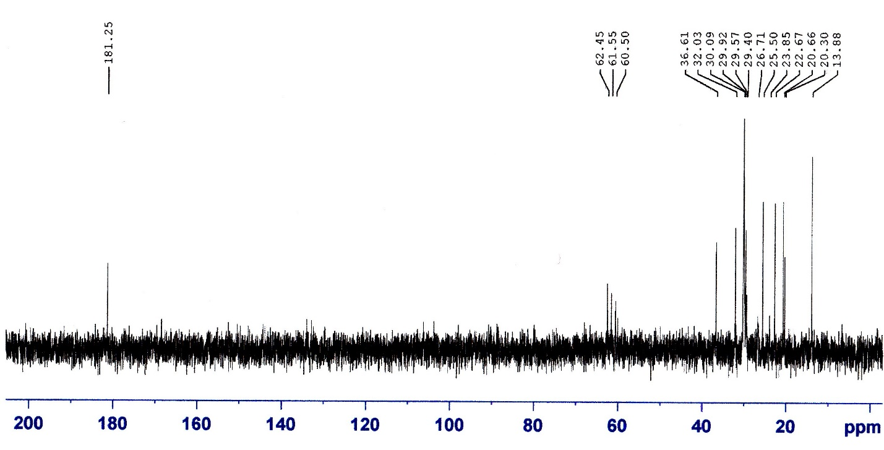
Fig.S9. ¹³C-NMR spectrum of the hexadecylbis(2-hydroxypropyl)ammonium adipinate

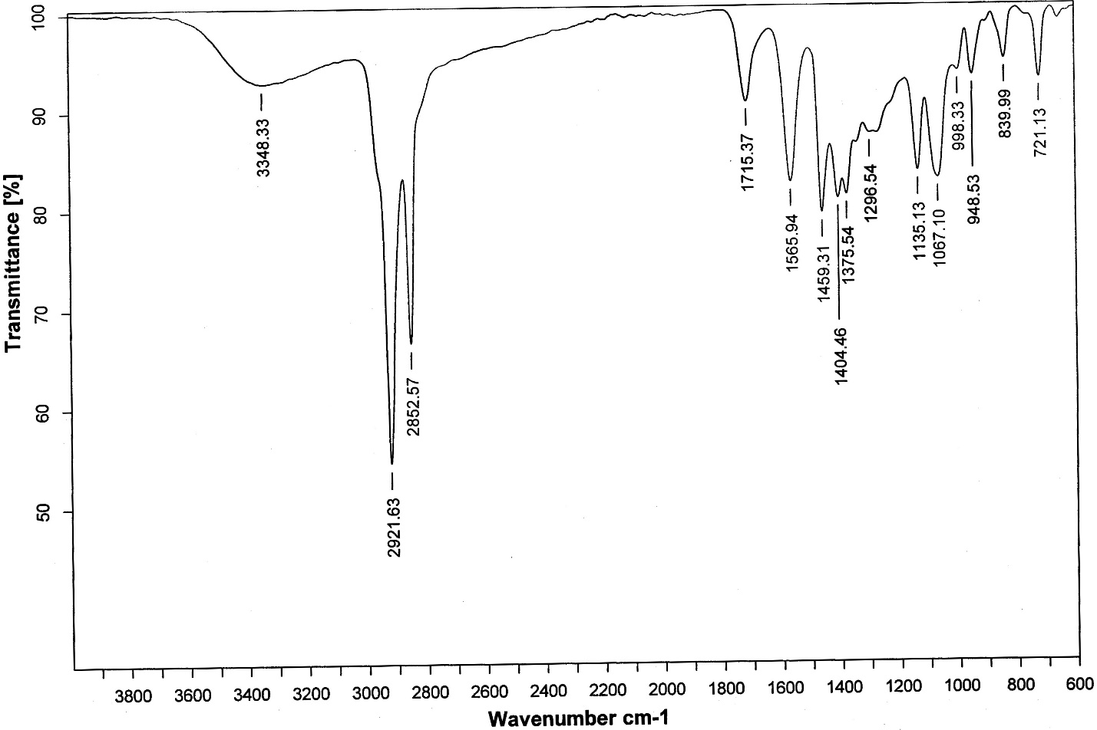
Fig.S10. IR spectrum of the hexadecylbis(2-hydroxypropyl)ammonium sebacate
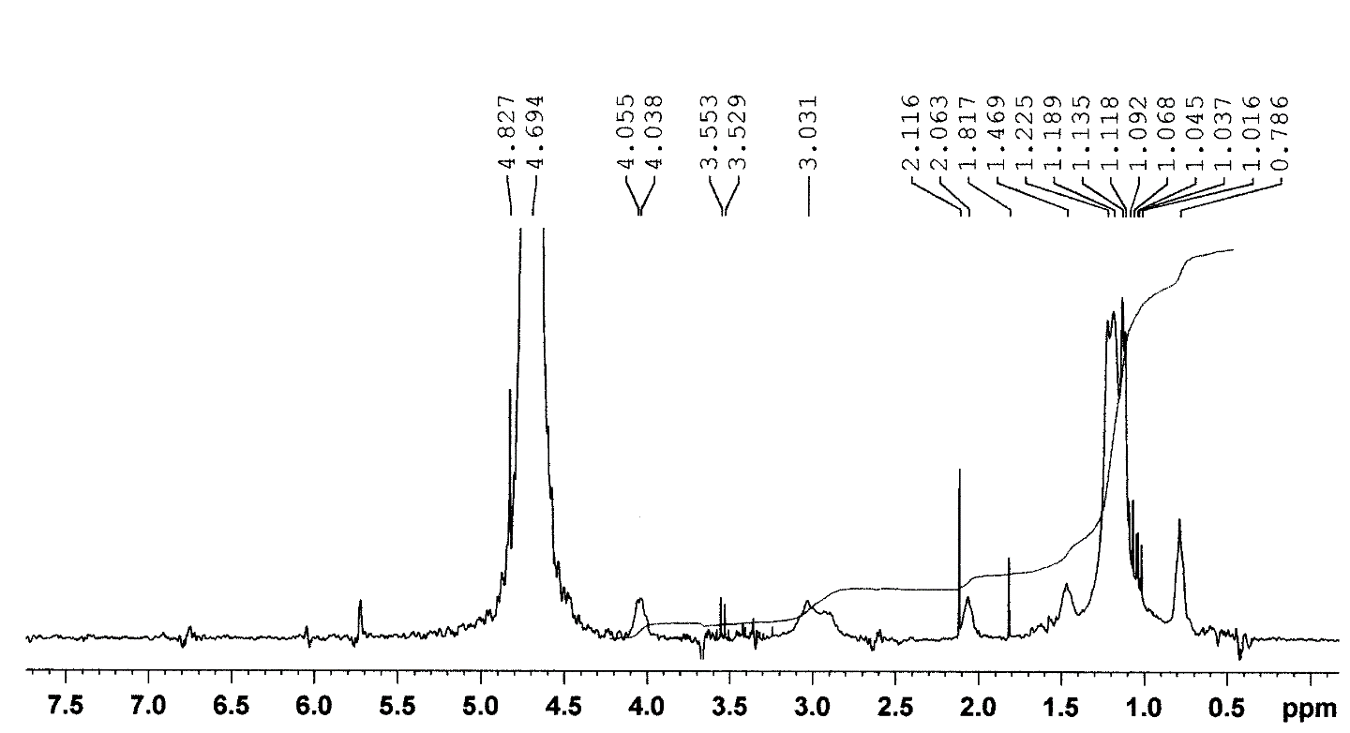
Fig.S11. ¹H-NMR spectrum of the hexadecylbis(2-hydroxypropyl)ammonium sebacate

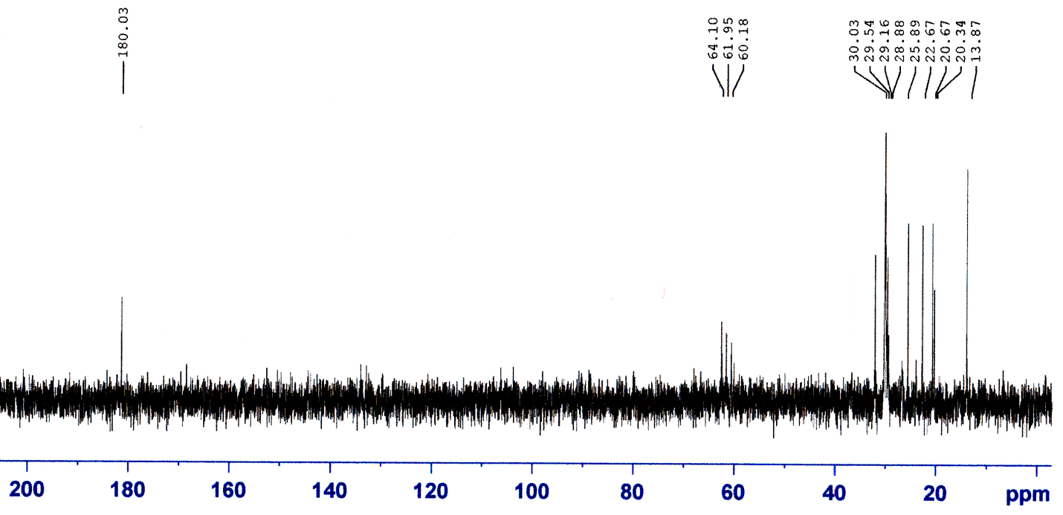
Fig.S12. ¹³C-NMR spectrum of the hexadecylbis(2-hydroxypropyl)ammonium sebacate
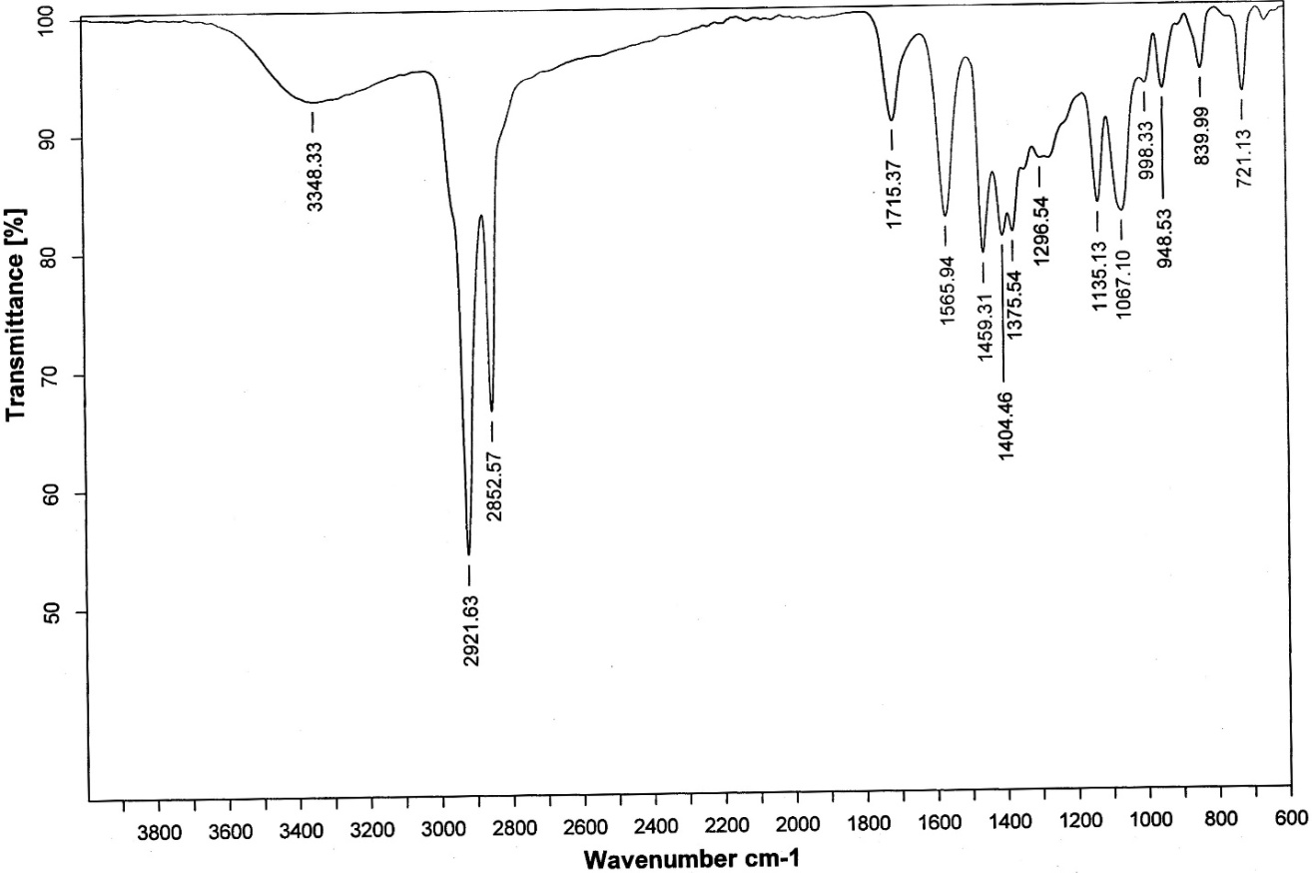
Fig.S13. IR spectrum of the hexadecylbis(2-hydroxypropyl)ammonium maleinate

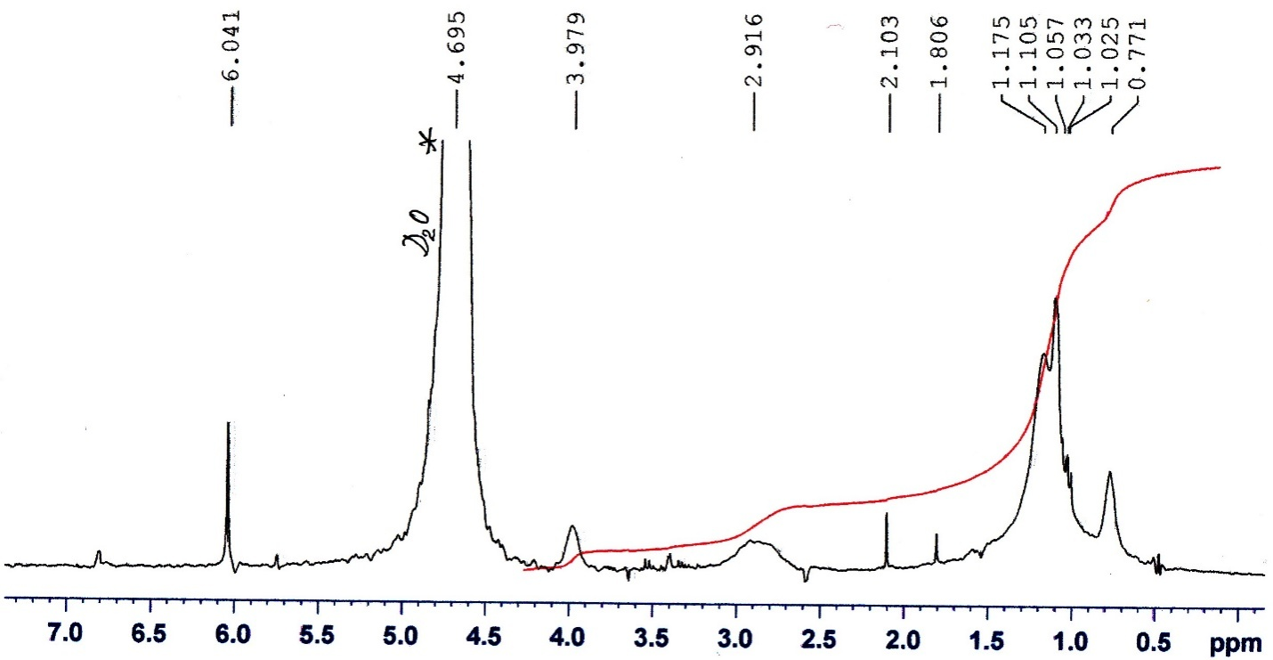
Fig.S14. ¹H-NMR spectrum of the hexadecylbis(2-hydroxypropyl)ammonium maleinate

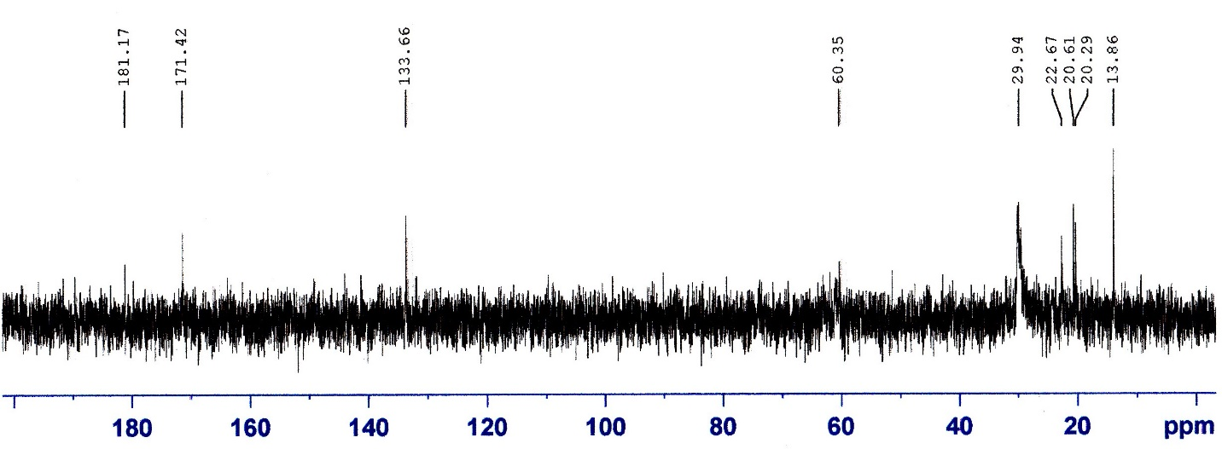
Fig.S15. ¹³C-NMR spectrum of the hexadecylbis(2-hydroxypropyl)ammonium maleinate

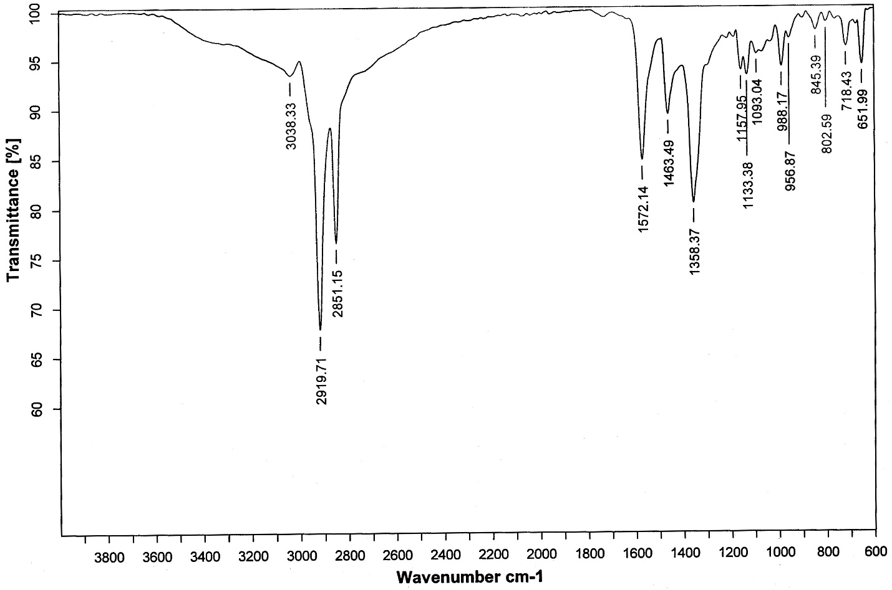
Fig.S16. IR spectrum of the hexadecylbis(2-hydroxypropyl)ammonium fumarate

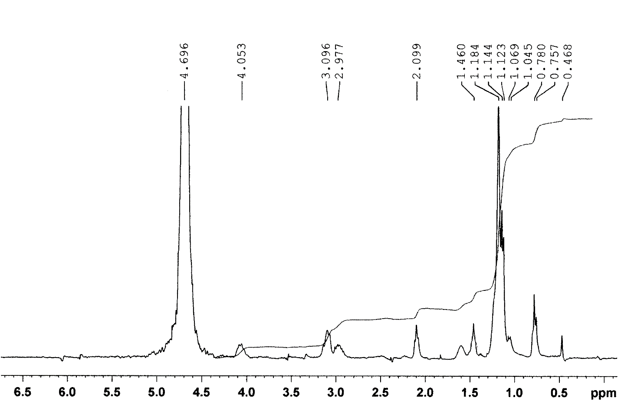
Fig.S17. ¹H-NMR spectrum of the hexadecylbis(2-hydroxypropyl)ammonium fumarate

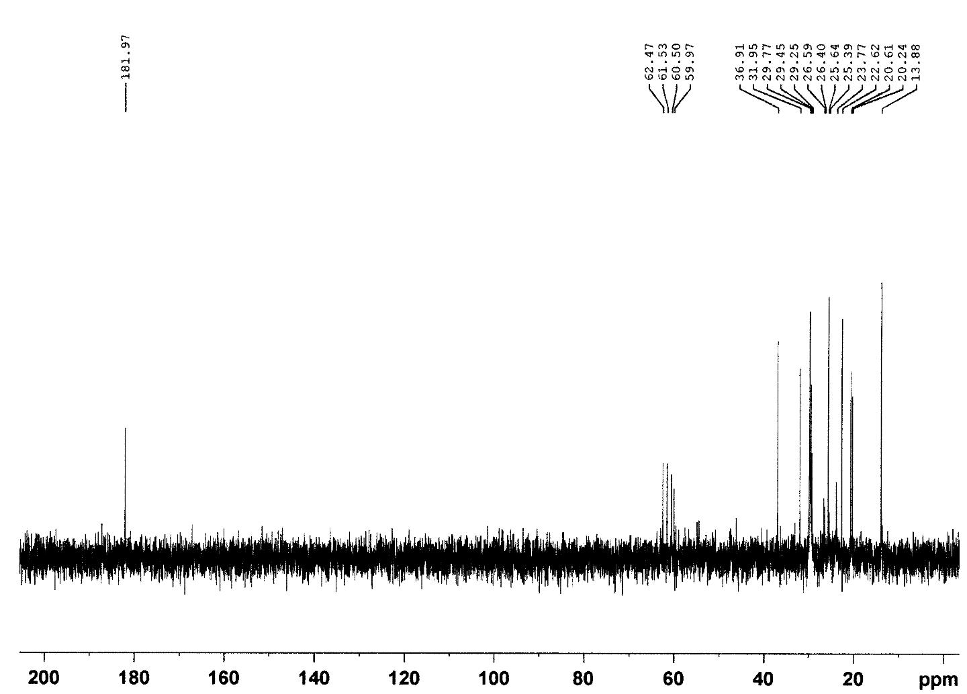
Fig.S18. ¹³C-NMR spectrum of the hexadecylbis(2-hydroxypropyl)ammonium fumarate
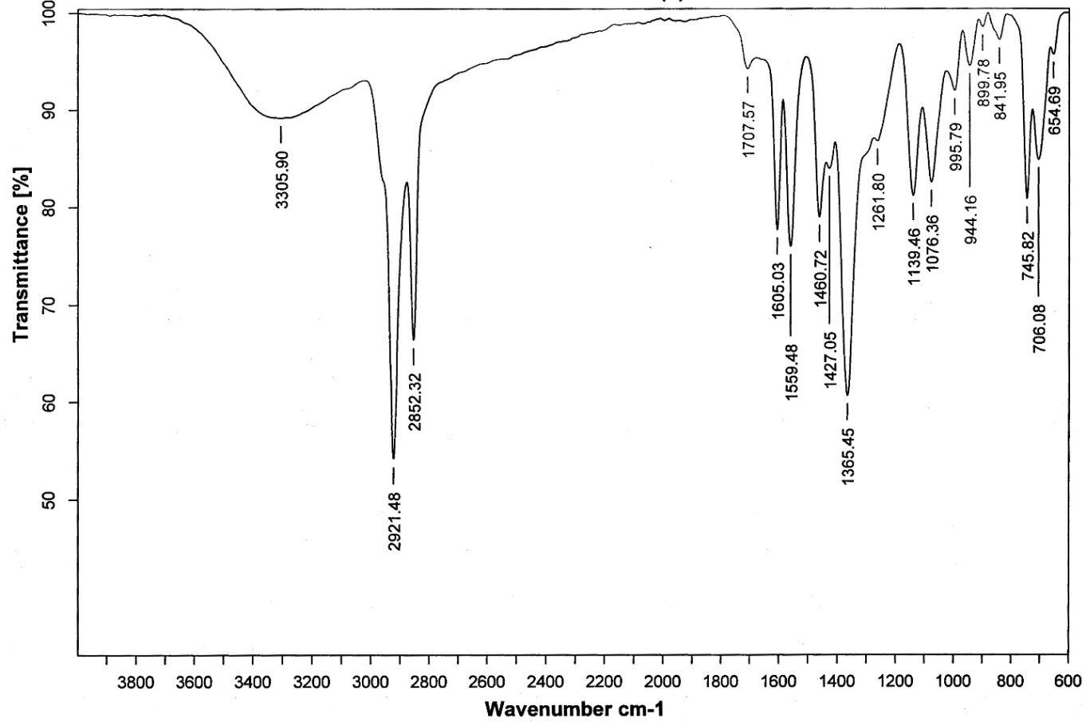
Fig.S19. IR spectrum of the hexadecylbis(2-hydroxypropyl)ammonium isophthalate

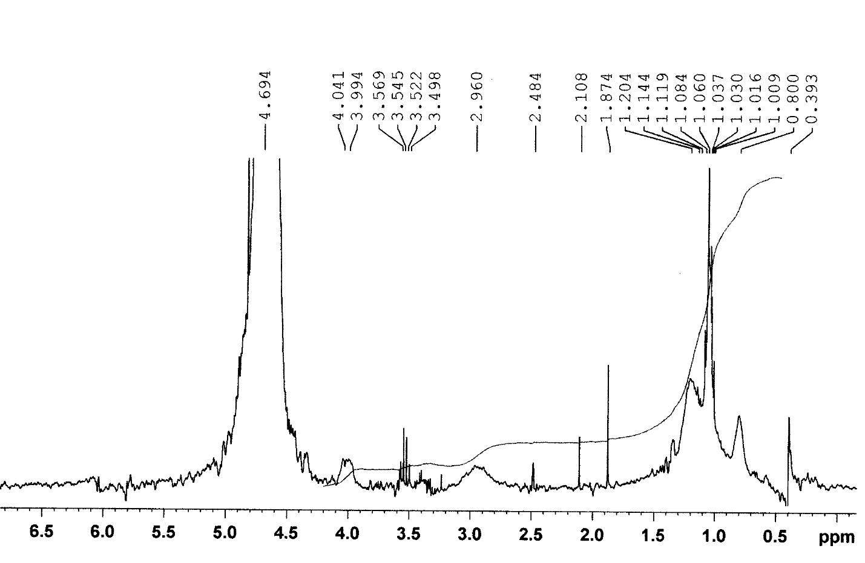
Fig.S20. ¹H-NMR spectrum of the hexadecylbis(2-hydroxypropyl)ammonium isophthalate
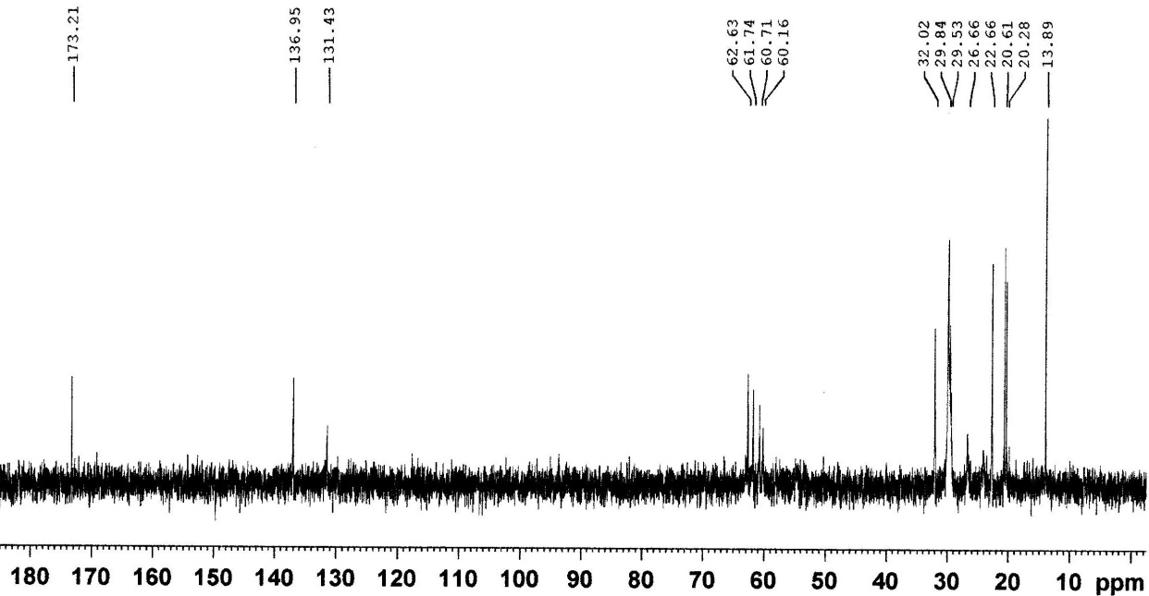
Fig.S21. ¹³C-NMR spectrum of the hexadecylbis(2-hydroxypropyl)ammonium isophthalate

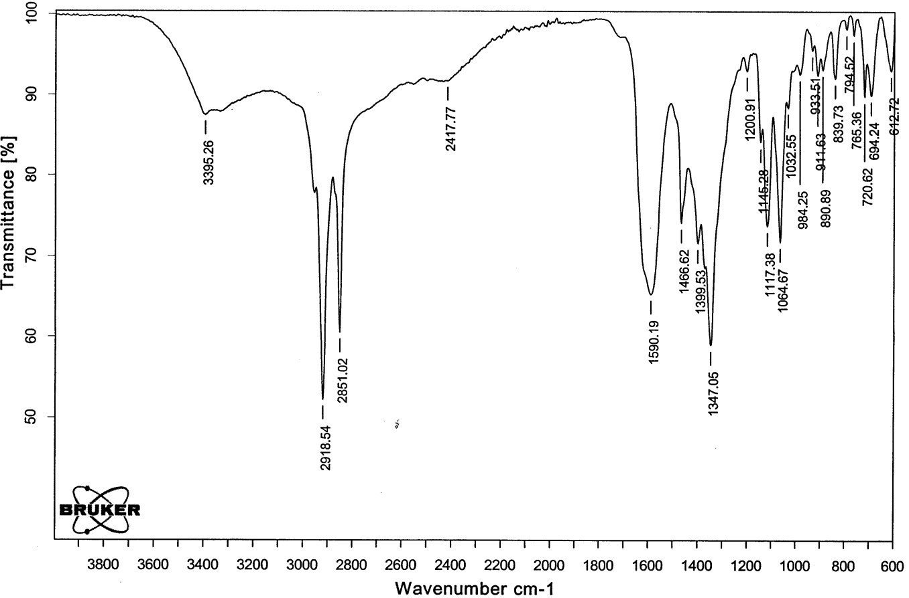
Fig.S22. IR spectrum of the hexadecylbis(2-hydroxypropyl)ammonium tartarate

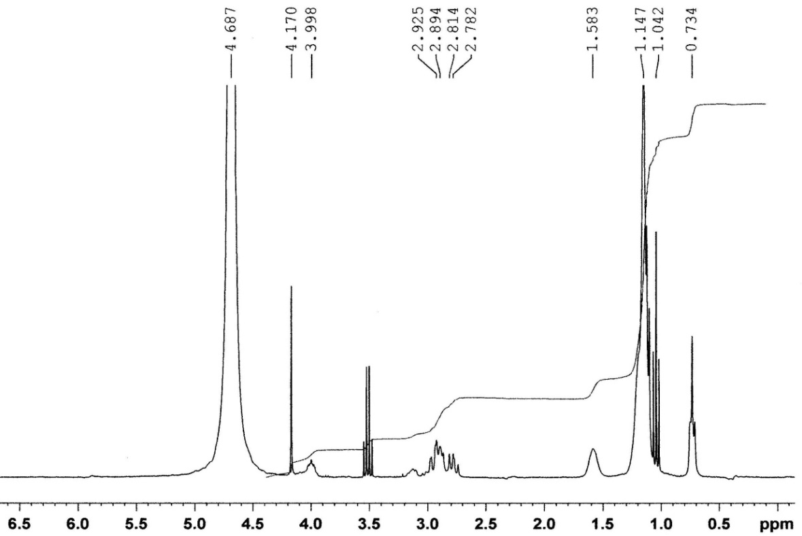
Fig.S23. ¹H-NMR spectrum of the hexadecylbis(2-hydroxypropyl)ammonium tartarate

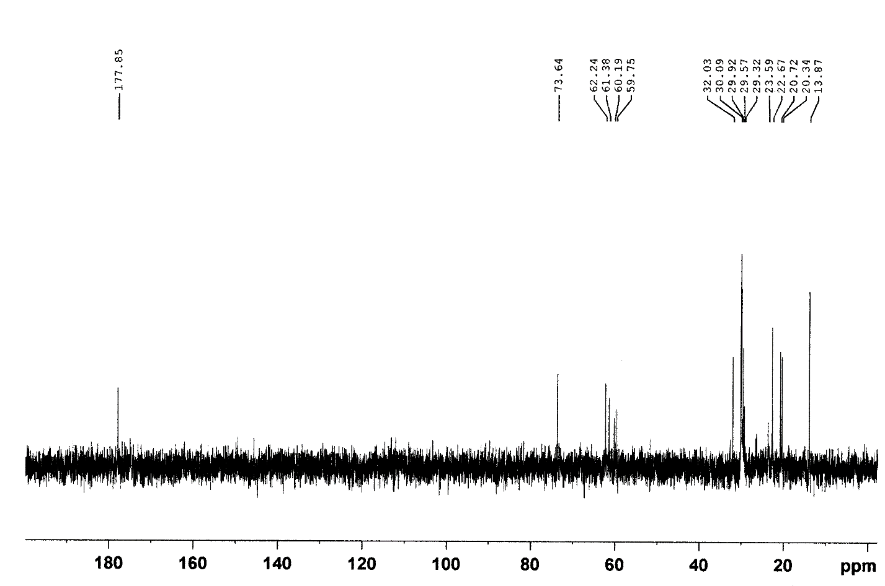
Fig.S24. ¹³C-NMR spectrum of the hexadecylbis(2-hydroxypropyl)ammonium tartarate

