Appendix 1. Screenshots of participant-facing app. Approved by Cohero Health.

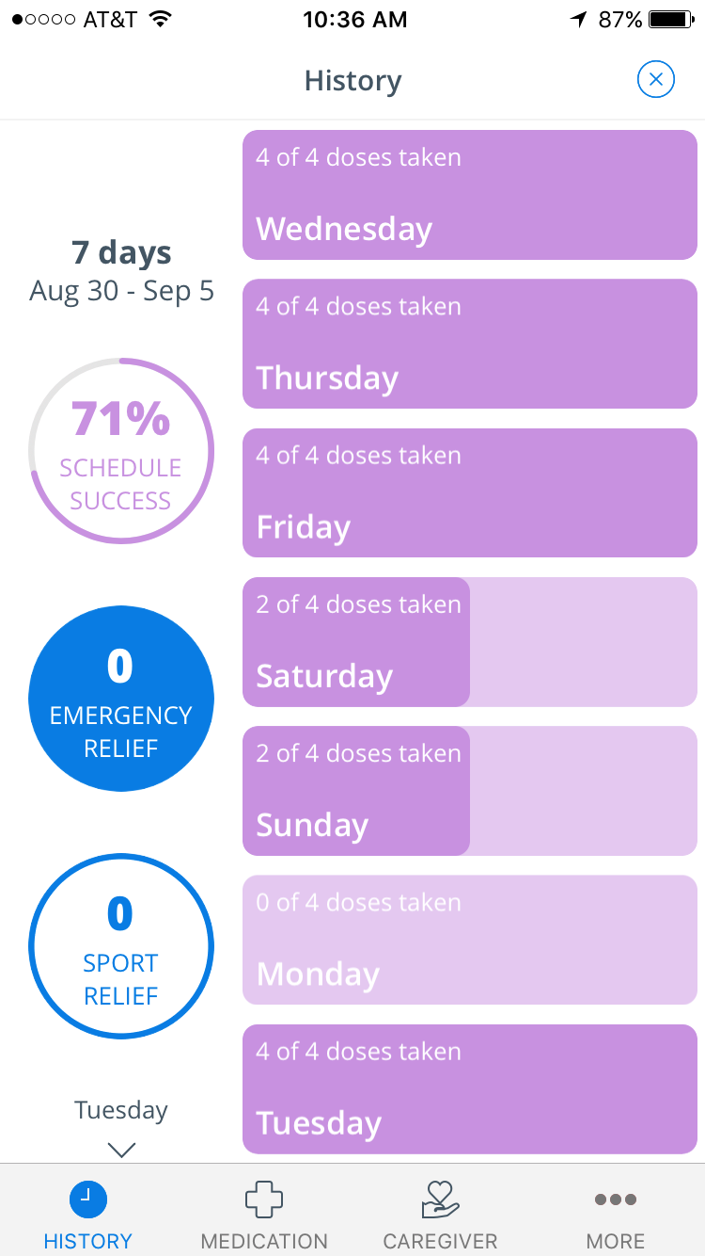

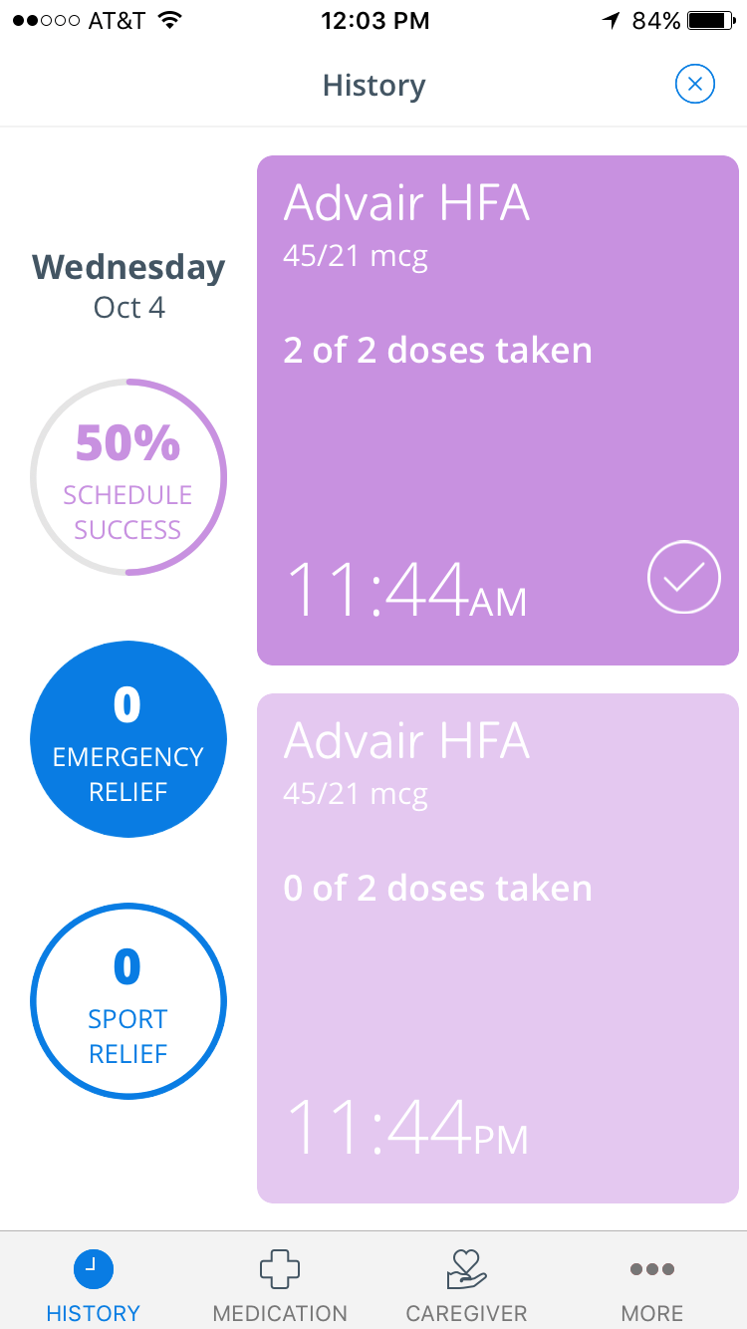

Appendix 2. Participant messaging.
Message Type | Push Notification Language
Daily Adherence Reminders  (1 per day) | Hi! This is your friendly daily controller inhaler reminder. Quick fact: children who take controller medication daily have less future asthma attacks.
 | Hello! A friendly reminder to make sure your child took their daily controller inhaler. Even for older children, parents are an important part of improving asthma control.
 | Hi! Did your child take their daily controller inhaler today? Quick fact: when taken regularly, daily controllers reduce the number of emergency room visits.
 | Hello there! Has your child taken all of their daily controller puffs today? Remember to always use a spacer with those puffs.
 | Hi! A quick reminder to make sure that your child took their daily asthma inhaler. Quick tip: have your child take daily controller inhaler with another daily activity (tooth-brushing).
 | Greetings! This is a friendly daily controller inhaler reminder for you. When taken regularly, daily inhalers reduce the number of missed school days.
 | Hello! This is your friendly daily controller inhaler reminder. Quick tip: when your child is away from home remember to send medications and a spacer with them.
Weekly Sync Reminder | Get credit for the puffs your child took this week! Sync your inhaler sensor with your phone tonight!
Weekly Feedback  (>75% average weekly adherence) | Way to go! Your child took XX out of YY controller puffs last week (about 3 out of every 4 puffs). You beat your goal!  Your child earned $XX this week, towards their end of the month reward ([chosen reward]). Congrats!
Weekly Feedback  (50-75% average weekly adherence) | Not bad! Your child took XX out of YY puffs and earned $XX last week. This goes towards their [chosen reward] this month!  Your child’s goal is to take at least 3 out of every 4 controller puffs (75%) daily. Try this next week—you got this!
Weekly Feedback  (<50% average weekly adherence) | Your child took less than half of their controller puffs last week. S/he has earned $XX this week.  Remember, the medicine is only helpful if you take at least 3 out of every 4 puffs. Try this next week—you can do it!

