Supplemental online materials
Effects of hormone replacement therapy on endometrial hormone concentrations and progesterone receptor expression in recurrent pregnancy loss: a self-controlled study
Limei Zhang¹, Yingying Zhang¹, Lu Luo¹, Jifan Tan², Mengxi Jia³, Xiang Hua¹, Qiong Wang^{1,*}, Canquan Zhou¹
¹Reproductive Medicine Center, Department of Obstetrics and Gynecology, the First Affiliated Hospital of Sun Yat-sen University, Guangzhou, China
²Department of Obstetrics and Gynecology, the Seventh Affiliated Hospital of Sun Yat-sen University, Guangzhou, China
³Distinct Healthcare, Guangzhou, China

*Correspondence: Qiong Wang, wangqionggz@hotmail.com

Progesterone measurement
The endometrium tissue was divided into two parts: one was fixed immediately in formalin (10%), the other was added in the lysis buffer (RIPA, Thermo), bullet blender (S:5×3 min) and lysed by 30s sonication (frequency 1:2, rate 50%). Then the completed lysed tissue was confirmed by a microscope. Finally, the supernatant of lysed tissue was collected after centrifugation as endometrial tissue lysate. The progesterone level of both the peripheral blood and endometrial tissue lysate were measured by Immulite ^{[1]}.
Antibodies and immunohistochemistry
Fixed endometrium tissues were processed as paraffin blocks. The 4mm-thick sections of fixed tissue were deparaffinated in xylene, and then rehydrated through a series of graded ethanol solutions. The antigen retrieval was achieved by microwave pretreatment ^{[2]}. The sections were incubated with endogenous peroxidases at room temperature for 10 min, followed by repeated wash using phosphate buffered saline (PBS, pH=7.4). They were then blocked with 5% normal goat serum for 30 min and washed with PBS. Next, the sections were incubated with primary antibodies against progesterone receptor A (hPRa7, Thermo, 1:100) or progesterone receptor B (hPRa6, Thermo, 1:100) ^{[3]} overnight at 4℃, followed by the incubation with secondary antibiotics (Detection system, K5007, Dako) for 1h. Finally, boundary antibody (Detection system, K5007, Dako) with 3.3’-diaminobenzidine substrate was incubated with sections for 1 - 5 min. Control samples underwent the same procedures without primary antibodies to exclude non-specific interactions. All the slides were scanned using an Olympus BX51 microscope (Olympus, Japan).

Analysis of immunohistochemical results
Endometrial cells were divided into epithelial and stromal cells parts during cell analysis, and positive cells were counted by two independent experienced pathologists. The number and intensity of the stained cells were used to describe the immunohistochemical characteristics. For qualitative analysis, samples were considered as negative when no stained on tissue section was observed. In all other cases, the samples were positive. The intensity of staining was evaluated as following: 0 equates to negative, 1 equates to weak, 2 equates to moderate and 3 equates to intense immunostaining ^{[3, 4]}.The percentage of stained cells was calculated by two independent experienced pathologists.
For each observed slide, a calculated value known as H-score ^{[5]}was used for further analysis.
H-score = Σ Pi(i+1),
i is the intensity of staining varying from 0 to 3 and Pi is the percentage of stained cells.

Table S1. Patient characteristics
 | Average | Range
Age (years) | 30.86±3.87 | 21−39
BMI (kg/m²) | 20.77±1.86 | 16.9−24.52
Number pregnancies lost | 2.52±0.79 | 2−6
Basal FSH/LH | 1.69±0.45 | 0.54−2.94

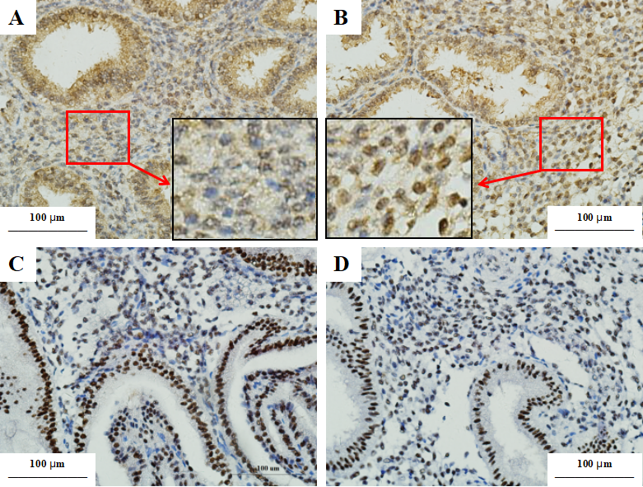
Figure S1. Immunochemical staining of endometrial PRA and PRB under NC and HRT conditions. (A-B) Optical microscope images of endometrial tissues after PRA immunochemical staining under NC (A) and HRT (B). (C-D) Optical microscope images of endometrial tissues after PRB immunochemical staining under NC (C) and HRT (D). Immunopositive cells are brown, while non-immunoreactive cells are blue. Higher PRA expression was observed in stromal cells under the HRT condition compared to the NC condition. There was no difference in PRA expression by glandular cells or PRB expression by glandular and stromal cells between HRT and NC conditions.

References:
[1] Ficicioglu C, Gurbuz B, Tasdemir S, et al. High local endometrial effect of vaginal progesterone gel[J]. Gynecological Endocrinology. 2004, 18(5): 240-243.
[2] Patricia A. Mote J A L C. Immunohistochemical Detection of Progesterone Receptors in Archival Breast Cancer[J]. Biotechnic & Histochemistry. 1997.
[3] Mote P A, Johnston J F, Manninen T, et al. Detection of progesterone receptor forms A and B by immunohistochemical analysis[J]. J Clin Pathol. 2001, 54(8): 624-630.
[4] Rebecca L. Arnett-Mansfield A D G V, Clarke A C L. Relative Expression of Progesterone Receptors A and B in Endometrioid Cancers of the Endometrium1[J]. CANCER RESEARCH. 2001.
[5] Budwit-Novotny D A, Mccarty K S, Cox E B, et al. Immunohistochemical analyses of estrogen receptor in endometrial adenocarcinoma using a monoclonal antibody[J]. Cancer Res. 1986, 46(10): 5419-5425.

