Supplementary files

Figure 1: Patient flow throughout the study

Figure 2: Number of ACU referrals of women diagnosed with cancer

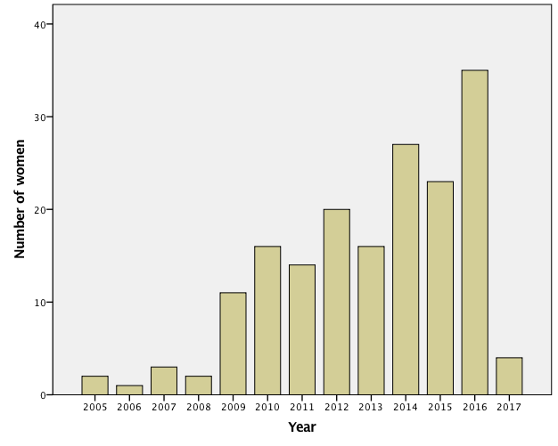

Table 1: Women referred to the ACU: cancer diagnoses

Cancer Type | N (%)
Breast | 97 (56.4)
Hodgkin’s Lymphoma | 26 (15.1)
Cervical | 11 (6.4)
Brain | 8 (4.7)
Ovarian | 7 (4.1)
Bowel Cancer | 5 (2.9)
Endometrial | 4 (2.3)
Acute Myeloid Leukaemia | 3 (1.7)
Non-Hodgkin’s Lymphoma | 2 (1.2)
Nasopharyngea | 2 (1.2)
Adrenal | 1 (0.6)
Melanoma | 1 (0.6)
Tonsil | 1 (0.6)
Chronic Myeloid Leukaemia | 1 (0.6)
Sarcoma | 1 (0.6)
Stomach | 1 (0.6)
Myelodysplasia syndrome | 1 (0.6)

Table 2: Service ratings

Feedback score given | Reasoning | N  (missing n=2)
Excellent | “from the receptionist to the embryologist, I was made totally at ease” (STH52)  “all staff members were considerate and friendly, they appeared to go beyond what you might expect” (STH24). “very informative but empathetic, kind and supportive” (STH21)  “caring, friendly, professional” (STH57)  “all the staff were incredibly friendly and supportive to my situation. Being so young they tailored the care and service they gave me, which made me feel supported”. (STH10, aged 20) | 14
Very good | “excellent care at the unit but no after-care” (STH50) | 10
Good | “given the incorrect information regarding funding for a second round of treatment and this caused a lot of distress at the time”  “all doctors should know funding details necessary to give correct advice” (STH20 | 4
Neither good nor bad |  | 3
Poor?
Extremely poor | “People we had contact with did not listen so we lost all confidence in their ability to perform their medical tasks” (STH31). | 1

